Chad Huntebrinker’s Homework 4

Chad Huntebrinker

2024-09-24

Question 2.4b and c: With a 99% confidence interval for B1, test using the test statistic t* to find a linear association. Find the P-value.

#Chad Huntebrinker  
#Problem 2.4b  
#Load the library and data in to R  
library(readxl)  
  
excel_data <- read_excel("Grade_Point_Average_Data.xlsx")  
  
# GPA ~ ACT  
# Fit the model and get the summary of the model  
model_1 <- lm(GPA~ACT_Score,data=excel_data)  
sum_of_model_1 <- summary(model_1)  
sum_of_model_1

##   
## Call:  
## lm(formula = GPA ~ ACT_Score, data = excel_data)  
##   
## Residuals:  
## Min 1Q Median 3Q Max   
## -2.74004 -0.33827 0.04062 0.44064 1.22737   
##   
## Coefficients:  
## Estimate Std. Error t value Pr(>|t|)   
## (Intercept) 2.11405 0.32089 6.588 1.3e-09 ***  
## ACT_Score 0.03883 0.01277 3.040 0.00292 **   
## ---  
## Signif. codes: 0 '***' 0.001 '**' 0.01 '*' 0.05 '.' 0.1 ' ' 1  
##   
## Residual standard error: 0.6231 on 118 degrees of freedom  
## Multiple R-squared: 0.07262, Adjusted R-squared: 0.06476   
## F-statistic: 9.24 on 1 and 118 DF, p-value: 0.002917

sum_of_model_1$coefficients[2,4]

## [1] 0.002916604

# Plot the graph just to see  
plot(GPA~ACT_Score,data=excel_data)  
abline(model_1,col="red")

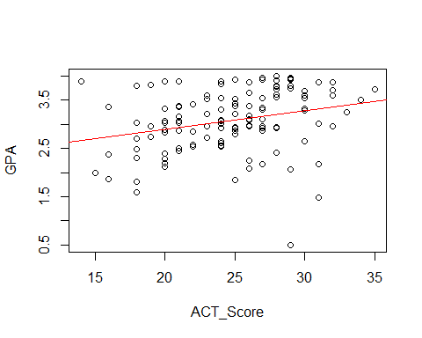

#Calculate the t score  
b1 <- sum_of_model_1$coefficients[2, 1]  
se_b1 <- sum_of_model_1$coefficients[2, 2]  
  
#a = 0.01  
t_1 <- b1 / se_b1  
  
#If the t_1 > than the t score, than we conclude that H1 is true (which is B1 != 0)  
t_1 > qt(0.995, 118)

## [1] TRUE

#Problem 2.4c  
#Calculate the p_value  
p_1 <- 2 * (1 - pt(t_1, 118))  
  
#If the p score is less than alpha, than H1 is true (which is B1 != 0)  
p_1 < 0.01

## [1] TRUE

Problem 2.6b: With a level of significance of .05, conduct a t test and find the P-value to see if there is a linear association

#Chad Huntebrinker  
#Problem 2.6b  
#Load the library and data in to R  
library(readxl)  
  
excel_data <- read_excel("Airfreight_Breakage_Data.xlsx")  
  
#Number_Broker ~ Number_Transferred  
#Fit the model  
model_2 <- lm(Number_Broker~Number_Transferred,data=excel_data)  
sum_of_model_2 <- summary(model_2)  
sum_of_model_2

##   
## Call:  
## lm(formula = Number_Broker ~ Number_Transferred, data = excel_data)  
##   
## Residuals:  
## Min 1Q Median 3Q Max   
## -2.2 -1.2 0.3 0.8 1.8   
##   
## Coefficients:  
## Estimate Std. Error t value Pr(>|t|)   
## (Intercept) 10.2000 0.6633 15.377 3.18e-07 ***  
## Number_Transferred 4.0000 0.4690 8.528 2.75e-05 ***  
## ---  
## Signif. codes: 0 '***' 0.001 '**' 0.01 '*' 0.05 '.' 0.1 ' ' 1  
##   
## Residual standard error: 1.483 on 8 degrees of freedom  
## Multiple R-squared: 0.9009, Adjusted R-squared: 0.8885   
## F-statistic: 72.73 on 1 and 8 DF, p-value: 2.749e-05

sum_of_model_2$coefficients[2,4]

## [1] 2.748669e-05

#Plot to see the graph  
plot(Number_Broker~Number_Transferred, data = excel_data)  
abline(model_2,col="blue")

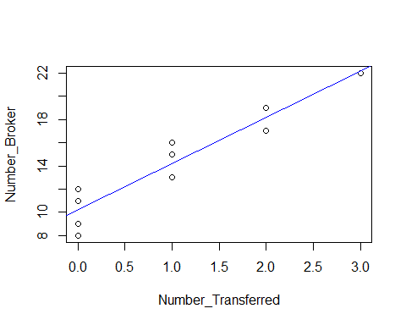

#Calculate the t score  
b1 <- sum_of_model_2$coefficients[2, 1]  
se_b1 <- sum_of_model_2$coefficients[2, 2]  
  
#a = 0.05  
t_1 <- b1 / se_b1  
  
#If the t_1 > than the t score, than we conclude that H1 is true (which is B1 != 0)  
t_1 > qt(0.975, 8)

## [1] TRUE

#Calculate the p_value  
p_1 <- 2 * (1 - pt(t_1, 8))  
  
#If the p score is less than alpha, than H1 is true (which is B1 != 0)  
p_1 < 0.01

## [1] TRUE

Problem 2.14a: Find the confidence interval with a 90% confidence interval for the mean service time on calls in which six copier are serviced

#Chad Huntebrinker  
#Problem 2.14a  
#Load the library and data in to R  
library(readxl)  
  
excel_data <- read_excel("Copier_Maintenance_Data.xlsx")  
  
#Total_Minutes ~ Number_Of_Copiers  
#Fit the model  
model_3 <- lm(Total_Minutes~Number_Of_Copiers,data=excel_data)  
sum_of_model_3 <- summary(model_3)  
  
#Plot to see the graph  
plot(Total_Minutes~Number_Of_Copiers, data = excel_data)  
abline(model_3,col="blue")

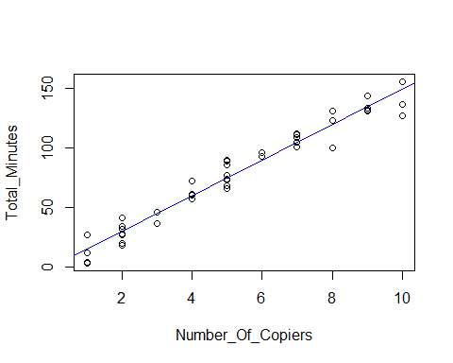

#Get b1 and se_b1  
b1 <- sum_of_model_3$coefficients[2, 1]  
se_b1 <- sum_of_model_3$coefficients[2, 2]  
  
#Get the mean service time for 6 copiers serviced  
Y_hat <- predict(model_3, data.frame(Number_Of_Copiers=6))  
  
#Now get the confidence interval  
predict(model_3, data.frame(Number_Of_Copiers=6), interval = "confidence", level = 0.90)

## fit lwr upr  
## 1 89.63133 87.28387 91.9788

Problem 2.27a and c: With a control risk for type 1 error of .05, find if there is a negative linear association. Estimate with a 95% confidence interval the difference in expected mm for women whose ages differ by one year.

#Chad Huntebrinker  
#Problem 2.27a  
#Load the library and data in to R  
library(readxl)  
  
excel_data <- read_excel("Muscle_Mass_Data.xlsx")  
  
#Muscle_Mass ~ Age  
#Fit the model  
model_4 <- lm(Muscle_Mass~Age,data=excel_data)  
sum_of_model_4 <- summary(model_4)  
  
#Plot to see the graph  
plot(excel_data$Muscle_Mass~excel_data$Age)  
abline(model_4,col="green")

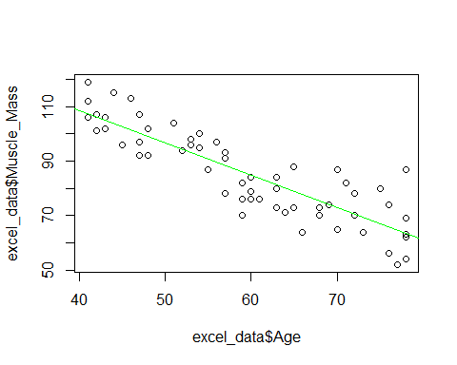

#Get b1 and se_b1  
b1 <- summary(model_4)$coefficients[2, 1]  
se_b1 <- summary(model_4)$coefficients[2, 2]  
  
#Find t score  
t_1 <- b1 / se_b1  
  
#If the t_1 > than the t score, than we conclude that H1 is true (which is B1 != 0)  
t_1 < qt(0.05, 58)

## [1] TRUE

#Find p score  
p_1 <- pt(t_1, 58)  
  
#Problem 2.27c  
qt(0.975, 58)

## [1] 2.001717

b1

## [1] -1.189996

se_b1

## [1] 0.09019725

#Lower confidence  
b1 - (qt(0.975, 58) * se_b1)

## [1] -1.370545

#Higher confidence  
b1 + (qt(0.975, 58) * se_b1)

## [1] -1.009446

Problem 2.65:Obtain a separate interval estimate of B1 for each egion. Use a 95% confidence coefficient in each case.

#Chad Huntebrinker  
#Problem 2.65  
#Load the library and data in to R  
library(readxl)  
  
excel_data <- read_excel("SENIC_Data.xlsx")  
  
#First  
#For Infection_Risk, plot the Data  
plot(Length_of_Stay ~ Infection_Risk, data = excel_data, pch = 16, xlab = "Infection Risk", ylab = "Length of Stay")  
  
#Fit a Linear Regression model  
model_7 <- lm(Length_of_Stay ~ Infection_Risk, data = excel_data)  
  
#Find b coefficients  
b7_coefficients <- model_7$coefficients  
  
#Add the fitted line  
abline(b7_coefficients, lwd =2, lty =2, col="red")

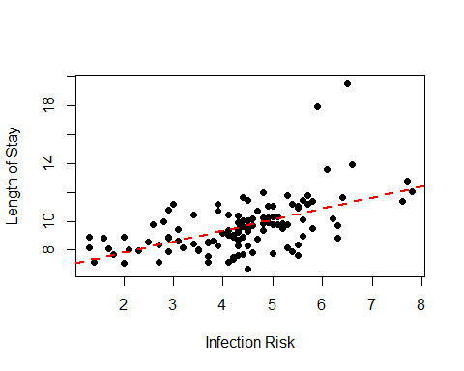

#Second  
#For Available_facilities_and_services, plot the Data  
plot(Length_of_Stay ~ Available_facilities_and_services, data = excel_data, pch = 16, xlab = "Available facilities and services", ylab = "Length of Stay")  
  
#Fit a Linear Regression model  
model_8 <- lm(Length_of_Stay ~ Available_facilities_and_services, data = excel_data)  
  
#Find b coefficients  
b8_coefficients <- model_8$coefficients  
  
#Add the fitted line  
abline(b8_coefficients, lwd =2, lty =2, col="green")

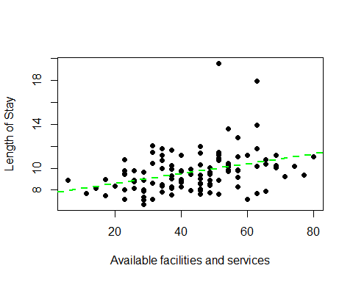

#Third  
#For Routine_Chest_X-ray, plot the Data  
plot(Length_of_Stay ~ `Routine_Chest_X-ray`, data = excel_data, pch = 16, xlab = "Routine Chest X-ray", ylab = "Length of Stay")  
  
#Fit a Linear Regression model  
model_9 <- lm(Length_of_Stay ~ `Routine_Chest_X-ray`, data = excel_data)  
  
#Find b coefficients  
b9_coefficients <- model_9$coefficients  
  
#Add the fitted line  
abline(b9_coefficients, lwd =2, lty =2, col="blue")

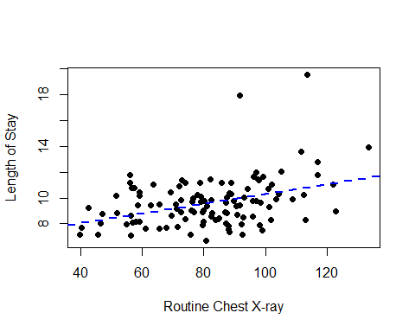

#Get the summary of each model  
sum7 <- summary(model_7)  
sum8 <- summary(model_8)  
sum9 <- summary(model_9)  
sum7$coefficients[2,4]

## [1] 1.176961e-09

sum8$coefficients[2,4]

## [1] 0.000111339

sum9$coefficients[2,4]

## [1] 2.905559e-05

#Calculate the t score  
b7 <- summary(model_7)$coefficients[2, 1]  
se_b7 <- summary(model_7)$coefficients[2, 2]  
  
b8 <- summary(model_8)$coefficients[2, 1]  
se_b8 <- summary(model_8)$coefficients[2, 2]  
  
b9 <- summary(model_9)$coefficients[2, 1]  
se_b9 <- summary(model_9)$coefficients[2, 2]  
  
#a = 0.05  
t_7 <- b7 / se_b7  
t_8 <- b8 / se_b8  
t_9 <- b9 / se_b9  
  
#Calculate the lower and upper confidence bounds for each variable  
b7 - (qt(0.975, 112) * se_b7)

## [1] 0.5336665

b7 + (qt(0.975, 112) * se_b7)

## [1] 0.9871753

b8 - (qt(0.975, 112) * se_b8)

## [1] 0.02260447

b8 + (qt(0.975, 112) * se_b8)

## [1] 0.06681087

b9 - (qt(0.975, 112) * se_b9)

## [1] 0.02060314

b9 + (qt(0.975, 112) * se_b9)

## [1] 0.05490852