Chad Huntebrinker’s Homework 5

Chad Huntebrinker

2024-10-01

Question 3.3:

#Chad Huntebrinker  
  
library(readxl)  
  
excel_data <- read_excel("Grade_Point_Average_Data.xlsx")  
  
# GPA ~ ACT  
# Fit the model and get the summary of the model  
model_1 <- lm(GPA~ACT_Score,data=excel_data)  
sum_of_model_1 <- summary(model_1)  
sum_of_model_1

##   
## Call:  
## lm(formula = GPA ~ ACT_Score, data = excel_data)  
##   
## Residuals:  
## Min 1Q Median 3Q Max   
## -2.74004 -0.33827 0.04062 0.44064 1.22737   
##   
## Coefficients:  
## Estimate Std. Error t value Pr(>|t|)   
## (Intercept) 2.11405 0.32089 6.588 1.3e-09 ***  
## ACT_Score 0.03883 0.01277 3.040 0.00292 **   
## ---  
## Signif. codes: 0 '***' 0.001 '**' 0.01 '*' 0.05 '.' 0.1 ' ' 1  
##   
## Residual standard error: 0.6231 on 118 degrees of freedom  
## Multiple R-squared: 0.07262, Adjusted R-squared: 0.06476   
## F-statistic: 9.24 on 1 and 118 DF, p-value: 0.002917

# Plot the graph just to see  
plot(GPA~ACT_Score,data=excel_data)

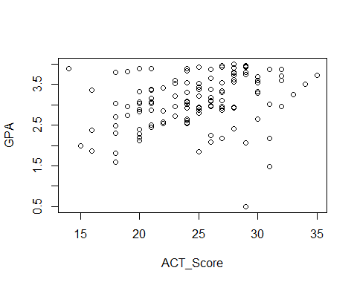

#Problem 3.3a - Create boxplot  
boxplot(excel_data$ACT_Score, horizontal = TRUE)

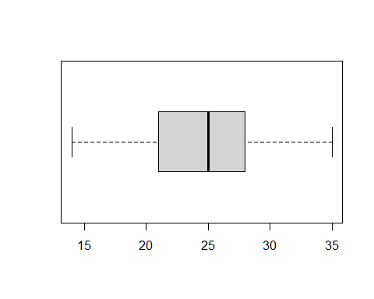

#Problem 3.3b - Create dot plot of residuals  
residuals_model_1 <- resid(model_1)  
  
stripchart(residuals_model_1, main = "Dot Plot of Residuals", xlab = "Residuals", method = "jitter")

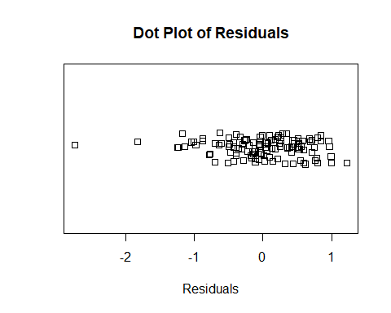

#Problem 3.3c - Create plot of residuals against the fitted values  
fitted_values <- fitted(model_1)  
plot(residuals_model_1 ~ fitted_values, main = "Residual Plot", xlab = "Fitted Values", ylab = "Residuals")  
abline(h = 0, lty = 2)

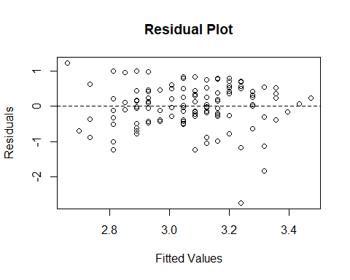

#Problem 3.3d - Create Normal Plot  
q <- qqnorm(residuals_model_1, main = "Normal Probability Plot of Residuals")  
qqline(residuals_model_1)

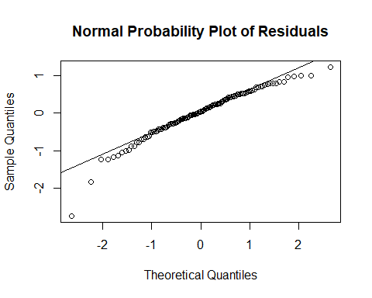

cor.test(q$x, q$y, method=c("pearson")) # Table B6 in book

##   
## Pearson's product-moment correlation  
##   
## data: q$x and q$y  
## t = 47.128, df = 118, p-value < 2.2e-16  
## alternative hypothesis: true correlation is not equal to 0  
## 95 percent confidence interval:  
## 0.9634938 0.9821475  
## sample estimates:  
## cor   
## 0.9744497

#Problem 3.3e - calculate t sample test statistic and the Brown-Forsythe test  
group_1 <- subset(excel_data, excel_data$ACT_Score < 26)  
group_2 <- subset(excel_data, excel_data$ACT_Score >= 26)  
  
model_group1 <- lm(GPA~ACT_Score,data=group_1)  
model_group2 <- lm(GPA~ACT_Score,data=group_2)  
  
median_1 <- median(resid(model_group1))  
median_2 <- median(resid(model_group2))  
  
abs_dev_group1 <- abs(resid(model_group1) - median_1)  
abs_dev_group2 <- abs(resid(model_group2) - median_2)  
  
  
s <- sqrt((sum((abs_dev_group1 - mean(abs_dev_group1))^2) + sum((abs_dev_group2 - mean(abs_dev_group1))^2))   
 / (nrow(excel_data) - 2))  
  
two_sample_t <- ((mean(abs_dev_group1) - mean(abs_dev_group2)) / (s * (sqrt(1/nrow(group_1) + 1/nrow(group_2)))))  
print(two_sample_t)

## [1] -0.9533587

#Is H0 true? We find it is not  
abs(two_sample_t) > qt(0.995, 118)

## [1] FALSE

#Problem 3.3f - Plot x2 and x3 with the residuals  
plot(residuals_model_1 ~ excel_data$Intelligence_Test_Score,   
 main = "X2 Residual Plot", xlab = "Intelligence Test Score", ylab = "Residuals")  
abline(h = 0, lty = 2)

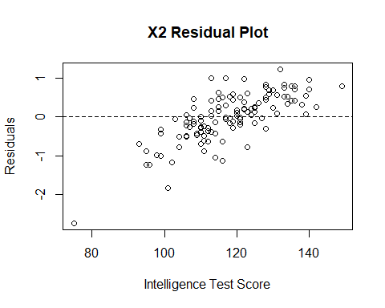

plot(residuals_model_1 ~ excel_data$Class_Rank_Percentile,   
 main = "X3 Residual Plot", xlab = "Class Rank Percentile", ylab = "Residuals")  
abline(h = 0, lty = 2)

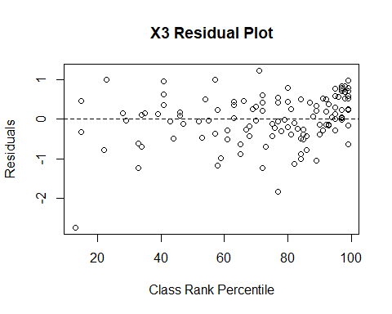

Question 3.8:

#Chad Huntebrinker  
  
library(readxl)  
  
excel_data <- read_excel("Crime_Rate_Data.xlsx")  
  
# Fit the model and get the summary of the model  
model_1 <- lm(Crime_Rate~Highschool_Diploma_Percentage,data=excel_data)  
sum_of_model_1 <- summary(model_1)  
sum_of_model_1

##   
## Call:  
## lm(formula = Crime_Rate ~ Highschool_Diploma_Percentage, data = excel_data)  
##   
## Residuals:  
## Min 1Q Median 3Q Max   
## -5278.3 -1757.5 -210.5 1575.3 6803.3   
##   
## Coefficients:  
## Estimate Std. Error t value Pr(>|t|)   
## (Intercept) 20517.60 3277.64 6.260 1.67e-08 ***  
## Highschool_Diploma_Percentage -170.58 41.57 -4.103 9.57e-05 ***  
## ---  
## Signif. codes: 0 '***' 0.001 '**' 0.01 '*' 0.05 '.' 0.1 ' ' 1  
##   
## Residual standard error: 2356 on 82 degrees of freedom  
## Multiple R-squared: 0.1703, Adjusted R-squared: 0.1602   
## F-statistic: 16.83 on 1 and 82 DF, p-value: 9.571e-05

# Plot the graph just to see  
plot(Crime_Rate~Highschool_Diploma_Percentage,data=excel_data)

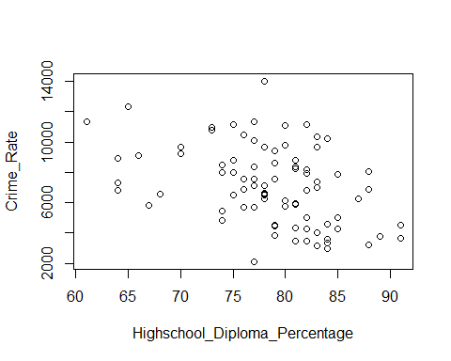

#Problem 3.4a - Create stem and leaf plot  
stem(excel_data$Highschool_Diploma_Percentage)

##   
## The decimal point is 1 digit(s) to the right of the |  
##   
## 6 | 1444  
## 6 | 5678  
## 7 | 00334444  
## 7 | 5555666677777778888888999999  
## 8 | 000011111112222222233333344444  
## 8 | 55578889  
## 9 | 11

#Problem 3.4b - Create boxplot of residuals  
residuals_model_1 <- resid(model_1)  
  
boxplot(residuals_model_1, horizontal = TRUE)

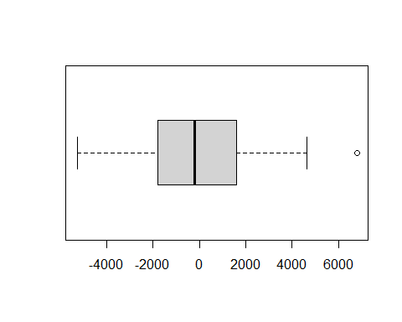

#Problem 3.4c - Create a residual plot with the fitted values  
fitted_values <- fitted(model_1)  
plot(residuals_model_1 ~ fitted_values, main = "Residual Plot", xlab = "Fitted Values", ylab = "Residuals")  
abline(h = 0, lty = 2)

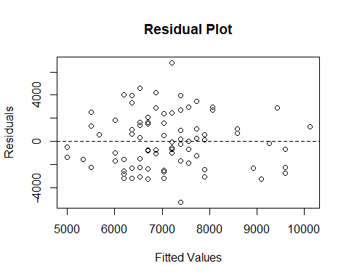

#Problem 3.4d - Get the correlation coefficient and the normal probability plot  
q <- qqnorm(residuals_model_1, main = "Normal Probability Plot of Residuals")  
qqline(residuals_model_1)

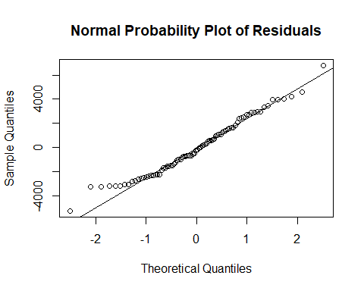

cor.test(q$x, q$y, method=c("pearson")) # Table B6 in book

##   
## Pearson's product-moment correlation  
##   
## data: q$x and q$y  
## t = 59.465, df = 82, p-value < 2.2e-16  
## alternative hypothesis: true correlation is not equal to 0  
## 95 percent confidence interval:  
## 0.9824370 0.9926123  
## sample estimates:  
## cor   
## 0.988603

#Problem 3.4e - Do the Brown-Forsythe test  
group_1 <- subset(excel_data, excel_data$Highschool_Diploma_Percentage < 69)  
group_2 <- subset(excel_data, excel_data$Highschool_Diploma_Percentage >= 69)  
  
model_group1 <- lm(Crime_Rate~Highschool_Diploma_Percentage,data=group_1)  
model_group2 <- lm(Crime_Rate~Highschool_Diploma_Percentage,data=group_2)  
  
median_1 <- median(resid(model_group1))  
median_2 <- median(resid(model_group2))  
  
abs_dev_group1 <- abs(resid(model_group1) - median_1)  
abs_dev_group2 <- abs(resid(model_group2) - median_2)  
  
  
s <- sqrt((sum((abs_dev_group1 - mean(abs_dev_group1))^2) + sum((abs_dev_group2 - mean(abs_dev_group1))^2))   
 / (nrow(excel_data) - 2))  
  
two_sample_t <- ((mean(abs_dev_group1) - mean(abs_dev_group2)) / (s * (sqrt(1/nrow(group_1) + 1/nrow(group_2)))))  
print(two_sample_t)

## [1] -0.9155

#Is H0 true? We find it is not.  
abs(two_sample_t) > qt(0.975, 82)

## [1] FALSE

Question 3.9:

#Chad Huntebrinker  
  
#Problem 3.9  
x_values <- c(2, 3, 4, 5, 6, 7, 8, 9, 10, 11)  
residual_values <- c(3.2, 2.9, -1.7, -2.0, -2.3, -1.2, -0.9, 0.8, 0.7, 0.5)  
  
plot(residual_values ~ x_values)  
abline(h = 0, lty = 2)

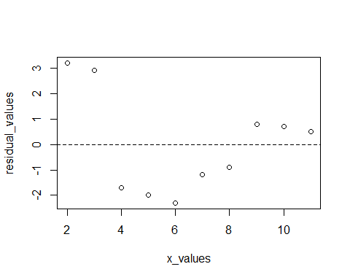

Question 3.11:

#Chad Huntebrinker  
  
#Problem 3.11a  
  
x_values <- c(-1, 0, 1, -1, 0, 1, -1, 0, 1)  
residual_values <- c(0.5, 2.1, -3.4, 0.3, -1.7, 4.2, -0.6, 2.6, -4.0)  
  
plot(residual_values ~ x_values)  
abline(h = 0, lty = 2)

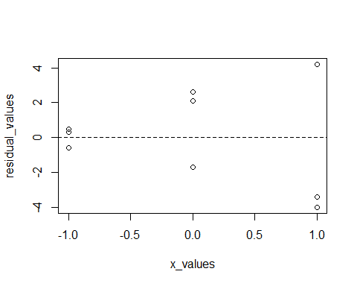

#They have a megaphone type  
  
#Problem 3.11b  
m.sig <- lm(residual_values^2~x_values)  
anova(m.sig)

## Analysis of Variance Table  
##   
## Response: residual_values^2  
## Df Sum Sq Mean Sq F value Pr(>F)   
## x_values 1 330.04 330.04 51.348 0.0001828 ***  
## Residuals 7 44.99 6.43   
## ---  
## Signif. codes: 0 '***' 0.001 '**' 0.01 '*' 0.05 '.' 0.1 ' ' 1

csq <- (anova(m.sig)$"Sum Sq"[1]/2)/((anova(m.sig)$"Sum Sq"[2]/9)^2)  
csq > qchisq(0.95,1)

## [1] TRUE

#Ha is true