Chad Huntebrinker’s Homework 7

Chad Huntebrinker

2024-10-28

Problem 2.23

#Chad Huntebrinker  
  
library(readxl)  
  
excel_data <- read_excel("Grade_Point_Average_Data.xlsx")  
  
# GPA ~ ACT  
# Fit the model and get the summary of the model  
model_1 <- lm(GPA~ACT_Score,data=excel_data)  
sum_of_model_1 <- summary(model_1)  
sum_of_model_1

##   
## Call:  
## lm(formula = GPA ~ ACT_Score, data = excel_data)  
##   
## Residuals:  
## Min 1Q Median 3Q Max   
## -2.74004 -0.33827 0.04062 0.44064 1.22737   
##   
## Coefficients:  
## Estimate Std. Error t value Pr(>|t|)   
## (Intercept) 2.11405 0.32089 6.588 1.3e-09 ***  
## ACT_Score 0.03883 0.01277 3.040 0.00292 **   
## ---  
## Signif. codes: 0 '***' 0.001 '**' 0.01 '*' 0.05 '.' 0.1 ' ' 1  
##   
## Residual standard error: 0.6231 on 118 degrees of freedom  
## Multiple R-squared: 0.07262, Adjusted R-squared: 0.06476   
## F-statistic: 9.24 on 1 and 118 DF, p-value: 0.002917

# Plot the graph just to see  
plot(GPA~ACT_Score,data=excel_data)

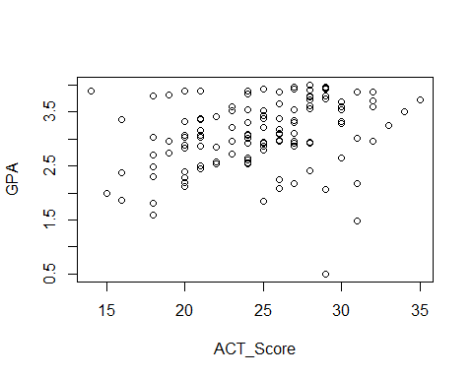

#Problem 2.23a  
anova_table <- anova(model_1)  
  
#Problem 2.23b  
#MSR  
anova_table$`Mean Sq`[1]

## [1] 3.587846

#MSE  
anova_table$`Mean Sq`[2]

## [1] 0.3882848

#They will estimate the same quantity when the null hypothesis is true (H0: B1 = 0).  
  
#Problem 2.23c  
#H0: B1 = 0: F* <= qf(1 - 0.01, 1, 118)  
#Ha: B1 != 0: F* > qf(1 - 0.01, 1, 118)  
#Check to see if Ha is true:  
anova_table$`F value`[1]

## [1] 9.240243

qf(1 - 0.01, 1, 118)

## [1] 6.854641

anova_table$`F value`[1] > qf(1 - 0.01, 1, 118)

## [1] TRUE

#Conclusion: B1 != 0, there is a linear association  
  
#Problem2.23d  
model_1_reduced <- lm(GPA~1,data=excel_data)  
anova_table2 <- anova(model_1_reduced,model_1)  
  
#Absolute magnitude of reduction  
anova_table2$`Sum of Sq`[2]

## [1] 3.587846

#Relative reduction  
anova_table2$`Sum of Sq`[2] / anova_table2$RSS[1]

## [1] 0.07262044

#It's also known as R^2 or coefficient of determination  
summary(model_1)$r.square

## [1] 0.07262044

#Problem 2.23e  
sqrt(anova_table2$`Sum of Sq`[2] / anova_table2$RSS[1])

## [1] 0.2694818

#r = +0.2694818  
  
#Problem 2.23f  
#In this case, r has a more clear-cut operational interpration. This is due to the answer  
#of r (+0.2694818) showing that there is a slight positive linear relationship between  
#the two variables. And we can see that is the case on the graph too (positive linear relationship  
#between points until we get to around 27).

Problem 2.29

#Chad Huntebrinker  
  
#Load the library and data in to R  
library(readxl)  
excel_data <- read_excel("Muscle_Mass_Data.xlsx")  
  
#Muscle_Mass ~ Age  
#Fit the model  
model_3 <- lm(Muscle_Mass~Age,data=excel_data)  
sum_of_model_3 <- summary(model_3)  
  
#Plot to see the graph  
plot(Muscle_Mass~Age, data = excel_data)

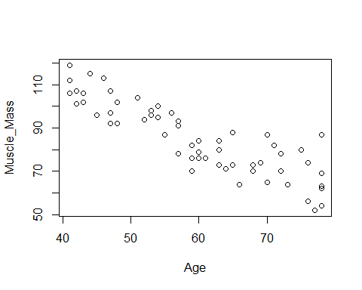

#Problem 2.29a  
SSE_model_3 <- excel_data$Muscle_Mass - predict(model_3, data.frame(Age=excel_data$Age))  
  
  
SSR_model_3 <- predict(model_3, data.frame(Age=excel_data$Age)) - mean(excel_data$Muscle_Mass)  
  
plot(SSE_model_3 ~ Age, data = excel_data)

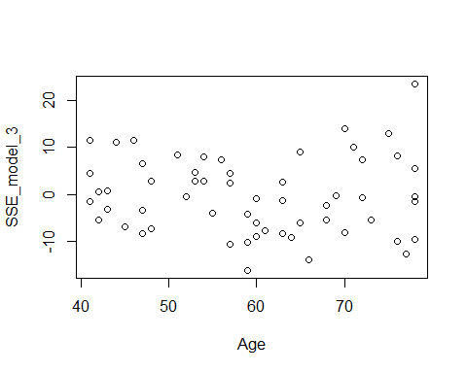

plot(SSR_model_3 ~ Age, data = excel_data)

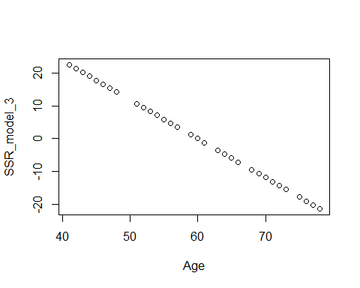

#It looks like the SSR plays a larger component of SSTO.  
#That means that R^2 will be closer to 1, leading to a greater degree in linearity  
  
  
#Problem 2.29b  
anova_table <- anova(model_3)  
  
#Problem 2.29c  
#H0: B1 = 0: F* <= qf(1 - 0.05, 1, 58)  
#Ha: B1 != 0: F* > qf(1 - 0.05, 1, 58)  
#Check to see if Ha is true:  
anova_table$`F value`[1]

## [1] 174.062

qf(1 - 0.05, 1, 58)

## [1] 4.006873

anova_table$`F value`[1] > qf(1 - 0.05, 1, 58)

## [1] TRUE

#Conclusion: B1 != 0, there is a linear association  
  
#Problem 2.29d  
model_3_reduced <- lm(Muscle_Mass~1,data=excel_data)  
anova_table2 <- anova(model_3_reduced,model_3)  
  
1 - anova_table2$`Sum of Sq`[2] / anova_table2$RSS[1]

## [1] 0.2499332

#0.2499332 or 24.99%  
#It is relatively small  
  
#Problem 2.29e  
#R^2 = 0.7500668  
anova_table2$`Sum of Sq`[2] / anova_table2$RSS[1]

## [1] 0.7500668

#r = -0.866064  
sqrt(anova_table2$`Sum of Sq`[2] / anova_table2$RSS[1])

## [1] 0.866064

Problem 2.32

#Chad Huntebrinker  
  
library(readxl)  
  
excel_data <- read_excel("Crime_Rate_Data.xlsx")  
  
# Fit the model and get the summary of the model  
model_4 <- lm(Crime_Rate~Highschool_Diploma_Percentage,data=excel_data)  
sum_of_model_4 <- summary(model_4)  
sum_of_model_4

##   
## Call:  
## lm(formula = Crime_Rate ~ Highschool_Diploma_Percentage, data = excel_data)  
##   
## Residuals:  
## Min 1Q Median 3Q Max   
## -5278.3 -1757.5 -210.5 1575.3 6803.3   
##   
## Coefficients:  
## Estimate Std. Error t value Pr(>|t|)   
## (Intercept) 20517.60 3277.64 6.260 1.67e-08 ***  
## Highschool_Diploma_Percentage -170.58 41.57 -4.103 9.57e-05 ***  
## ---  
## Signif. codes: 0 '***' 0.001 '**' 0.01 '*' 0.05 '.' 0.1 ' ' 1  
##   
## Residual standard error: 2356 on 82 degrees of freedom  
## Multiple R-squared: 0.1703, Adjusted R-squared: 0.1602   
## F-statistic: 16.83 on 1 and 82 DF, p-value: 9.571e-05

# Plot the graph just to see  
plot(Crime_Rate~Highschool_Diploma_Percentage,data=excel_data)

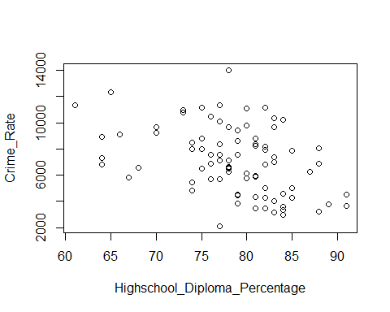

#Problem 2.32a  
model_4_reduced <- lm(Crime_Rate~1,data=excel_data)  
summary(model_4)

##   
## Call:  
## lm(formula = Crime_Rate ~ Highschool_Diploma_Percentage, data = excel_data)  
##   
## Residuals:  
## Min 1Q Median 3Q Max   
## -5278.3 -1757.5 -210.5 1575.3 6803.3   
##   
## Coefficients:  
## Estimate Std. Error t value Pr(>|t|)   
## (Intercept) 20517.60 3277.64 6.260 1.67e-08 ***  
## Highschool_Diploma_Percentage -170.58 41.57 -4.103 9.57e-05 ***  
## ---  
## Signif. codes: 0 '***' 0.001 '**' 0.01 '*' 0.05 '.' 0.1 ' ' 1  
##   
## Residual standard error: 2356 on 82 degrees of freedom  
## Multiple R-squared: 0.1703, Adjusted R-squared: 0.1602   
## F-statistic: 16.83 on 1 and 82 DF, p-value: 9.571e-05

summary(model_4_reduced)

##   
## Call:  
## lm(formula = Crime_Rate ~ 1, data = excel_data)  
##   
## Residuals:  
## Min 1Q Median 3Q Max   
## -5006.2 -2090.7 -180.7 1728.3 6904.8   
##   
## Coefficients:  
## Estimate Std. Error t value Pr(>|t|)   
## (Intercept) 7111.2 280.5 25.35 <2e-16 ***  
## ---  
## Signif. codes: 0 '***' 0.001 '**' 0.01 '*' 0.05 '.' 0.1 ' ' 1  
##   
## Residual standard error: 2571 on 83 degrees of freedom

#Problem 2.32b  
#1)  
SSE_F <- deviance(model_4)  
  
#2)  
SSE_R <- deviance(model_4_reduced)  
  
#3)  
dfF = 82  
  
#4)  
dfR = 83  
  
#5)  
F_stat <- ((SSE_R - SSE_F) / (dfR - dfF)) / (SSE_F / dfF)  
  
#6)  
#H0: B1 = 0: F* <= qf(1 - 0.01, dfR - dfF, dfF)  
#Ha: B1 != 0: F* > qf(1 - 0.01, dfR - dfF, dfF)  
#Check to see if Ha is true:  
F_stat

## [1] 16.83376

qf(1 - 0.01, dfR - dfF, dfF)

## [1] 6.95442

F_stat > qf(1 - 0.01, dfR - dfF, dfF)

## [1] TRUE

#Conclusion: B1 != 0, there is a linear association  
  
#Problem 2.32c  
#t-test for with alpha = 0.01 that B1 != 0  
abs(sum_of_model_4$coefficients[2,3]) > qt(1 - 0.01/2, 82)

## [1] TRUE

abs(sum_of_model_4$coefficients[2,3])

## [1] 4.102897

sqrt(F_stat)

## [1] 4.102897

#Yes, they are

Problem 2.64

#Chad Huntebrinker  
  
#Load the library and data in to R  
library(readxl)  
excel_data <- read_excel("SENIC_Data.xlsx")  
  
#Length_of_Stay ~ Infection_Risk  
#Fit the model  
model_5 <- lm(Length_of_Stay~Infection_Risk,data=excel_data)  
sum_of_model_5 <- summary(model_5)  
  
#Length_of_Stay ~ Available_facilities_and_services  
model_6 <- lm(Length_of_Stay~Available_facilities_and_services,data=excel_data)  
sum_of_model_6 <- summary(model_6)  
  
#Length_of_Stay ~ Routine_Chest_X-ray  
model_7 <- lm(Length_of_Stay~`Routine_Chest_X-ray`,data=excel_data)  
sum_of_model_7 <- summary(model_7)  
  
sum_of_model_5$r.square

## [1] 0.2845623

sum_of_model_6$r.square

## [1] 0.1264072

sum_of_model_7$r.square

## [1] 0.1462924

#The largest reduction in variability with the average length of stay is Infection Risk