Chad Huntebrinker’s Midterm

Chad Huntebrinker

2024-10-13

#Chad Huntebrinker  
#Midterm Exam  
  
#Load the library and data in to R  
library(readxl)  
  
excel_data <- read_excel("Student_Data.xlsx")  
  
#Fit the model (Problem 13)  
model_2 <- lm(GPA~M,data=excel_data)  
sum_of_model2 <- summary(model_2)  
  
# Plot the graph just to see  
plot(GPA~M,data=excel_data)  
abline(model_2,col="blue")

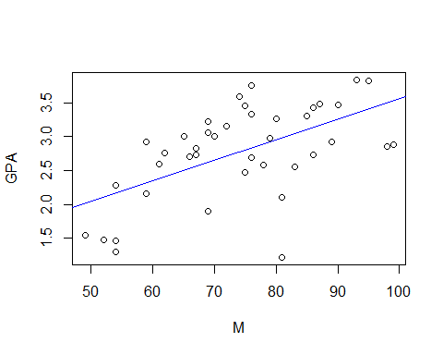

#Problem 14: estimate error variance  
sum_of_model2$sigma^2

## [1] 0.3317446

#Problem 15 and 16:  
t.star <- summary(model_2)$coefficients[2,3]  
#Test H1 (which we find true so we say there is evidence for linear association)  
t.star > qt(0.95, 38)

## [1] TRUE

#Problem 17:  
CI <- predict(model_2, se.fit = TRUE, data.frame(M=60), interval = "confidence", level = 0.99)  
CI$fit

## fit lwr upr  
## 1 2.348824 1.985658 2.71199

#Problem 18:  
CI_Pio <- predict(model_2, se.fit = TRUE, data.frame(M=99), interval = "confidence", level = 0.99)  
CI_Pio$fit

## fit lwr upr  
## 1 3.528368 2.992555 4.064182