In this essay I want to discuss XML and JSON. There will be a description of the advantages and disadvantages of each. I will also provide code snippets of each. I will also discuss the major differences between the two. **“**JSON (JavaScript Object Notation) is a lightweight data-interchange format and it completely language independent. It is based on the JavaScript programming language and easy to understand and generate.” (GeeksforGeeks, 2019) “XML (Extensible markup language) was designed to carry data, not to display data. It is a W3C recommendation. Extensible Markup Language (XML) is a markup language that defines a set of rules for encoding documents in a format that is both human-readable and machine-readable.” (GeeksforGeeks, 2019).

Below are some differences between XML and JSON:

|  |  |
| --- | --- |
| **XML** | **JSON** |
| Extensible Markup Language | JavaScript Object Notation |
| Derived from SGML | Based in JavaScript Language |
| Markup language that uses tag structure to represent data items | It is a way of representing objects |
| Supports namespaces | No support for namespaces |
| Doesn’t support arrays | Supports arrays |
| Documentation can be hard to read and interpret | Files are easy to read compared to XML |
| More secure than JSON | Less secure |
| Supports comments | Doesn’t support comments |
| Supports various encoding | Only Supports UTF-8 encoding |

(GeeksforGeeks, 2019).

**Advantages of JSON:**

* Fast and efficient
* Responsive – meaning the parsing doesn’t require any extra code
* Approach - JSON is a simple data format because it relies on key-value pairs. Moreover, it simplifies writing and reading
* Data Sharing – Majority of browsers support it
* Majority of browsers support it

**Disadvantages of JSON:**

* Date data types are absent from JSON, requiring developers to look for alternatives
* Verbose - Due to its lack of conciseness, JSON code is imperceptible to most software
* Lack of support for comments
* As it less secure, it offers more security risks than the alternatives available

(Top 5+ Advantages and Disadvantages of JSON, 2022).

**Advantages of XML:**

* Supports Unicode, allowing almost any information in any written human language to be communicated
* Can represent common computer science data structures: records, lists, and trees.
* Self-documenting format describes structure and field names as well as specific values.
* Based on international standards
* Platform-independent, thus relatively immune to changes in technology

**Disadvantages of XML:**

* Syntax is redundancy
* Is verbose, especially for human readers, relative to other alternatives
* The distinction between content and attributes in XML seems unnatural to some and makes designing XML data structures harder
* XML namespaces are problematic to use

(SPEC INDIA, 2022)

Code snippet of JSON supporting an array:

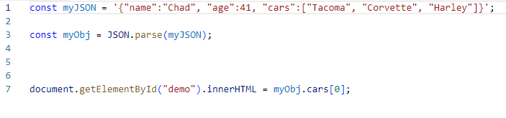

Console will log “Tacoma”

(JSON Arrays, n.d.)

Code snippet of creating an XML Dcoument:

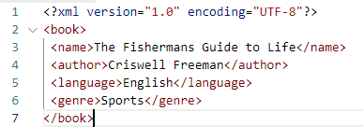

(Singh, 2018)

In conclusion we have defined what each XML and JSON is. We can see the differences between the two. We can also see the advantages and disadvantages of each. There are code snippets that give only a gimpse as to what they can do.

References:

GeeksforGeeks. (2019, February 19). *Difference between JSON and XML*. Retrieved September 20, 2022, from <https://www.geeksforgeeks.org/difference-between-json-and-xml/>

*Top 5+ Advantages and Disadvantages of JSON*. (2022, January 19). Yovak. Retrieved September 20, 2022, from <https://yovak.com/advantages-and-disadvantages-of-json/>

SPEC INDIA. (2022, February 24). *Advantages and Disadvantages of XML*. Retrieved September 20, 2022, from <https://www.spec-india.com/blog/advantages-and-disadvantages-of-xml>

*JSON Arrays*. (n.d.). Retrieved September 20, 2022, from <https://www.w3schools.com/JS/js_json_arrays.asp>

Singh, C. (2018, October 24). *XML Example*. BeginnersBook. Retrieved September 20, 2022, from <https://beginnersbook.com/2018/10/xml-example/>