Chad ONeal

Web-335

Assignment 1.4

Business Rules

All Images combined into a single word document

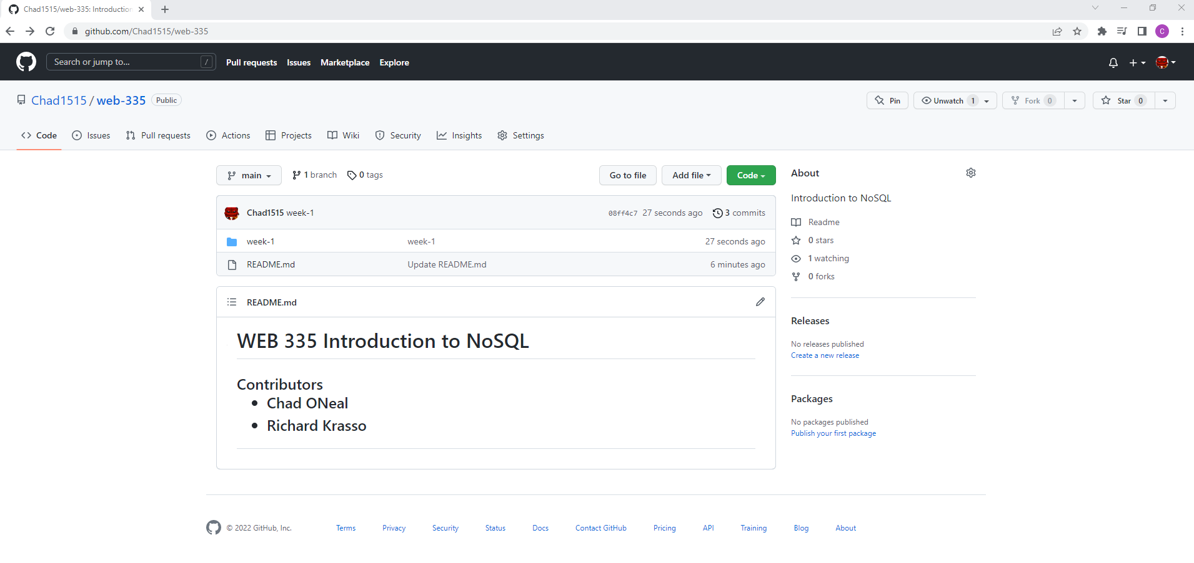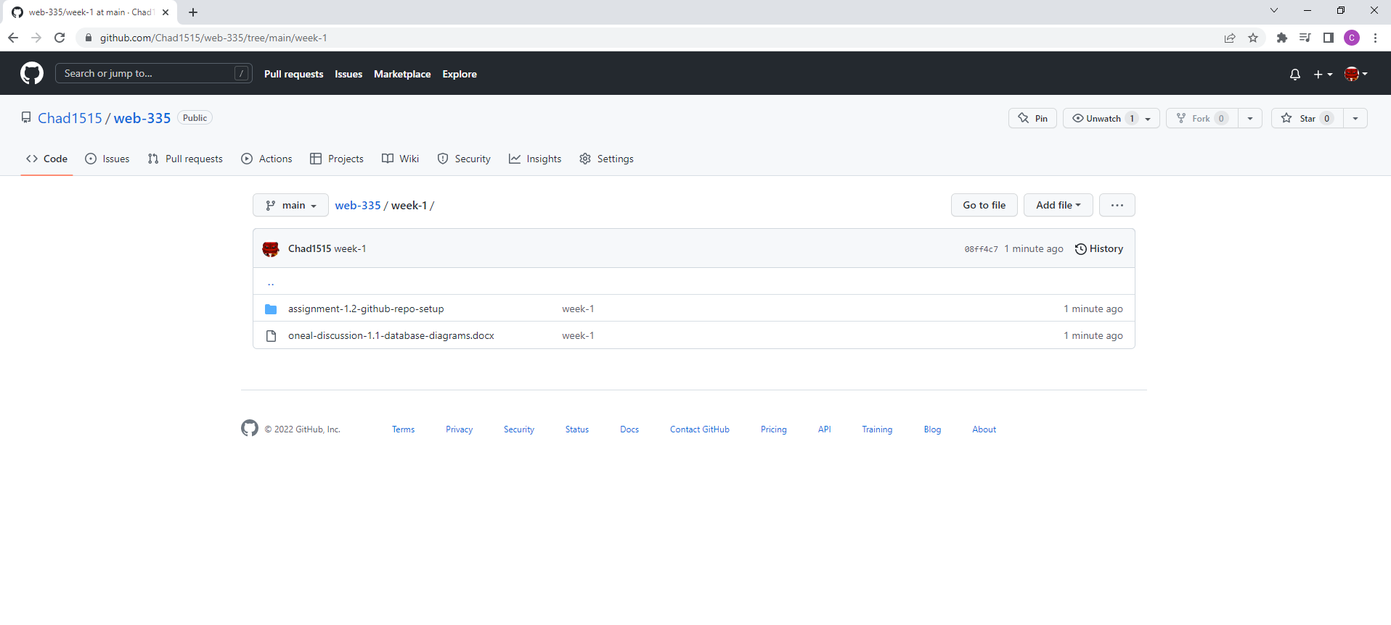

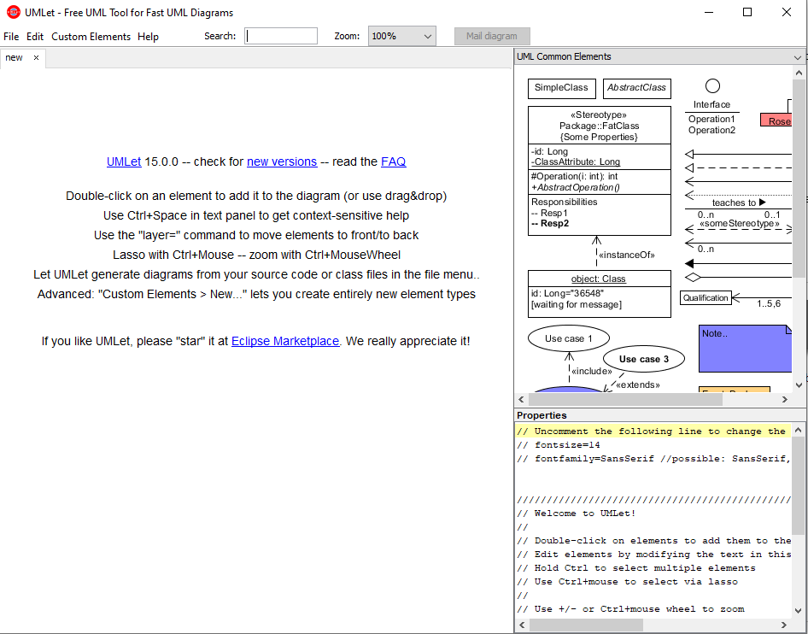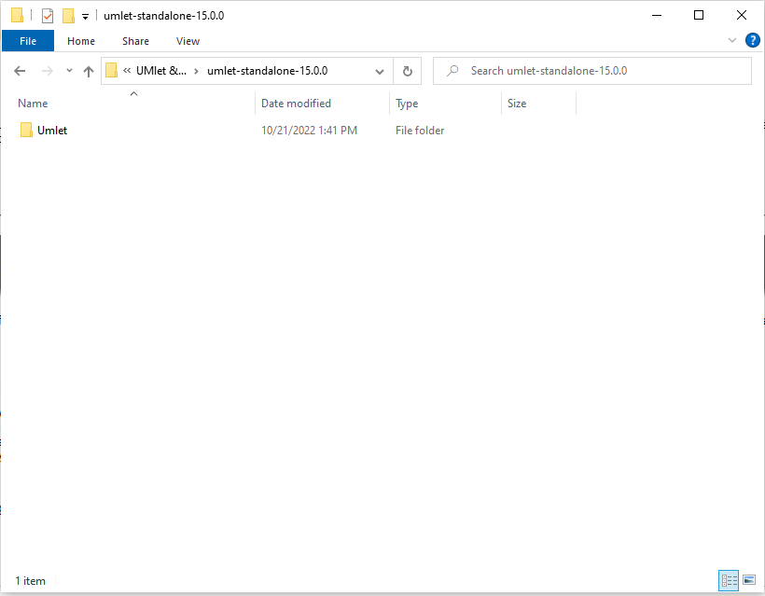

**ORD**



**ORD to Business Rules Translation**

1. a USER has many DEPENDENTS
2. a USER has many ROLES
3. a USER has one BIRTHDATE