Chad ONeal

Web-335

Assignment 3.2

2NF

NodeBookCo ORD:

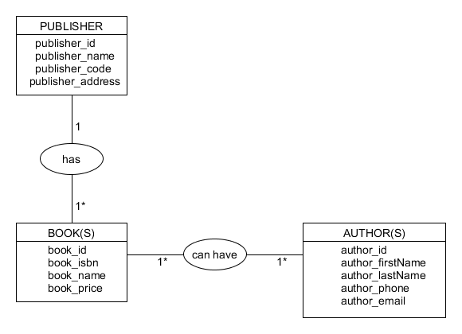

NodeBookCo data structure:

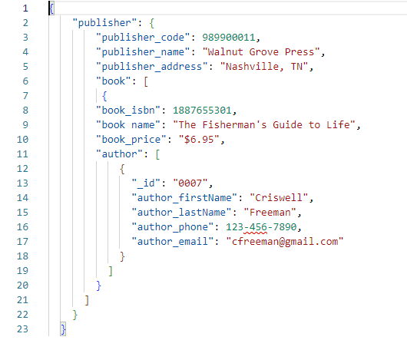

NodeSecurity ORD

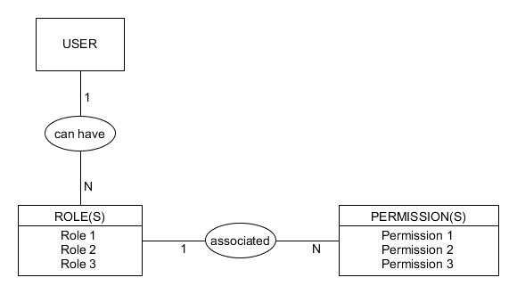

NodeSecurity data structure:

