Chad ONeal

11/09/2022

Web-335

Assignment 4.2 – MongoDB Atlas Setup

New database and collection named “user”

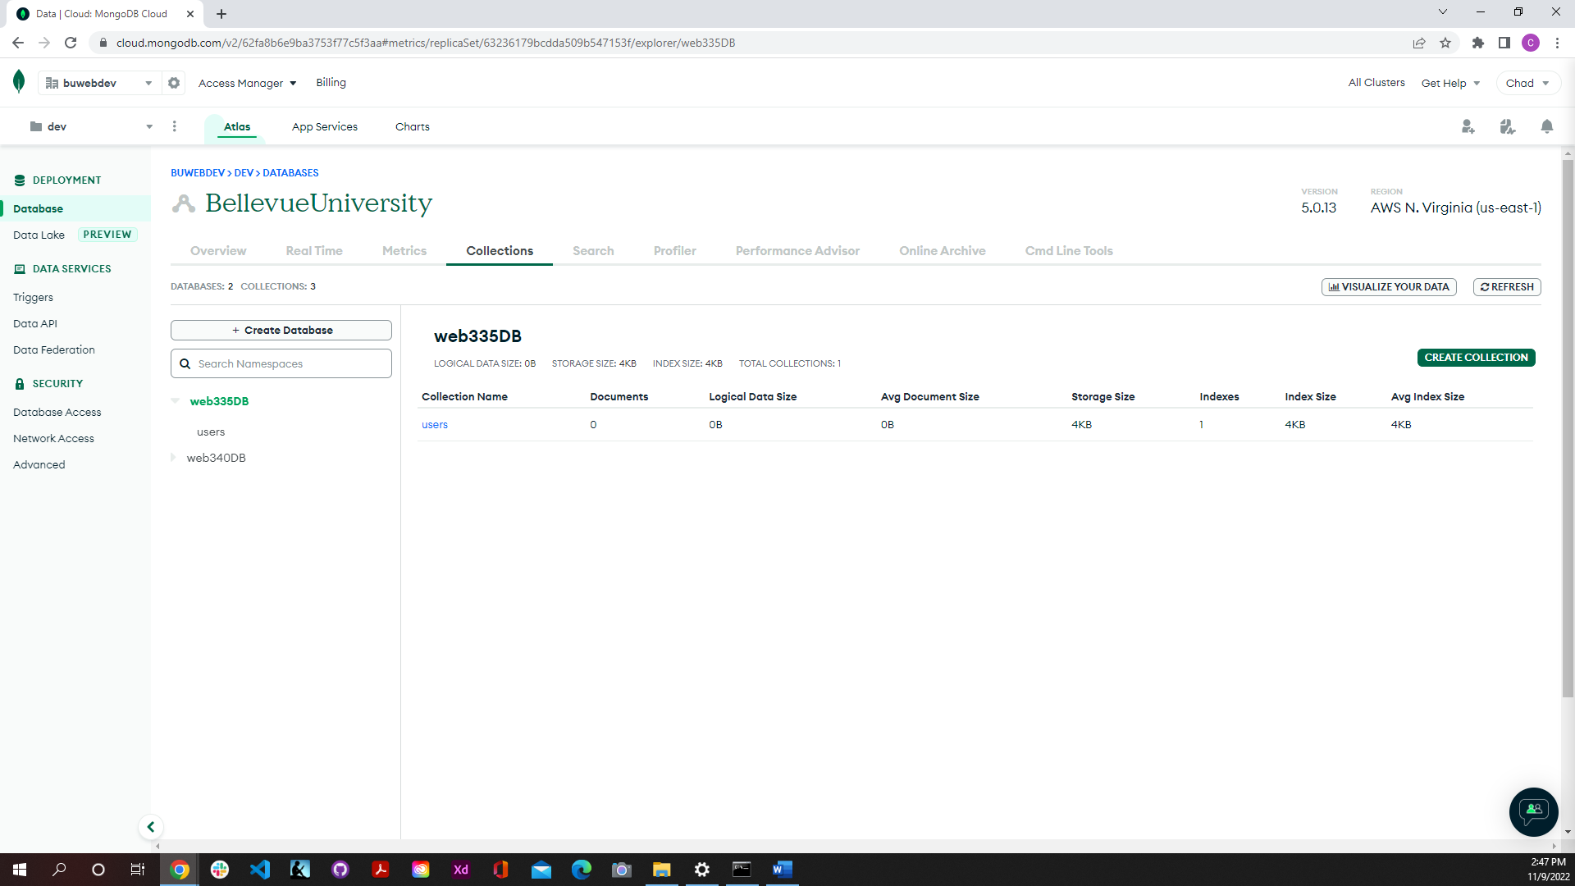

New custom role configred to “Collection Actions”

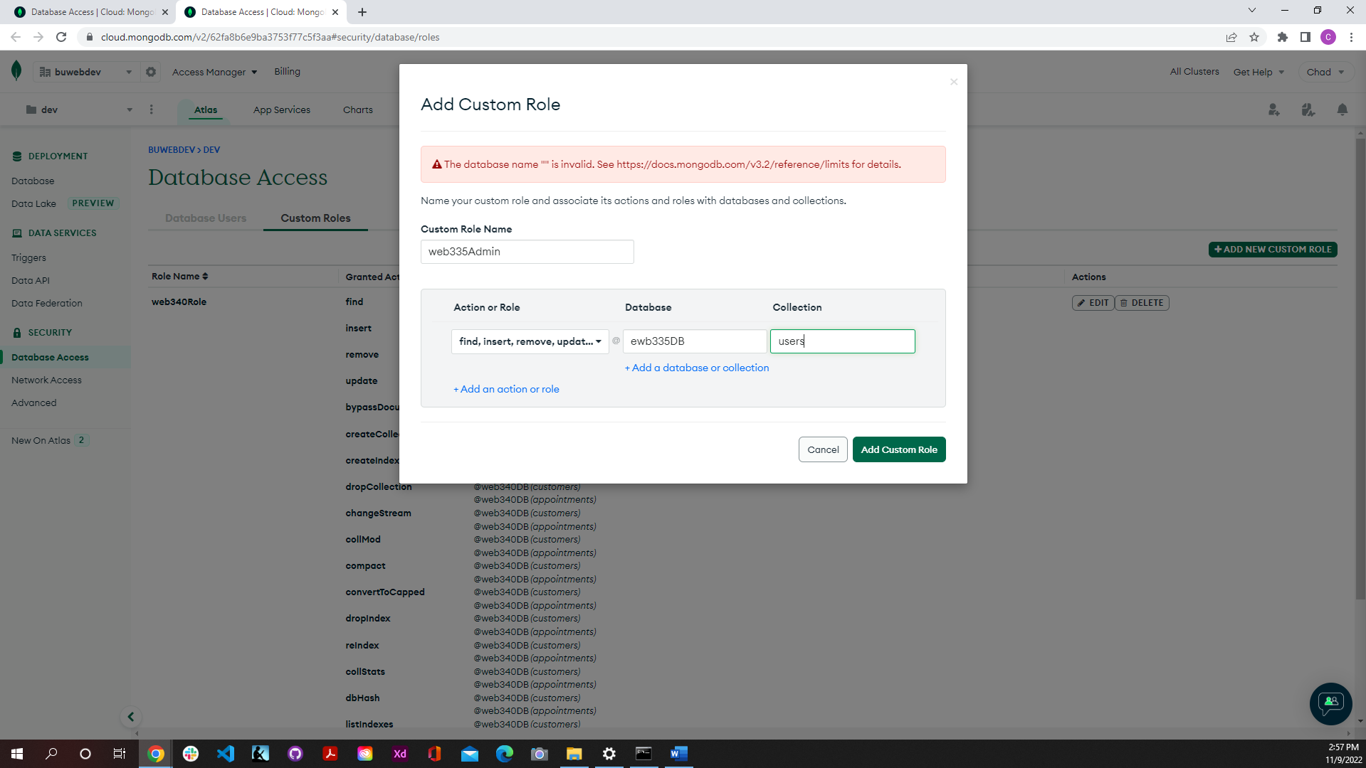

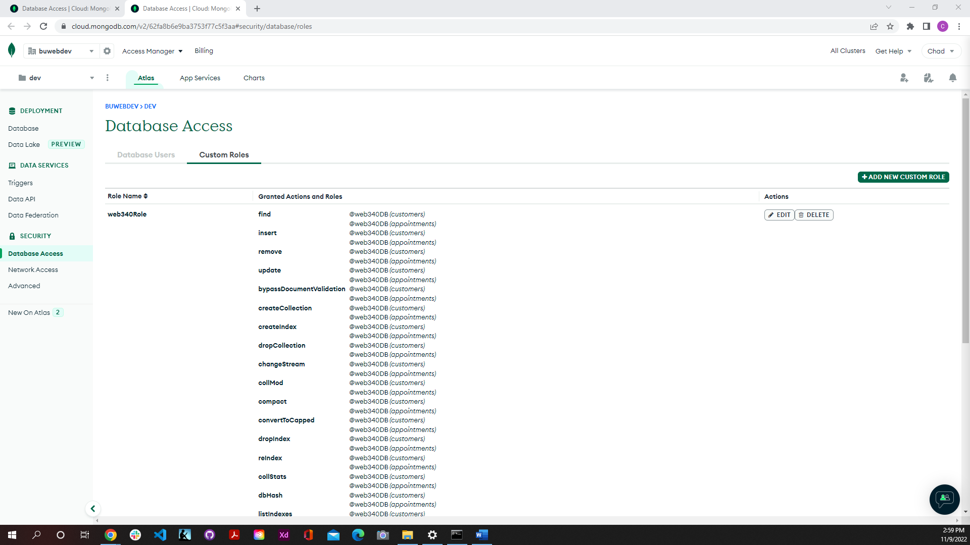

New database user

Mongosh installation

