In this thread I would like to discuss MongoDB’s $project, $match, and $sort aggregate operations. I will define what each of these are. I will also explain what each operation does. As well, I will provide an example of when the operation could be used. Let’s start with the $project aggregate operation.

The $project aggregate operation “passes along the documents with the requested fields to the next stage in the pipeline. The specified fields can be existing fields from the input documents or newly computed fields. The $project takes a document that can specify the inclusion of fields, the suppression of the _id field, the addition of new fields, and the resetting of the values of existing fields.” ($Project (Aggregation) — MongoDB Manual, n.d.). An example of when the $project aggregate could be used is to display a list of all documents in the users collection in web335DB and only show their firstName and email like the example below:

The $match aggregate operation “Filters the documents to pass only the documents that match the specified condition(s) to the next pipeline stage. $match takes a document that specifies the query conditions. The query syntax is identical to the read operation query syntax, i.e. $match does not accept raw aggregation. Instead, use a $expr query expression to include aggregation expression in $match.” ($Match (Aggregation) — MongoDB Manual, n.d.). An example of when the $match aggregate could be used is to display a list of all documents in the users collection in web335DB that have the firstName of “Brad” shown in the query below:

The $sort aggregate operation “Sorts all input documents and returns them to the pipeline in sorted order. $sort takes a document that specifies the field(s) to sort by and the respective sort order.” ($Sort (Aggregation) — MongoDB Manual, n.d.). An example of when the $sort aggregate could be used is to display a list of all documents in the users collection in web335DB in alphabetical order using the firstName field shown in the query below:

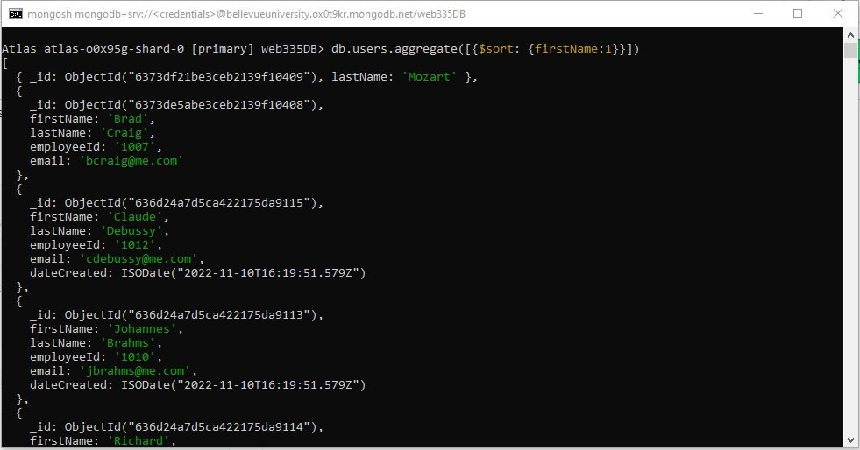

References:

*$project (aggregation) — MongoDB Manual*. (n.d.). Retrieved November 15, 2022 from <https://www.mongodb.com/docs/manual/reference/operator/aggregation/project/>

*$match (aggregation) — MongoDB Manual*. (n.d.). Retrieved November 15, 2022 from <https://www.mongodb.com/docs/manual/reference/operator/aggregation/match/>

*$sort (aggregation) — MongoDB Manual*. (n.d.). Retrieved November 15, 2022 from <https://www.mongodb.com/docs/manual/reference/operator/aggregation/sort/>