Chad ONeal

11/21/2022

Web_335

Assignment_6.2_Aggregate Queries

// display all documents in houses

db.houses.find()

// display all documents in students

db.students.find()

// add a document to students collection

db.students.insertOne({firstName: "Hermione", lastName: "Granger", studentId: "s1013", houseId: "h1007"})

// verify student "Hermione Granger" has been added

db.students.findOne({lastName: "Granger"})

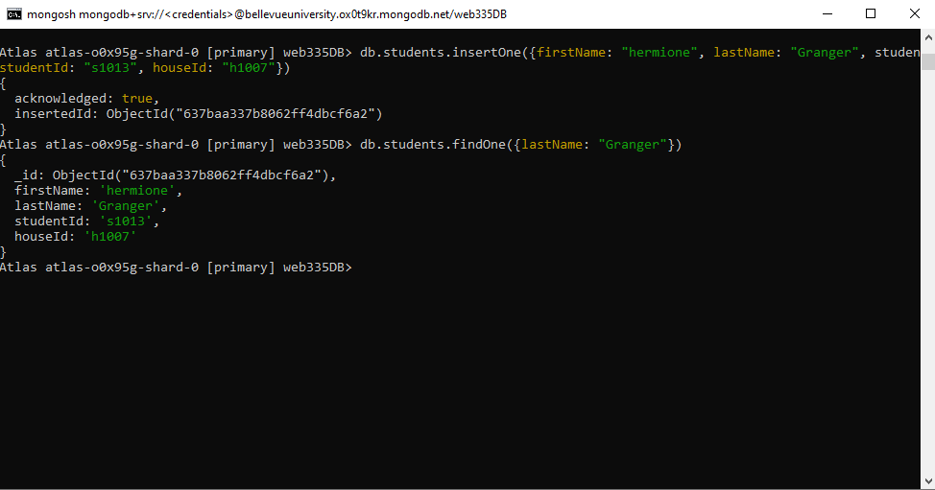

// delete student document added in last steps

db.students.deleteOne({studentId: "s1013"})

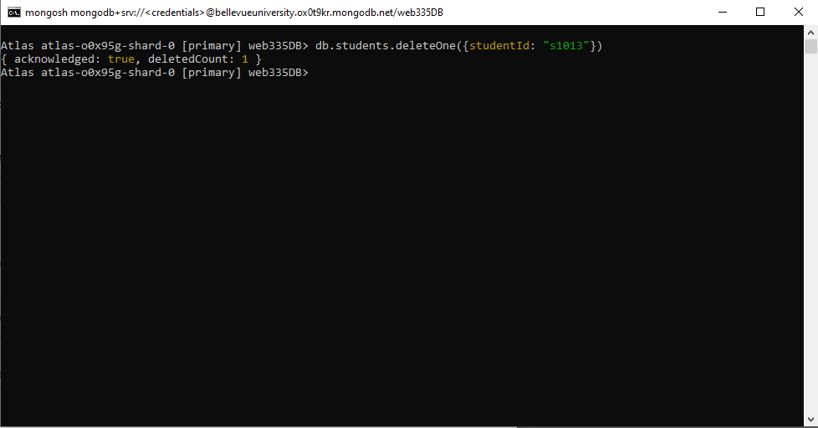

// verify student document deleted no longer exists in collection

db.students.findOne({lastName: "Granger"})

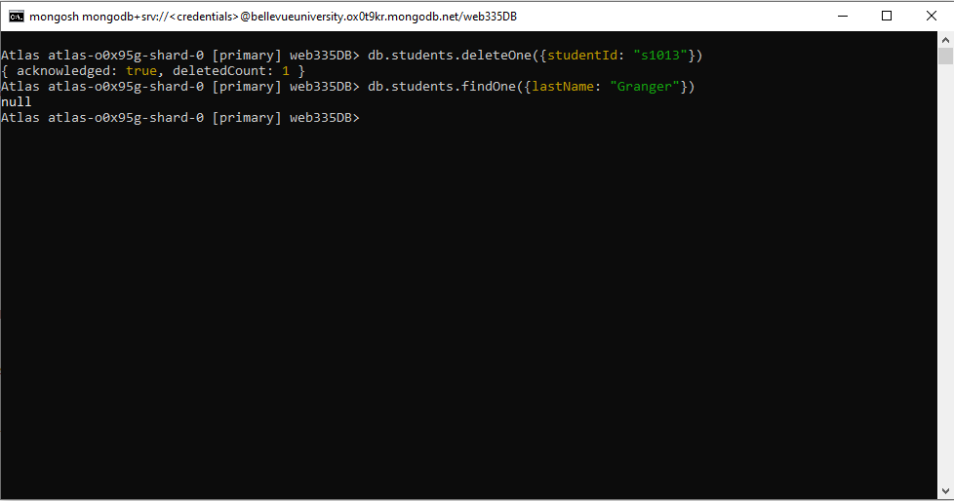

// list students by house

db.houses.aggregate([{$lookup:{from: "students", localField: "houseId", foreignField: "houseId", as:"house_students"}}])

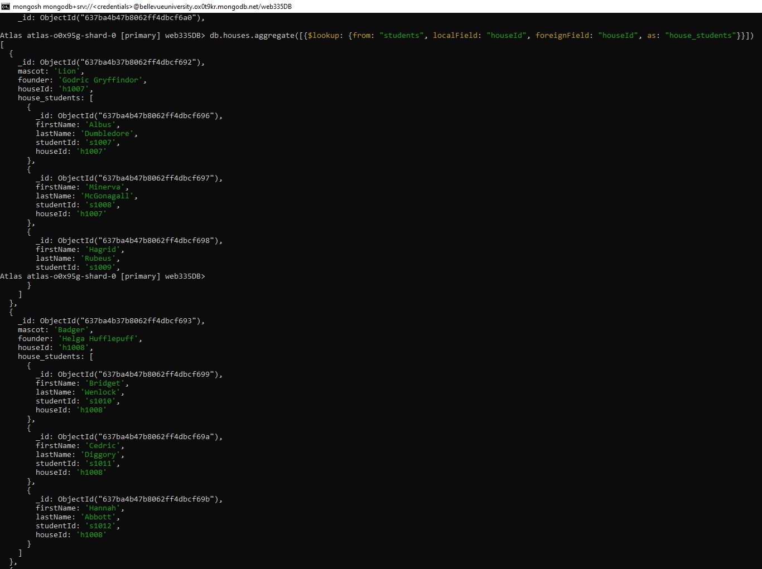

// list students in Gryffindor

db.houses.aggregate([{$match: { "houseId": "h1007"}}, {$lookup: {from: "students", localField: "houseId", foreignField: "houseId", as: "house_students"}}])

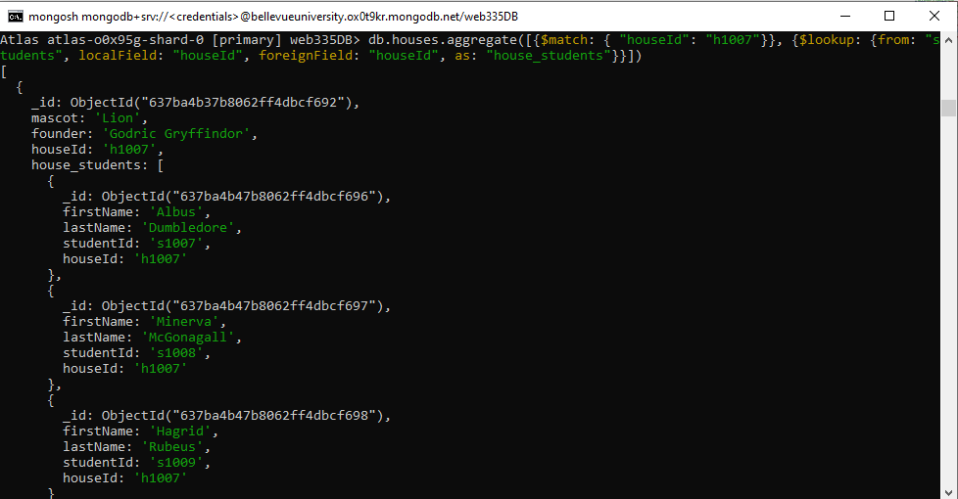

// list students in house with eagle mascot

db.houses.aggregate([{ $match: {"mascot": "Eagle"}}, {$lookup: { from: "students", localField: "houseId", foreignField: "houseId", as: "mascot_students"}}])

