Chad ONeal

11/11/2022

Web-420

Assignment 4.2 Composer API

**API unit tests**

Swagger Testing:

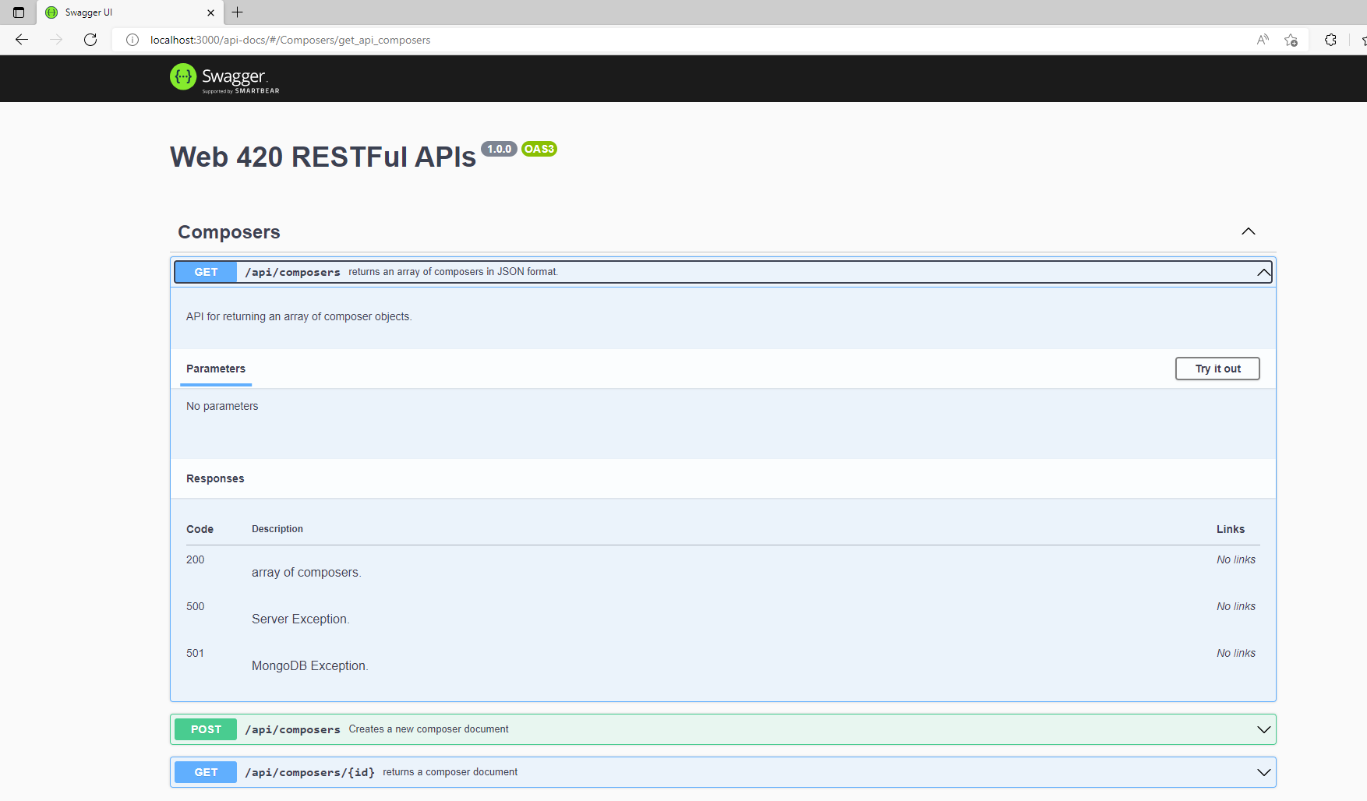

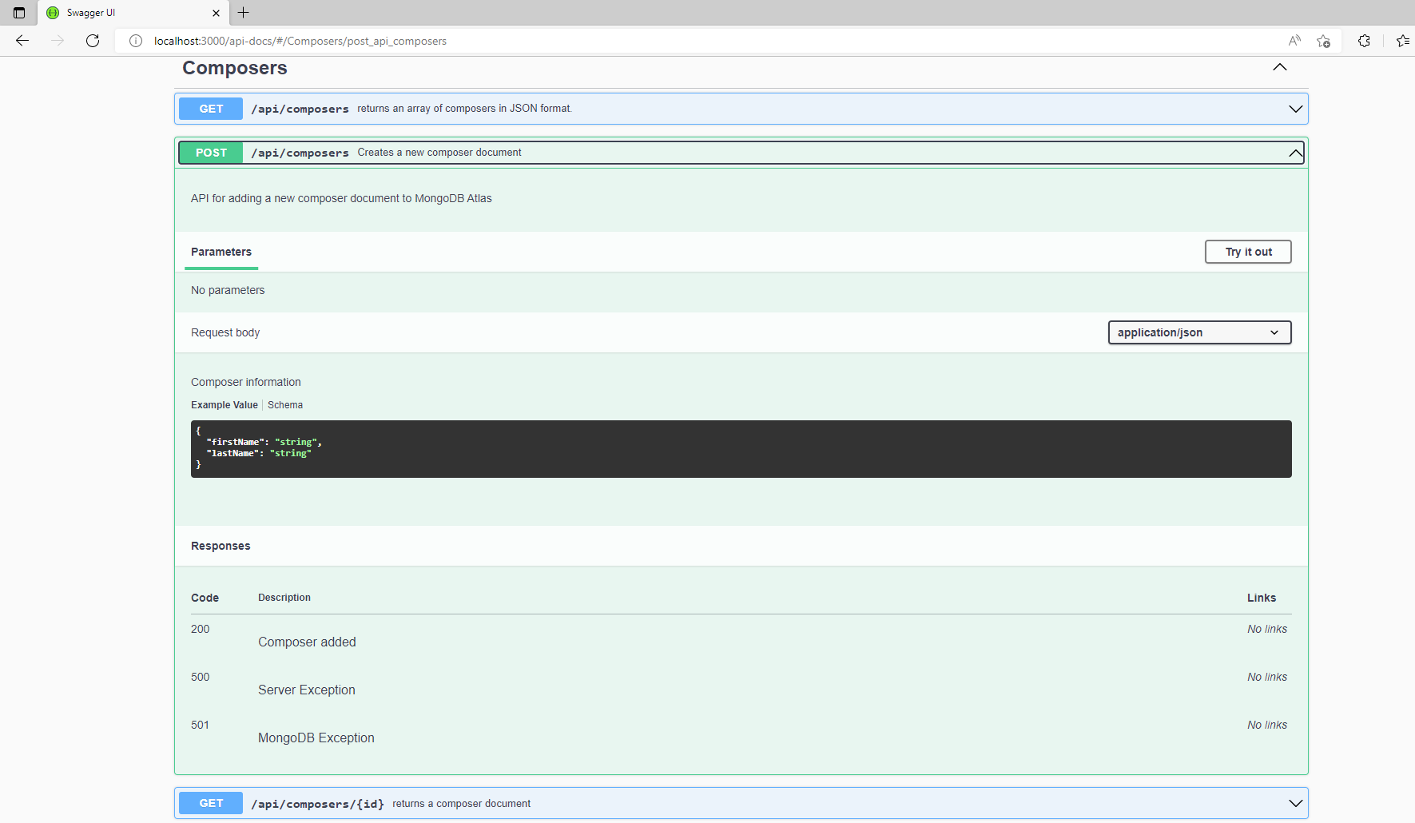

Soap UI testing:

GET test:

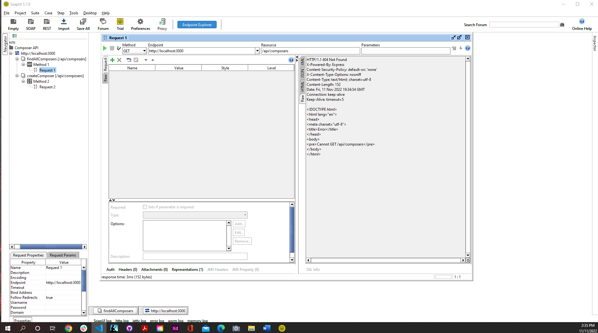

POST test:

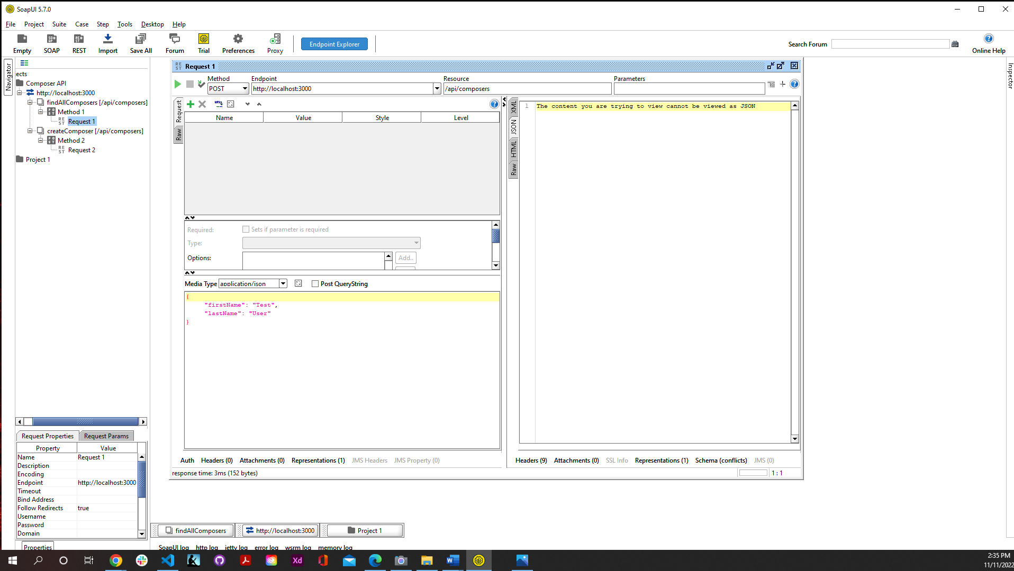

Personal -portfolio API Units Page:

