In this thread I would like to describe what an API really is. I will identify an API’s goals form the consumers perspective. I will discuss how to transpose those goals into a programmable representation. I will also talk about how to formally describe the programmable representation using OAS. So, what is an API actually?

“APIs are mechanisms that enable two software components to communicate with each other using a set of definitions and protocols. For example, the weather bureau’s software system contains daily weather data. The weather app on your phone “talks” to this system via APIs and shows you daily weather updates on your phone.” (Amazon Web Services, n.d.) To identify the goals of an API from the consumers perspective, we need to understand that our designs are for them, and not so specifically for us as developers. In doing so we need to know what our users are wanting to do and how they want to do it. By knowing these things, we can build an API that will satisfy the consumers goals. The example from the book “The Design of Web API’s is spot on for telling us how to do so:

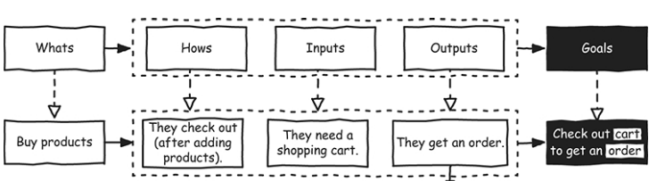

(Arnaud Lauret, 2019)

We can then to transpose those goals into a programmable representation by using a cheat sheet, for instance I will reference the composer API that we put together last week. Since we now know what the consumers are wanting to do we can use HTTP methods to help them perform different actions such as create, read, replace, or delete for the composer API.

|  |  |  |  |
| --- | --- | --- | --- |
| Action | HTTP method | Parameters | Expected Output |
| Create, add to | POST | Body  createComposer | {  "composerId":{  "firstName":"first",  "lastName":"last"  }  } |
| Read, retrieve, search | GET | Query  findAllComposers | {      "composers":[          {              "composerId0":{                  "firstName":"first0",                  "lastName":"last0"              }          },          {              "composerId1":{                  "firstName":"first1",                  "lastName":"last1"              }          }      ]  } |
| Action | HTTP method | Parameters | Expected Output |
| Modify, update partially | PATCH | Body  findComposerbyID | {  "composerId":{  "firstName":"first",  "lastName":"last"  }  } |
| Replace | PUT | Body  findComposerbyID | {  "composerId":{  "firstName":"first",  "lastName":"last"  }  } |

To formally describe the programmable representation using OAS we need to understand that “OpenAPI Specification is an open-source format and initiative for designing and creating machine-readable interface files that are utilized in producing, describing, consuming, and visualizing RESTful APIs and web services. The open API file permits software developers to define their API’s essentials, including:

* Present endpoints and each endpoint’s operations
* The input and output operation parameters
* Authentication techniques
* Things like contact information, terms of use, license, and much more”

(*What Is OpenAPI? | OpenAPI Definition | API Glossary*, n.d.)

API specifications are either written in YAML or JSON, formats that are readable, and easy to learn for both machines and humans.” Open API’s are used for:

* Generating a server stub for your API
* Generating client libraries for your API in more than 40 languages
* Using spec to join API-related tool with your API
* Create interactive API documentation that allows users to test the API calls straight in the browser.
* It can also be used by code generation tools to generate server [SDKs](https://rapidapi.com/blog/api-glossary/sdk/) and [client](https://rapidapi.com/blog/api-glossary/client/) CDKs in several programming languages, testing tools, and many other use cases.

 (*What Is OpenAPI? | OpenAPI Definition | API Glossary*, n.d.)

References:

Amazon Web Services. (n.d.). *What is an API? - API Beginner’s Guide - AWS*. Amazon Web Services, Inc. Retrieved November 1, 2022, from <https://aws.amazon.com/what-is/api/>

Arnaud Lauret. (2019). *The design of web APIs*. Manning Publications Co.

‌ *What is OpenAPI? | OpenAPI Definition | API Glossary*. (n.d.). The Last Call - RapidAPI Blog. Retrieved November 1, 2022, from <https://rapidapi.com/blog/api-glossary/openapi/>