Chad ONeal

11/15/2022

Web_420

Assignment_5.2_Persons_API

GET Test Swagger:

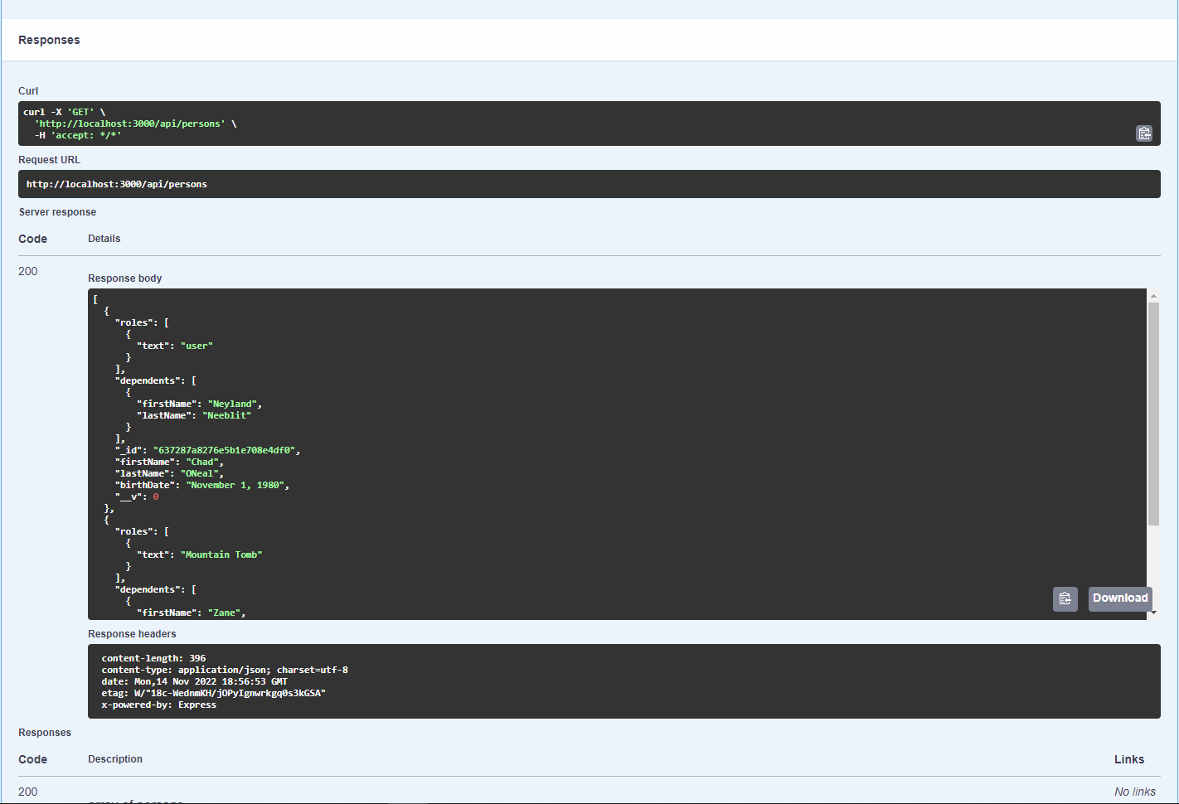

POST test Swagger:

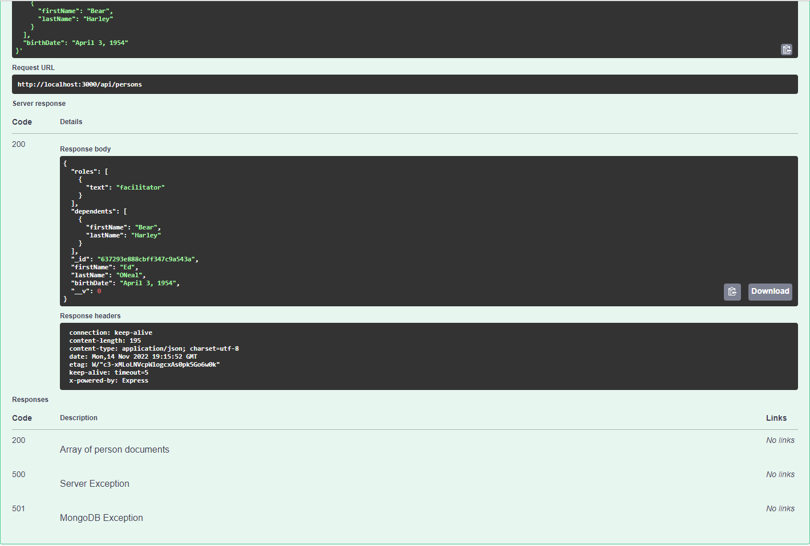

GET test Soap UI:

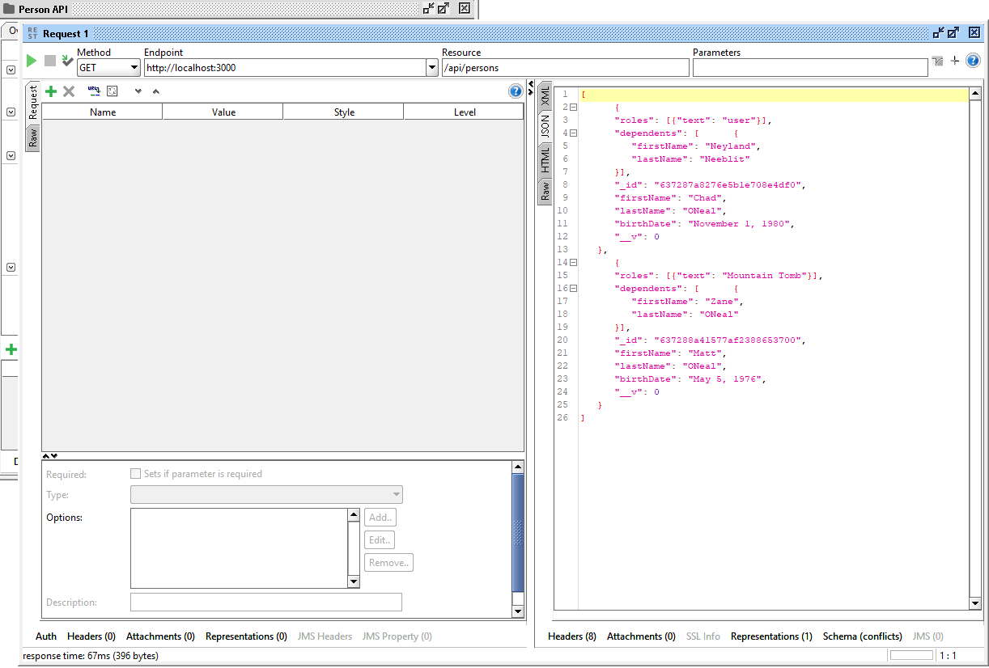

POST test Soap UI:

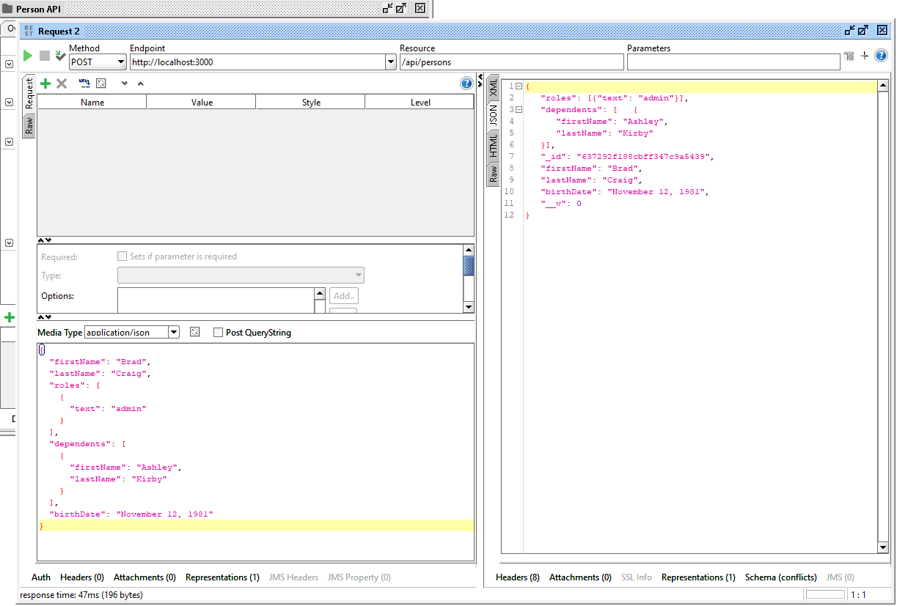

Personal-portfolio with new test added:



