Chad ONeal

11/20/2022

Web-420

Assignment 6.2 Node Security

Signup POST test Swagger:

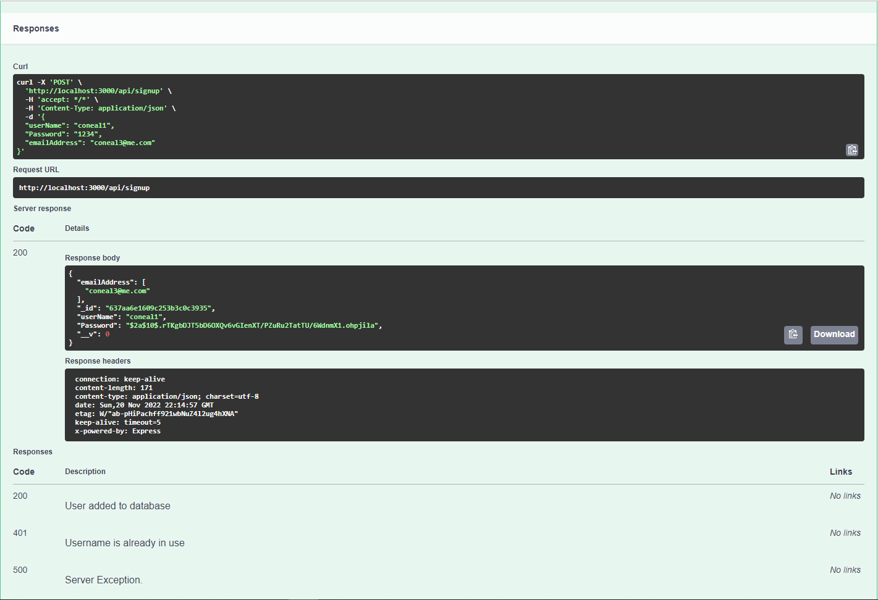

Login POST test Swagger:

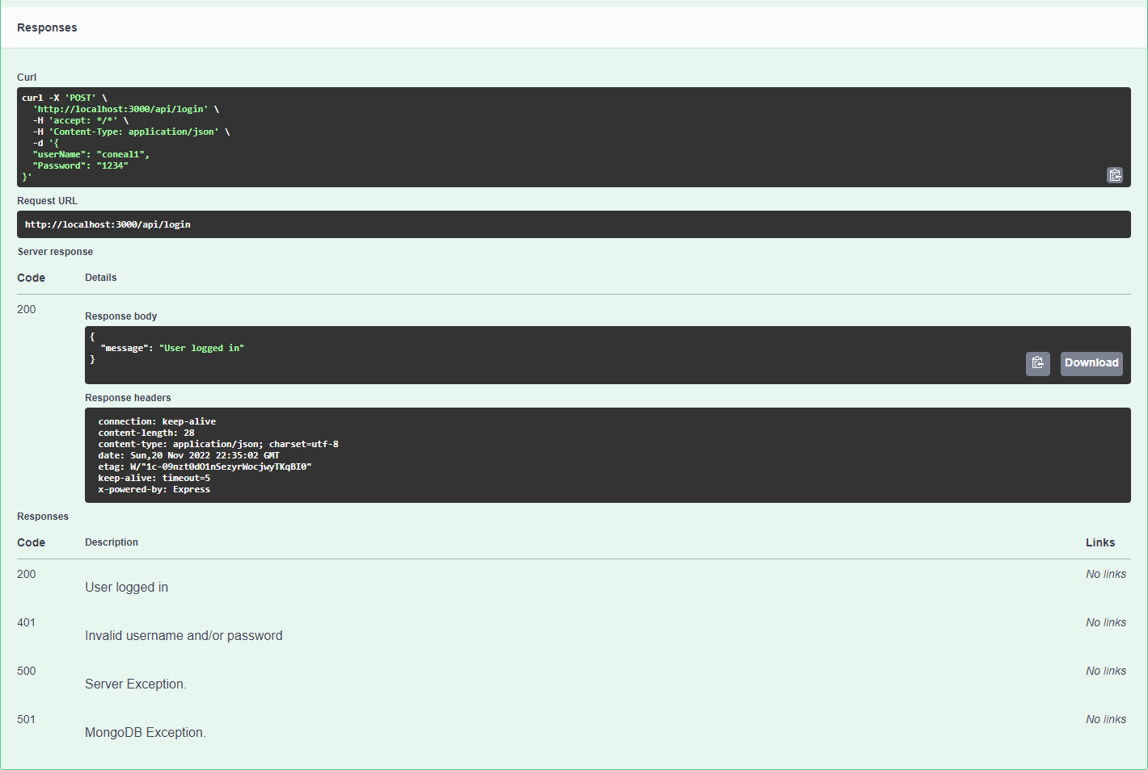

Sign-up POST test Soap UI:

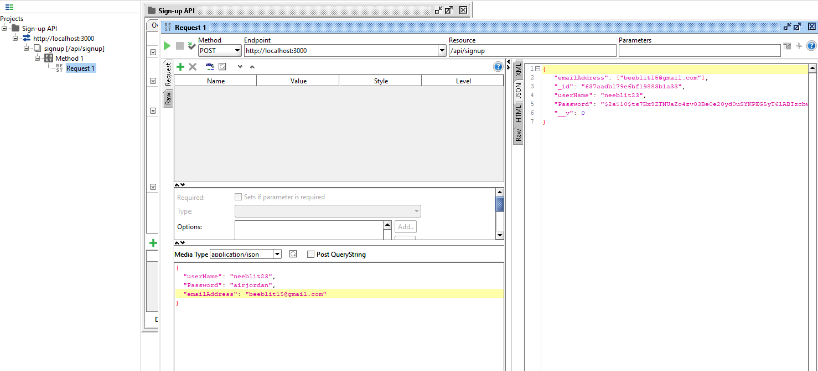

Login POST test Soap UI:

