Chad ONeal

11/28/2022

Web-420

Assignment 7.2 Node Shopper

findAllUserInvoicesByUserName GET test in Swagger:

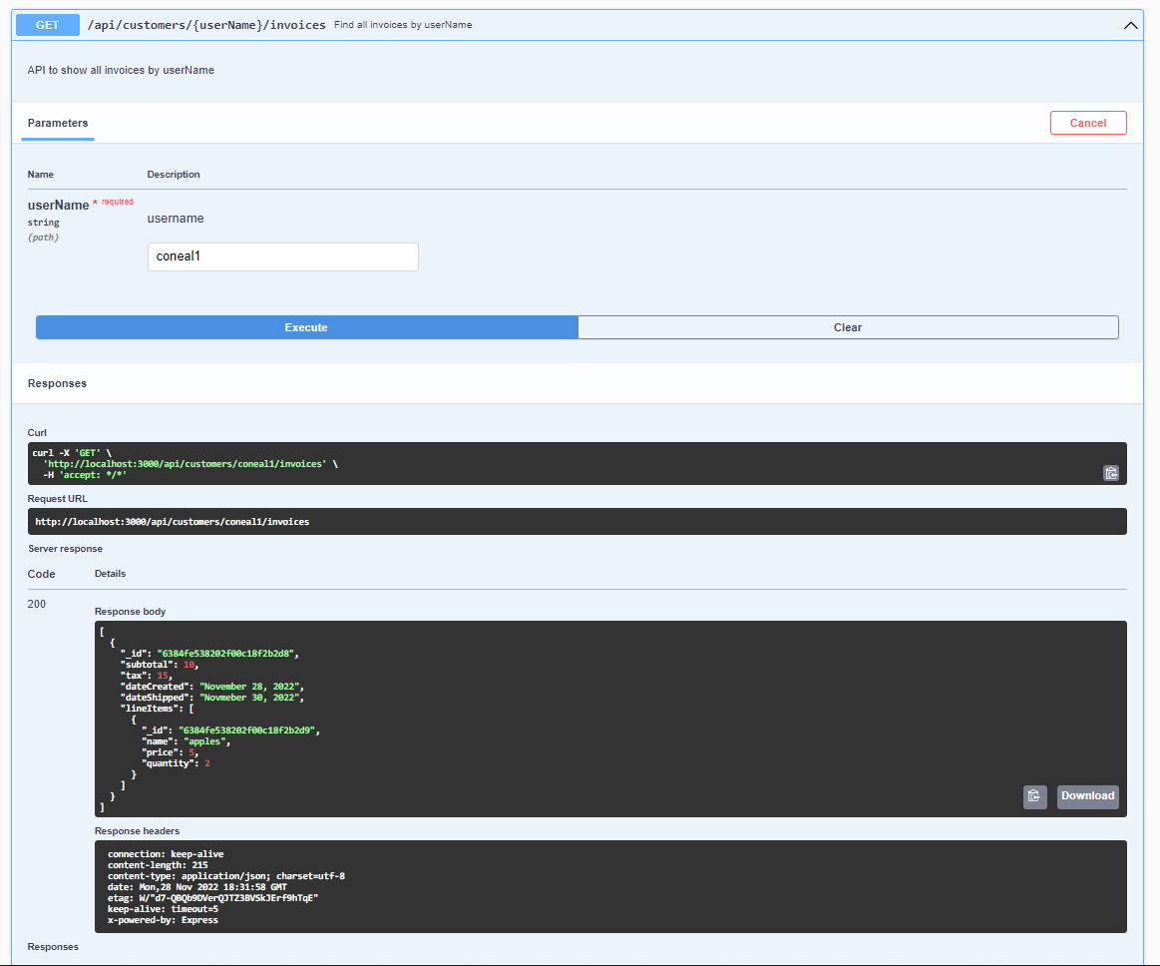

createCustomer POST test in Soap UI:

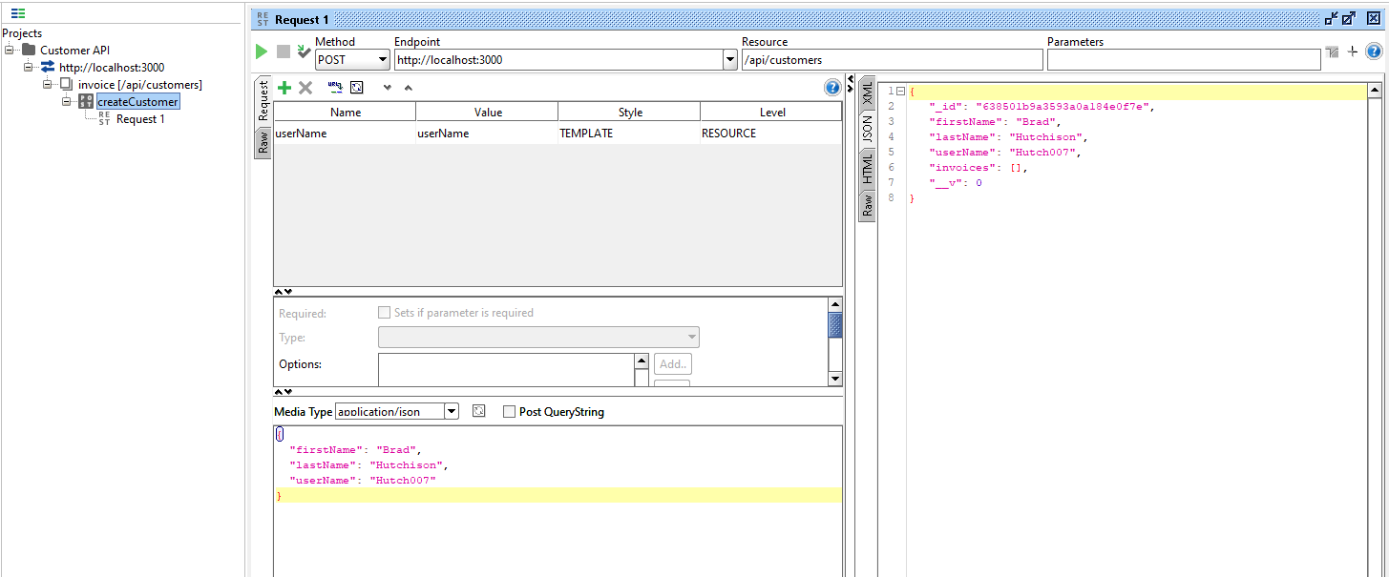

createInvoiceByUserName POST test in Soap UI

