Semantic versioning is a system that “versions” different release dates of software. Also known as (SemVer), semantic versioning has begun to be adopted by the web development community in the past few years. It has been stated that “semantic versioning has been a problem for software developers, release managers, as well as consumers.” (GeeksforGeeks, 2022). “Having a universal way of versioning the software development projects is the best way to track what is going on with the software as new plugins, addons, libraries and extensions are being built almost every day. This problem can be solved by Semantic Versioning. (GeeksforGeeks, 2022). SemVer is in the form of “Major.Minor.Patch”. Let’s consider the visual below to help explain this concept:

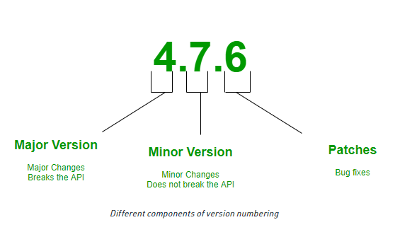

(GeeksforGeeks, 2022).

Semantic Versioning is a 3-component number in the format of X.Y.Z, where:

* **X** stands for a **major version**. The left most number denotes a major version. When you increase the major version number, you increase it by one, but you reset both patch version and minor versions to zero. If the current version is 2.6.9 then the next upgrade for a major version will be 3.0.0. Increase the value of X when breaking the existing API.
* **Y** stands for a **minor version**. It is used for the release of new functionality in the system. When you increase the minor version, you increase it by one, but you must reset the patch version to zero. If the current version is 2.6.9 then the next upgrade for a minor version will be 2.7.0. Increase the value of Y when implementing new features in a backward-compatible way.
* **Z** stands for a **Patch Versions:** Versions for patches are used for bug fixes. There are no functionality changes in the patch version upgrades. If the current version is 2.6.9 then the next version for a patch upgrade will be 2.6.10. There is no limit to these numbers. Increase the value of Z when fixing bugs.

(GeeksforGeeks, 2022).

References:

GeeksforGeeks. (2022, July 3). *Introduction to Semantic Versioning*. Retrieved November 28, 2022, from <https://www.geeksforgeeks.org/introduction-semantic-versioning/>