Chad ONeal

12/05/2022

Web -420

Assignment 8.2 Composer API, part 2

Composer API DELETE test Swagger (deleteComposerById):

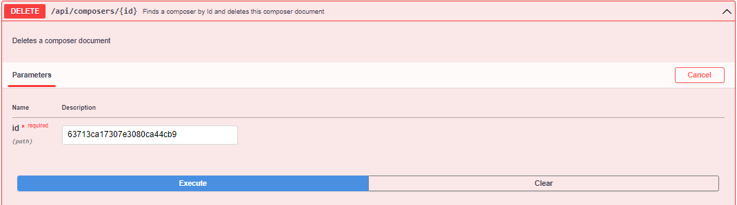

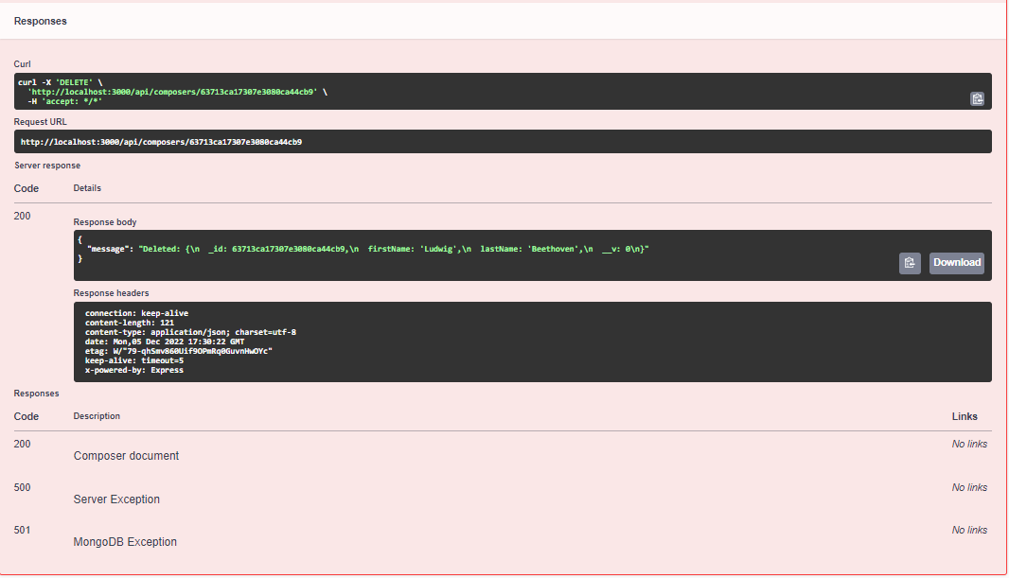

Composer API PUT test Soap (updateComposerById):

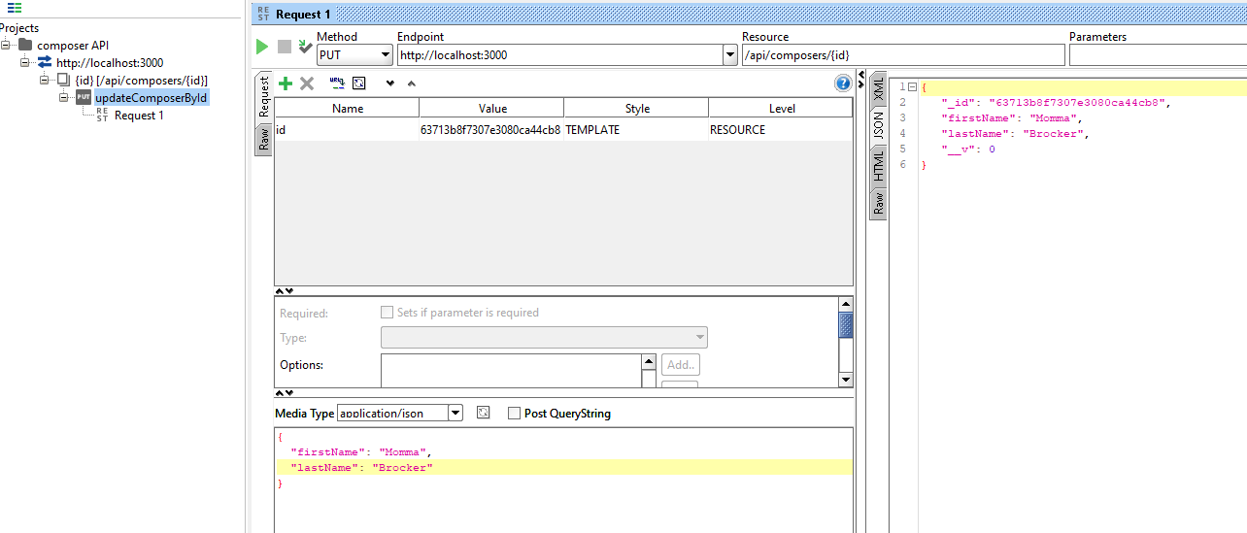

Personal Portfolio updates to include new images:

