IBM UrbanCode Release (UCR) Concepts Overview and Setup

January 26, 2018

Geoff Rosenthal ([Geoffrey.Rosenthal@perficient.com)](mailto:Geoffrey.Rosenthal@perficient.com))

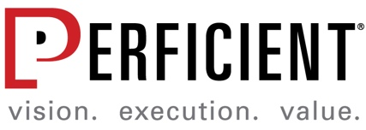

© 2018 Perficient, Inc. All Rights Reserve

Contents

1. Teams, Groups, and Roles 3

1.1. ACME Manage Security Settings 4

2. Lifecycles 4

3. Applications 5

4. Release Environments 6

5. Releases 6

6. Deployment Plans 8

7. Enterprise View 10

8. Pipeline View 11

9. Calendar 12

This document gives a high-level overview of UCR. It is intended for you to follow in sequential order in order to gain an understanding of the lower-level pieces that make up the high-level concepts in UCR.

# Teams, Groups, and Roles

UCR has a very granular user security model. You will setup user groups, teams, and roles within *Manage Security*. Ideally users (and groups) are defined in your corporate LDAP. They can also be created manually within UCR. Once UCR is populated with users, groups, roles, and teams need to be created/configured:

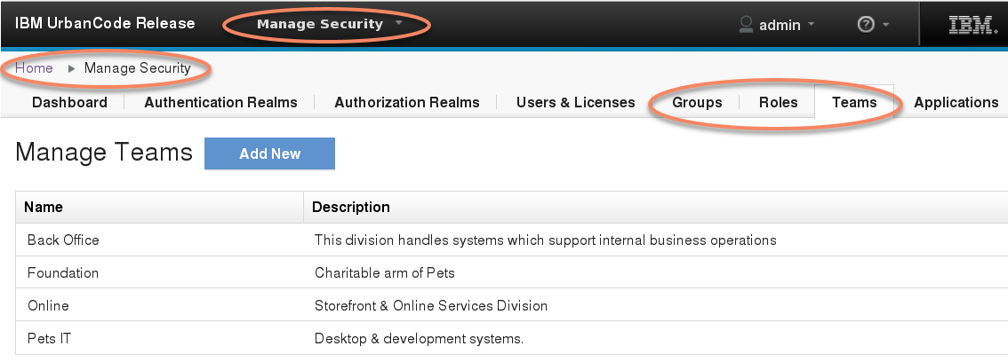

Groups:

* Ideally user groups are mapped from your corporate LDAP. They can also be created manually within UCR
* Groups contain individual users

Roles:

* Roles determine what specific privileges a user will have i.e. read, write, or no access to all of the various artifacts and views within UCR
* There are some provided roles that are installed with the tool installation e.x. Admin

Teams:

* A team includes all of the UCR defined roles (you don’t necessarily need to have users and/or groups assigned to each role within each team)
* For each role within a team you can assign one or more groups and/or one or more individual users
* One or more applications are assigned to a team
* **\*\*Each defined UCR release can only have one associated team\*\***

## ACME Manage Security Settings

For the sandbox environment at ACME, a connection to Active Directory within the IT group was created for user/group authentication. The Authentication Realm connection details are as follows:

* LDAP URL:
* User Search Base:
* User Search Filter: uid={0}
* Search User Subtree: checked
* Search Connection
* Search conection Password: <*password of search user*>
* Name Attribute: cn
* Email attribute: mail

Once the Authentication Realm is created, the Authorization Realm details are as follows:

* Specify how to search LDAP: Roles in LDAP reference their members…
* Group Search Base:
* Group Search Filter: uniqueMember={0}
* Group Name Attribute: cn
* Search Group Subtree: checked

***NOTE: Once the authentication realm and authorization realm has been created, you can add users by either searching for them from the actions menu on the Manage Authentication Realm, or a user can simply attempt to login to UCR with their credentials. Once the user is added or the user logs into UCR, their group membership should be automatically populated.

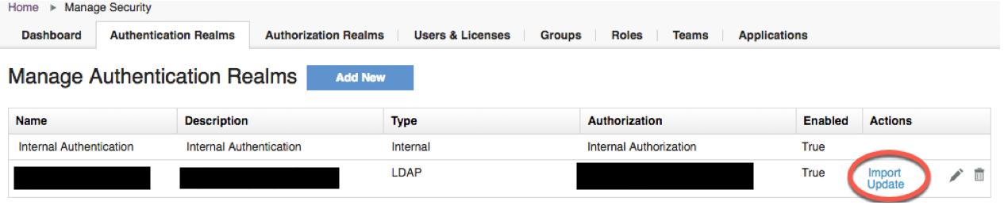

At ACME, within the UCR sandbox environment, the following groups were defined within Active Directory:

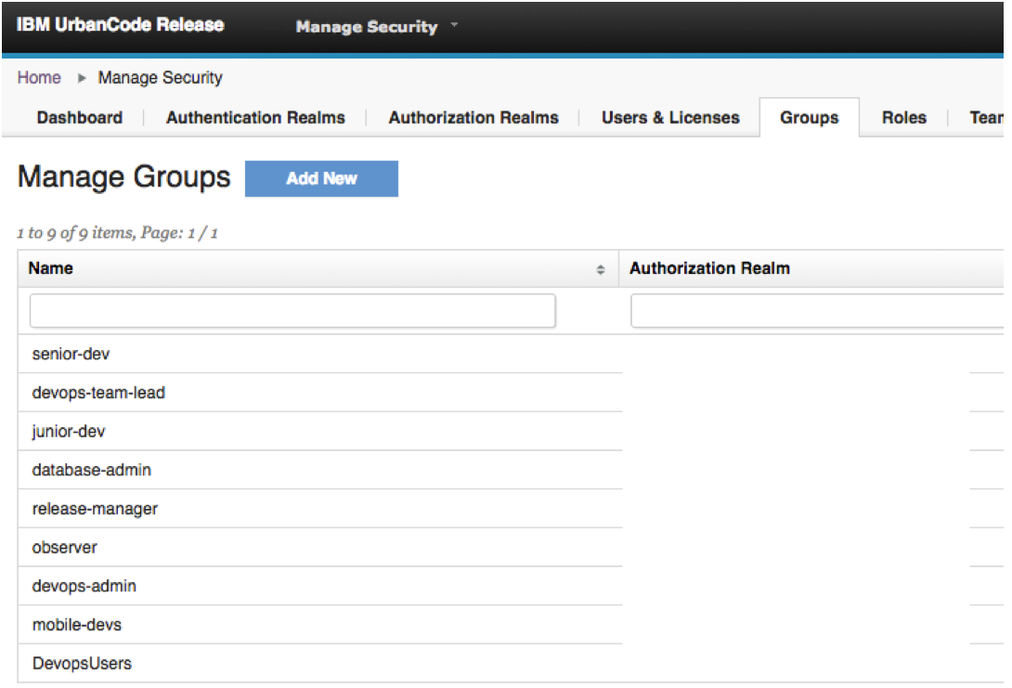

At ACME, within the UCR sandbox environment, the following roles were defined:

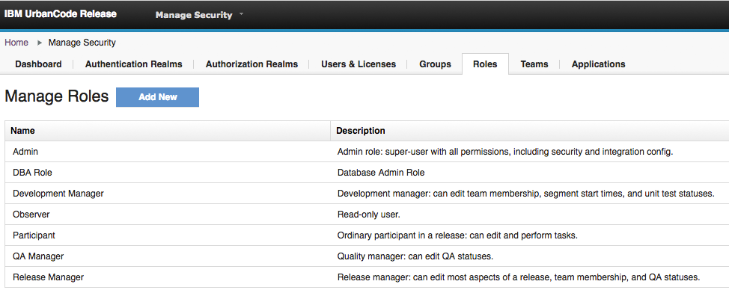

# Lifecycles

View/create a release lifecycle by selecting *Release Process* from the drop down menu. A lifecycle defines your process phases i.e. your environment pipeline flow e.x. DEV->QA->STAGE->PROD. The lifecycle is also where you define your phase quality gates.

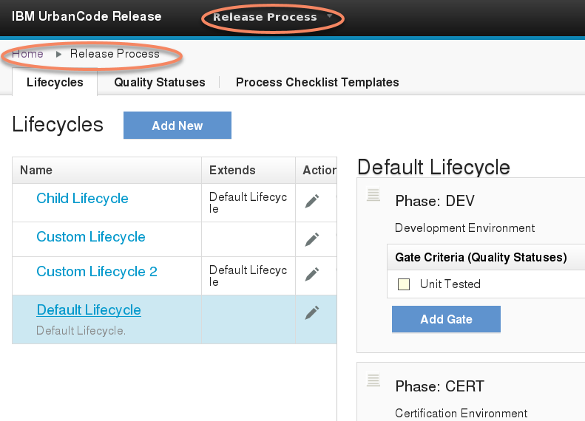

# Applications

You can view/manipulate applications by selecting *Applications* from the drop down menu.

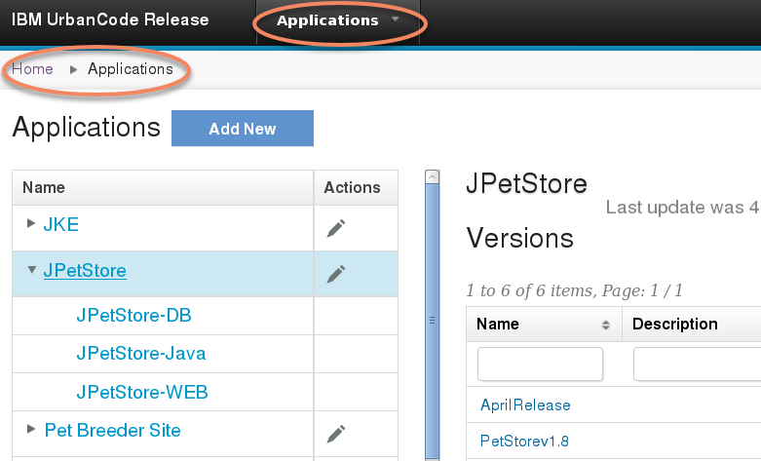

Ideally applications with their versions and associated environments will automatically be populated via integrations to deployment automation tools such as IBM UrbanCode Deploy (UCD). Applications can also be created and tracked manually.

Applications contain versions. A passed quality gate is assigned to a specific application version. A deployment process will invoke a specific application version (or multiple application versions) to be deployed to a target during that deployment plan execution.

Once applications are created manually or populated automatically you need to assign applications to specific teams. Navigate to *Manage Security->Applications* to assign applications to teams.

# Release Environments

Select *Environments* from the drop down menu. Within a defined release, for each lifecycle phase you will associate specific environments. These environments are your deployment targets during an actual deployment execution.

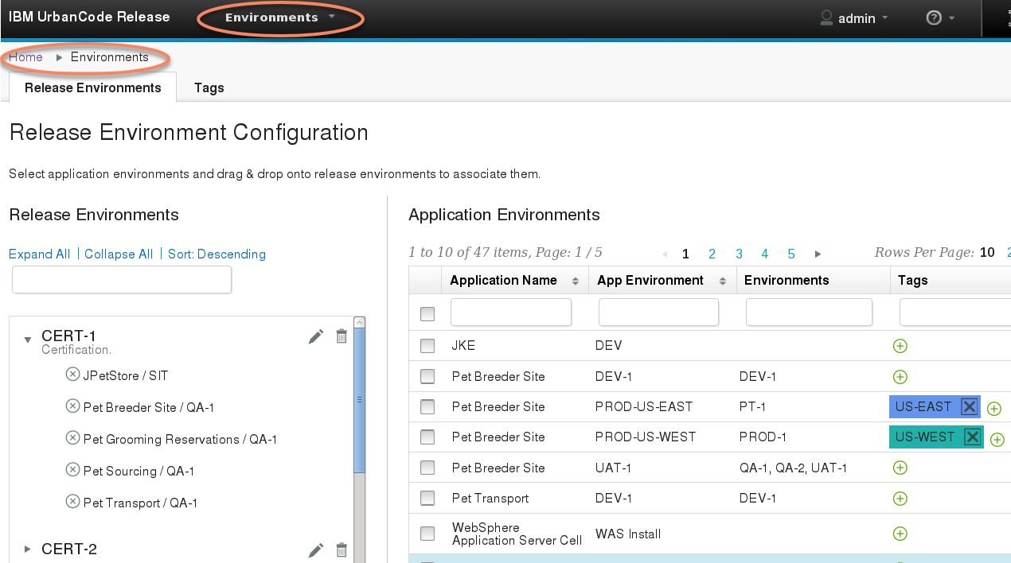

***Note that for manually created/controlled applications, a release environment and an application environment are actually one in the same. For a manual application, to make the release environments show up as applications environments, navigate to *Applications*, select a specific application and edit the application from the Action column. Then check the boxes in the Release Environments section to add or remove release environments as application environments.

For a release pipeline you will map release environments to pipeline phases. Within each pipeline phase, one or more application environment will be mapped to the release environment within that phase. This allows for your application teams to create whatever environment pipeline they wish with whatever environment naming they wish, but at a release level the environments will be mapped consistently.

Within *Environments* navigate to the *Release Environments* tab. Create appropriate Release Environments, then appropriately map Application Environments to those Release Environments by dragging and dropping Application Environments to Release Environments.

# Releases

Select *Releases & Deployments* from the drop down menu. The *Releases* tab lists all defined releases. A release follows a specific delivery lifecycle (i.e. environment phases DEV->QA->STAGE->PROD), is assigned to one team and is targeted for a specific date (most commonly it’s the production release target date that is used for the release date).

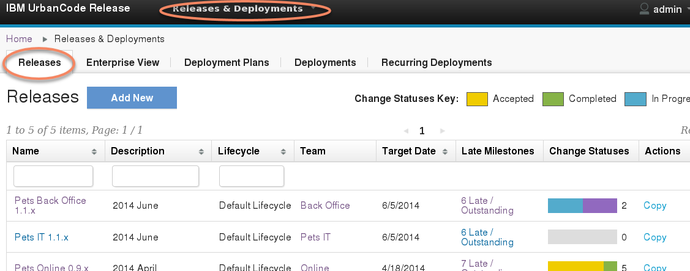

Within a specific Release you will associated participating applications. 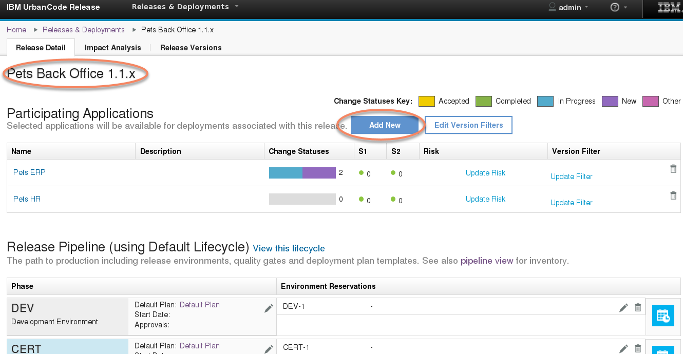

You will assign a start date for each phase and provide a default plan for that phase. You will also assign environment reservations within the Release Pipeline.

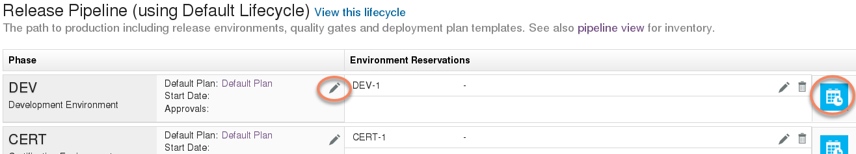

# Deployment Plans

Select *Releases & Deployments* from the drop down menu. The *Deployment Plans* tab lists all defined deployment plans. A deployment plan is a reusable template that specifies how to push applications out to environments.

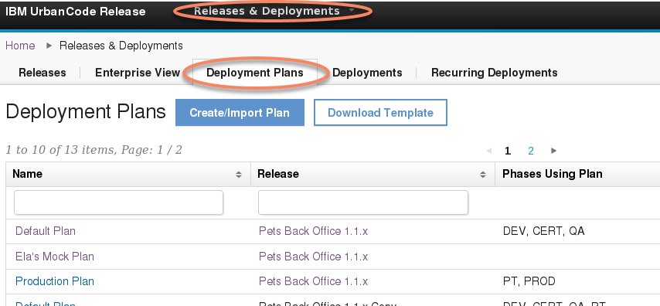

A deployment plan defines the orchestration of the execution of one or more applications being pushed out to target environments. A deployment plan consists of segments which are logical groupings (most often by execution order, role ownership, application or component).

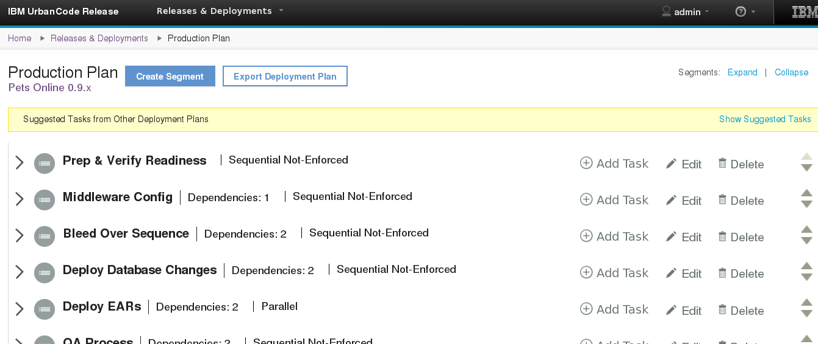

Each segment will contain tasks. A manual task refers to a task that will be performed by a human who will update that task’s status and comments accordingly. An automated deploy task will be performed by UrbanCode Deploy automatically during execution once that task’s pre-requisites have been met. This task will be updated by UrbanCode Deploy with appropriate execution results within the comments section of the task.

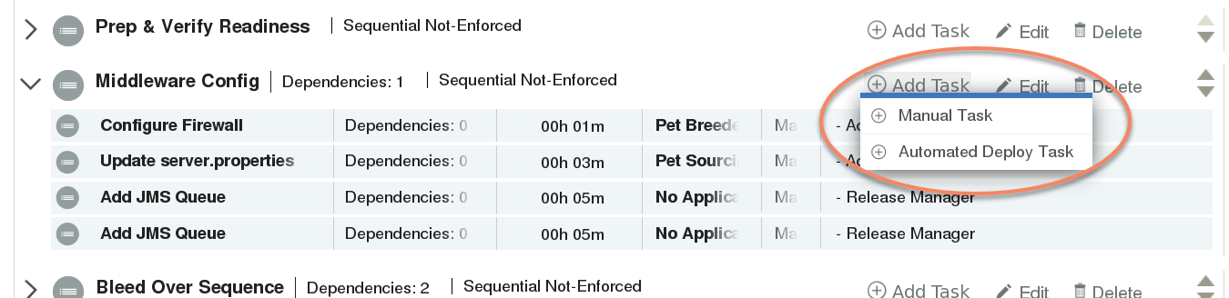

Fill in the task details as appropriate. Note that at execution time, the deployment overview dashboard shows progress based upon task tags.

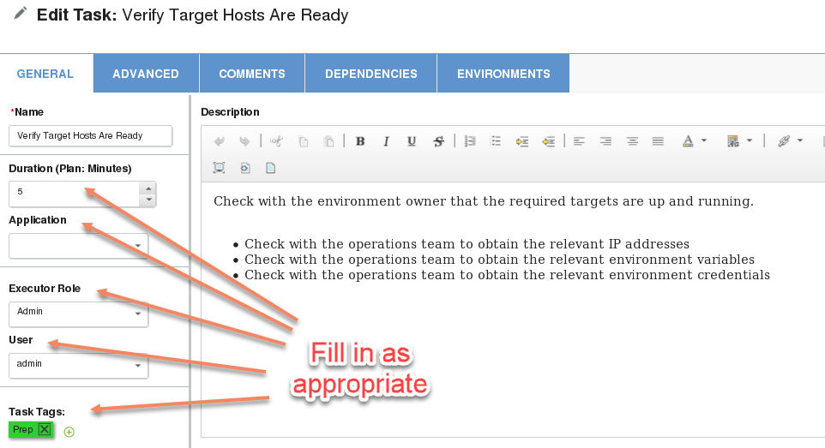

Select the **ENVIRONMENTS** tab. This tab defines how this task will behave for a specific environment. A deployment plan is executed within a specified environment. Thus in order for a task to be visible/executed for an environment you must ensure that environment is selected.

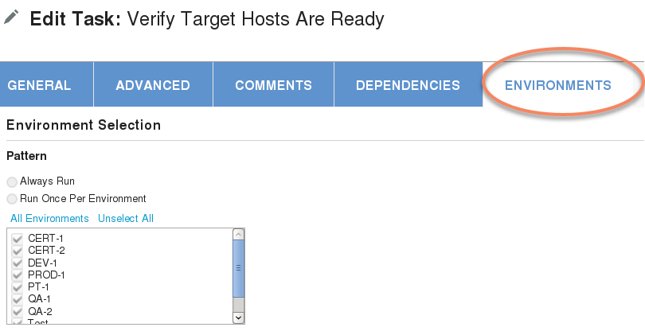

# Enterprise View

Select Releases & Deployments from the drop down menu. Select the Enterprise View tab. An enterprise view is a rollup of multiple releases. An enterprise view will give you a combined status of releases and applications within those releases within a single view.

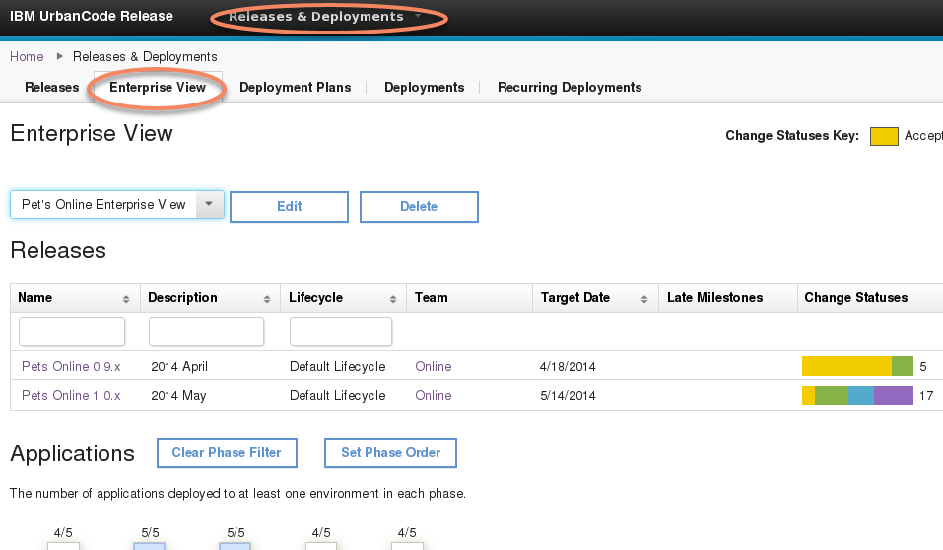

# Pipeline View

Select *Pipeline View* from the drop down menu. Select a specific release.

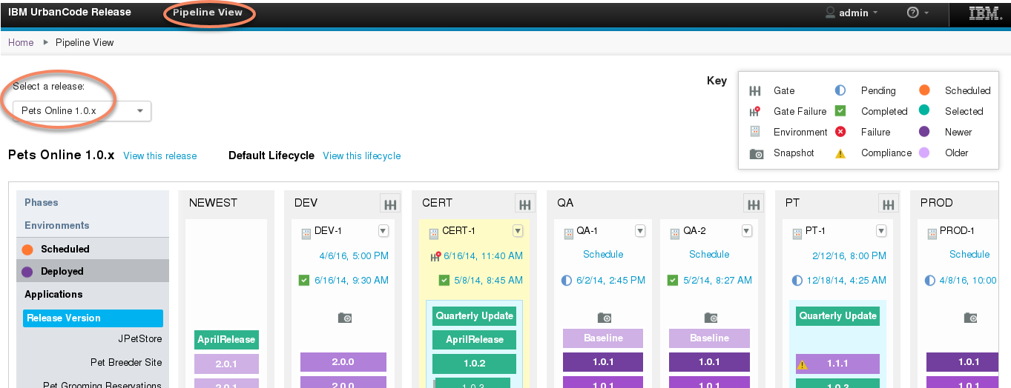

The pipeline view provides a rollup view of release phases as well as deployed and scheduled to be deployed applications within each phase. Note the icon and color Key within the view. Note the drop down arrow next to each environment name will allow you to manually update the environment inventory.

Click on the various pieces of the view to see more details:

* Application version: displays any assigned quality statuses and related components as defined in UrbanCode Deploy for that specific version.
* Gate icon (upper right of each phase): displays the required assigned quality statuses for an application to be deployed to that phase.
* Environment white space: click any white space within a specific environment to highlight that environment. Notice how the version colors change (based upon the view Key) for each environment.
* Scheduled/Deployed dates: each environment has a scheduled or deployed date or will just display the word “Schedule” to que the user that nothing has been scheduled. Click the date to view more details.

# Calendar

Select *Calendar* from the drop down menu to view the global calendar. You can select specific date ranges. You can add a new deployment by selecting the **Add New Deployment** button on the upper right.

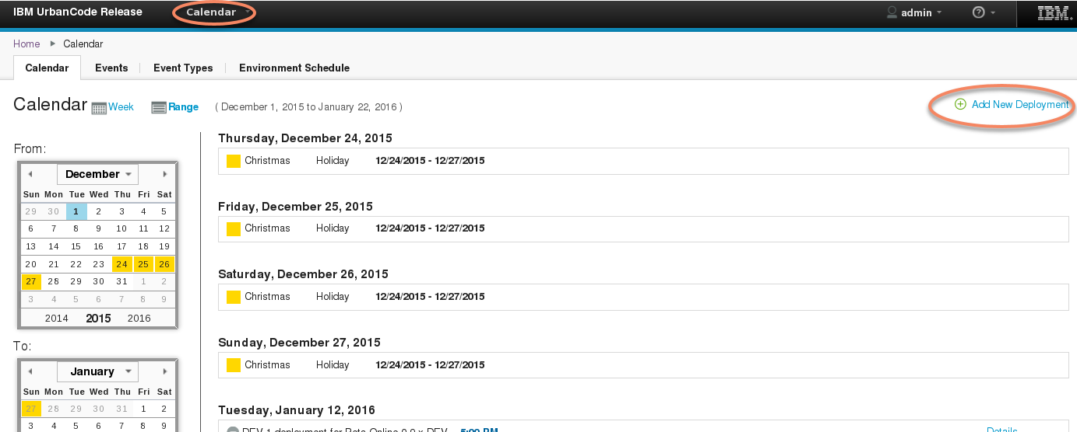

|  |  |
| --- | --- |
| Note that by default the calendar filters are not selected, thus the calendar will not show any information. Add filter choices in order to display desired information. |  |