UrbanCode Deploy (UCD) Server Installation Instructions

January 26, 2018

Geoff Rosenthal ([Geoffrey.Rosenthal@perficient.com)](mailto:Geoffrey.Rosenthal@perficient.com))



Contents

1 Manual sandbox installation on Windows 3

1.1 Sanity checks to ensure the server is running 5

2 LDAP Configuration 7

3 MySQL Installation 9

**For the complete UrbanCode Deploy product documentation, see:**

[**https://www.ibm.com/support/knowledgecenter/SS4GSP/ucd_welcome.html**](https://www.ibm.com/support/knowledgecenter/SS4GSP/ucd_welcome.html)

# Manual sandbox installation on Windows

Pre-requisite – Java must be installed on the target server before the server installation can take place. Java 8 is required as of UCD 6.2.4.

Ensure that Java is installed on the target server

1. Ensure that the JAVA_HOME environment variable is properly set on the target server:
   1. Open the Windows Environment Variables
   2. Under System variables ensure that there is a “JAVA_HOME” variable with a value set to the appropriate installation location of Java on the server

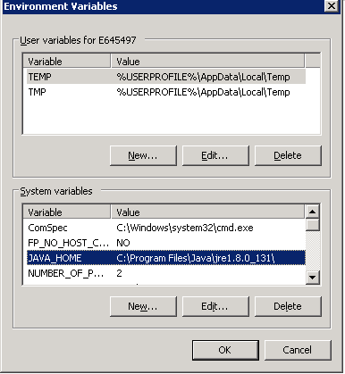

1. Copy the UCD server installation zip package to the target server. Contact the UCD administrator for the installation package or download the package from the IBM Passport Advantage website:

<https://www-01.ibm.com/software/passportadvantage/software_subscription_support_ov.html>

1. Extract the UCD server zip package into a known folder location
2. Run a Windows command prompt as administrator
3. Change the current working directory to the root directory (…\ibm-ucd-install) of the extracted zip archive
4. Run the script “install-server.bat”
   1. For the Java home directory use the path specified in the JAVA_HOME environment variable unless directed otherwise by the UCD administrator or server administrator
   2. Accept the full IBM license agreement
   3. For the installation directory specify <directory>
   4. The server will not be used as a node for high availability, choose “N”
   5. The server should store application data in the default specified location unless your UCD administrator instructs you otherwise
   6. Consult your UCD administrator for the correct host name for the UCD web UI
   7. Unless instructed otherwise by your UCD administrator, choose to always use a secure connection using SSL
   8. Consult your server administrator for the correct ports to be specified for the web UI for secure and unsecure connections
   9. Specify a known password for the temporary admin user for the server and keep this password in a known safe place. We will change this login as soon as UCD in configured to use the corporate LDAP for authentication
   10. Consult your infrastructure administrator on which port to specify for agent communication (usually port 7918 is used)
   11. The server and agent communication should not require mutual authentication. Choose “No”
   12. For the port and hostname of your Rational License Key Server, consult your UCD administrator for the correct value. If you leave this value blank, the UCD server will be installed in trial mode. You will then have 60 days to specify a valid license key server
   13. You should choose to create a database schema unless this server is being setup for high-availability. Consult your UCD administrator if you have questions
   14. **DATABASE CONNECTION STEPS DETAILS**
   15. Choose “yes” to install the UCD server as a Windows service
   16. Specify the default service name (ibm-urbancode-deploy) unless instructed otherwise by your UCD administrator
   17. Specify the default service user account unless instructed otherwise by your UCD administrator
   18. Consult your UCD administrator about choosing to start the service automatically. Typically the UCD service should start automatically when the server starts up or is re-booted so that the UCD server will startup automatically.
   19. The UCD server should now have been installed successfully. You should see a “BUILD SUCCESSFUL” message:

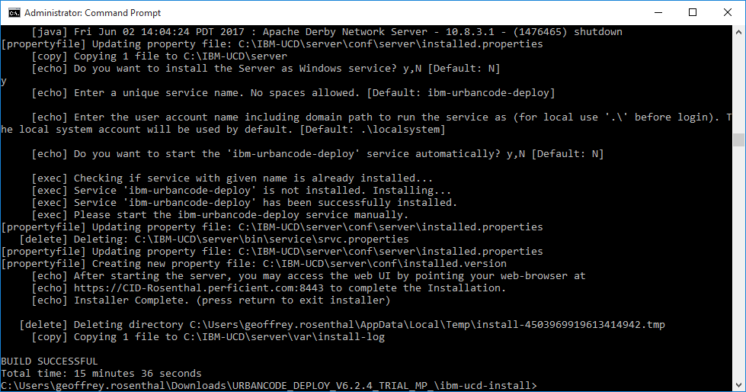

## Sanity checks to ensure the server is running

Windows Service:

Open your Windows Services. Find the service names “IBM UrbanCode Deploy Server” and check to see if the services is running.

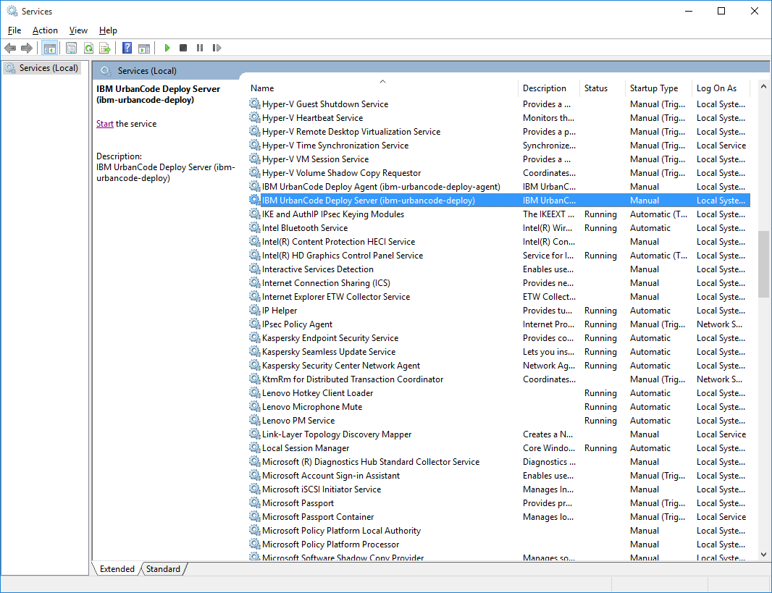

Right-click the service name and view the service properties. In the service properties you can start or stop the service. You can also set the Startup type.

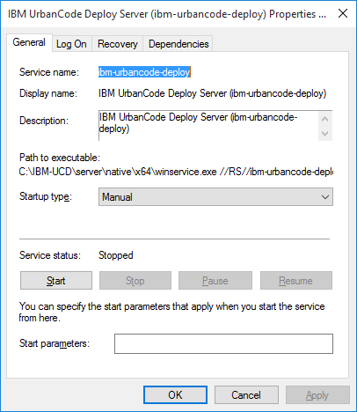

Running Java Process

This is a little more difficult to find than the Windows service, but there should be a Java process running for the agent. The running agent Java process will be listed as a Java Platform Binary (see screenshot below).

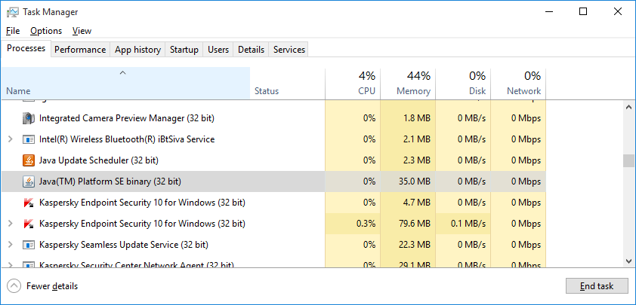

Right-click the process name to view its properties. The path (“Location” value) of the process binary will be the path you specified for the JAVA_HOME location. The agent uses this instance of Java to run.

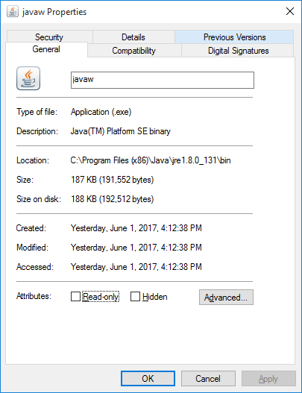

# LDAP Configuration

For user authentication, UCD should be connected to the corporate LDAP. This will enable UCD users to login to UCD with their corporate ID and password (just as they do to login, for example, to their workstation).

Note that some LDAP details of how certain properties were found are described after the following configuration steps.

1. Login to UCD as the administrator user. This should be the user specified in step 6.i from the installation instructions above
2. Navigate to Settings->Security column->Authentication

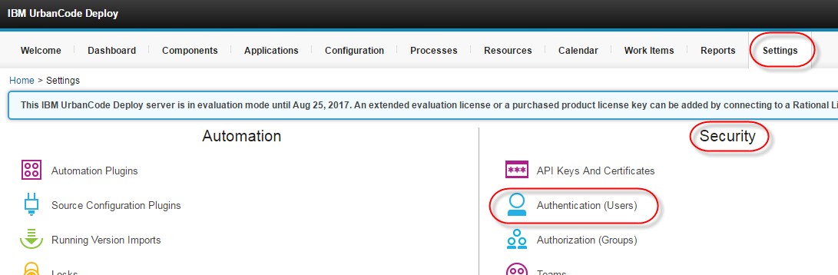

1. Push the Create Realm selection in the left-hand browse pane

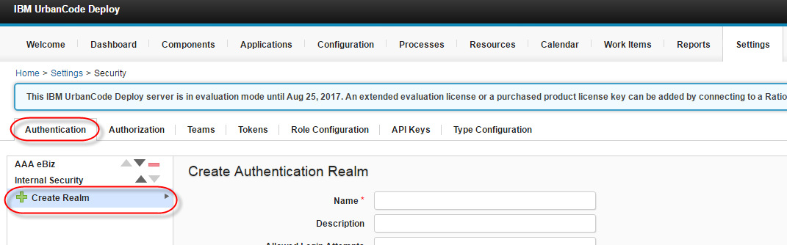

1. Fill in the Authentication Realm settings
   1. Name – a descriptive name for this authentication
   2. Description – a description of this authentication
   3. Allowed Login Attempts – leave blank and/or consult your security team for the required allowed login attempts limit
   4. Type – Choose **LDAP or Active Directory**
   5. Authorization Realm – select the Internal Security realm. This will require you to manually create groups and add users to those groups
   6. LDAP URL:
   7. Search Anonymously – unchecked
   8. Search Connection DN: *CN=<bind user>*

**(replace <bind user> with the bind user name of the LDAP service account**)

* 1. Search Connection Password – the password for the user specified in h.
  2. Specify the radio button for **LDAP users may exist in many directories, search across LDAP using a criteria**
  3. User Search Base:
  4. User Search Filter: (sAMAccountName={0}) (**field is case sensitive**)
  5. Search User Subtree – checked
  6. Name Attribute: *displayName* (**attribute is case sensitive**)
  7. Email Attribute: *mail* (**attribute is case sensitive**)

1. Click **Save** to create the authentication realm
2. You should now be able to login to UCD using LDAP user id and password combinations. Note that users can login, but they will not have access to anything in UCD (applications, environments, settings, components, etc.) until teams and roles are configured for a user.

# MySQL Installation

For a UCD sandbox server you can run the UCD installation script and specify for the installation process to install a local Derby database along with the UCD server. However, Derby is an extremely un-reliable database and should not be used for more than simple testing. As an alternative to Derby, you can install MySQL to UCD testing purposes. While MySQL should still be treated as a temporary/non-production/testing purposes only database, it is known to be more reliable than Derby.

Check the UCD system requirements to ensure you download a version of MySQL that is supported by the version of UCD that you are using.

<http://www-01.ibm.com/support/docview.wss?uid=swg27038801>

MySQL downloads can be found here (note that you’ll need a free Oracle account to download any software):

<https://www.mysql.com/downloads/>

You will need to download:

* MySQL Installer (to install MySQL on Windows)
* MySQL Community Server
* Connector/J (provides the JDBC connector that the UCD installation will need)

Use the MySQL documentation to run a typical installation. Make note of the configured MySQL port (default 3306) and root user password.

<https://dev.mysql.com/doc/mysql-installer/en/>

Once the MySQL database is installed, follow the UCD setup instructions for a MySQL database to create/configure a database accordingly:

<https://www.ibm.com/support/knowledgecenter/en/SS4GSP_6.1.1/com.ibm.udeploy.install.doc/topics/dbinstall_mysql.html>

The UCD installation/configuration instructions for the JDBC driver are confusing. Specifically the steps to copy the JDBC JAR file to *installer_directory*\lib\ext and to provide the JDBC driver class to connect to the database:

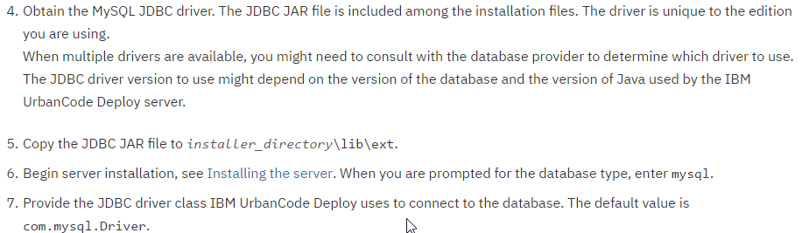

When you download and unzip the Connector/J package from the MySQL downloads site, at the parent level of the extracted archive should be a jar file with a name like: mysql-connector-java-*version*-bin.jar. This is the file you should copy as-is to *installer_directory*\lib\ext. The name of the driver class to connect to the database should still be the default of com.mysql.Driver regardless of the jar file name.