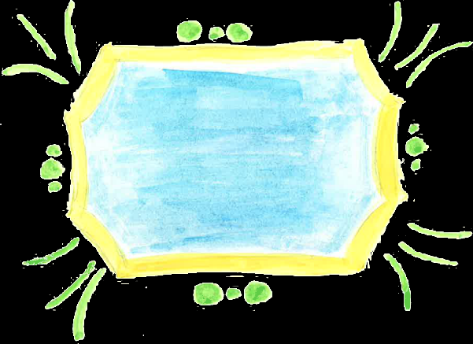

Turtle

Go on an

Adventure

Mr. Fox

and

&