# **Appointments Web Application**

The Appointments Web Application displays a list of patient appointments for the day in an ASP.net GridView. The GridView has 5 columns (LinkButton “Check In”, AppointmentId, Time, Patient and Doctor). When the LinkButton is clicked, the patient is checked in and a text is sent to the doctor that is seeing the patient and the page is reloaded. Once reloaded, with the updated information, a second GridView is loaded onto the page, this one displays all checked in patients.

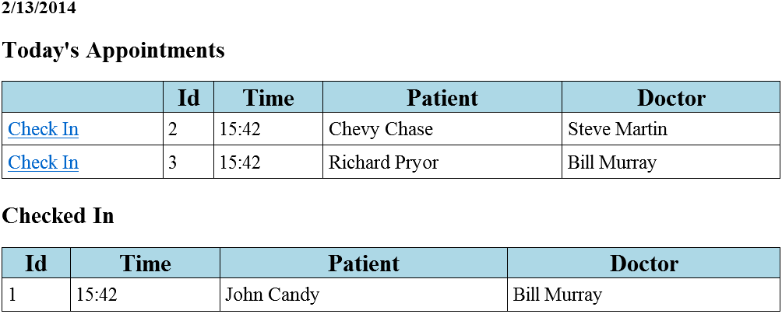

## **Take Project for a Spin**

To test the project you will need to:

**Database:**

1. Attach the **HealthcareDB** to an instance of SQL server, or run the **HealthcareDB_SetupScript.sql** script in SQL Server Management Studio. Both are located in the **healthcare_appointment_webapp\DatabaseObjects**.

**Site:**

1. Open the site in Visual Studio from **File > Open Site**
2. Change the **web.config** file adding your SQL Server instance connection string.
   1. <add name="HealthcareDBConnectionString" connectionString="Data Source=**SLAVE_1\SQLEXPRESS**;Initial Catalog=HealthcareDB;Integrated Security=True" providerName="System.Data.SqlClient"/>
   2. In the above connection string you can change the bolded **SLAVE_1\SQLEXPRESS** text to your SQL Server instance.
3. Your **web.config** will look similar to mine in the following image:

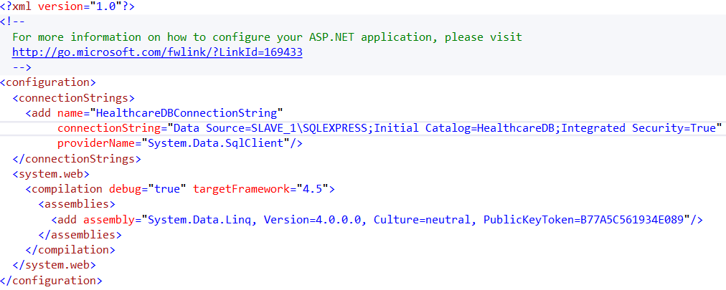

1. Now press the **f5** button to open the site in the browser of your preference.
2. Once the site is open click the **Check In** link button on a patient of your choosing.
   1. WAIT! You just texted me (Chad Phillips)
   2. I used my phone number for each contact in the database. If you would like to receive the text, in the **PhoneNumbers** table change the Doctors’ **PhoneNum** to your cell phone number, so long as you can receive texts.
   3. The doctors’ **ContactId’s** 2 (Steve Martin, the dentist in Little Shop of Horrors) and 4 (Bill Murray, Dr. Peter Venkman in Ghostbusters)