TEMPLATE
  - working
Chungil Chae
Wed, 1 April 2026
Table of contents

비정부 출연기관 패널 데이터 분석

Panel Data Analysis of Non-Government Owned Research Institutes
Updated in 2026-03-31

Citation
채충일. (준비 중). 투고 예정.

Abstract
본 연구는 한국 공공기관 패널 데이터를 활용하여 비정부 출연기관의 특성과 성과를 분석하는 패널 데이터 분석 연구입니다.

Planning

Schedule
- tba

Progress
- 초기화 단계

Authorship and Authors

Author Contribution
- Supervision: Chungil (Chad) Chae
- Project administration:
  - Chungil (Chad) Chae
- Conceptualization:
  - Chungil (Chad) Chae
- Data acquisition:
  - Chungil (Chad) Chae
- Data curation:
  - Chungil (Chad) Chae
- Formal analysis:
- Chungil (Chad) Chae
- Investigation:
  - Chungil (Chad) Chae
- Methodology:
  - Chungil (Chad) Chae
- Resources:
- Validation:
- Visualization:
- Writing – original draft:
  - Chungil (Chad) Chae
- Writing – review & editing:
  - Chungil (Chad) Chae

Authors

Chungil Chae, Ph.D., M.S.
- chadchae@gmail.com
- orcid: 000-0002-7364-1525
- Google Scholar
- Chae (2024)
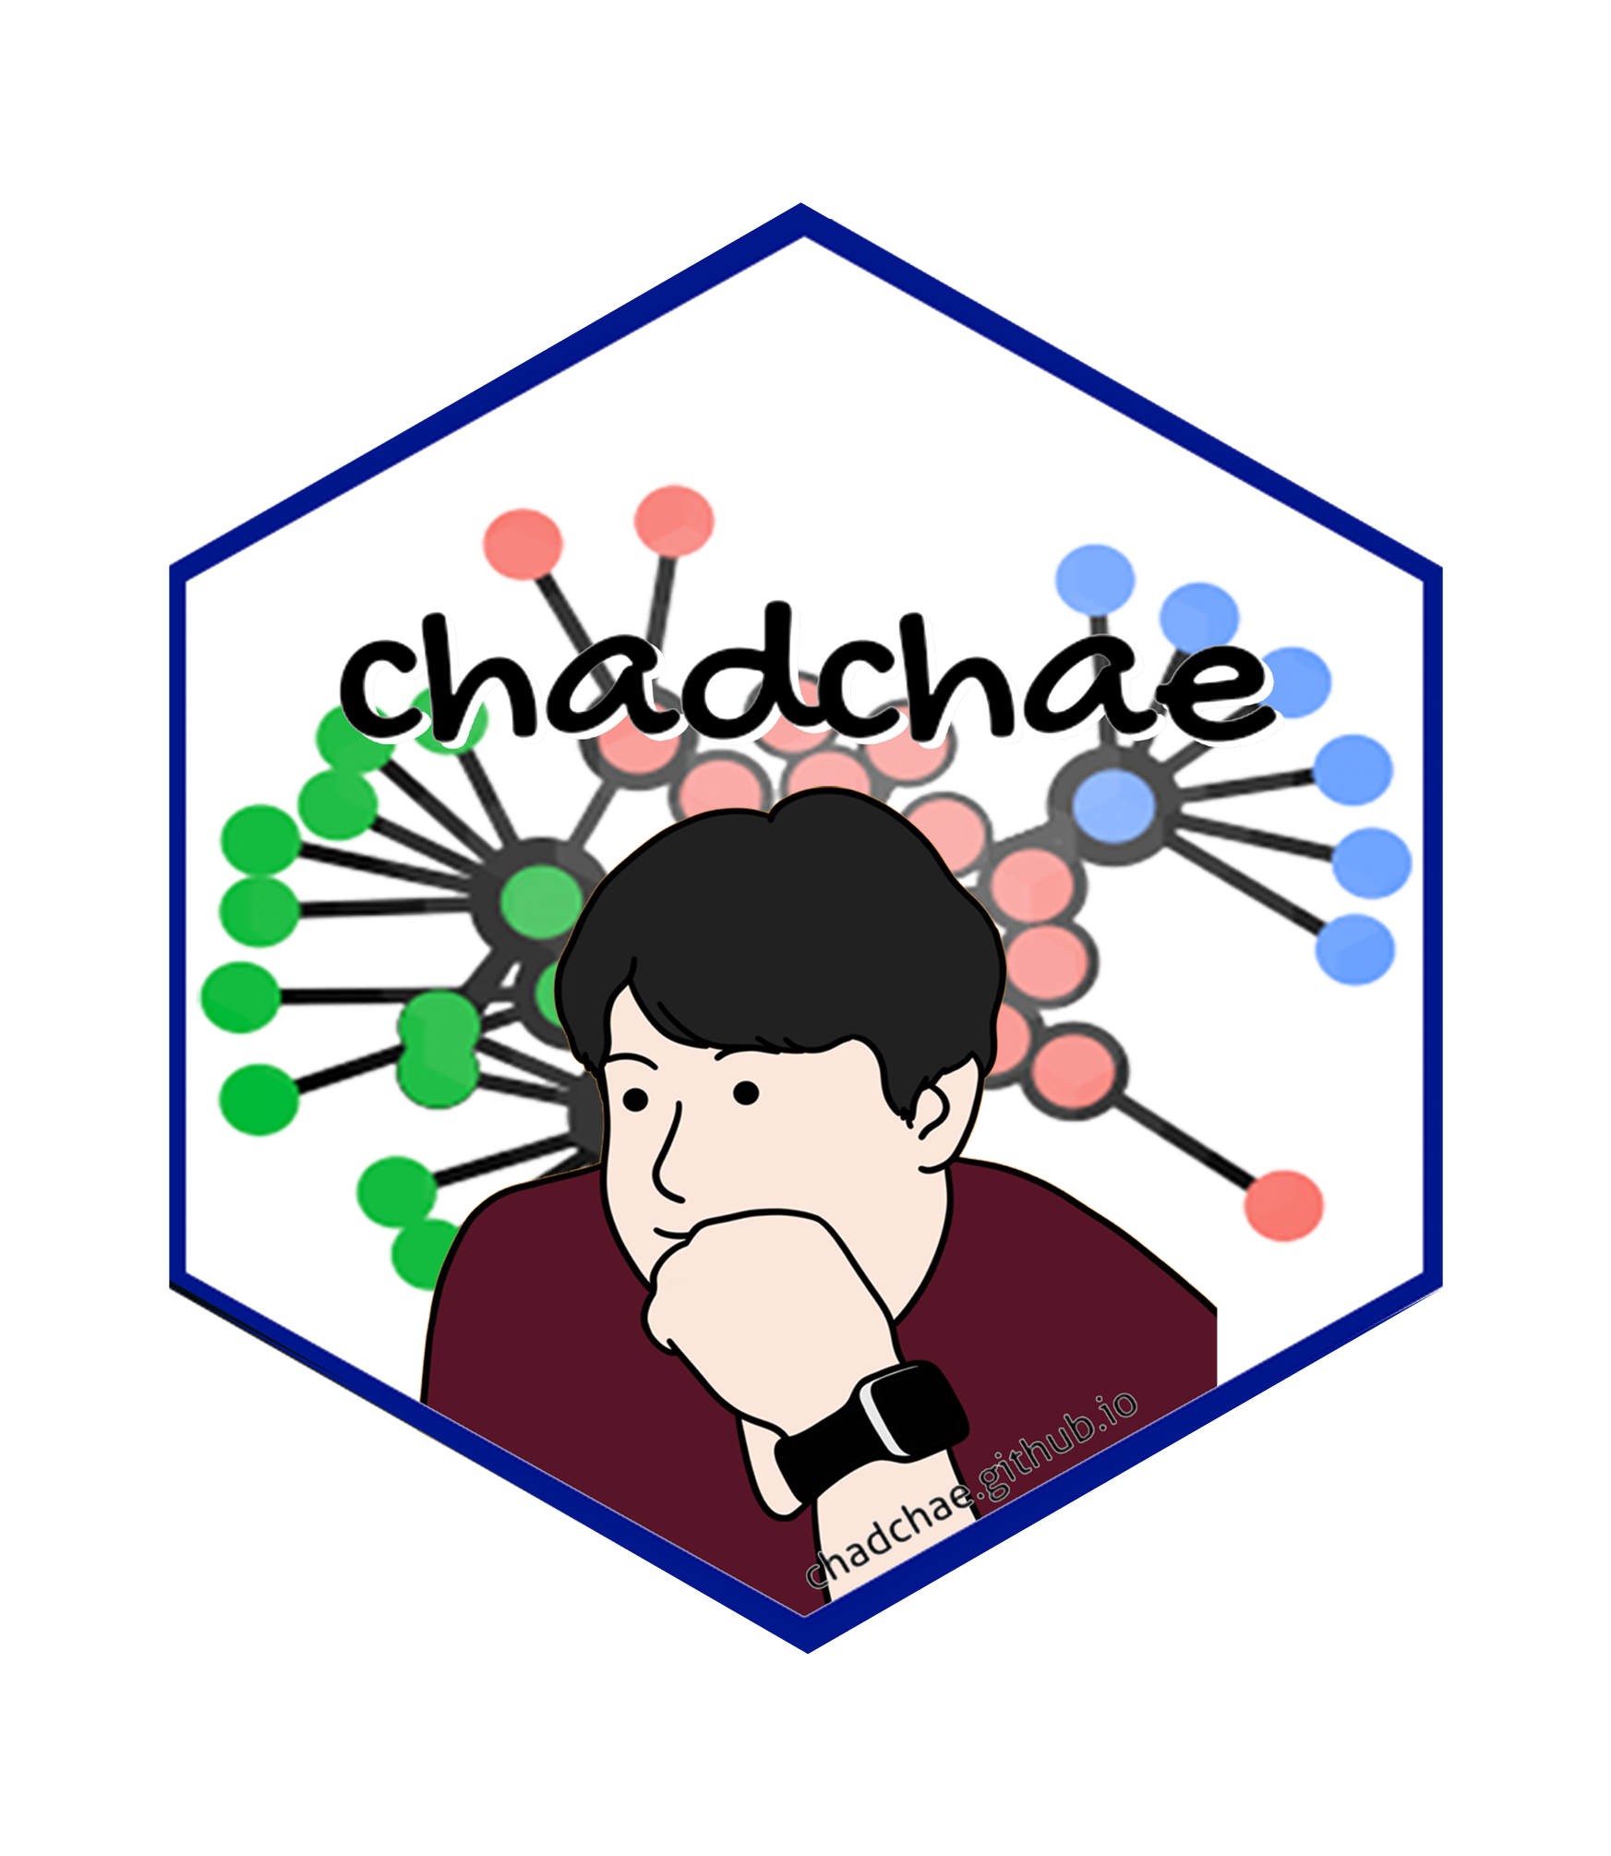
Chungil Chae Chae (2024) is an assistant professor in the field of business analytics, with a distinguished track record in organizational behavior, human resource development (HRD), learning, and development.

Acknowledgement
- tba

Declaration

IRB

Funding

AI

Research Log

xxxx-xx-xx
- entry.

Meeting Log

xxxx-xx-xx
- 10:00-10:30: Kick-off meeting

Analysis Version

Version 0.0.1
- Starting draft

Draft Version

Ver 0.0.1
- Starting draft

Ideas and Thoughts

Research Q & A

Procedures

Related Theories

Theortical Relationship

Theoritical Framework

Hypothesis

Methdology

Method

Data Collection

Data

Searching and Inclusion & Exclusion

Round 1

Search kewwords and category

keywords combination

Round 2

Search kewwords and category

keywords combination

Round 3

Search kewwords and category

keywords combination

PRISMA

Reference List
Category, Classification and Decision Note for Selected Literature in Rounds

Round 1

Round 2

Round 3

Additional (during and after writing)

Reserach Problems

Key References

Quotes and Paraphrases

Products

References
Chae, C. (2024). Introduction to chad (chungil) chae. https://chadchae.github.io

