Tourism Biblio and Topic Modeling
  - working
Chungil Chae
Wed, 1 April 2026
Table of contents

A bibliometric analysis of tourists’ experience and happiness in tourism (2000-2024)

Abstract
This study presents a bibliometric analysis of research on tourists’ experiences and happiness in tourism from 1992 to 2025. Using co-citation analysis, keyword co-occurrence, and thematic mapping, this study identifies key research themes, influential works, and emerging trends. The findings reveal four major thematic clusters: Health, Satisfaction, Perceptions, and Quality of Life, with satisfaction playing a central role in linking various subfields of tourism research. The analysis highlights a growing emphasis on well-being, digital tourism, and sustainability, along with increasing interdisciplinary and international collaborations. Future research should explore cultural variations in happiness, the influence of travel on mental resilience, and the role of digital innovations in shaping tourism experiences. This study provides a comprehensive mapping of the intellectual landscape of tourism and well-being, offering valuable insights for researchers, policymakers, and industry practitioners.

Planning

Schedule
- 2025/03/01 Submit

Progress
- 1st round revision

Authorship and Authors

Author Contribution
- Supervision: Jangwook Kwon
- Project administration:
  - Jangwook Kwon
- Conceptualization:
  - Jangwook Kwon
- Data accusation:
- Chungil (Chad) Chae
- Data curation:
- Chungil (Chad) Chae
- Formal analysis:
- Chungil (Chad) Chae
- Investigation:
  - Jangwook Kwon, Chungil (Chad) Chae
- Methodology:
  - Chungil (Chad) Chae
- Resources:
  - Jangwook Kwon, Chungil (Chad) Chae
- Validation:
  - Jangwook Kwon, Chungil (Chad) Chae
- Visualization:
  - Jangwook Kwon, Chungil (Chad) Chae
- Writing – original draft:
  - Jangwook Kwon, Chungil (Chad) Chae
- Writing – review & editing:
  - Jangwook Kwon, Chungil (Chad) Chae

Authors

Jangwook Kwon
- jwkwon@dongseo.ac.kr
- orcid: 000-0000-0000-0000
- Google Scholar
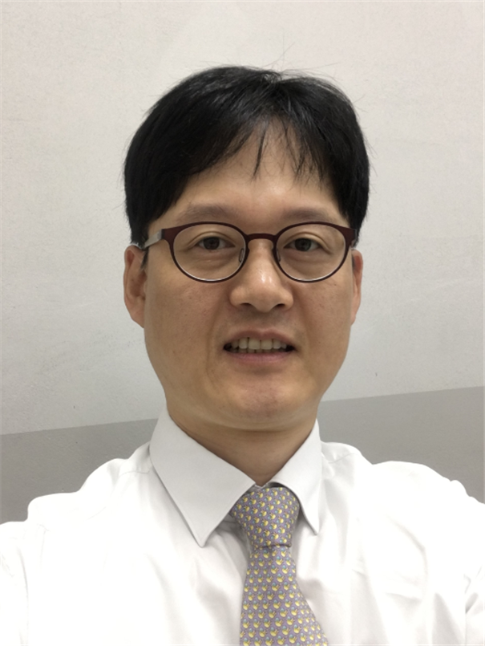
Jangwook Kwon is a distinguished academic and professional in the field of tourism, with expertise spanning tourism studies, brand marketing, and MICE (Meetings, Incentives, Conferences, and Exhibitions). He holds a Ph.D. in Tourism from Hanyang University, an MBA from Keio University, and a degree in Public Administration from Hankuk University of Foreign Studies. Dr. Kwon has a diverse and impactful career, having previously worked at the Korea Tourism Organization in various roles, including in the Brand Marketing Team, Tokyo Office, and Human Resources Development Team. He is currently serving as a board member of the MICE Tourism Association, a consultant for the Korea Tourism Organization’s Tourism Plus TIPS program, and holds several advisory roles in local tourism organizations, including the Busan Metropolitan City Tourism Development Committee and the Ulsan Tourism Foundation. His research interests focus on areas such as the impacts of tourism on local economies, the role of technology in tourism, and consumer behavior within the tourism industry. Dr. Kwon has published numerous articles in reputable journals and has contributed to various research projects aimed at advancing tourism policy and strategy. He has also been recognized with several prestigious awards, including the Minister of Culture, Sports and Tourism Citation and Best Paper awards. In addition to his academic and professional roles, Dr. Kwon is a published author, having written books such as The Hidden Secrets of Travel: Serendipity and Uncertainty and Practical Strategies for Using Tourism Data, both of which have been widely recognized in the tourism community.

Hoon Lee
- kenpoet@naver.com
- orcid: 000-0000-0000-0000
- Devision of Tourism, Hanyang University, Seoul, South Korea
- Google Scholar
Hoon Lee is a professor at Hanyang university in Seoul, Korea. He is the head of the Hanyang Tourism Research Institute, and has advised on tourism policy of Seoul and Korea national tourism organization(KNTO). His current research interests are happiness in tourism, fair & sustainable tourism, and tourism content development.

Chungil Chae, Ph.D., M.S. Corresponding Author
- chadchae@gmail.com
- orcid: 000-0002-7364-1525
- Google Scholar
- Chae (2024)
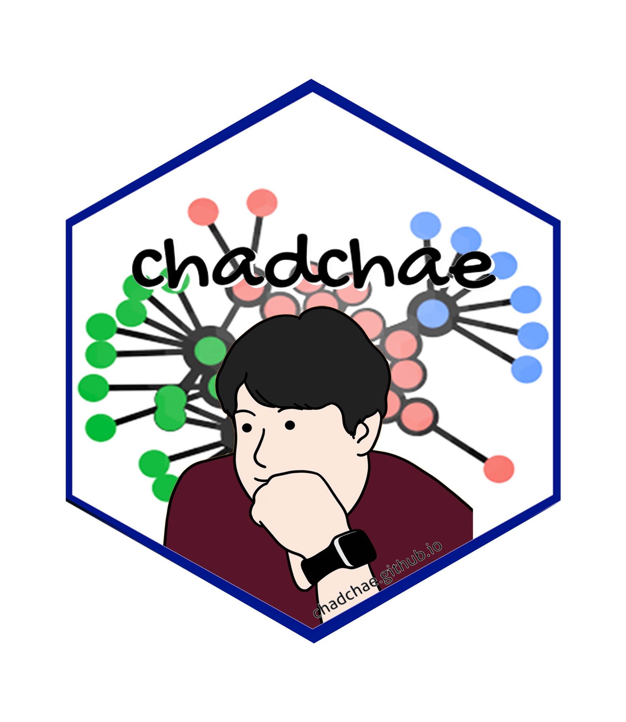
Chungil Chae (Chad), Ph.D., is an Assistant Professor in Business Analytics at Wenzhou-Kean University, specializing in data analytics, human resource development, and knowledge-sharing in multinational organizations. With a Ph.D. from Pennsylvania State University, his research integrates business intelligence, workforce education, and computational social science. Dr. Chae has an extensive publication record in top-tier journals and has received multiple academic awards, including the Outstanding Paper in the Emerald Literati Awards. He has held positions as a post-doctoral scholar at Penn State and has contributed to various funded research projects in cognitive science and business analytics. His expertise extends to teaching business analytics, data mining, and management courses while actively engaging in curriculum development and academic service.

Acknowledgement
- The authors sincerely appreciate the contributions of the following individuals to this manuscript. Danny, Diane, Jason, and Joanna assisted with proofreading, while Owen and Vilchega contributed to data collection. Bruce provided valuable support in the literature investigation. Their efforts and dedication have enhanced the quality and integrity of this work, and we extend our heartfelt gratitude for their assistance.

Declearation

IRB
- Data collected from public database and not involved with any critical human subject, therefore, not a subject of IRB review.

Conflict of Interest
- No conflicts of intests to disclose.

Funding
- No Specific funding was received for this reserach.

AI
- Generative AI has used for proof reading and revision stage for enhancing quality and clearity of language.

Research Log

xxxx-xx-xx
- entry.

Meeting Log

xxxx-xx-xx
- 10:00-10:30: Kick-off meeting

Analysis Version

Version 0.0.1
- Starting draft

Draft Version

Ver 0.0.1
- Starting draft

Ideas and Thoughts

Research Q & A

Procedures

Related Theories

Theortical Relationship

Theoritical Framework

Hypothesis

Methdology

Method

Data Collection

Data

Searching and Inclusion & Exclusion

Round 1

Search kewwords and category

keywords combination

Round 2

Search kewwords and category

keywords combination

Round 3

Search kewwords and category

keywords combination

PRISMA

Reference List
Category, Classification and Decision Note for Selected Literature in Rounds

Round 1

Round 2

Round 3

Additional (during and after writing)

Reserach Problems

Key References

Quotes and Paraphrases

Products

References
Chae, C. (2024). Introduction to chad (chungil) chae. https://chadchae.github.io

