OPTO
Operational manual for Topspin

UW-Madison

Version 1.2.34
Drafted on Nov 6th , 2025

Table of Contents

1. Introduction: 3
2. Installation Guide: 3
3. Adding Shortcuts for OPTO: 3
4. Initial Setup: 4
4.1 Selecting the region if interest for the integration: 4
4.2 Shape Optimization for Cross Polarization with OPTO: 5
5. Opening OPTO in TOPSPIN: 7
5.1 Troubleshooting OPTO start-up issues: 7
6. Closing OPTO in TOPSPIN: 8
7. Accessing OPTO Settings: 9
8. OPTO Capabilities and Settings: 9
9. Running OPTO for Shimming: 11
10. Running OPTO for Magic Angle Setting: 12
11. Running OPTO for CP: 13

1. Introduction:
This manual is included with the installer and can be found in the unzipped folder under the file name "opto-help.pdf". After successful installation, this manual can be accessed by pressing the 'Help' button located under the OPTO tabs within TOPSPIN. The manual provides a comprehensive guide to all OPTO settings and capabilities, including an example run to demonstrate how OPTO can be utilized for TOPSPIN.
For the latest version of OPTO for Topspin, go to https://git.doit.wisc.edu/nmrfam-public/opto-releases/-/blob/main/README-TOPSPIN.md

2. Installation Guide:
- Download the most recent opto-topspin.zip file from Barry for now.
- Launch a terminal.
- Use the cd <directory-path> command to navigate to the directory that contains opto-topspin.zip.
- Execute the unzip opto-topspin.zip command to extract the opto-topspin.zip file.
- Switch to the directory that was just extracted.
- Install opto by running the sudo ./install.sh <topspin-version> command.
  - For instance: sudo ./install.sh topspin3.6.2
- To uninstall OPTO run sudo ./uninstall.sh <topspin-version>

3. Adding Shortcuts for OPTO:
- Launch the TOPSPIN software.
- Right-click on the empty space on the Tabs section as shown below.
  - 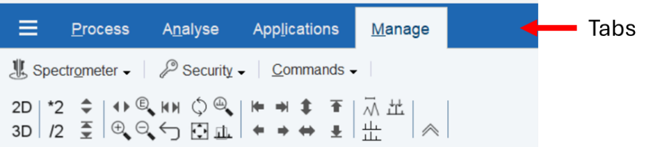
- Choose ‘Add new Tab’.
- Input the following:
Tab ID: OPTO, Tab Text: Opto, Flowbar File: opto.prop
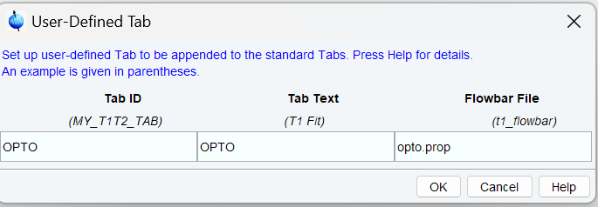
Figure: Screen shot showing the addition of shortcut to topspin toolbar.

4. Initial Setup:
Shimming: OPTO utilizes a text file named opto-shim.dat to define the shim names, their limits, and step size. A default file is included with the installation and can be found at $topspin-home/exp/stan/nmr/lists/vd. This file can be modified by running the edlist opto-shim.dat command in the topspin command line.

4.1 Selecting the region of interest for the integration:
OPTO utilizes an integration file opto-intrng to calculate the total area of a specified region. To save a region of interest:
- Acquire a 1D spectrum.
- Access the integration module by entering .int
- Clear any existing integral regions.
- Define the region of interest.
- Click on Export integration regions
- Save the file to an opto-intrng file by clicking the Write New button if it is first time or double click on the opto-intrng to re-write the existing file. Make sure that the File location is selected as default topspin folder example: “/opto/topspin4.4.0/exp/stan/nmr/lists/intrng”
- If region of interest needs to be changed then re do the steps (c) to (f).
This process ensures the region of interest is saved to the opto-intrng file. Note that OPTO reads full spectral width by default if no opto-intrng file exists. If multiple regions are stored in the opto-intrng file, OPTO only processes the first region. It will show the following message in the topspin terminal if these is not opto-intrng file exists.
No opto-intrng file found!!!!! using the full spectra width for integration!!!!!! save the opto-intrng file to select the region for intergration

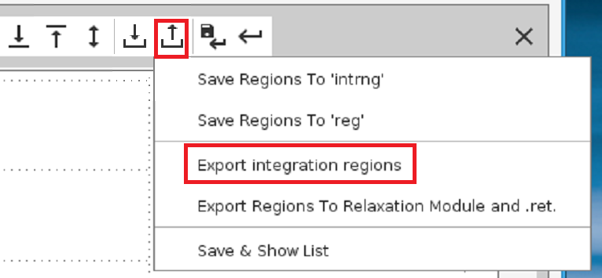
Figure 2: Screen shot showing the method to save opto-intrng file with the selected region of interest for the integration.

4.2 Shape Optimization for Cross Polarization with OPTO:
OPTO can optimize the shape parameters for a given Ramp on selected nuclei. Ramp shapes are defined by two key parameters: BETA and DELTA.
4.2.1 Definition of Variables and Conventions:
- BETA: Influences the overall amplitude and the steepness of the modulation curve.
- DELTA: Affects the angular coefficient in the tangent function, influencing the curvature of the modulation profile.
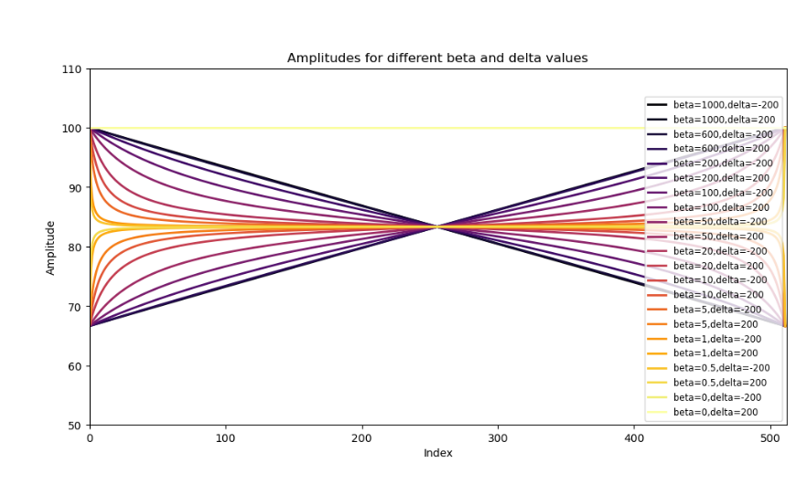
Figure: Tangential ramp shapes with different BETA and DELTA values
    - Index Number: Each pair of BETA and DELTA parameters is assigned an index number (e.g., BETA 1 / DELTA 1, BETA 2 / DELTA 2).
The index number must correspond to the SPNAM number in the pulse sequence being optimized. For example, if the ramp shape to be optimized is SPNAM41, then the corresponding parameters should be named BETA41 and DELTA41.
This ensures that multiple shapes can be modulated within the same pulse program during a single optimization run.

    - Naming Convention: Each tangent ramp shape requires both BETA and DELTA values, defined with their respective index numbers, in the parameter file.
For instance, BETA41 and DELTA41 will generate a shape file named tan-shape-opto-41 in the user directory:$TOPSPIN_HOME/exp/stan/nmr/lists/wave/user This shape is automatically loaded into SPNAM41 as temp file during the optimization. By changing the index numbers in the BETA and DELTA names, any number of shapes can be created.
    - Saving the Shape File: Upon successful completion of the optimization run, OPTO saves the final optimized shape file named tan-shape-opto-x-beta_y-delta_z, where x is the index number, and y and z represent the corresponding BETA and DELTA values, respectively and automatically loads this shape to conduct further experiments.
    - After a successful optimization run, OPTO saves the final optimized shape as: tan-shape-opto-x-beta_y-delta_z, where x is the index number, and y and z are the corresponding BETA and DELTA values. The optimized shape is automatically loaded for subsequent experiments.

5. Opening OPTO in TOPSPIN:
- To open OPTO, click on the 'open-opto' button. This will open OPTO GUI.
- If you are using Topspin version 3.6 or later, you must start Topspin from the terminal to view the OPTO output, as it is displayed only in the Topspin terminal window.
Note: If an error message appears in the TOPSPIN window (see figure below), TOPSPIN must be restarted before starting OPTO. This is necessary if the previous session of OPTO was not closed properly (see below).
5.1 Troubleshooting OPTO start-up issues: If the following message appears while starting OPTO, click on the 'Details' button to see more information.
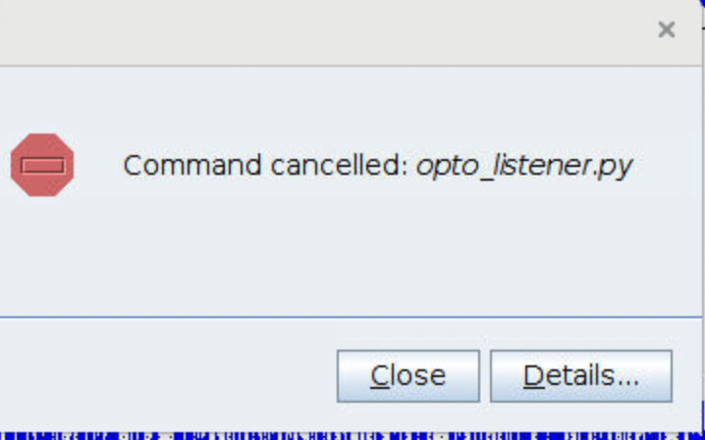
If this message appears, it may indicates that OPTO was not properly closed from the previous session. Click on Details.
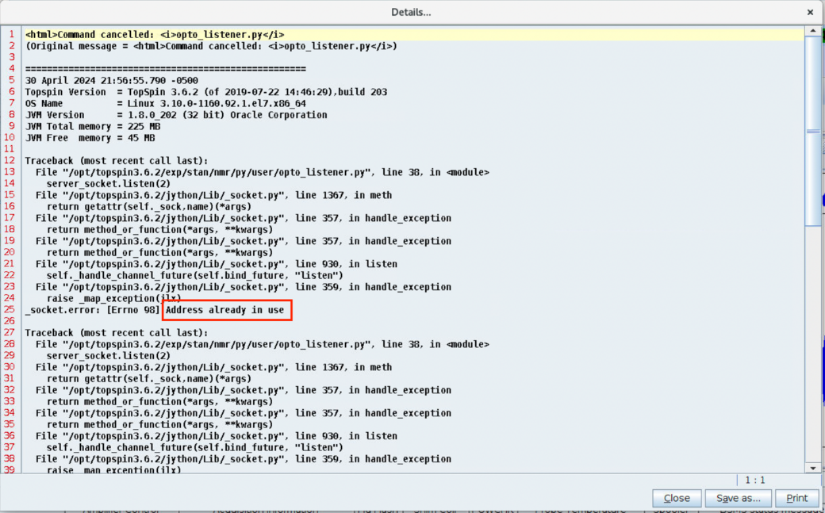
After clicking on details if you see the above message, In this case TOPSPIN software needs to be restarted.

6. Closing OPTO in TOPSPIN:
- To close OPTO, Click on close-opto in the OPTO tab from the topspin
- OPTO can also be opened by typing the command open-opto in the TOPSPIN command line and closed with the command close-opto.
- When executing the close-opto command, the TOPSPIN terminal should display the message "Closing server socket….." If this message does not appear in the terminal window, TOPSPIN needs to be restarted before starting another OPTO session.
NOTE: It is strongly recommended to click on close-opto before starting a new OPTO session to ensure that any previous session is properly terminated.
6.1 Additional Information:
- OPTO is only usable with one-dimensional spectra. It can be started when an active 1D dataset is open, and this dataset will remain active for the entire session until the close-opto command is executed or the 'close-opto' button is pressed.
- This action will close the communication socket, and closes the OPTO GUI allowing a new session of OPTO to be opened on the same or a different dataset as needed.
- If the same session continues, OPTO will always use the initial dataset from which it was opened, and all displayed FID/Linewidth/intarea plots are saved per session. For a given session, OPTO will plot the relative intensity/FID plots for all the runs executed within that session.
- If the session is closed using close-opto, the session will be cleared.

7. Accessing OPTO Settings:
- OPTO settings can be accessed by clicking on the 'OPTO-settings' button or by executing the opto-settings command in the TOPSPIN command window.
- This action opens a window to choose settings as described below.
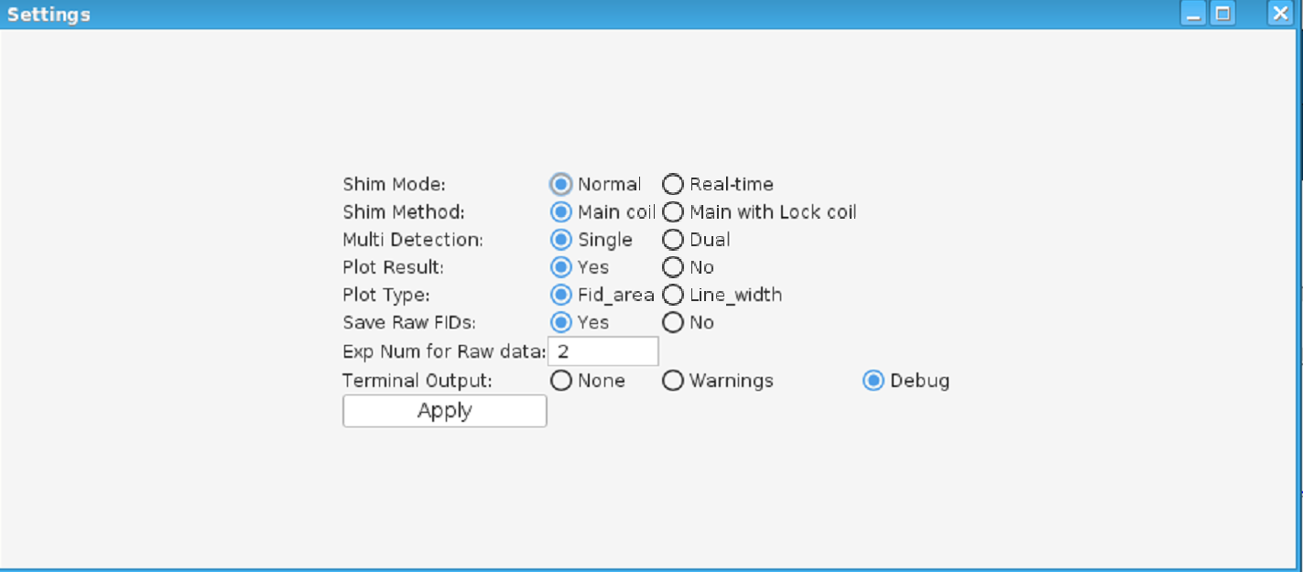
Figure: OPTO settings window showing various functionalities and their selection

8. OPTO Capabilities and Settings:
8.1 Shim Mode:
- Normal:
  - In this mode, OPTO runs the active experiment with a specified number of scans and proceeds only after the experiment is complete before starting the next experiment. This mode is recommended for samples with low signal-to-noise ratio (SNR) for shimming.
- Real-time:
  - In this mode, OPTO reads the Free Induction Decay (FID) after each scan without reloading all parameters, similar to the 'gs' mode in TOPSPIN. High SNR samples are required for this mode as it uses just one scan to read the FID.
8.2 Instructions to Set Up Shimming in Real-Time Mode:
- Load the pulse sequence opto-realtime-hpdec (provided and placed in $topspin-dir/exp/stan/nmr/pp/user).
- Adjust parameters as necessary.
- Set the number of scans to 32.
- Start the experiment with the zg command.
- Use the tr command to transfer the data.
- After a few scans, use the tr command again.
- Observe that the spectral intensity should remain consistent.
- Open the 'OPTO-settings' window.
- Select 'Shim Mode: Real-time'.
- Click the 'Apply' button and confirm in the next window.
Note: Real-time shim mode will begin the acquisition with a very large number of scans (e.g., 100,000) and will display a lengthy experiment time. After the OPTO run finishes, it will stop automatically. Any 1D experiment can be converted into real-time mode. This requires modification to the pulse sequence. Please contact NMRFAM for any questions on how to modify your pulse sequence for real-time mode.
8.3 Shim Methods:
- Main Coil:
  - Designed to shim using one coil (typical configuration).
- Main Coil with Lock Coil: (Under Development)
  - This method is intended to shim two coils simultaneously if the probe features a main coil and a separate lock coil.
Instructions for Setting Dual Coil Shim (Under Development)
- Run an experiment to collect the signal from the main coil (e.g., 13C signal from adamantane).
- Run another experiment to collect the 2H spectra.
- In the 'OPTO-settings' window, select 'Main Coil with Lock'.
- Enter the experiment number for the lock coil.
- Enter a scaling factor if different from the default.
- Click 'Apply'.
8.4 Multi-Detection (Under Development):
- This setting allows for either single or dual detection; however, it is currently inactive and the manual is still under construction.
8.5 Plotting Results:
- OPTO plots results in the TOPSPIN window. Users can choose between plotting FID area or linewidth for shimming purposes.
- For parameter optimization, OPTO will plot the integrated intensity only.
8.6 Saving Raw FIDs:
- If enabled, you will be prompted to enter the experiment number to save the raw FID.
Instructions for Saving Raw FIDs:
- Copy the current active experiment to a new another experiment by typing the edc command in the TOPSPIN terminal.
- Convert this 1D dataset into a 2D dataset by clicking on the 2D icon in the AquaPar parameter window(eda).
- With the 2D dataset active, type 1S TD and enter 1024 or a larger number in the indirect dimension based on the number of FIDs you want to save. Here the status parameter needs to be changed to a larger number to save more FIDs into the file.
- Enter the newly created number into the raw Fid save exp number window
Note: If real-time mode shimming is selected, no raw data will be saved.
8.7 Terminal Output:
- Debug: Select this option to display all communications between OPTO and TopSpin, along with the detailed OPTO logs.
- Warnings: Displays only warnings and OPTO logs.
- None: Displays only OPTO logs.
NOTE: OPTO settings such as plotting results or debug mode can be modified in real time while OPTO is running. This feature is useful if you wish to temporarily stop plotting or enable debug output for a short period during the OPTO. To adjust these options, open Settings, make the desired changes, and click OK. The updated settings will take effect at the next evaluation point.
Warning!! Only the plotting and terminal output settings should be changed during an active OPTO run. Modifying any other settings while OPTO is running may lead to unexpected behavior or errors.

9. Running OPTO for Shimming:
Prerequisites: Have a valid opto-shim and, standard sample loaded and MA adjusted, initial spectra is acquired.
  - Open the experiment and acquire a initial spectrum.
  - Click on opto-settings button or type opto-settings in the topspin command line
  - Select the settings as required, leave them as it is for default settings and click apply.
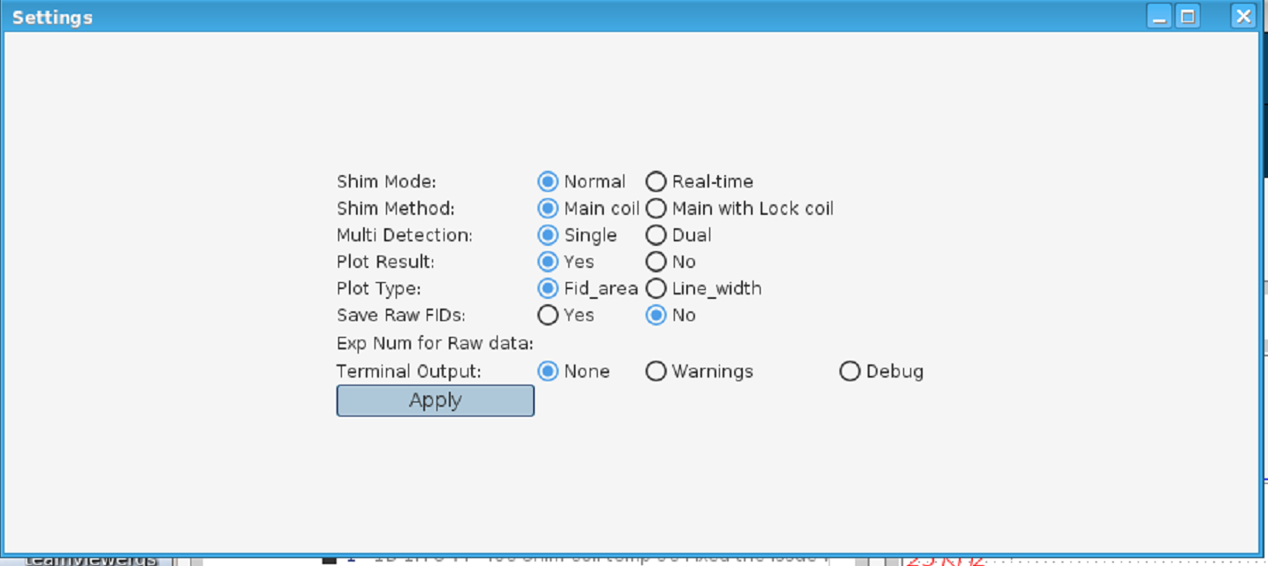

  - Click on the open-opto button or type open-opto .
  - At this point, the OPTO-window will appear
  - Click on New
  - Click on load shims, this will load all the shims that were given in opto-shim file
  - Click OK
  - Click on add pass
  - In pass 1 select the first order shims (x1, y1, z1). Click on add pass and enter number 2, this will create pass 2
  - In pass 2 select the second order shims (xy, xz, yz, z2, x2y2). ). Click on add pass and enter number 3, this will create pass 3

  - In pass 3 select the third order shims (x3, y3, z3, xz2, yz2, zxy, zx2y2).
  - Change the Range to 10, and CoV tol to 0.01 Max time to 3o or any resoanble time for experiment.
  - Save the job by clicking on the save button
  - Click Run job.
  - This will start running the job, and the results will be plotted with in the topspin window and can also be seen on the topspin terminal.
  - Additionally user can choose between FID_area vs linewidth to plot in topspin to plot the results.
  - For additional improvements to the shimming, run the above passes 1-3 twice more after they have converged with setting the acquisition time to 200 ms for the first replicate, and then set the acquisition time to 400 ms for the last replicate.

10. Running OPTO for Magic Angle Setting:
- Prepare the Sample:
  - Insert a standard sample suitable for setting the magic angle, such as KBr. Spin the sample to anticipated speed. Load previously acquired 1D spectrum and acquire a initial spectra. Create new experiment (edc). This methos is useful if you have high SNR sample. In case of the low SNR samples it is recommend to use the normal method.
- Load the Pulse Program:
  - Load the opto-realtime-hpdec pulse program.
- Set Nucleus and Parameters:
  - Change the observed nucleus to 79Br.
  - Enter the necessary power levels and pulse widths.
  - Set the decoupling power (PLW12) to 0.
- Adjust OPTO Settings:
  - Open the opto settings by clicking on settings button in the Opto tab and select 'Real-time' in the shim mode section.
  - Choose the FID_area to plot.
  - Click on 'Apply'.
- Start OPTO:
  - Open OPTO by clicking on the 'open-opto' button.
  - Start the acquisition when prompted by clicking 'OK'.
  - Click on new
  - Claick on Add Row
  - Enter a dummy parameter like D59 and values likes 1 to 1000. Here we using D59 as dummy parameter, can be changed to any other unused parameter if needed.
- Optimize Parameters
  - Click on add pass
  - Select 'Grid' and 'D59' to optimize.
  - Select integration to Time
  - Click on 'Run job'.
  - Change the number of steps to 5000 and click 'OK'.
- Monitor and Adjust:
  - OPTO will start and display a plot of the FID area in the TOPSPIN window, updating the intensity with every scan.
  - Adjust the magic angle according to the probe hardware instructions to maximize the intensity of the FID area.
- Complete the Process:
  - Once maximum intensity is reached, click on 'Abort nicely' to stop the process. This will end the OPTO job and stops the experiment.
  - Click OK on the opto complete message
  - Close the OPTO window and click on the 'close-opto' button in Opto tab with in TOPSPIN.
- Verify the Setting:
  - Acquire a 1D 79Br spectrum with 64 scans to further check the magic angle setting using the default experiment used in the initial setup (step a).

11. Running OPTO for CP:
- Sample Preparation:
  - Load the sample (in this example, NAV spinning at 13.33 kHz).
- Experiment Setup:
  - Open the experiment with default parameters (for example, "cp" from the Bruker library).
- Initial Spectrum Acquisition:
  - Acquire an initial spectrum with appropriate decoupling, acquisition time, and number of scans. Here the user is expected to have a theoretical starting point get an initial CP signal. A previously optimized CP experiment can be a good starting point here.
- Select Region of Interest:
  - Select the region of interest and save the region to an opto-intrng file.
- Create the job File:
  - Click on the open-opto button or type open-opto .
  - At this point, the OPTO-window will appear
  - Click on New
  - Click on Add Row
  - Enter parameter name (Example cnst41), nickname (optional) safe min, safe max and step size.
  - Click on add row and add all the parameters that needs be optimized
  - Set BETA and DELTA: Enter the parameters names BETA 41 and DELTA 41 and min and max BETA vales ranges form 0-1000 and delta can be -1000 to 1000. The optimum values for BETA ranges form 0-500 and delta ranges from -500 to 500 for most cases. Typical step size is 10 but can be any integer values with the given range.
  - Click on OK
  - Click on add pass
  - Select the parameters such as cnsta41 cnst 31 beta 41 delta 41
  - Save the job by clicking on the save button.
  - Click on 'Run job'.
  - The results will be plotted in the TOPSPIN window as the run progresses.

