**Chadel Dowridge**

**11/18/24**

**Oracle E-Business General Ledger**

**Question #1**

**Responsibilities > System Administrator > Security > User > Define**

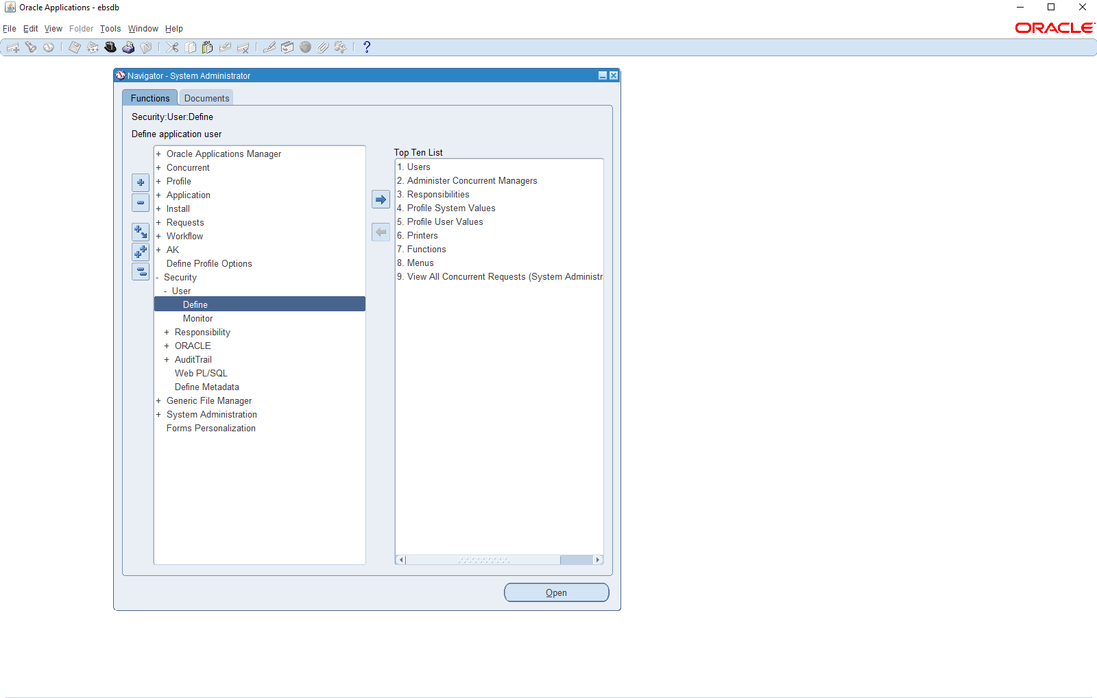

This is how you get to creating a user for EBS Oracle.

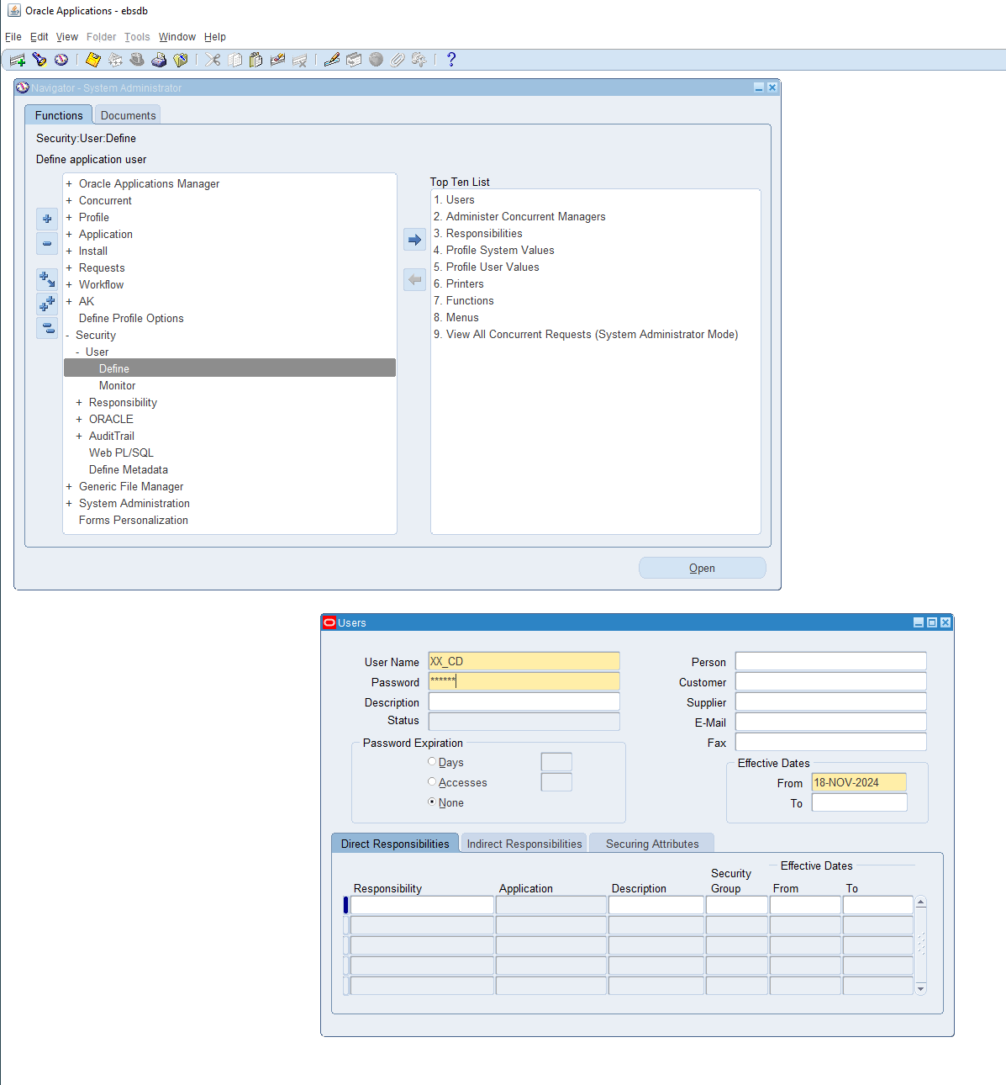

This is me showing me Creating the user my user name is **XX_CD**

**The XX is for the naming conversion and the CD are my initials**

**Question #2**

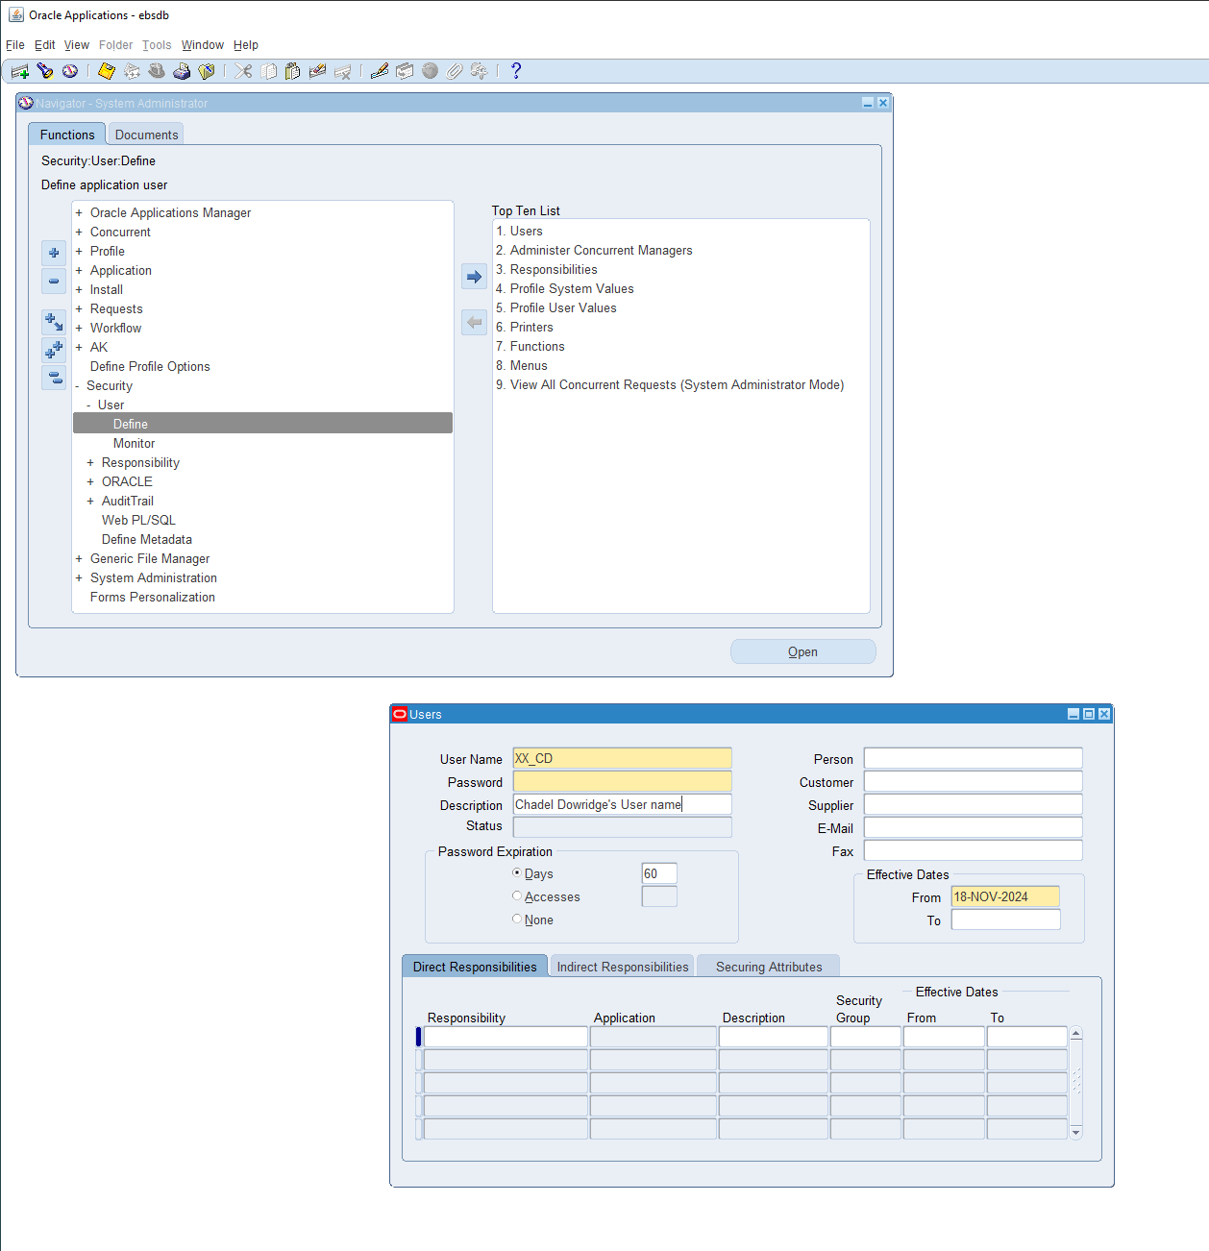

This is me adding the password Expiration to my user i just created.I have added 60 days to the expiration because that was asked for this assessment

abc123

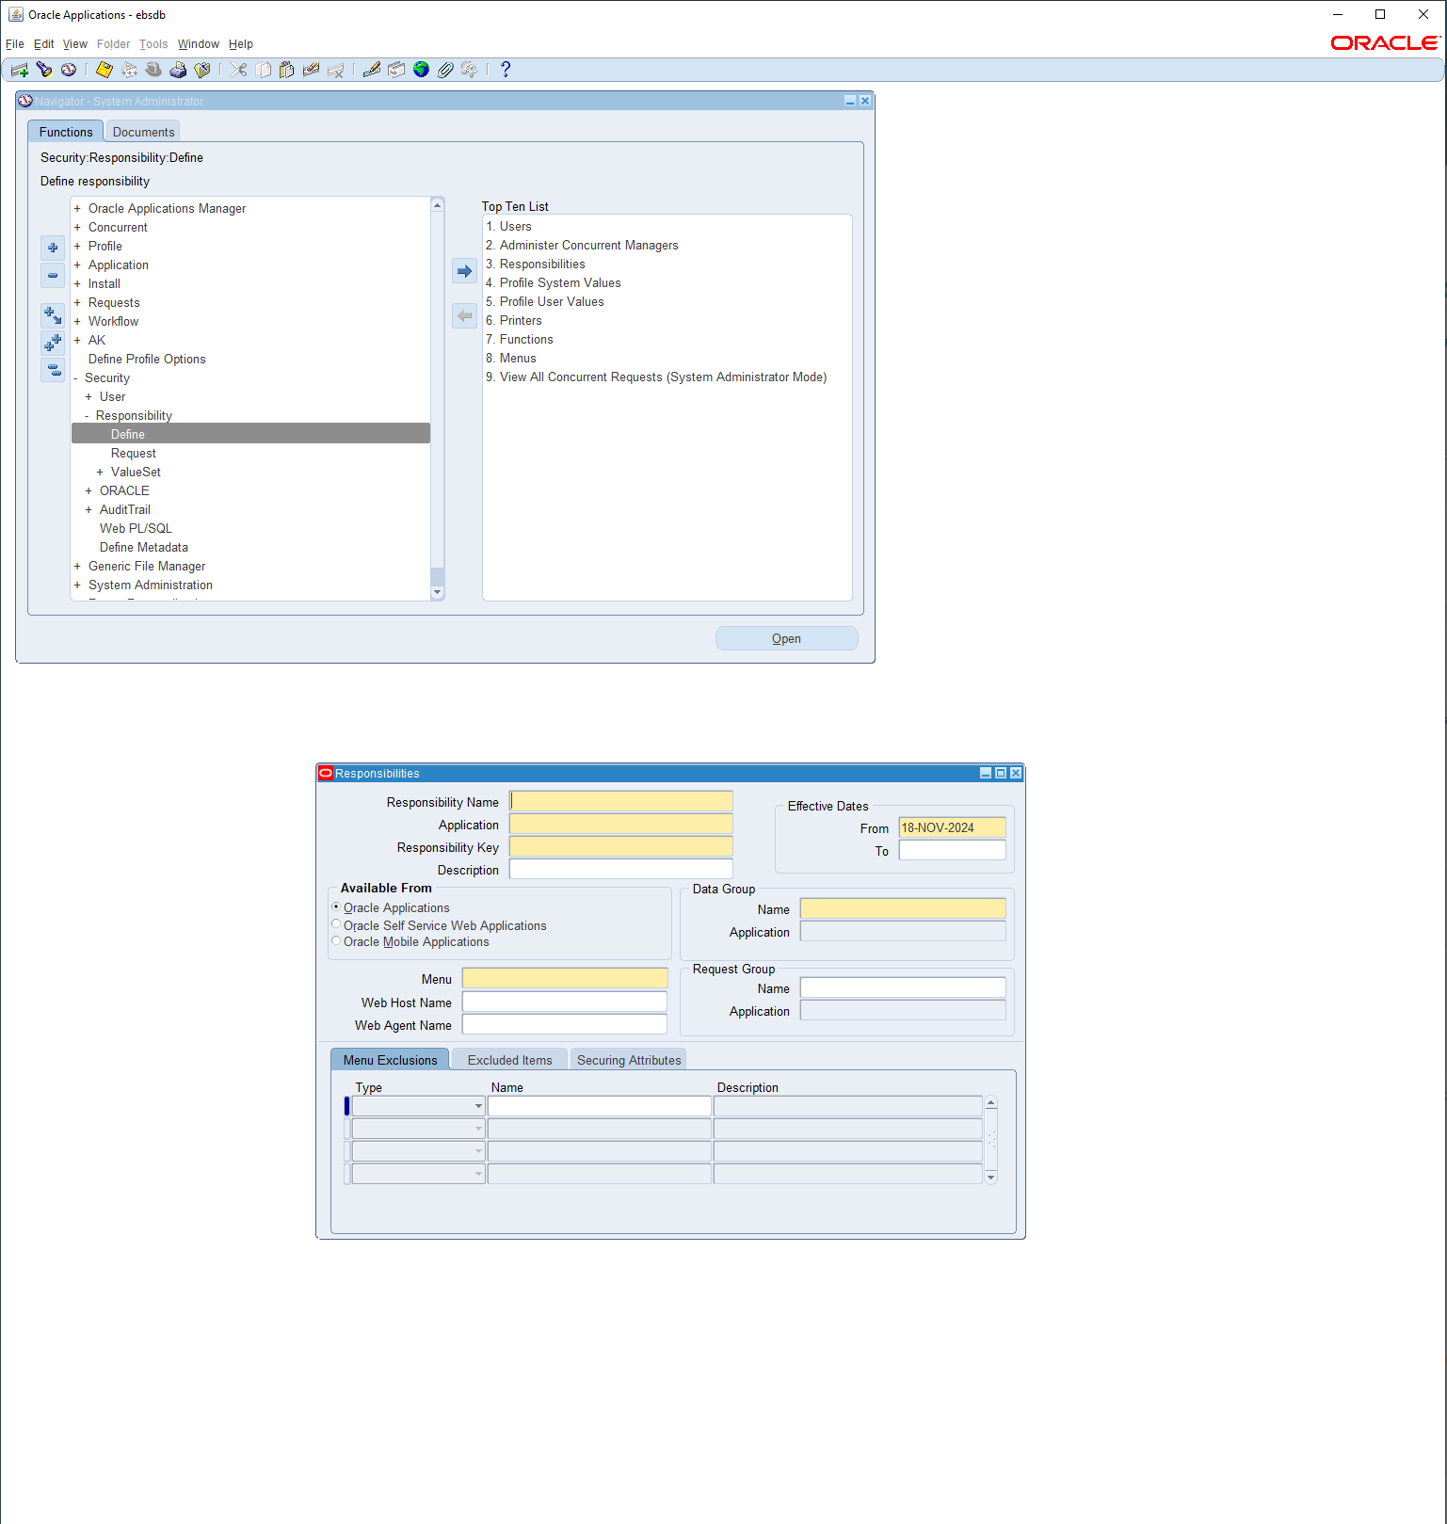

In order to set the responsibilities you have to use a path which is

**Responsibilities > System Administrator > Security > User > Define**

From there you can search each one of the responsibilities like this

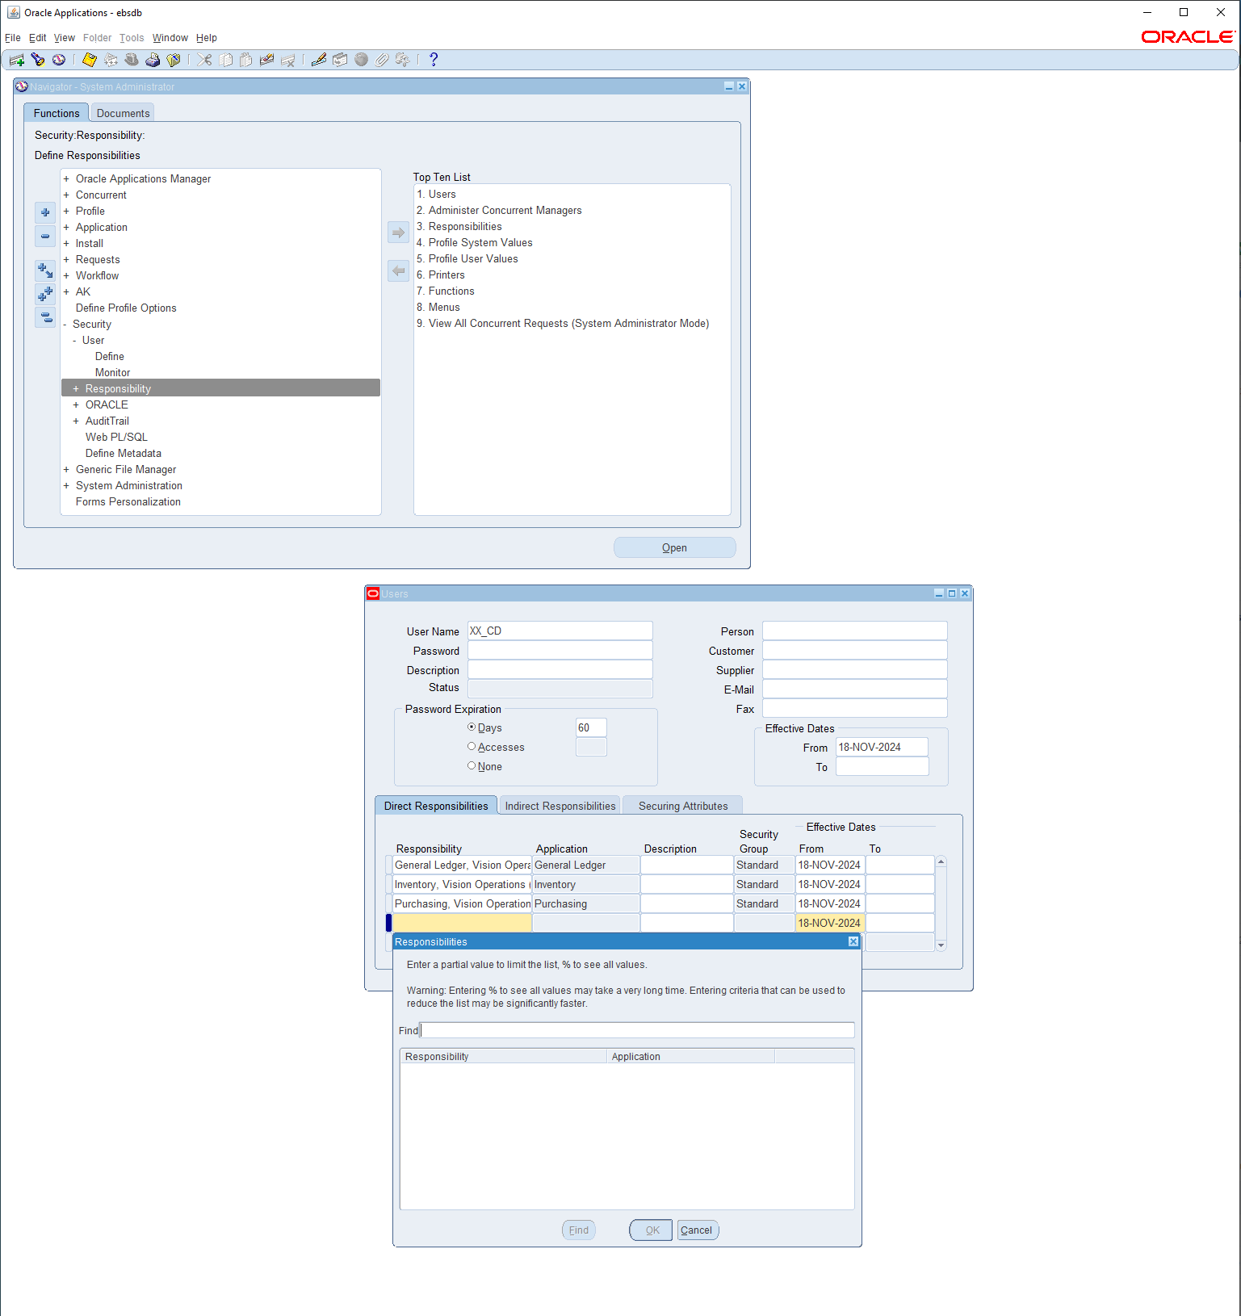

From here i added 3 assignments that was asked from the assignment given which are

* **Vision Operation General Ledger.**
* **Vision Operation Inventory**.
* **Vision Operation Procurement**

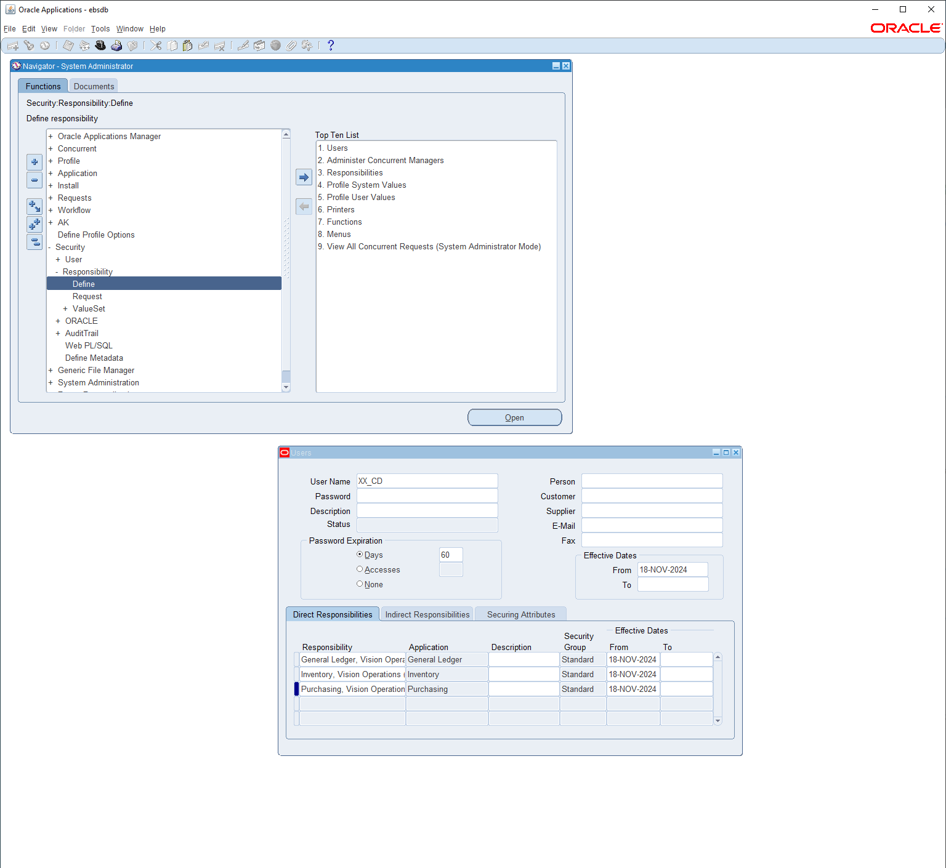

I added these responsibilities by searching for each of them using these search parameters

%Vision%Operation%General%Ledger

%Vision%Operation%inventory

%Vision%Operation%Purchasing

From here this finishes question #1 and #2 by creating a user with a username and password

For question #1 and for question 2 i added a 60 day password expiration.

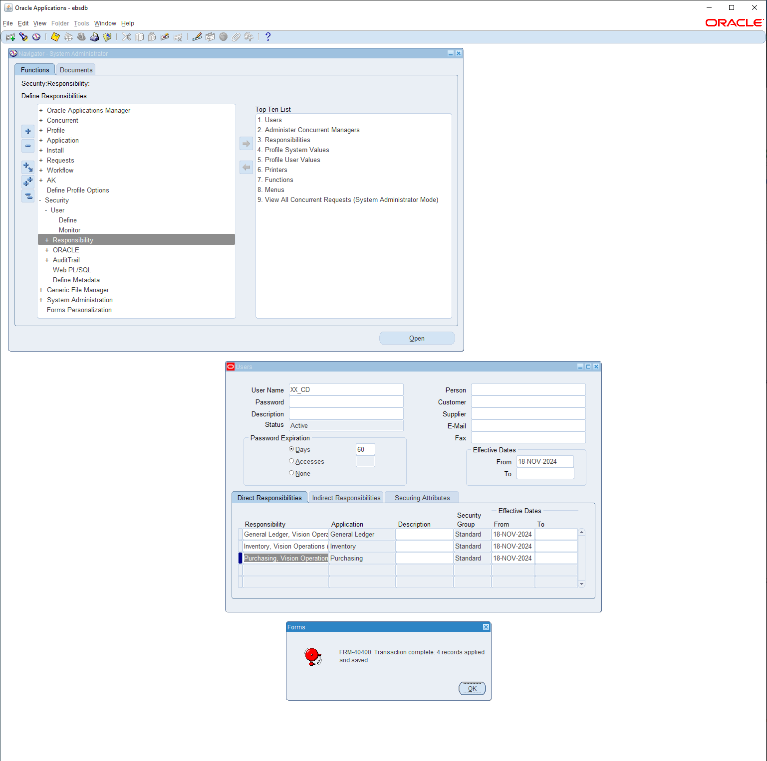

This is me closing the form saving the changes from my user creation.

Question #3

3. In **Vision Operation General Ledger** responsibility.

Form Accounting Setup Manager> Find the **Vision Operation [Primary Ledger]**

In this Ledger finds the **4C** Component, mentions the 4C name & take the screen shot as Evidence.

1. Find the Respective Calendar **Vision Operation [Primary Ledger].**

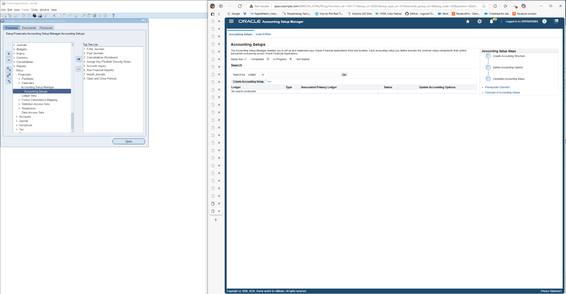

The first thing i did was follow this path which is

**Path: General Ledger>Setup>Financials>Accounting Setup Manager> Accounting Setups**

After getting to this path i continued by searching for Vision Operation [Primary Ledger] in the Search tab here

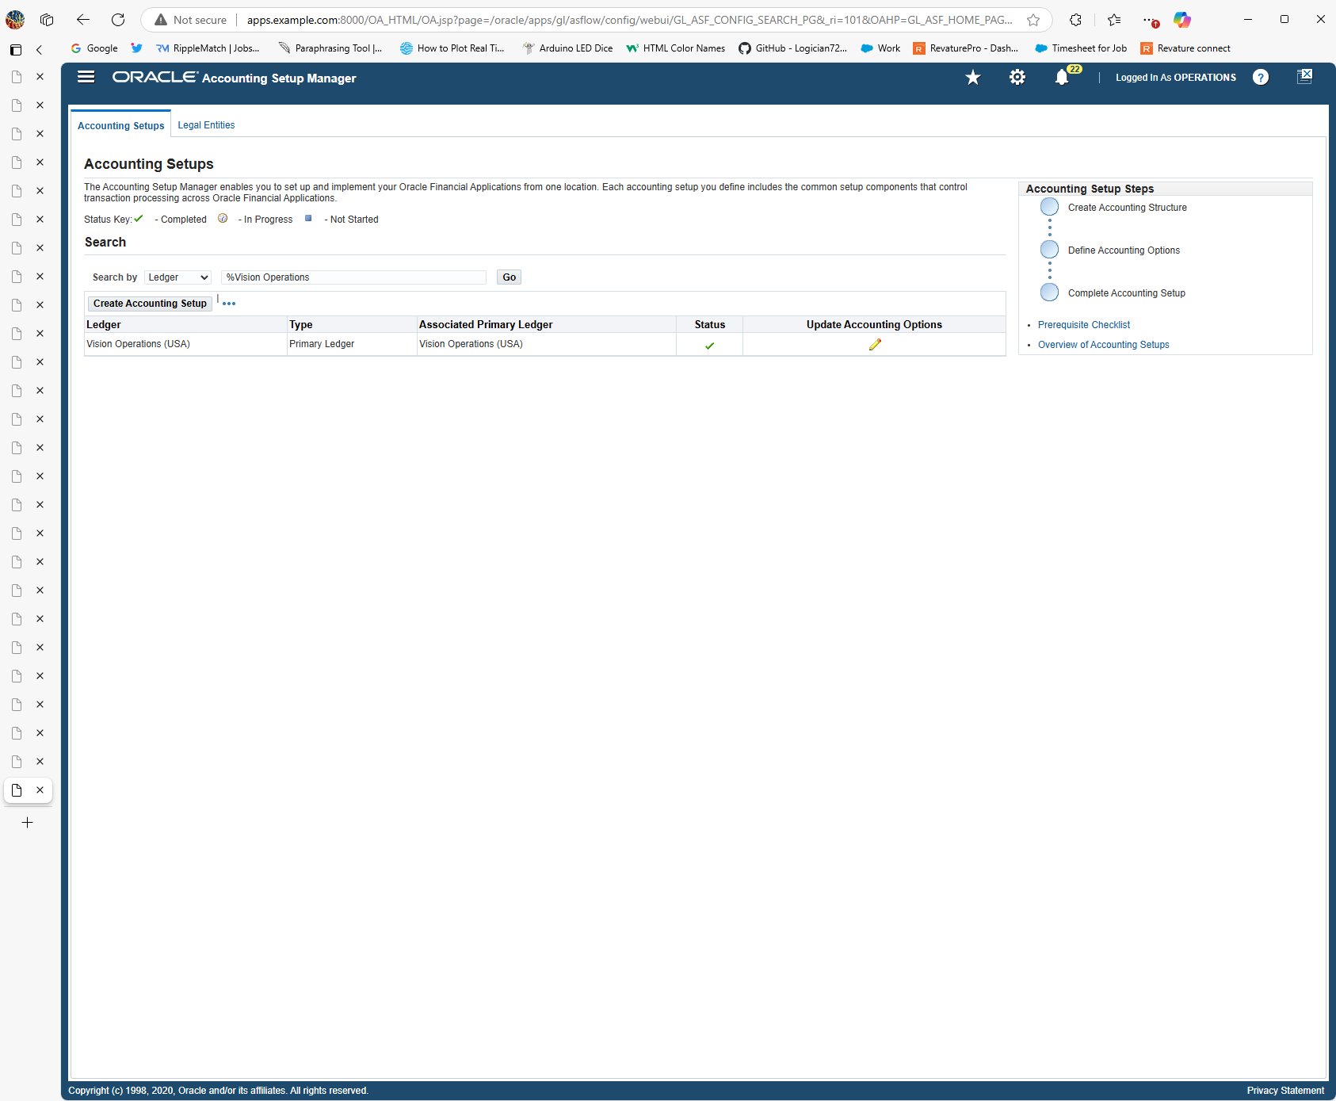

From here i clicked on the pencil to access the update the Accounting Options

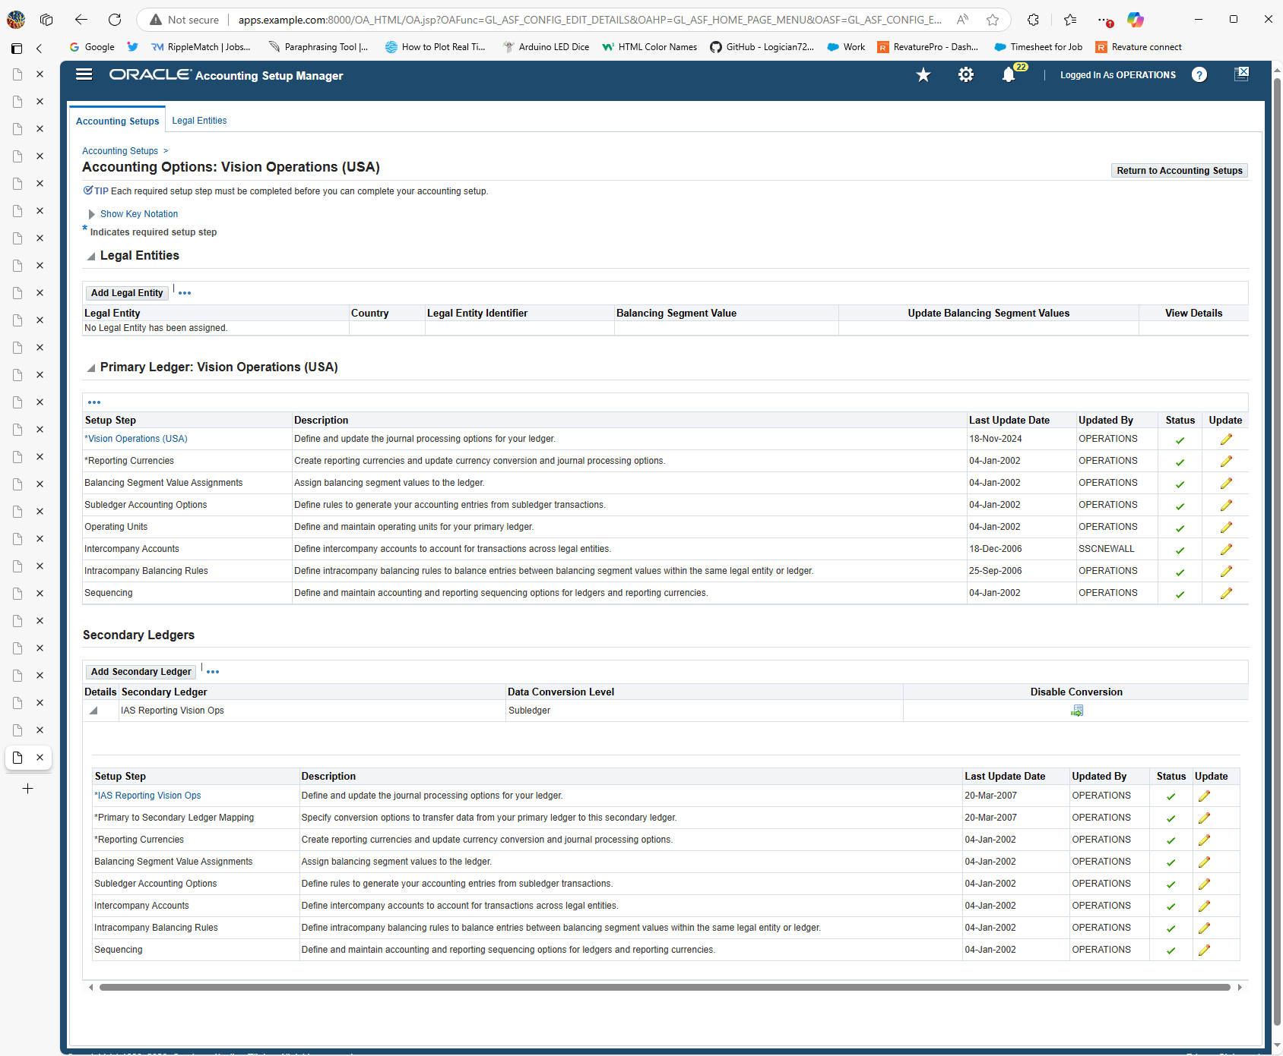

From here i clicked on Vision Operations (USA) to search for 4C component by clicking on the pencil in the corner to update the ledger

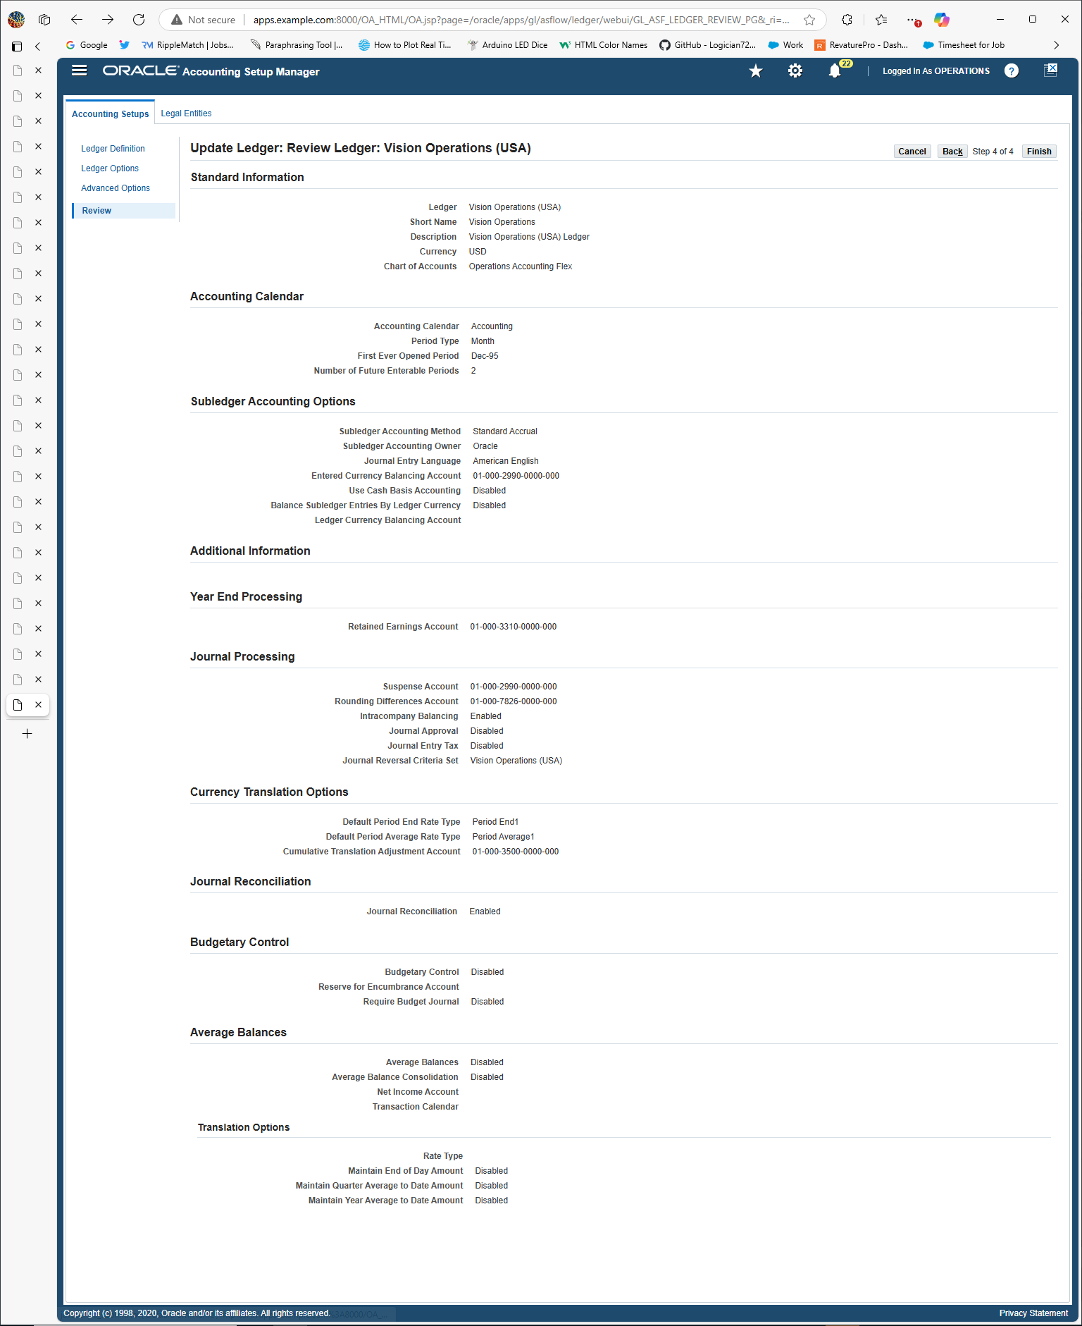

Where this is where the 4Cs are located which are

Charts of Accounts

Calendar

Currency

And the Subledger Accounting Method or SLAM

The values for each of the 4Cs are

Charts of Accounts = **Operations Accounting Flex**

Calendar = **First Ever Opened Period Dec-95**

Currency = **USD**

SLAM = **Standard Accrual**

**Those 4 values makes up 4C because they all display crucial values that are extremely valuable to the ledger because it displays the name, where it took place, the type of currency it uses and how its process is in the system.**

Question #4

**Find all the Account Code Combinations.**

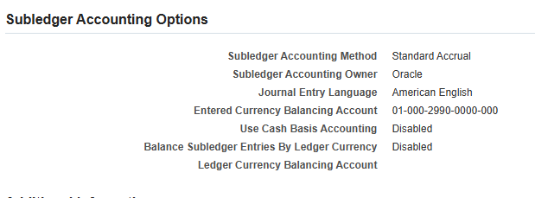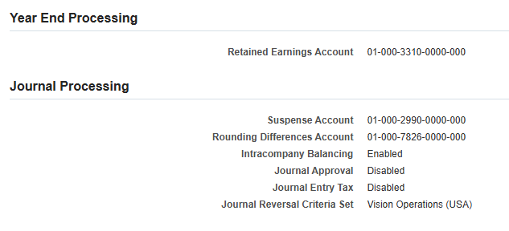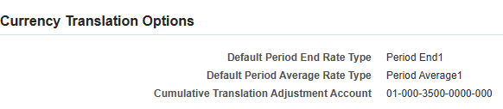

**This is all of the account code combinations that were found in the Vision Operations**

**Question #5**

**Find all the Journals [SOURCE: Payables].**

**First step i did was follow this path**

**PATH: General Ledger > Inquiry > Journal**

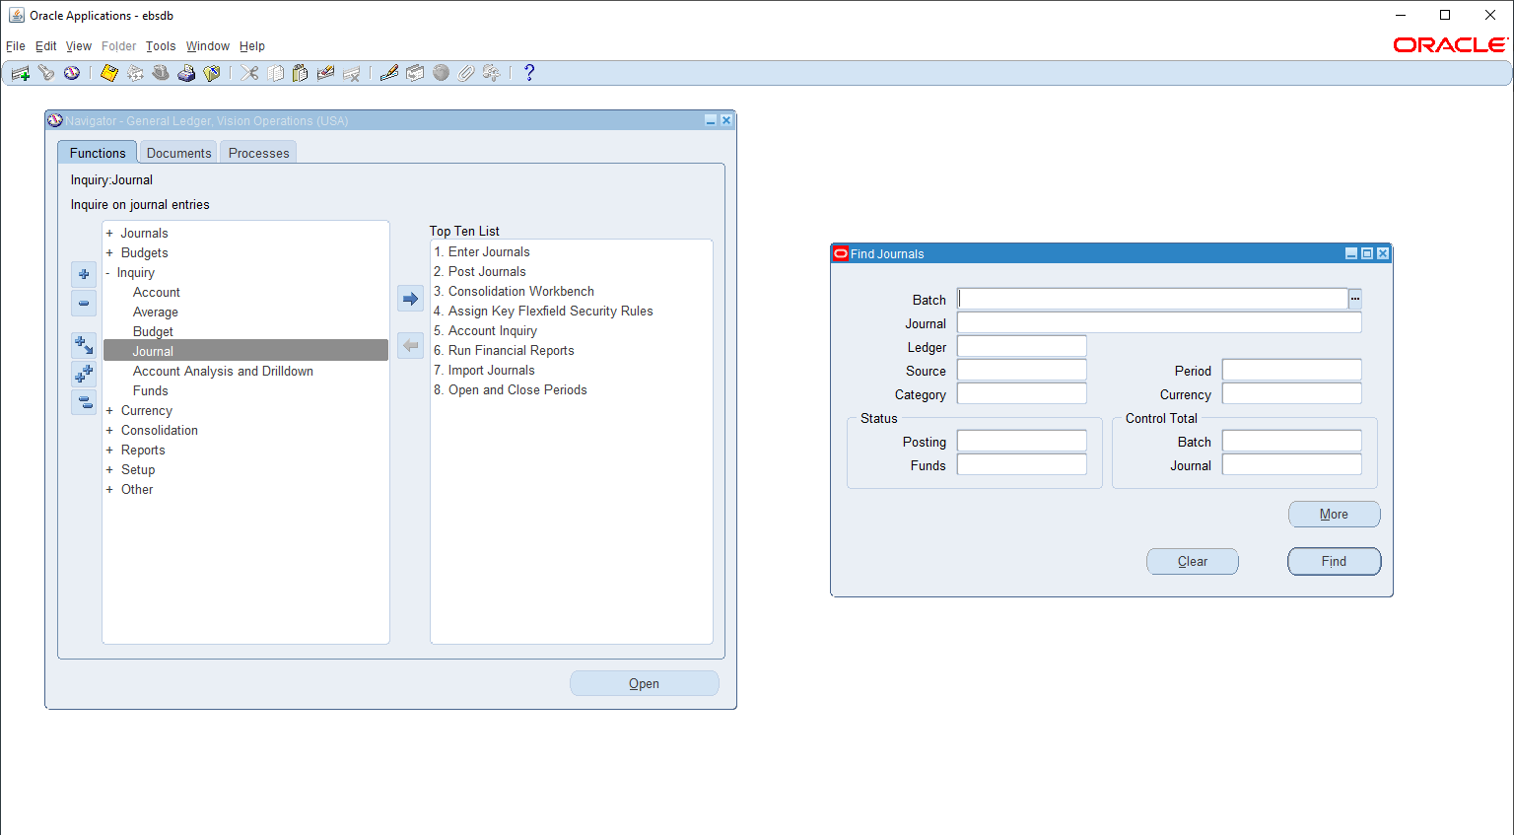

**After this i put in the source of the journal because thats the journals im looking for**

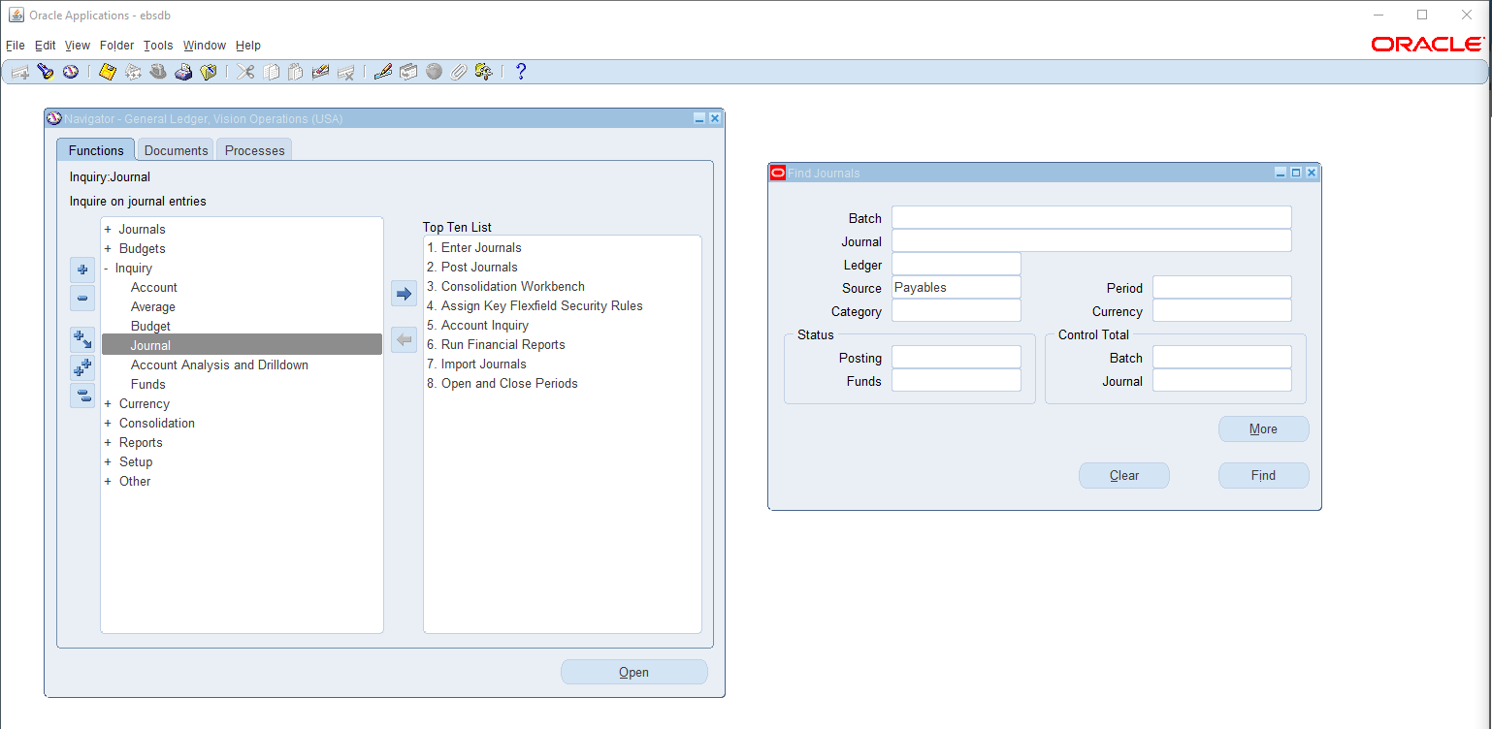

**From here I pressed the find function to find the journal entries underneath payables.**

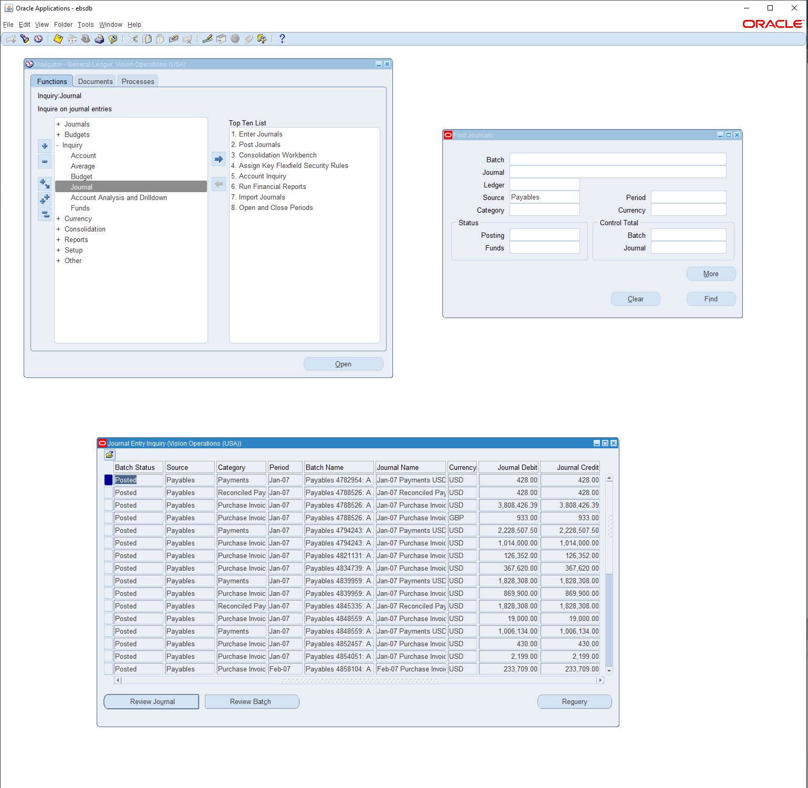

**This showed all the important categories for the payables journal entry such as the category, batch name, Journal debit, journal Credit which is very important to know aloof these categories for the transactions.**

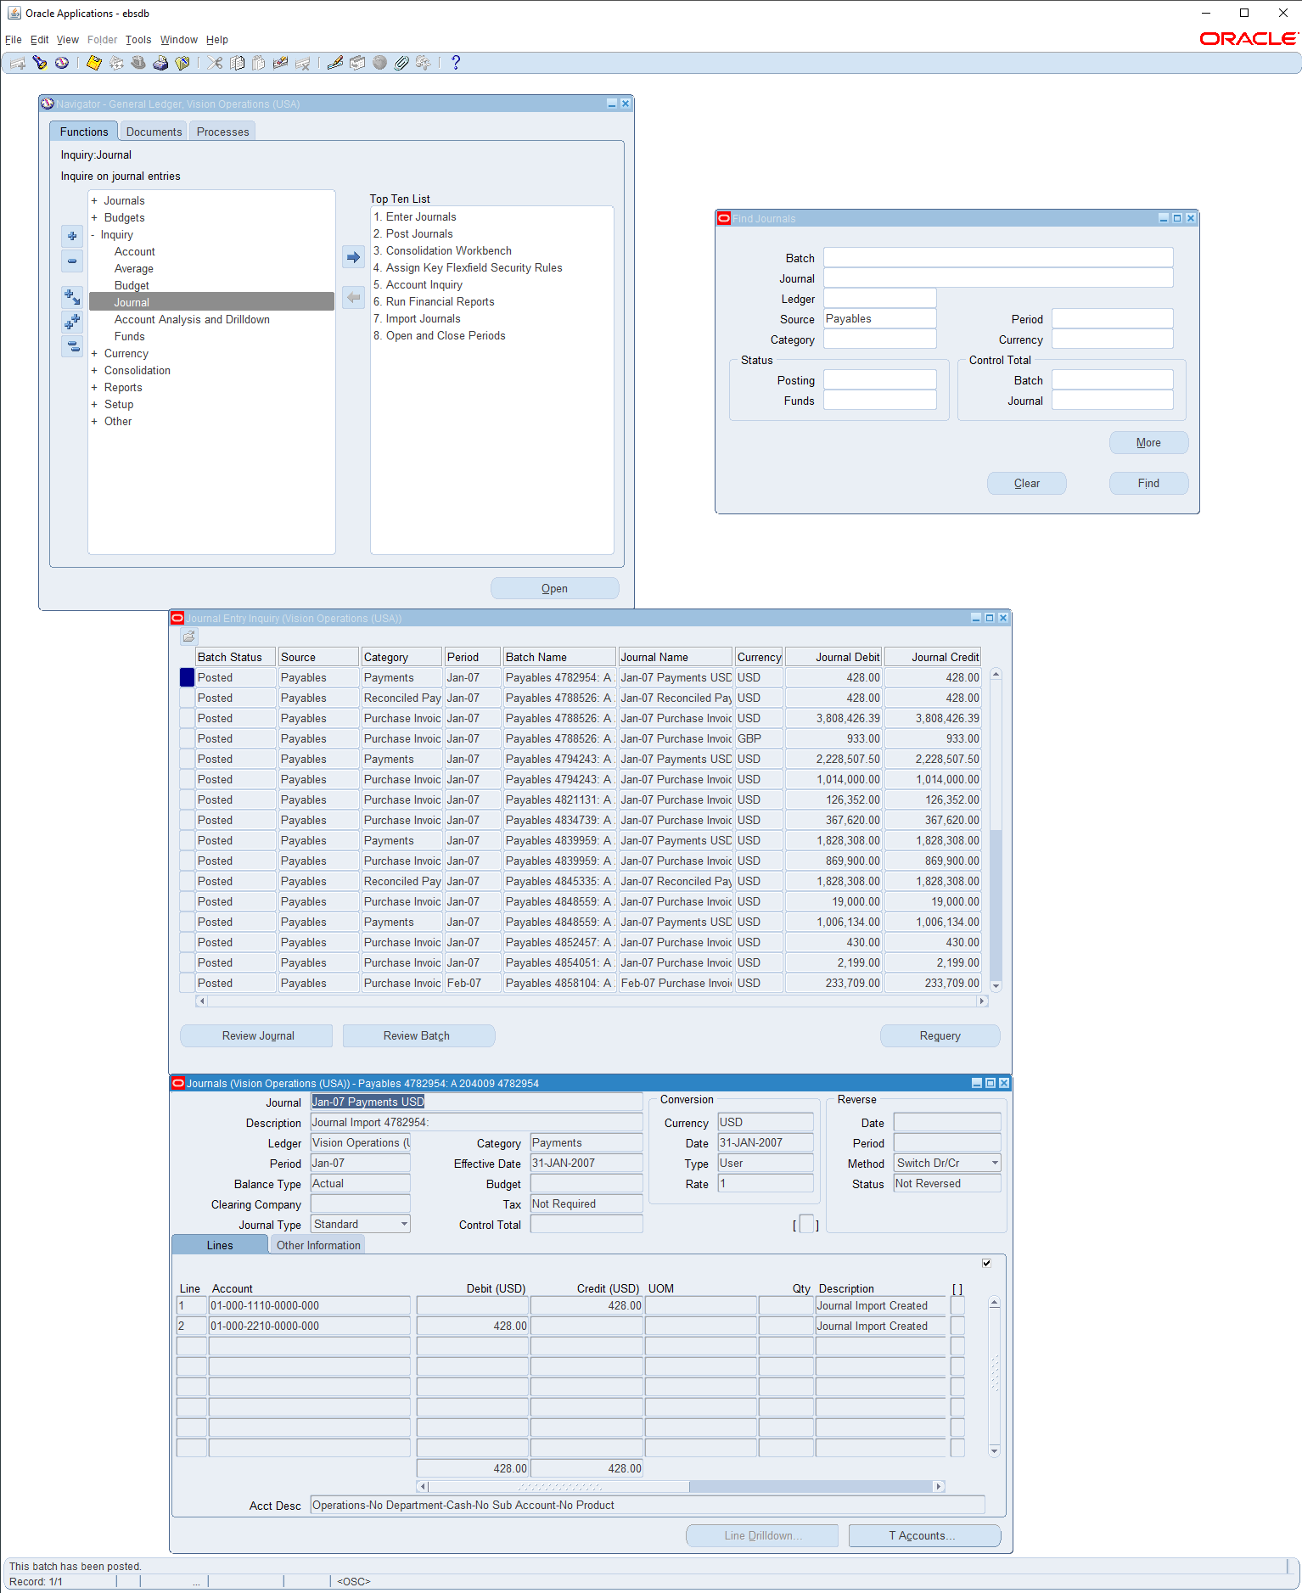

**And this photo is the full journal of Jan 07 that displays all the necessary requirements.**

**Question #6:**

**6. In the Journal Header from record History find the respective Database Table name.**

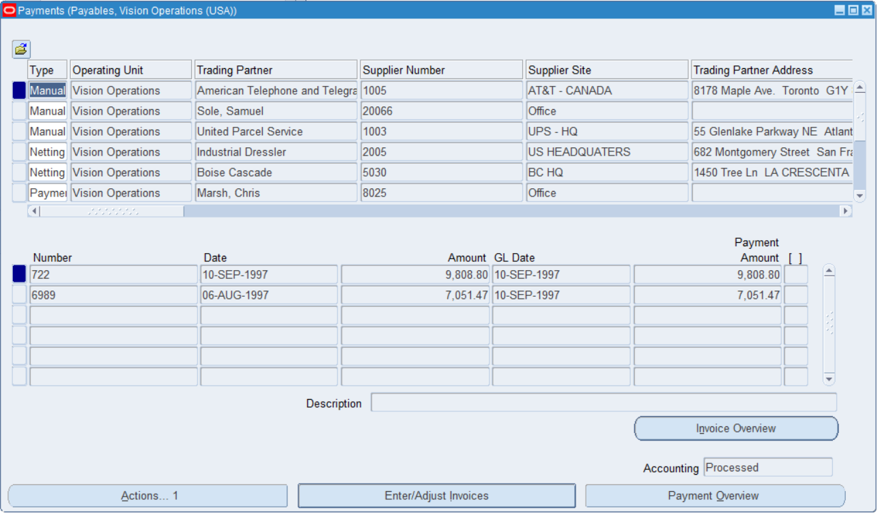

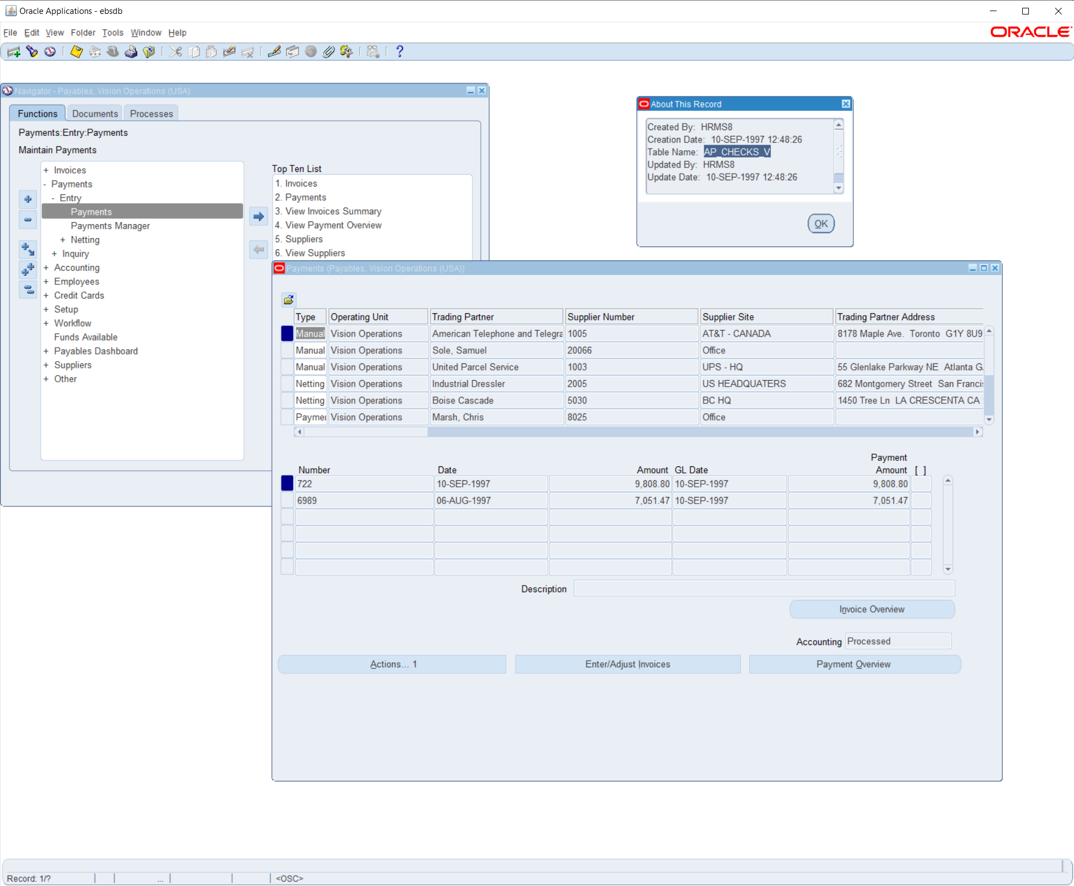

**Question #7**

**7. Find the one Manual [Source] & one Payable [Source].**

**First step i did was follow this path**

**PATH: Payables > Payments > Entry > Payments**

**Second step i did was us Ctrl + f11 to fill the payment sources then i was able to get these 2 segments below**

**(Payable)**

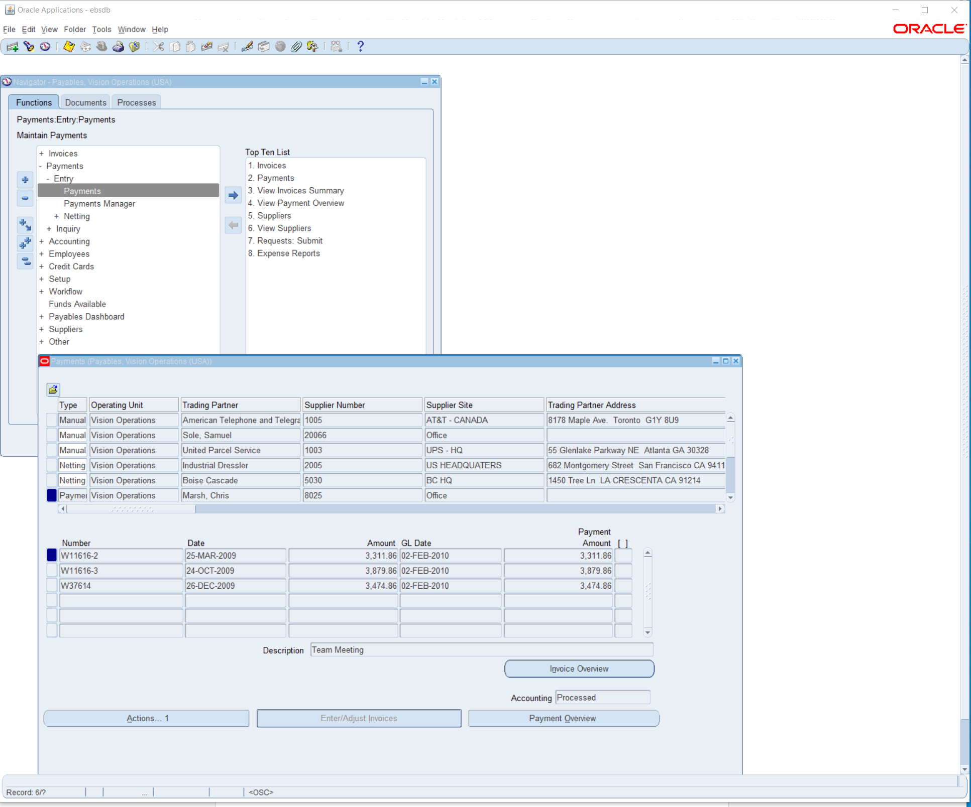

**Manual**

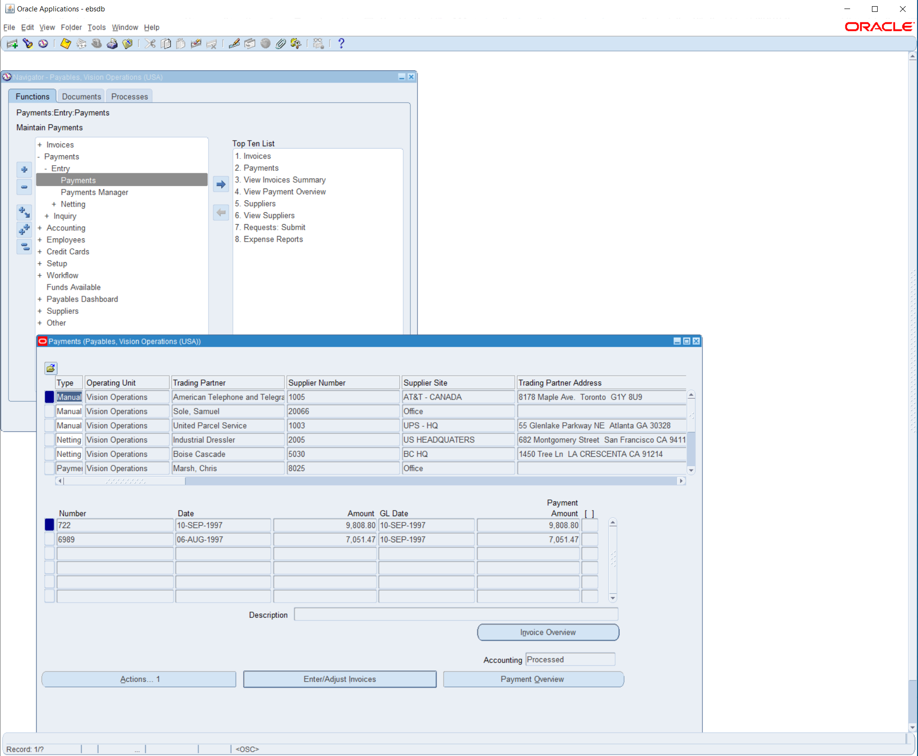

**Question #8**

**8.How can you review posted journal entries in Oracle GL? Steps & screen shot**

**First step i did was follow this path**

**PATH: General Ledger > Journals > Post >**

**Second step I did was use Ctrl + f11 to fill the journal entry so I posted the entries in order to review them.**

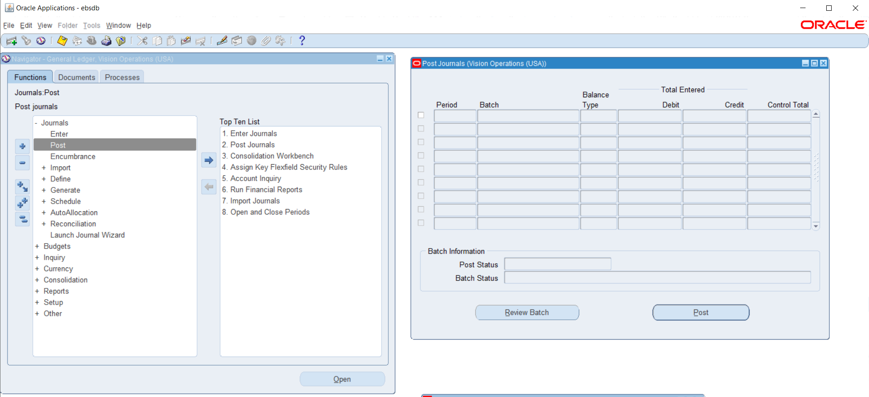

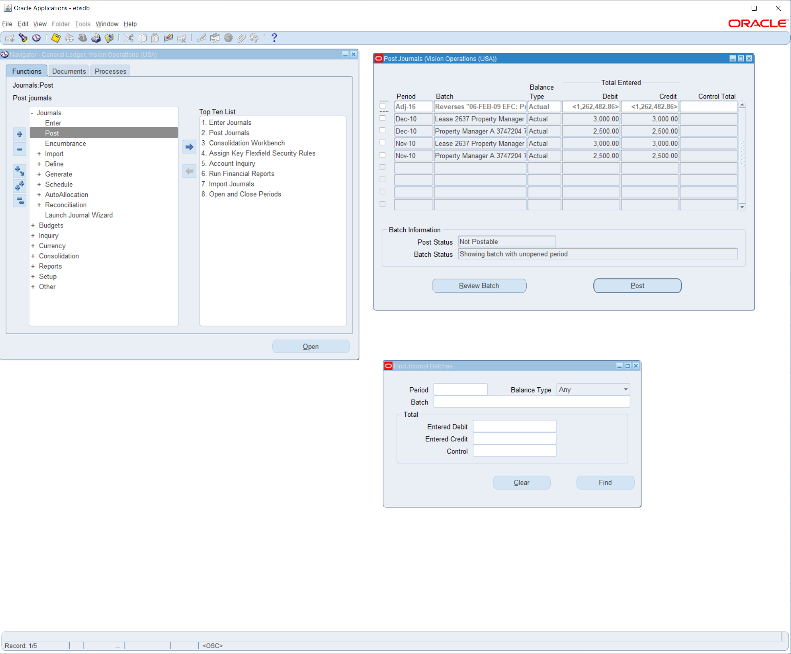

**Question #9**

**9. Find the Chart of Accounts [COA] Structure in General Ledger.**

**First step i did was follow this path**

**PATH: General Ledger > Setup > Accounts > Combinations**

**Second step I did was use Ctrl + f11 to fill the GL accounts to figure out the account numbers,type which states the COA  
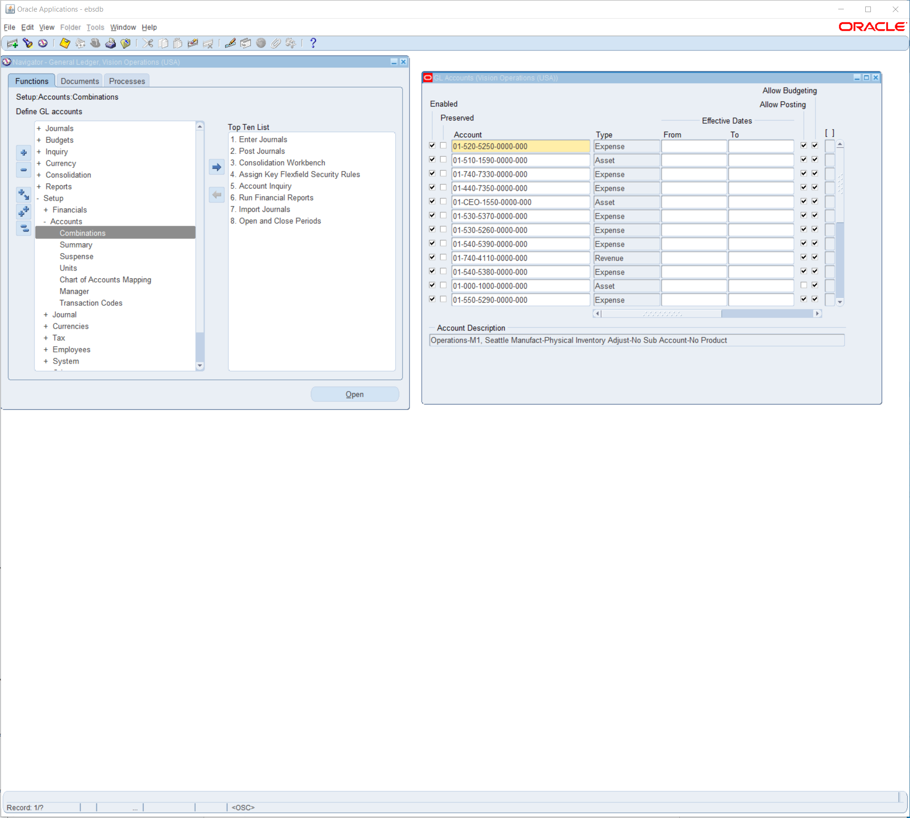**

**Question #10**

**10.How are you going to run one Concurrent Request from General Ledger (Navigation).**

**N/A**

**Question #11**

**11. In One Ledger Set what are all components common in all the Ledger?**

**COA (Charts of Accounts), Accounting Calendar, Currency, and SLAM Subledger Accounting Options.**

**All of these components are important because they create a system that allows the Ledger to function properly.**

**Question #12**

**12. Find how many types of accounts in Oracle GL [Account Code Combination]?**

**There are 6 types of Accounts**

**Asset, Liability,Equity,Revenue,Expense,Statistal**

**All of these accounts are used for a complete financial system in GL and they depend on each other to work as one system called CSSs. but the 2 we have seen so far are expenses and assets shown below**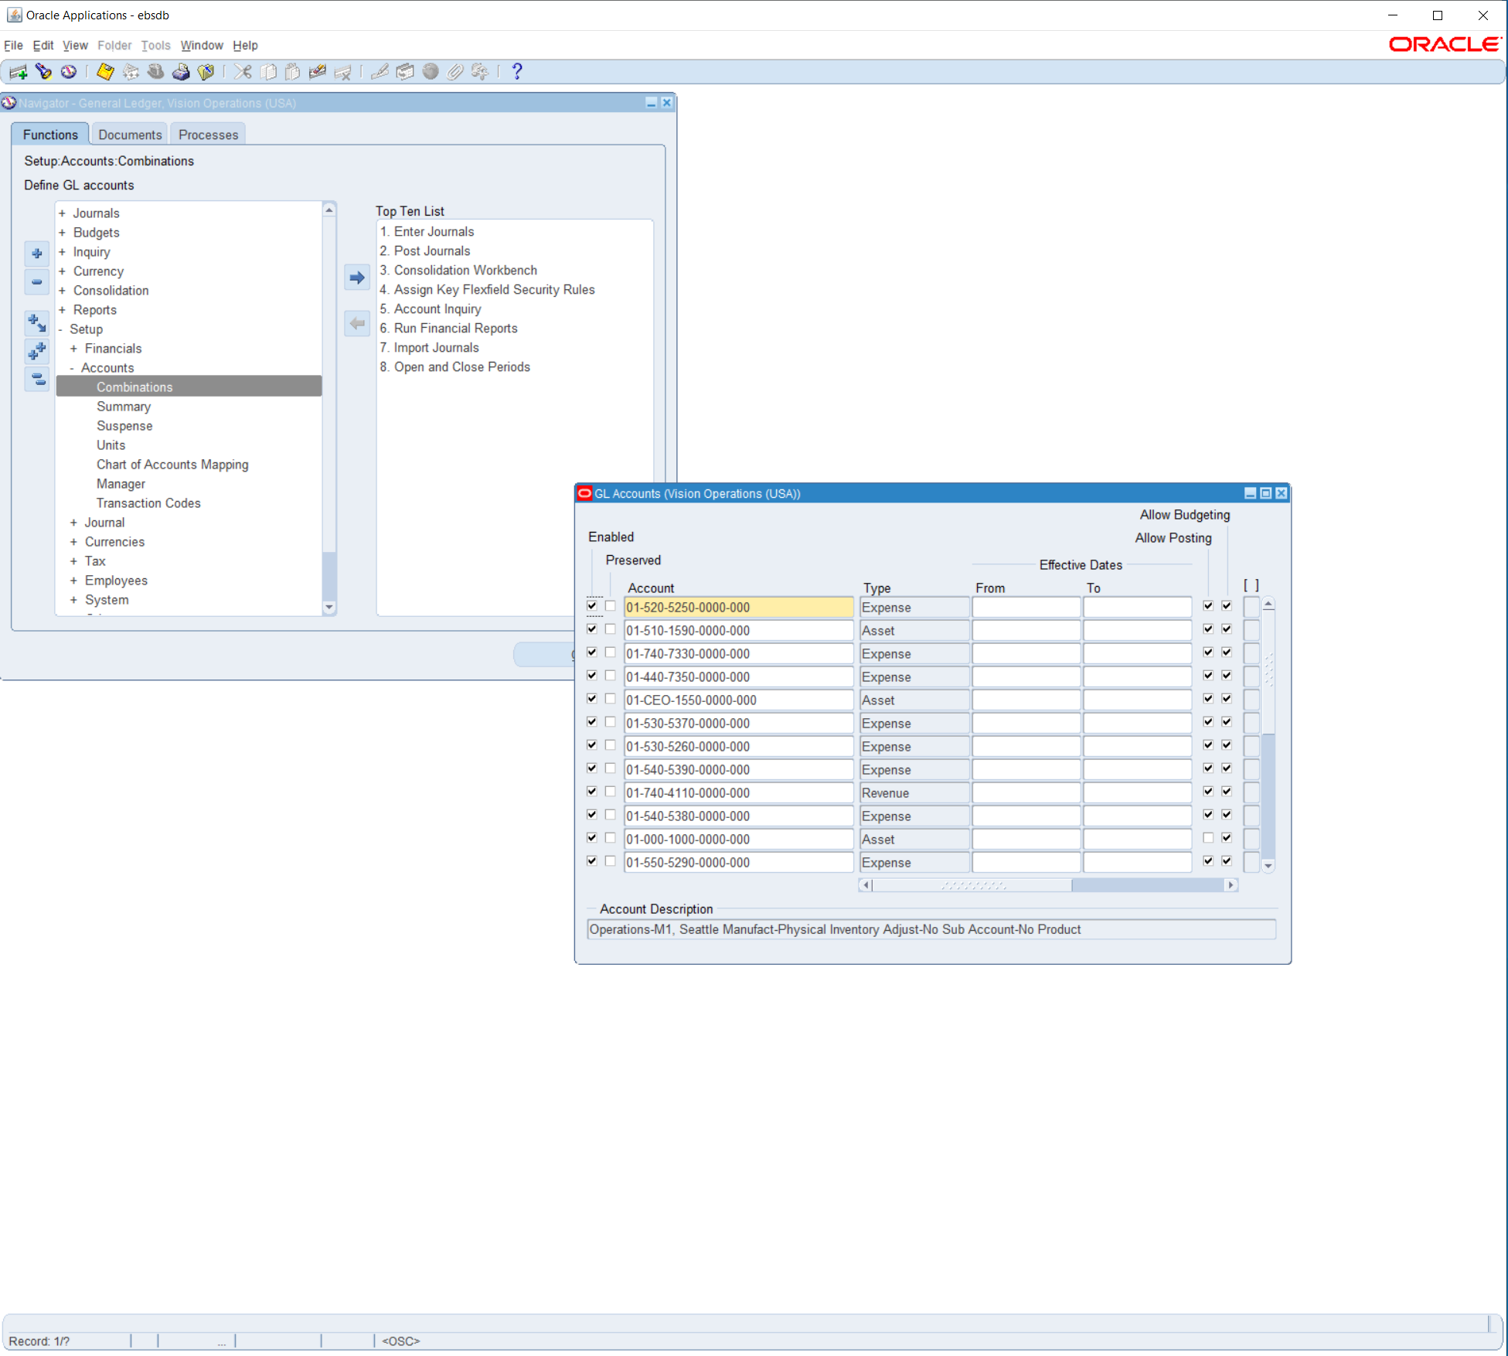

**Question #13**

**13. Check & show the Structure of Chart of Account segment structure.**

