**I. Why is it justified to use the LU or QR-factorizations as opposed to calculating an inverse matrix?**

It is justified to use LU/QR factorizations rather than calculating an inverse primarily because not all matrices can be inverted. However, all square matrices can be factorized through QR-factorizations. QR is also significantly faster than calculating an inverse due to the lack of Gaussian elimination.

**II. What is the benefit of using LU or QR-factorizations in this way?**

Since LU and QR-factorizations are more efficient to solve with very minimal error (see graph below), it is beneficial to use them to solve a system of linear equations such as this example with the Hilbert Matrix. Having less Gaussian eliminations means less operations that could lead to error.

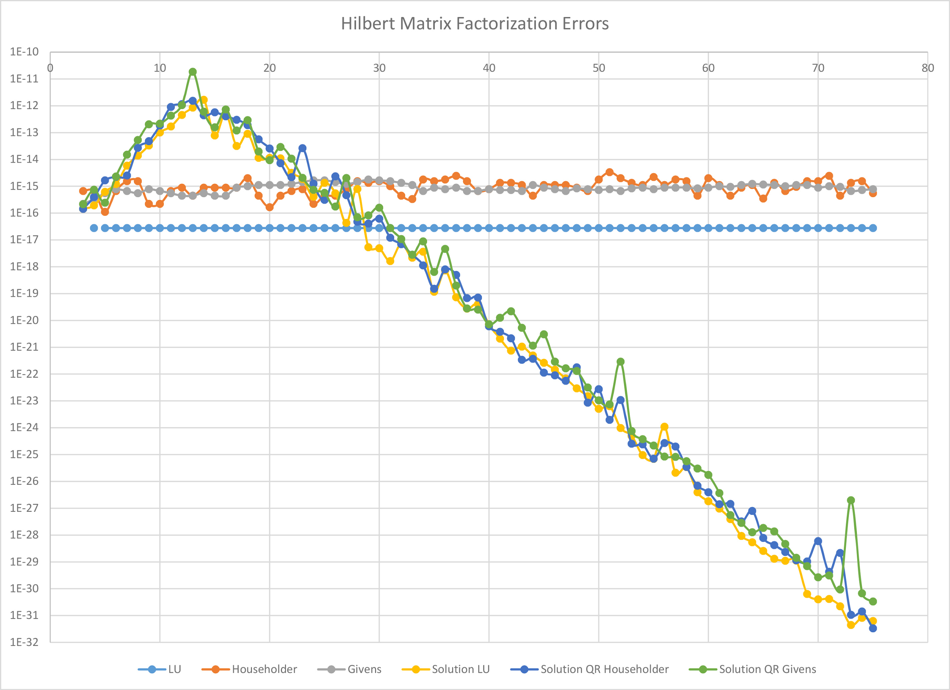

Vertical Axis: Error

Horizontal Axis: Size of NxN Hilbert Matrix (N)