To obtain the desired precision of 10E-8, decoding by Gauss-Seidel consistently took one iteration independent of *n* for decoding both y0 and y1. Decoding by Jacobi method took about half of *n* number of iterations for decoding y0 and about n iterations for decoding y1. The length of the initial stream is only important for Jacobi in terms of iterations as previously described. For both methods, when decoding y1, neither could handle a sequence longer than *n* = 98. However, for decoding y0, neither could handle a sequence longer than about 193. So, although they both eventually reach the correct answer, Gauss-Seidel uses much fewer iterations to reach the same level of tolerance and can handle the same sized bit streams as Jacobi.

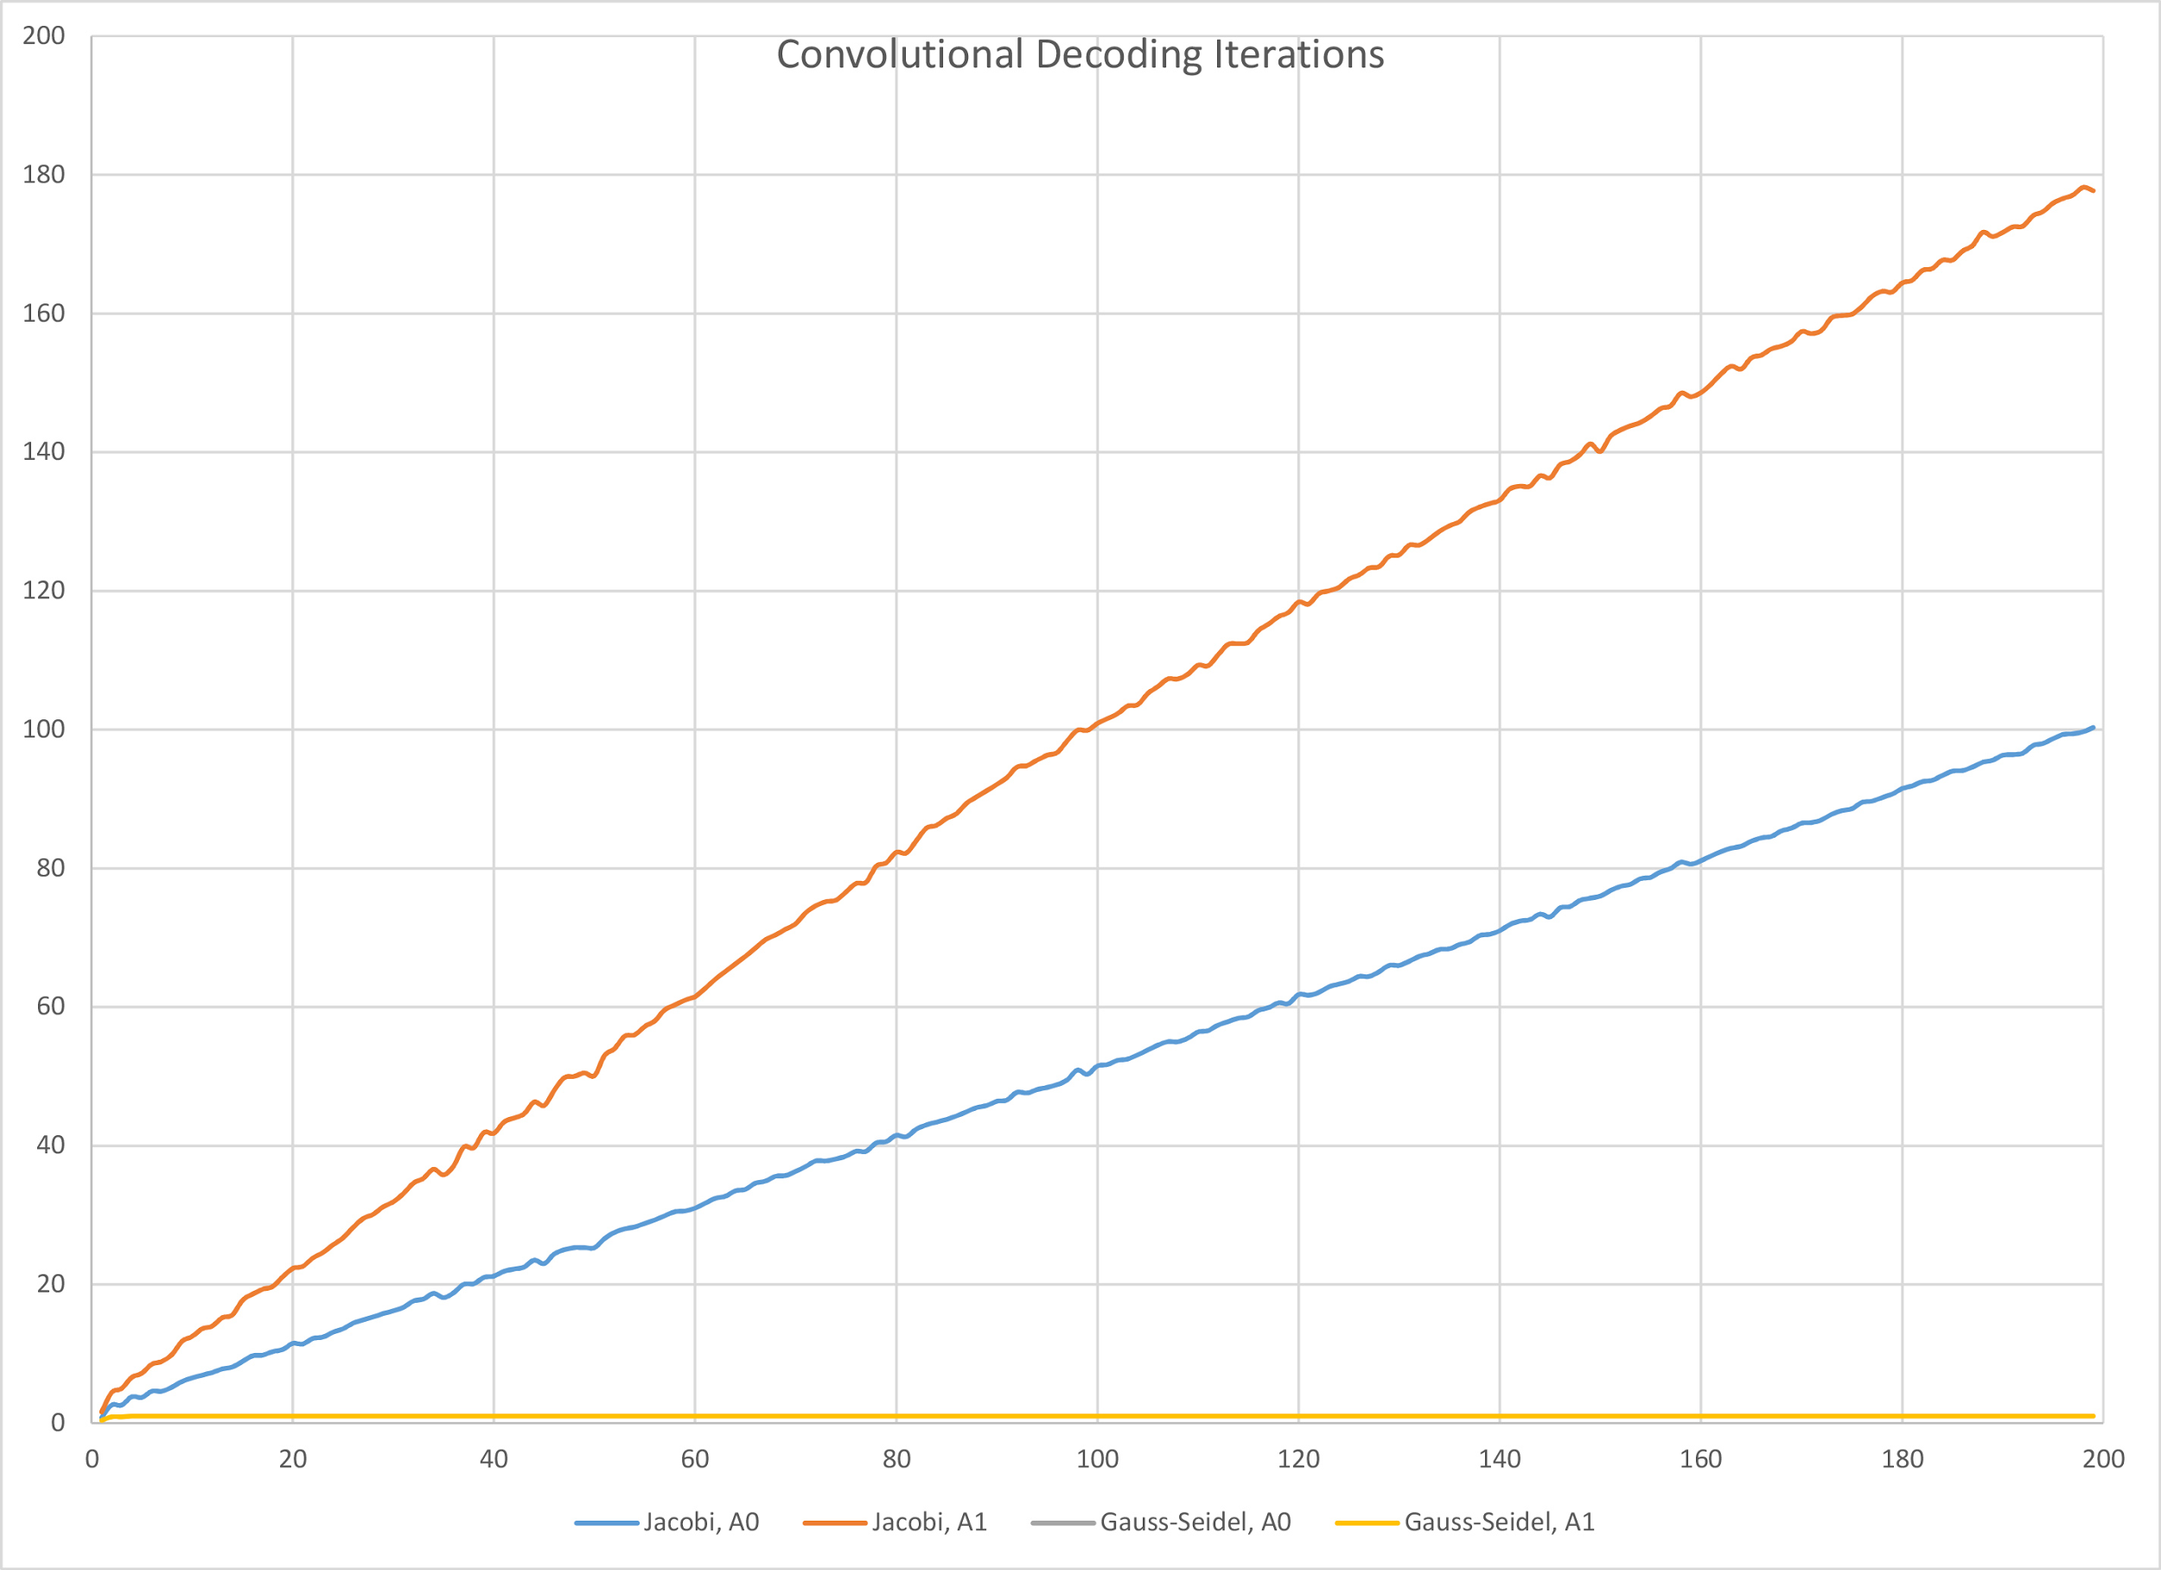

Vertical Axis: Number of Iterations

Horizontal Axis: Length of the input bitstream (n)