1. In this city, based on the first row, it is evident that no one is having babies within the age brackets of 0-9, and 50+. From the remaining four age groups that are having babies that reach *n1*, the age group from 10-19 is having the most babies. Therefore, it could be presumed that there is a teenage pregnancy problem in this city. The survival rates appear to be relatively normal.
2. See the graph and table below for the population distributions, total populations, and the change in total population from 2000-2050.

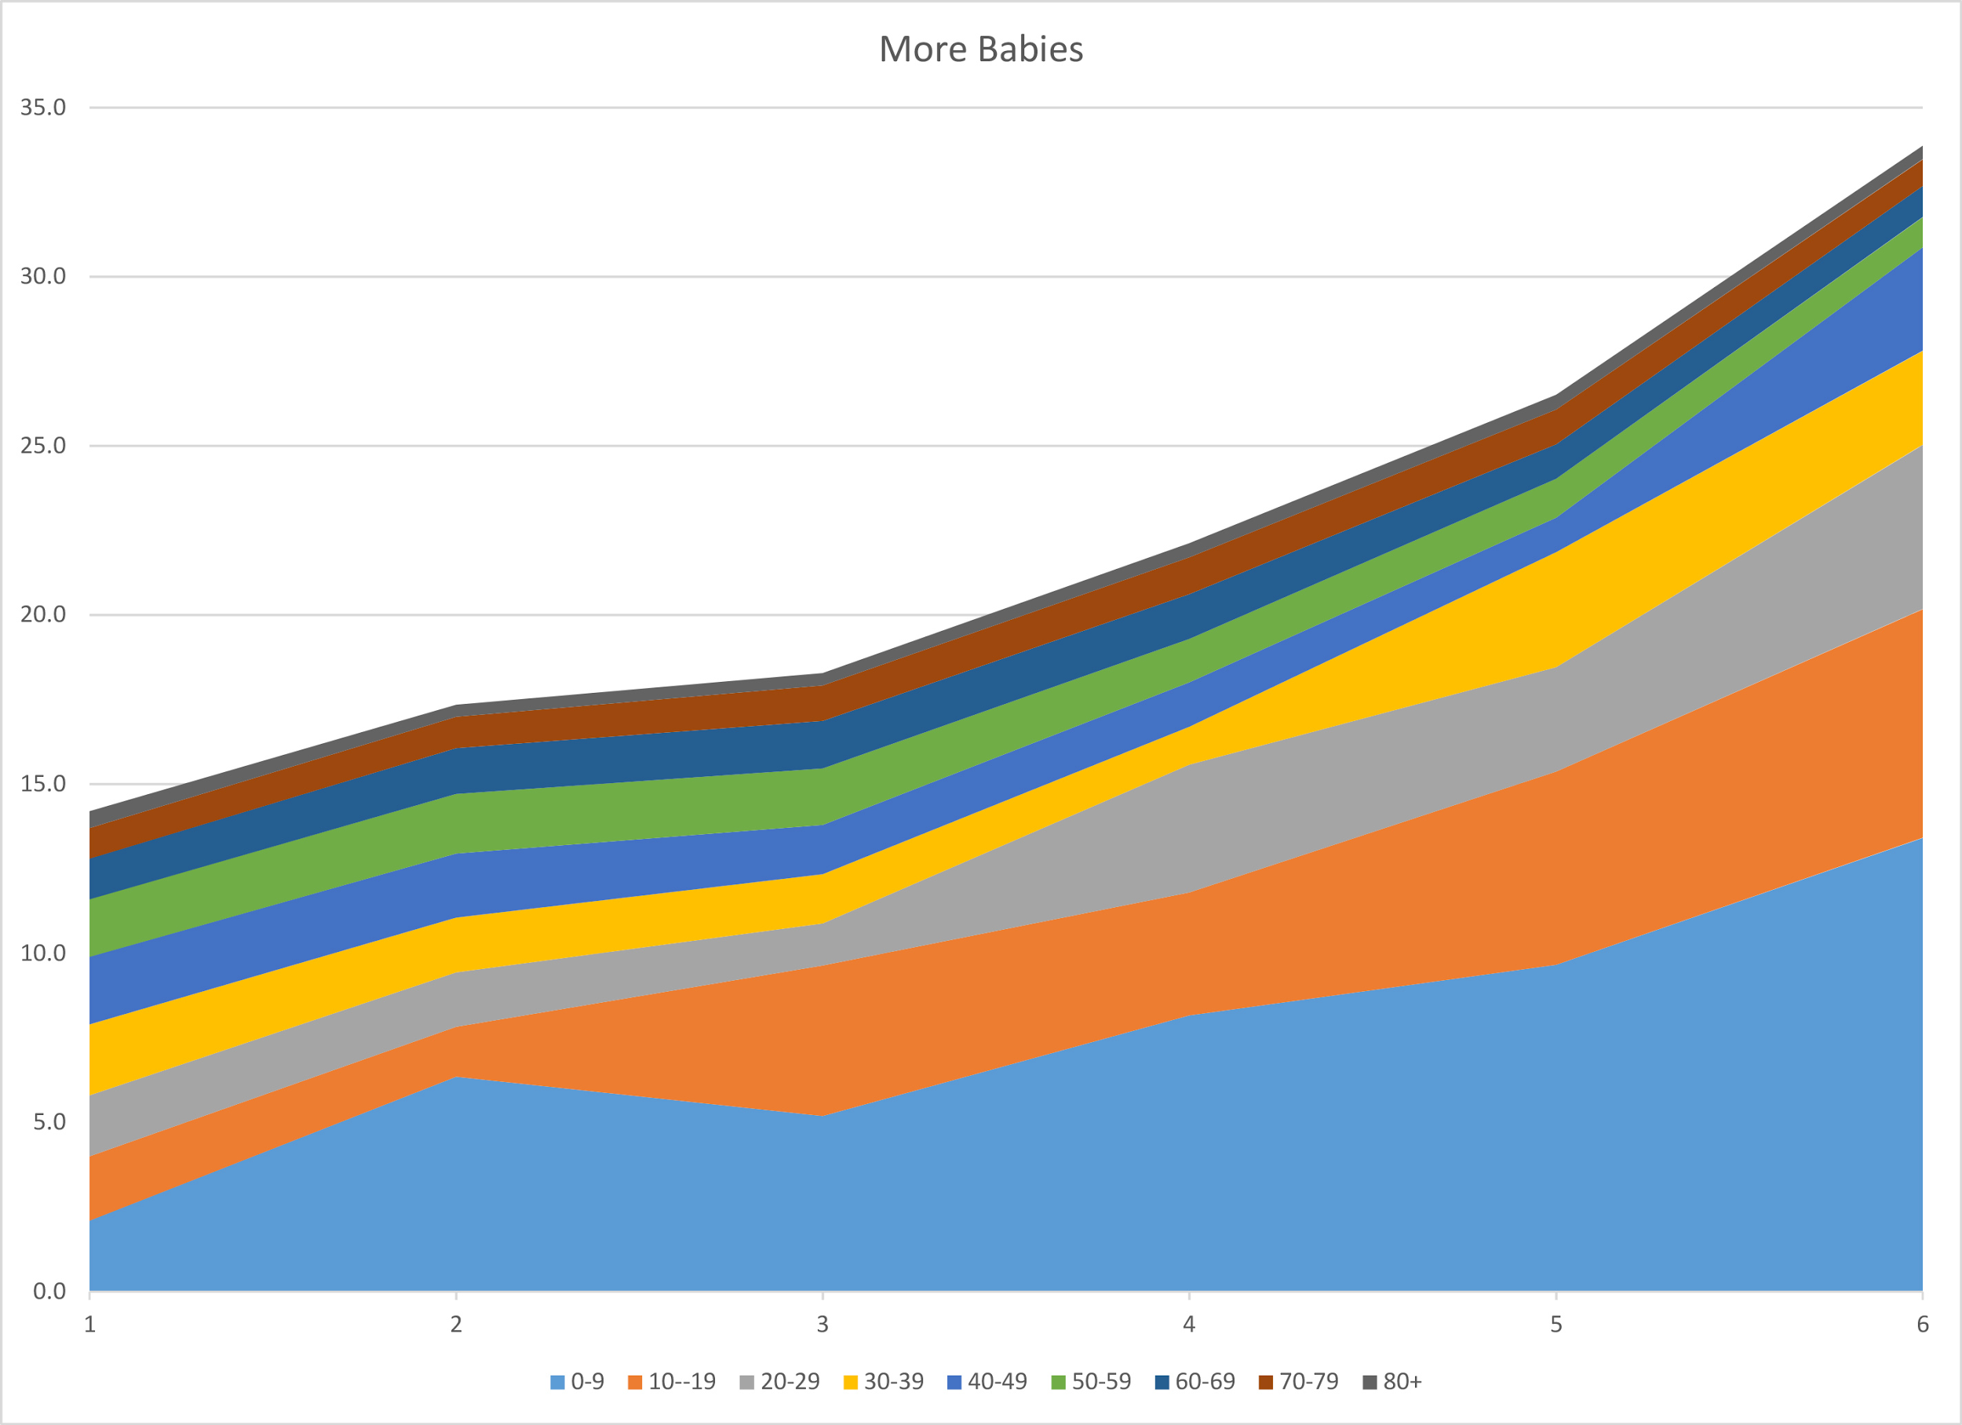

Vertical Axis: Population (10E5)

Horizontal Axis: Decades starting from 2000 (1 = 2000, 2 = 2010, etc.)

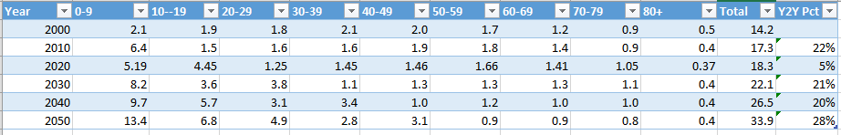

Population numbers in 10E5

(Last column should be labeled decade to decade change in percent)

1. The dominant eigenvalue for this Leslie matrix is about 1.29. This is approximately equal to the change in total population from decade to decade, so this means that in the long run the population will grow by about 29% a decade. This means that the population will become unstable. We ran the simulation until 2600, and the population change was still about 1.29 as predicted and the total population had only ever increased to exponential proportions.
2. By decreasing the birth rate of the second age group by half (or essentially improving on the teenage pregnancy problem as stated before) in the year 2020, the population data is given in the second table below. The eigenvalue for this new Leslie matrix is about 1.17. This still means that the population is unstable and continuously growing. However, the population increase is less than it was before this change in 2020, so the growth is less severe.

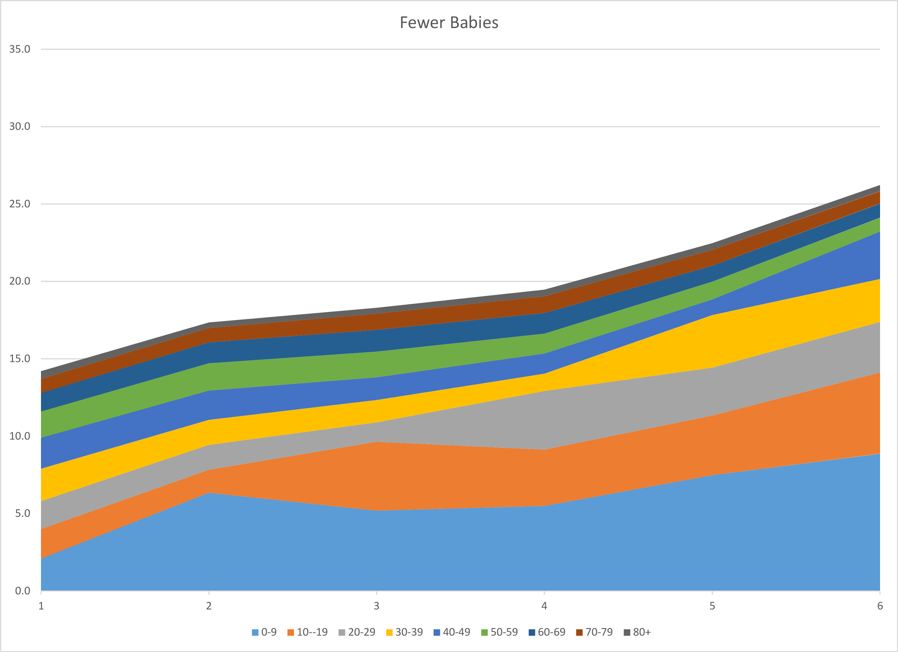

Vertical Axis: Population (10E5)

Horizontal Axis: Decades starting from 2000 (1 = 2000, 2 = 2010, etc.)

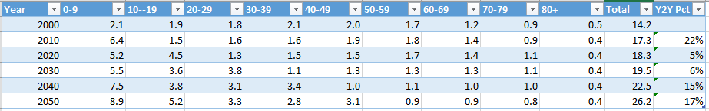

Population numbers in 10E5

(Last column should be labeled decade to decade change in percent)