**HW1**

**20200639 Chae Woo Jin**

**Problem**: Determine whether the given integer is palindrome, or not.

* **Key Idea**: Only the integer which is palindrome is the same as the original number even if the order is reversed.
* **Implementation**:
* 1. Read Integer:

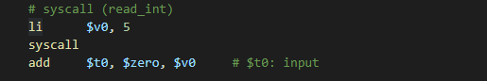

* 2. Implement function that returns integer with reversed order from given input

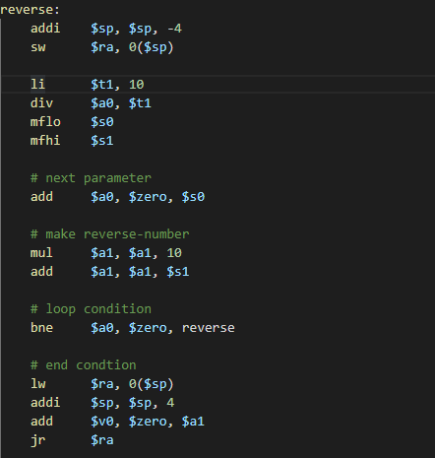

We can get reversed integer using for loop, following the sketch below.

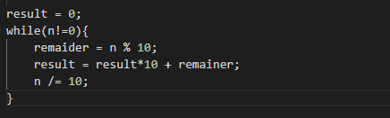

* 3. Compare Original Integer with Reversed Integer:

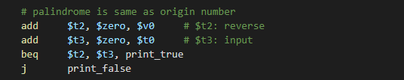

* 4. Print result:

