**Homework 2**

**20200639 Chae Woo Jin**

**Chapter 4:** 1, 4, 10, 12, 14

**Chapter 5:** 1, 2, 5, 6, 7

**Chapter 4**

**#1.**

(4.2) $p\left(X\right)=\frac{e^{β_{0}+β_{1}X}}{1+e^{β_{0}+β_{1}X}}$, $\frac{p\left(X\right)}{1-p(X)}=\frac{\frac{e^{β_{0}+β_{1}X}}{1+e^{β_{0}+β_{1}X}}}{\frac{1}{1+e^{β_{0}+β_{1}X}}}=e^{β_{0}+β_{1}X}$ (4.3)

**#4.**

(a) On average, $\frac{1}{10}$ will be used to make the precision, because observations are uniformly distribution.

(b) On average, when $p=2$, $\frac{1}{10}×\frac{1}{10}=\frac{1}{100}$ will be used.

(c) On average, when $p=100$, ${\left(\frac{1}{10}\right)}^{100}$ will be used.

(d) As $p$ increases linear, the proportion of observations against whole data set which are used to predict the real value decreases exponentially.

(e) The length of p-dimensional hypercube which contains 10% of the training observation is $\sqrt[p]{\frac{1}{10}}$, so that the volume of this hypercube is $\frac{1}{10}$, which is a proportion that it contains its training observations.

**#10.**

$$\log\left(\frac{\operatorname{Pr}\left(Y=k | X=x\right)}{\operatorname{Pr}\left(Y=K | X=x\right)}\right)=\log\left(\frac{π_{k}f_{k}\left(x\right)}{π_{K}f_{K}\left(x\right)}\right)$$

$$=\log\left(\frac{π_{k}\exp\left(-\frac{1}{2}{\left(x-μ_{k}\right)}^{2}/σ^{2}\right)}{π_{K}\exp\left(-\frac{1}{2}{\left(x-μ_{K}\right)}^{2}/σ^{2} \right)}\right)$$

$$=\log\left(\frac{π_{k}}{π_{K}}\right)-\frac{1}{2}\frac{{\left(x-μ_{k}\right)}^{2}}{σ^{2}}+\frac{1}{2}\frac{{\left(x-μ_{K}\right)}^{2}}{σ^{2}}$$

$$=\log\left(\frac{π_{k}}{π_{K}}\right)-\frac{1}{2σ^{2}}\left\{{\left(x-μ_{k}\right)}^{2}-{\left(x-μ_{K}\right)}^{2}\right\}$$

$$=\log\left(\frac{π_{k}}{π_{K}}\right)-\frac{1}{2σ^{2}}\left\{2\left(μ_{K}-μ_{k}\right)x-(μ_{K}^{2}-μ_{k}^{2})\right\}$$

$$=\log\left(\frac{π_{k}}{π_{K}}\right)+\frac{μ_{K}^{2}-μ_{k}^{2}}{2σ^{2}}+\frac{\left(μ_{k}-μ_{K}\right)x}{σ^{2}}$$

$$=a_{k}+b_{k}x$$

$∴a_{k}=\log\left(\frac{π_{k}}{π_{K}}\right)+\frac{μ_{K}^{2}-μ_{k}^{2}}{2σ^{2}}$, $b_{k}=\frac{μ_{k}-μ_{K}}{σ^{2}}$

**#12.**

(a) $\log\left(\frac{\hat{Pr}\left(Y=orange|X\right)}{1-\hat{Pr}\left(Y=orange|X\right)}\right)=\hat{β_{0}}+\hat{β_{1}}X$. Therefore, log odds of orange versus apple in my model is $\hat{β_{0}}+\hat{β_{1}}X$

(b) $\log\left(\frac{\hat{Pr}\left(Y=orange|X\right)}{1-\hat{Pr}\left(Y=orange|X\right)}\right)=({\hat{α}}_{orange0}-{\hat{α}}_{apple0})+({\hat{α}}_{orange1}-{\hat{α}}_{apple1})X$. Therefore, log odds of orange versus apple in friend’s model is $({\hat{α}}_{orange0}-{\hat{α}}_{apple0})+({\hat{α}}_{orange1}-{\hat{α}}_{apple1})X$

(c) $\left\{\begin{aligned}{\hat{α}}_{orange0}-{\hat{α}}_{apple0}=2 \\ {\hat{α}}_{orange1}-{\hat{α}}_{apple1}=-1\end{aligned}\right.$. However, finding a solution of 4 parameters with 2 equations is impossible.

(d) $\left\{\begin{aligned}{\hat{α}}_{orange0}-{\hat{α}}_{apple0}=1.2-3=-1.8=\hat{β_{0}} \\ {\hat{α}}_{orange1}-{\hat{α}}_{apple1}=-2-0.6=-2.6=\hat{β_{1}}\end{aligned}\right.$.

(e) The models are identical with different parameterization so they should perfectly agree.

**#14.**

(a)



(b)

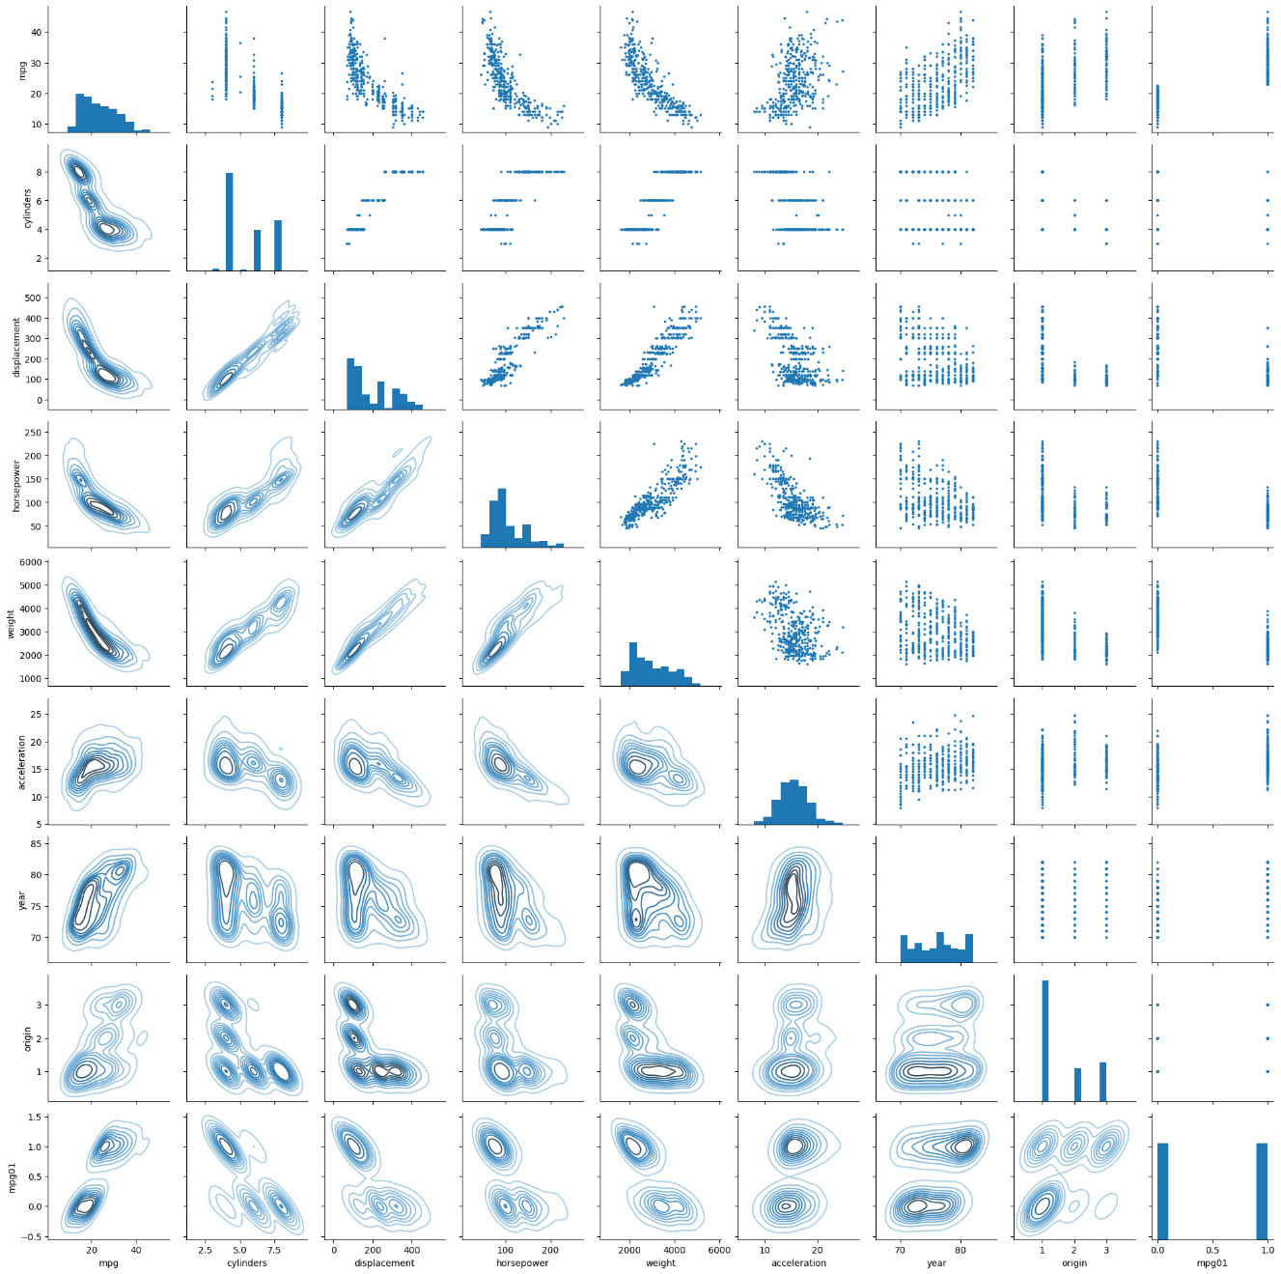

[Scatterplots between features]

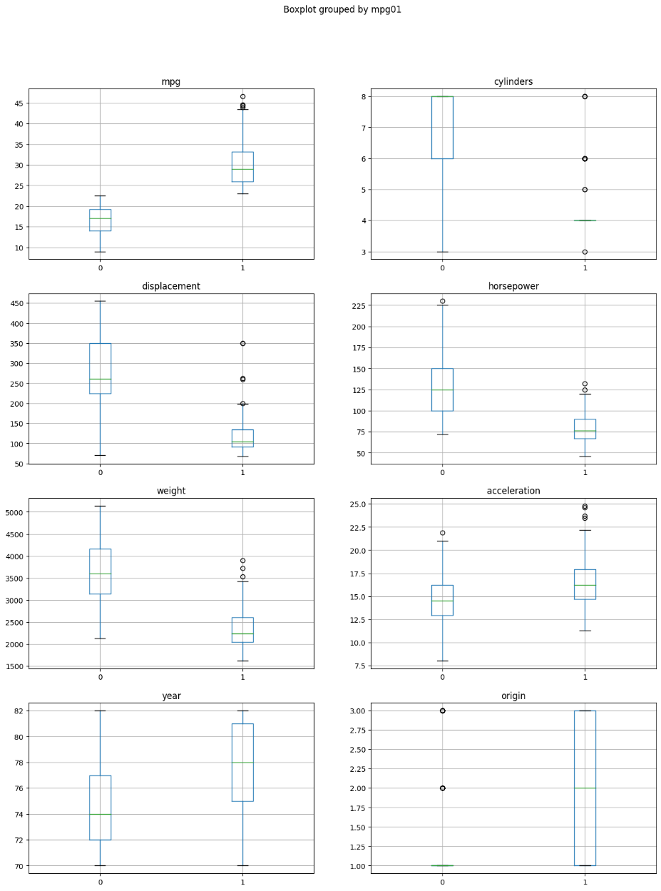

[Boxplots grouped by mpg01]

'cylinders', 'displacement', 'horsepower', 'weight', 'acceleration', and 'year' seems well to fit mpg01

(c)

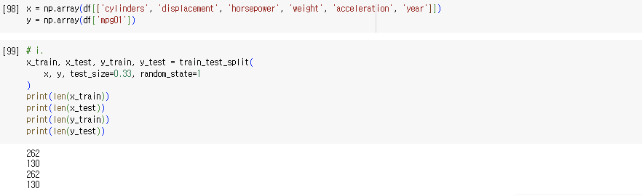

**※ From (d) to (h), 'cylinders', 'displacement', 'horsepower', 'weight', 'acceleration', and 'year' will be used as predictors of ‘mpg01’.**

(d)

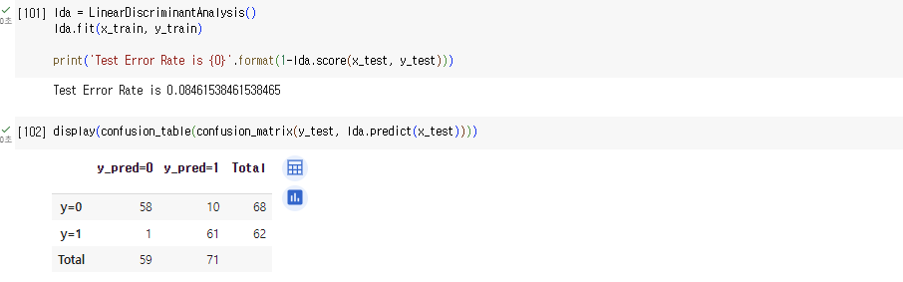

Test error (LDA): 0.084615

(e)

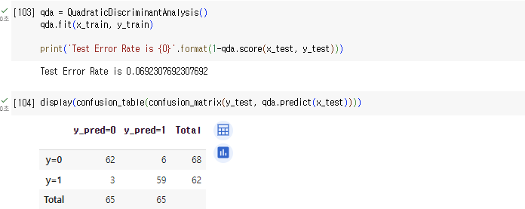

Test error (QDA): 0.069230

(f)

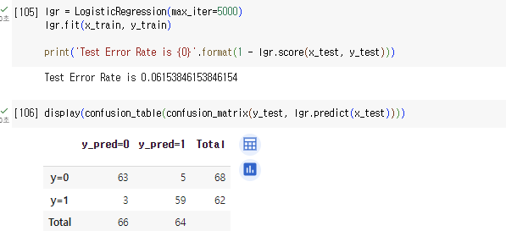

Test error (Logistic Regression): 0.061538

(g)

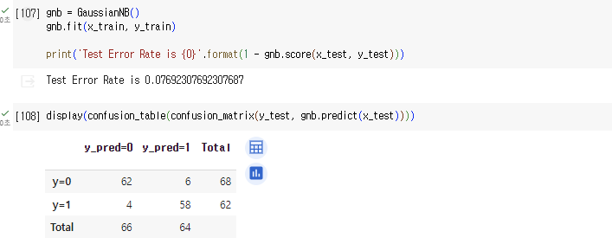

Test error (Naïve Bayes): 0.076923

(h)

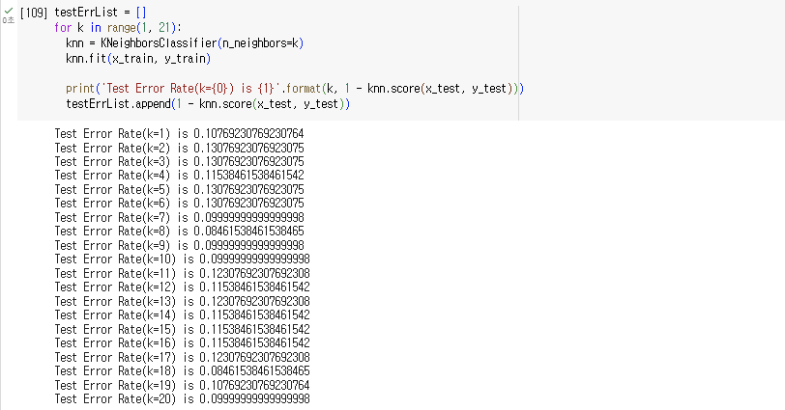

When we consider only overall test error rate, it seems **k=8** perform the best on the data set.

**Chapter 5**

**#1.**

$$f\left(α\right)=Var\left(αX+\left(1-α\right)Y\right)=α^{2}Var\left(X\right)+{\left(1-α\right)}^{2}Var\left(Y\right)+2α\left(1-α\right)Cov\left(X, Y\right)$$

To find $α$ that minimizes $f\left(α\right)$, lets differentiate it with regard to $α$.

$$\frac{d}{dα}f\left(α\right)=2αVar\left(X\right)-2\left(1-α\right)Var\left(Y\right)+2\left(1-2α\right)Cov\left(X, Y\right)=0$$

$∴α=\frac{2Var\left(Y\right)-2Cov(X, Y)}{2Var\left(Y\right)+2Var\left(Y\right)-4Cov\left(X, Y\right)}=\frac{σ_{Y}^{2}-σ_{XY}}{σ_{X}^{2}+σ_{Y}^{2}-2σ_{XY}}$ (5.6)

Examining $f(x)$ near $x=α$ tells that $f(x)$ is minimized at $x=α$

**#2.**

(a) $1-\frac{1}{n}$

(b) As each bootstrap sample is a random sample, this probability is the same. $1-\frac{1}{n}$

(c) As every sample is independent, it is ${\left(1-\frac{1}{n}\right)}^{n}$

(d) It is $1-{\left(1-\frac{1}{5}\right)}^{5}=0.67232$

(e) It is $1-{\left(1-\frac{1}{100}\right)}^{100}=0.63397$

(f) It is $1-{\left(1-\frac{1}{10000}\right)}^{10000}=0.63212$

(g) The probability likely to converge in $1-e^{-1}$ as $j$ increases, since $\lim_{j→∞}{{\left(1-\frac{1}{j}\right)}^{j}}=\frac{1}{e}$.

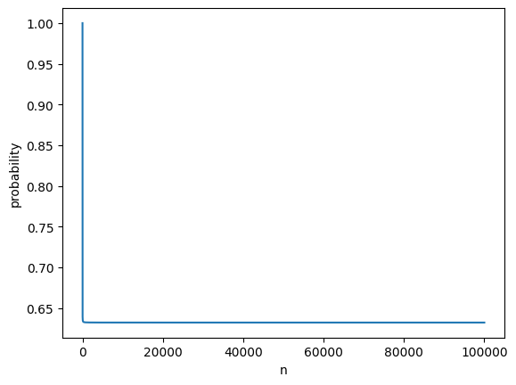

(h) 0.6398639863986398, result from bootstrapping resembles theoretical probability.

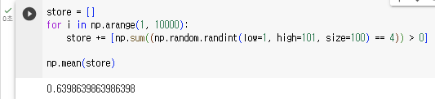

**#5.**

(a)

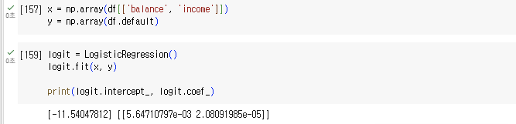

(b)

i.

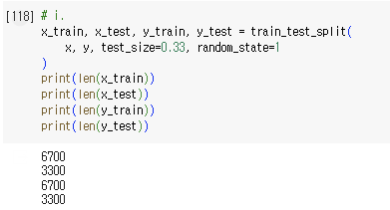

ii.

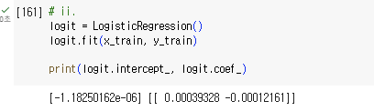

iii.

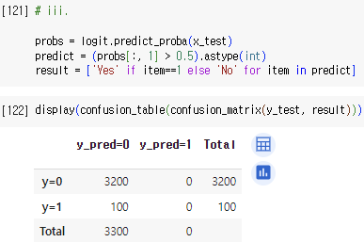

iv.

Validation set overall error rate is 100/3300 = 0.030303

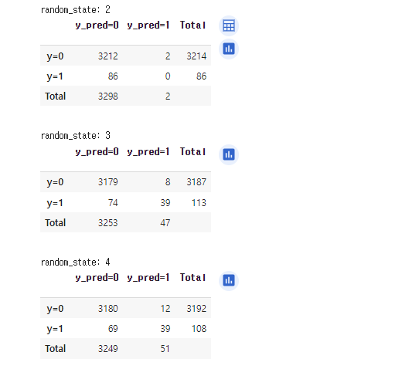(c)

**[Validation Set Overall Error Rate]**

- random_state (2) => (86+2)/3300 = 0.026667

- random_state (3) => (74+8)/3300 = 0.024848

- random_state (4) => (69+12)/3300 = 0.024545

The results obtained are variable and depend on the samples allocated to training vs. test.

(d)

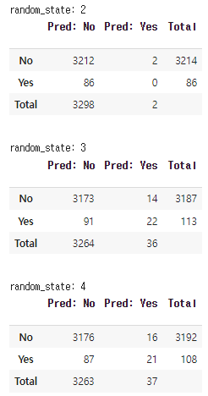 **[Validation Set Overall Error Rate (Including ‘Student’)]**

- random_state (2) => (86+2)/3300 = 0.026667

- random_state (3) => (91+14)/3300 = 0.031818

- random_state (4) => (87+16)/3300 = 0.031212

Including student does not seem to make a substantial improvement to the test error.

**#6.**

(a)

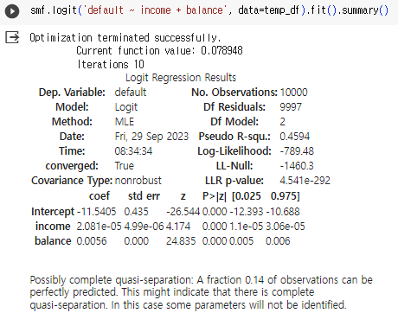

standard error of estimated coefficient(income): 4.99e-06

standard error of estimated coefficient(balance): 0.000

(b)

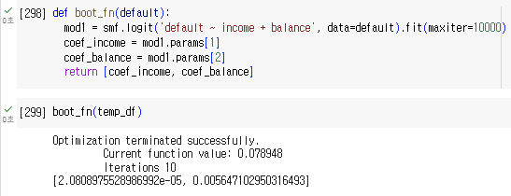

(c)

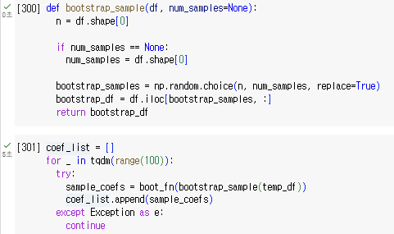

(d)

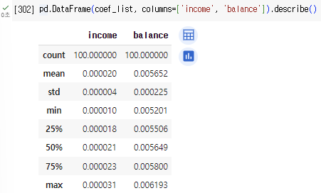

From (a), estimated coefficients and standard errors of these coefficients for logistic regression of income and balance was [2.081e-05, 0.0056], and [4.99e-06, 0.000] respectively. According to the bootstrapping method, we obtained coefficients [0.000020, 0.005639], standard errors [0.000006, 0.000228] for these coefficients. From this result, one can conclude that result from bootstrapping resembles well with the original one.

**#7.**

(a)

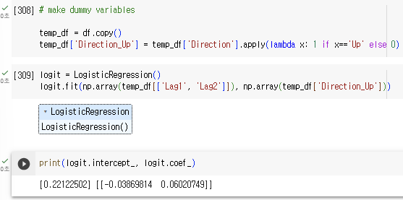

estimated coefficient (Lag1): -0.03869814

estimated coefficient (Lag2): 0.06020749

(b)

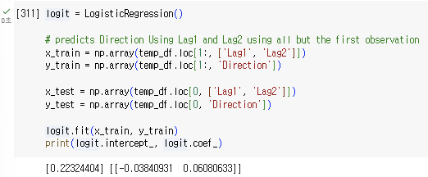

estimated coefficient (Lag1): -0.03840931

estimated coefficient (Lag2): 0.06080633

(c)

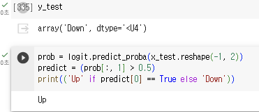

It isn't correctly classified.

(d)

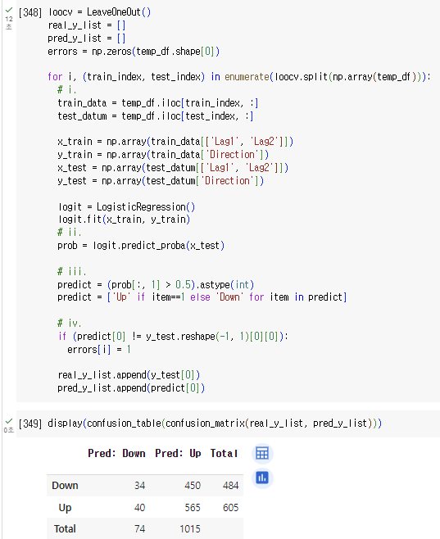

(e)

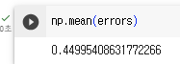

The LOOCV test error rate is 45% which implies that our predictions are marginally more often correct than not.