**User Manual**

**Poverty Analyzer**



**Submitted by:**

Carl Michael C. De Taza

Sue C. Sinangote

David Frank Edison Regodos



**Prompt:** Introduction

**Poverty Analyzer**

Welcome to the Poverty Analyzer user manual. An innovative web-based application developed using the Django framework in Python, coupled with the joblib library to integrate a machine learning model. This application allows you to evaluate if your household is considered poor or not poor using a Decision tree model. This user manual provides step-by-step instructions on how to use the app.

**Installation**

Before using the Poverty Analyzer App, make sure you have the required libraries installed. You can install the necessary libraries using the following commands:

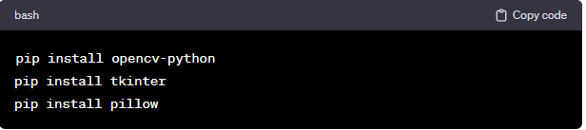

pip install Django==4.1.3

scikit-learn==1.0.2

joblib==1.3.2

imbalanced-learn==0.11.0

**Running the Program**

1. Open a terminal or command prompt.

2. Navigate to the directory containing the Django.

3. Run the script by executing the command: `python manage.py runserver `



**Prompt:** Here are the steps!

1. 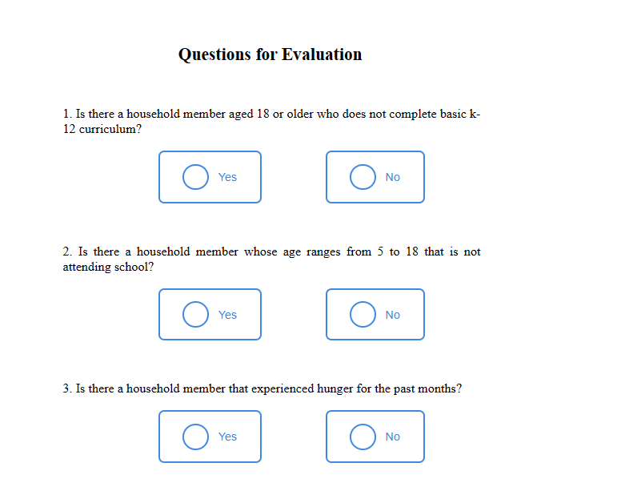**Evaluation Screen:**

  - Upon running the program, a page titled "Poverty Analyzer" will appear.

- This screen has a 13 questions which will be a variable or indicator that will be use by the model this web-app have.

   - After you fill up all the question there is a submit button to process the data.

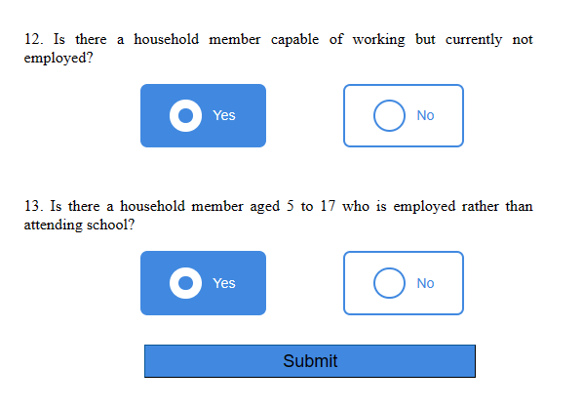

**2. Process the Data:**

  - after submitting the evaluation form, the data will be process by the Decision tree model. Using joblib library the model can be called multiple times without changing it accuracy.

1. **Result:**

 - There is two result that will displayed based on your answer in the evaluation form.   - Possible result is poor and not poor.

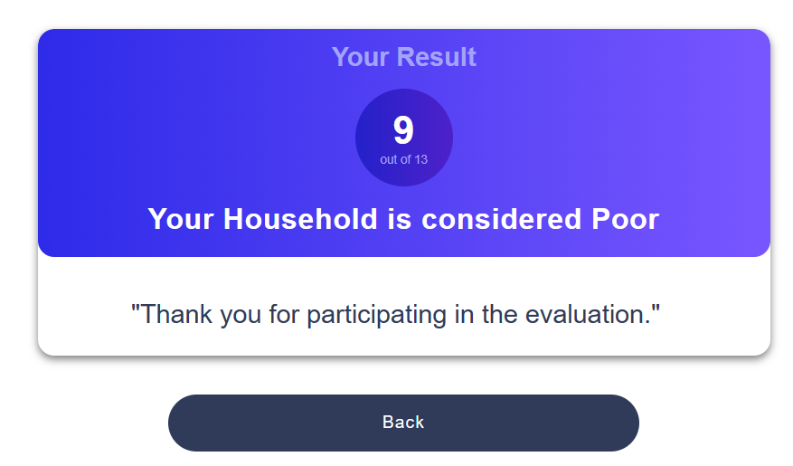

1. **Closing the Program:**

   - You can close the program by clicking the close button on the window.

Thank you for using the Poverty Analyzer App! If you have any questions or feedback, please refer to the application's documentation or contact the developer.

**END**