**Image Processing App User Manual**

**Introduction**

Welcome to the Image Processing App user manual. This application allows you to load an image, apply a series of image processing operations, and display processed images. This user manual provides step-by-step instructions on how to use the app.

**Table of Contents**

1. Installation
2. Running the Program
3. Loading an Image
4. Image Processing
5. Displaying Images

**1. Installation**

Before using the Image Processing App, make sure you have the required libraries installed. You can install the necessary libraries using the following commands:

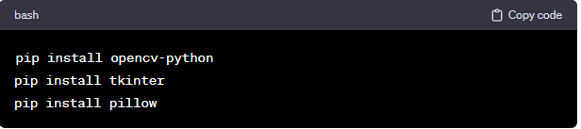

These commands use the `pip` package manager to install the OpenCV library (`opencv-python`), the Tkinter library (`tkinter`), and the Pillow library (`pillow`). Ensure that you have a working internet connection and that your Python environment is properly set up.

**2. Running the Program**

1. Open a terminal or command prompt.

2. Navigate to the directory containing the Python script.

3. Run the script by executing the command: `python script_name.py` (Replace `script_name.py` with the actual name of the Python script).

**3. Loading an Image**

To load a new image, follow these steps:

- Click the "Load New Image" button.

- A file dialog will open. Navigate to the location of the image you want to process.

- Select an image file (supported formats: jpg, png, jpeg) and click "Open."

**4. Image Processing**

The Image Processing App applies a series of image processing operations to the loaded image. The current processing operations include:

- Converting the image to grayscale.

- Inverting the grayscale image.

- Applying median blur to the inverted image.

- Inverting the smoothed image.

- Creating a sketch effect by dividing the original grayscale image by the inverted smoothed image.

To process an image:

- After loading the image, the processed image will be displayed.

**5. Displaying Images**

The application displays processed images.

Feel free to explore the Image Processing App and experiment with different images to see the effects of the applied processing operations.

Thank you for using the Image Processing App! If you have any questions or feedback, please refer to the application's documentation or contact the developer.