**User Manual**

**Text Summarization App**



**Submitted by:**

Carl Michael C. De Taza

Sue C. Sinangote

David Frank Edison Regodos



**Prompt:** Introduction

**Text Summarization App**

The Text Summarization App is a simple graphical user interface (GUI) application built using the Tkinter library in Python. The purpose of this application is to generate a summary of input text using the BERT-based summarization model provided by the `summarizer` library.

**Features**

1. **Input Text Area:** Enter or paste the text you want to summarize in this area.

2. **Generate Summary Button:** Click this button to generate a summary of the input text.

3. **Output Text Area:** View the generated summary in this area.

**Installation**

   - Ensure that you have Python installed on your system.

   - Install the required libraries using the following command:

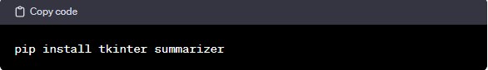

**Running the Program**

1. Save the provided code in a file with a `.py` extension, for example, `text_summarizer_app.py`.
2. Open a terminal and navigate to the directory containing the file.
3. Run the application using the following command:

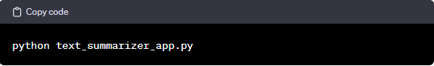

nlp.py



**Prompt:** Here are the steps!

**1. Input Text**

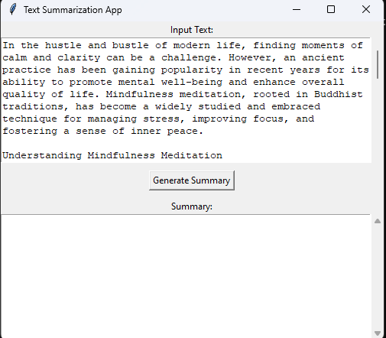

   - This area is labeled "Input Text." Enter or paste the text you want to summarize in this area. The text area is scrollable to accommodate large amounts of text.

**2. Generate Summary**

   - Click a button to initiate the text summarization process.

   - The application uses a BERT-based summarization model from the `summarizer` library.

**3. Summary**

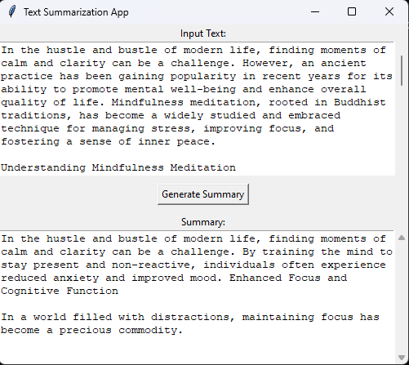

   - This area is labeled "Summary."

   - The generated summary will be displayed in this area.

   - The text area is scrollable to accommodate large summaries.

   - The text is initially disabled, preventing user input. It is enabled after generating a summary and disabled again when clearing the input text.

**END**