**User Manual**

**Medical Expert App**



**Submitted by:**

Carl Michael C. De Taza

Sue C. Sinangote

David Frank Edison Regodos



**Prompt:** Introduction

**Medical Expert App**

Welcome to the Medical Expert App! This program is designed to help you diagnose common illnesses based on the symptoms you are experiencing. Please follow the instructions below to use the system effectively.

**Installation**

Make sure you have Python installed on your system. The code uses the Tkinter library, which is included in most standard Python installations.

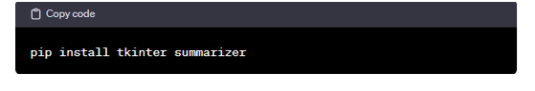

**Running the Program**

1. Open a terminal or command prompt.

2. Navigate to the directory containing the Python script.

3. Run the script by executing the command: `python script_name.py` (Replace `script_name.py` with the actual name of the Python script).

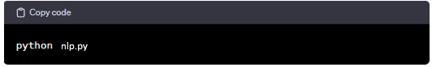

medical.py



**Prompt:** Here are the steps!

**1. Welcome Screen**

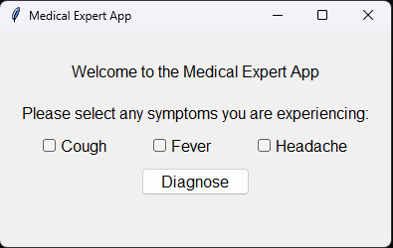

   - Upon running the program, a window titled "Medical Expert App" will appear.

   - The window will display a title label, welcoming you to the app.

**2. Instruction**

   - Below the title, you will find an instruction label asking you to select any symptoms you are experiencing.

**3. Symptoms Selection**

   - Check the checkboxes next to the symptoms you are currently experiencing.

   - The available symptoms are: Cough, Fever, and Headache.

**4. Diagnose**

   - After selecting your symptoms, click the "Diagnose" button.

   - The system will analyze your symptoms using simple rule-based logic.

**5. Diagnose Result**

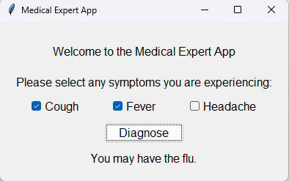

   - The result label below the "Diagnose" button will display the system's diagnosis based on your selected symptoms.

   - Possible diagnoses include the flu, a cold, a migraine, or a general healthy state.

**END**