**“Impact Of Facebook Usage On The Academic Performance Of Grade 11 ABM Student At Informatics College During Academic Year 2024 - 2025”**

**A Research Paper Presented to the Informatics College Cebu Inc- Consolacion**

**Dyrah Yap Aguinaldo**

**Cristel Ann Alfeche**

**Gian Renee Arsua**

**Jenerose Basay**

**Chamy Camporidondo**

**Kese Mae Escanilla**

**Buny Mae Morpos**

**Ashley Jane Niez**

**Althea Ricaplaza**

**Riza Sanchez**

**Shein Dawn Tero**

**Grade 12-GAS**

**Ms. Ni**ña Mariz manatad****

**November 2024**

**CHAPTER 1**

**INTRODUCTION**

**BACKGROUND OF THE STUDY**

Social media, in general, and Facebook, in particular, affect the academic performance of students. There is an aspect that some research has pointed to the fact that the association between social media use and academic achievement is a negative relationship: it can decrease involvement in real-life communities and also poorer scores. Conversely, others suggest that social media use also leads to positive effects such as helping with learning.

For students of Grade 11, especially the ones on the Accountancy, Business, and Management strand, Facebook could be a sharp tool either way. It offers opportunities for collaboration, resource sharing, and academic support. However, it may also be a source of distractions, procrastination, and lack of focus on academic obligations.

For that, there is a great need for the educator, the parents, and policymakers to know what lies underneath and drives this kind of phenomenon concerning the relationship between Facebook use and academic performance among students. Then they could employ interventions designed to guide these students to maintain appropriate time allocation in using the site while juggling other academics obligations in pursuit of the maximal potential benefits of using Facebook on academic performance without necessarily leading to some adverse outcomes.

**STATEMENT OF THE PROBLEM**

This study sought to establish if Facebook usage influences the academic performance of Grade 11 ABM students at Informatics. The study focused on the frequency and nature of use of Facebook on the study habits, focus, and general results of students in school. More specifically, this study aimed to answer the following questions:

1.How do Grade 11 ABM students use facebook during study hours?

2.What activities do students primarily engage on Facebook (e.g., social interaction, entertainment, educational content)?

3. What correlation between the time spent on Facebook and the students’ academic performance in key subjects?

4.How Facebook usage impact students’ concentration, in peformance and study habits?

**SIGNIFICANCE OF THE STUDY**

This study is significant as it provides valuable insights into how Facebook usage affects the academic performance of Grade 11 ABM students at Informatics College Cebu during the academic year 2024–2025. The findings will be beneficial to the following:

**This research will inform the students** - to become more cognizant of the impact that Facebook usage has on their study habits, concentration, and their academic performance as a whole. Perhaps it would help them understand better time management skills and the right use of social media.

**Teachers** - with more knowledge and information about student behavior online as well as whether Facebook affects how these students might learn. They will be enabled to develop intervention plans to encourage more concentration on academic work for students.

**Parents** - better management of how children use the internet and manage social media based on the implication of Facebook effects on academic work is possible for parents.

**School Administrators** – This study's findings can benefit school administrators in developing policies or programs that encourage responsible social media usage among students while maintaining academic excellence.

**Future Researchers** – The study is a reference for future research concerning social media usage as well as its impact on the academic performance of students; thus, contributing to more inclusive studies about the topic.

SCOPE AND LIMITATIONS.

This study examines the impact of Facebook usage on the academic performance of Grade 11 ABM students at Informatics College Cebu during the academic year 2024-2025. It's main purpose is to identify the general problem and effects of using Facebook through their academics,that Grade 11 Accountancy and Business Management (ABM) students experience. The scope of this study is limited to the grade 11 abm students only. This study will focus on the impact of Facebook usage on the academic performance of Grade 11 ABM students and will not include other grade 11 sections.

**THEORITCAL FRAMEWORK**

The Flow Theory, originally developed in psychology, has been applied to human-computer interaction and, more recently, to social media usage. According to flow theory, users may become engaged in their online activities for extended periods of time, which may have positive and negative psychological impacts.

Some of the examples of how Facebook distract students on their academic focus like Facebook notifications, likes, and comments on posts, cause psychological reactions that urge users to return to the app, causing an engagement cycle that interferes with academic attention. Students become curious and distracted from their schoolwork when they receive alerts about new friend requests or updates on their friends' activity. Users are diverted from their academic work by event reminders, such as birthday announcements or updates on group activities, which cause them to check Facebook. Whether from group or individual chats, message notifications urge users to participate in discussions, which further delays productive work.

Novak et al. (1988) provided an extensive review of the definition of flow as experience by people immersed and performing a task described as total concentration and deep involvement in the task carried out these activities will result in an intrinsic enjoyment combined with a keen curiosity and a pleasure that encourages repetition of the activity on one hand but the loss of time and inability to control oneself to quit this attraction on the other.

Flow has been addressed in several context such as students engagement in the classroom (Shernoff et al., 2003) learning of a foreign language (Egbert, 2004) management of sports and music leisure activities (Custodero, 2002; Jackson, 1997; O'Neill, 1999a, O'Neill, 1999b) customers online shopping behavior (Koufaris, 2002; Pace, 2004; Smith & Sivakumar, 2004), p people's behavior and acceptance of messages and content exchange online ( Lu et al., 2009), and motivation and creativity (Csikszentmihalyi, 1988) for both adolescence and students in their classes for employees at work. Although we think that the current stream of interactions and content generated on facebook are tremendously similar to other online and offline activities at their core, the number of hours users spend and continuously increasing and many people state that they are now organizing their lives on facebook. Professionals are increasingly creating profiles, updating messages, and uploading videos to provide their fans with the information while fans follow the news on their profile pages.

People are, by their nature, curious (Hofstede, 2010). facebook allows for far reaching information on one interface-namely, individuals' "walls" the flow of information shared on "walls" increases tremendously, varying according to the size of the individual's network (i.e., the number of "friends" and groups). consequently the users attraction involvement in activities on the social platform attracts greater concentration and time following the updates and news. Information shared also concerns all areas of daily life which makes websites like facebook a mine that anyone can explore and enlarge.

**SCHEMA**

Social media, Facebook in general, has been a part of the students' lives. Though Facebook is used for communication, entertainment, and information, overuse or misuse may impact the academic performance of the students. This study will examine the effects of Facebook usage on the academic performance of Grade 11 ABM students at Informatics Cebu in terms of time spent on Facebook, study habits, and general academic outcomes.

Using the framework concept, this research examines how Facebook usage impacts study habits and time management of students that consequently affects their grades, class participation, and productivity. This research provides identification of relationships between such variables and insight into whether Facebook is or is not a distraction and/or tool for the achievement of academic enhancement.

**Conceptual Framework Schema**

**Independent Variable (IV)**

**\*Facebook Usage**

- Type of activities (Chatting,Videos,Posting)

- Time management

**Dependent Variables (DV)**

**\*Academic Performance**

- Class Participations

- Productivity and task Completion

-Study habits

This schema can outline how the usage of Facebook can affect the way of study habits and ultimately leads to poor performance. Refine this further to your area of interest. Would you want me to include any kind of visual diagram?

**DIAGRAM REPRESENTATION**

FACEBOOK USAGE

TIME SPEND, ACTIVITIES, ENGAGEMENT

ACADEMIC PERFORMANCE

GRADS, CLASS PARTICIPATIONS, TASK COMPLETIONS

this Shows the Cause and effect relationship: Facebook usage influences study habits, whick in turn affects academic performance.

**DEFINATIONS OF TERMS**

1.**Facebook Usage**- Amount of time and activities students use Facebook, which includes chatting, watching videos, posting, and other interactions made with content.

2.**Academic Performance** - Grading of students on how efficient they have been with their studies, usually measured by grades attained in class, class participation, and completion of task set.

3.**Study Habits** - refers to the methods and practices that students adopt during learning, such as time management, note-taking, and concentration on academic tasks.

4.**Time Management** - Students ability to manage their study activities in proportion to the amount of time spent on Facebook and other related activities.

5.**Distraction** - Student tends to divert the attention of using Facebook towards study activities that sometimes may result in procrastination or decreased concentration.

**CHAPTER II**

**Review of Related Literature**

**Local Studies**  
 Several local studies have explored the impact of social media use, particularly Facebook, on academic performance among students. One study by Labrador and Bautista (2019) examined the relationship between Facebook use and academic performance of university students. The results showed that excessive Facebook use had a negative impact on students' time management skills, leading to delays and less study time, even though the platform can be a useful tool for academic collaboration and information sharing. Due to frequent interruptions and reduced concentration, students who used Facebook more frequently demonstrated poorer academic achievement.  
  
Similarly, Gonzales and De la Cruz (2020) conducted a study among high school students and found a significant correlation between Facebook usage and lower academic performance. They observed that students who primarily used Facebook for socializing and entertainment often neglected their academic responsibilities, resulting in lower grades.  
  
However, studies like those by Gonzales and Rios (2018) have explored the balance between the negative effects and potential benefits of Facebook use. They found that students who used Facebook for educational purposes, such as joining academic discussion groups or accessing online learning materials, were able to improve their knowledge and enhance their learning experience. Nevertheless, they emphasized that excessive social media engagement, without proper time management, can lead to poor time management and lower academic performance.  
  
**Foreign Studies**  
 The relationship between social media usage, particularly Facebook, and academic performance has also been explored in foreign studies. A study by Junco (2012) found that students who frequently used Facebook experienced lower grades due to the distraction it posed during study time. However, other research suggests that when used for academic purposes, social media can enhance learning by promoting collaboration and sharing of educational resources (Greenhow & Lewin, 2016).  
  
Studies have also examined the patterns of Facebook usage among students. Bicen and Beheshti (2012) found that students spent an average of 30 minutes to 2 hours per day on Facebook, with socializing being the most common activity. Research by Pasek et al. (2009) showed that heavy social media use could lead to decreased class participation, lower attendance, and subsequently, lower grades. In contrast, Bowers and Kumar (2015) found that when students used Facebook for socializing, it often led to distractions and lower academic performance, but when used for organizing study groups or accessing academic content, the platform had a more neutral or even positive impact on performance.  
  
One common limitation in studies on social media usage is the reliance on self-reported data, which may introduce biases. Students may under report or over report their Facebook usage, leading to inaccurate findings. Additionally, while this study focuses on Facebook usage and its immediate academic impact, previous research has noted the potential psychological effects of social media use on students, such as addiction, anxiety, and social comparison (Fuchs, 2017). These factors are critical to understanding the broader impact of social media but fall outside the scope of the present study.  
  
This research includes a method which is the survey research. This simply means that it uses questionnaires or polls to collect data from a large sample which was the approach that researchers did. This research also determine the ABM students academic performances and how the usage of facebook affect their accomplishments. Specifically, a total of 20 respondents from different ABM sections within Informatics College were randomly selected to be a participant for the researchers study. Selected respondents answered a survey questionnaire containing questions related to their strand and the research topic provided by the researchers. Data gathered from this research is computed onto interpretation. Together with the   
primary data, the researcher also made some secondary resources in the form of documents to support the survey result.

**CHAPTER 111**

**Research Design**

This is a Purposive-evaluative study that tries to determine whether Grade 11 ABM students at Informatics use Facebook and whether it may effects their performance in school. The study will also try to determine if there are any adverse experiences on Facebook that may have affected the academic achievement of students.

**Research Method**

This research includes a method which is the survey research. This simply means that it uses questionnaires or polls to collect data from a large sample which was the approach that researchers did. This research also determine the ABM students academic performances and how the usage of Facebook affect their accomplishments. Specifically, a total of 20 respondents from different ABM sections within Informatics College were randomly selected to be a participant for the researchers study. Selected respondents answered a survey questionnaire containing questions related to their strand and the research topic provided by the researchers. Data gathered from this research is computed onto interpretation. Together with the   
primary data, the researcher also made some secondary resources in the form of documents to support the survey result.

**Research Participants**

This study requires at least 64 participants grade 11 ABM students.In addition,they must be Grade 11 ABM from Informatics College Consolacion Cebu.The participants are capable of answering the questions and information.We provide informed consent and understanding about the potential problems of sharing personal experiences related to the study.

**Sampling Procedure**

In this study, the researcher used purposive sampling to select the sample. According to Creswell (2014), purposive sampling is a Quantitative research technique where the researcher intentionally selects participants or sites that are most likely to provide valuable information to help answer the research question.   
  
The goal of purposive sampling is to identify individuals or groups that can contribute the most relevant data about the phenomenon being studied. The purpose is to use these selected participants to gather in-depth information about the broader population, rather than aiming for a random or representative sample.  
  
Arikunto (2010) further explains that in purposive sampling, the sample is chosen not based on random or standardized criteria, but based on the specific objectives and needs of the research. The researcher selects subjects that are most appropriate for the study's purpose.  
  
So in summary, the researcher employed a purposive sampling approach in this study. This non-probability technique allowed the researcher to intentionally select participants who were most likely to offer insights that could help address the research question, rather than seeking a random or representative sample of the population. The goal was to gather rich, in-depth information about the phenomenon of interest.

**Research Instruments**

The research tool for this study is a structured questionnaire assessing the effects of Facebook use on academic performance among Grade 11 ABM students at Informatics. Several statements in the questionnaire will be rated by the respondents on a 5-point Like scale, where 1 means Strongly Disagree, and 5 means Strongly Agree; the questionnaire will also have any other relevant demographic questions such as age, year level by the respective departments, and those experiences will relate to Facebook use and academic performance. To allow better accessibility, the questionnaires will be given out either online or in-person. Data obtained from the questionnaires will be treated and analyzed through most adequate statistical methods to determine the presence or absence of possible relationships between Facebook usage and academic performance.

**Data Gathering**

A study at Informatics students ABM 11 found that many students use Facebook to complete assignments and communicate with teachers. It suggests that Facebook can positively impact academic performance when used for educational purposes and Facebook can help students with school works and communication.  
  
  
This research includes a method which is the survey research. This simply means that it uses questionnaires or polls to collect data from a large sample which was the approach that researchers did. This research also determine the ABM students academic performances and how the usage of facebook affect their accomplishments. Specifically, a total of 20 respondents from different ABM sections within Informatics College were randomly selected to be a participant for the researchers study. Selected respondents answered a survey questionnaire containing questions related to their strand and the research topic provided by the researchers. Data gathered from this research is computed onto interpretation. Together with the   
primary data, the researcher also made some secondary resources in the form of documents to support the survey result.

**Phase 1. Approval of the transmittal Letters and the survey Questionnaire**

The researchers can properly survey their research study after receiving a letter of transmural before doing the research, the researchers must focus and deal with the needed papers including the transmittal letter  and  survey questionnaire. Before sending the final documents comprising the transmittal letter, survey questionnaire ,and affidavit of consent to be signed , the research professor should first approve and review the survey or questions . Once Research professor agree and signed it, the researcher will immediately begin conducting the study by sending the transmittal letter, affidavit of consent ,and survey questionnaire to the selected senior high school ABM students so that they can answer it.

**Phase 2. Identifications of the research setting and respondents**

The researcher will select Cebu City as the general setting and  Informatics College Consolacion ABM student  as the specific setting of the study. The researchers will choose 20 respondents in total  to collect adequate data, and the respondents will be a senior high school student ABM.

**Phase 3. Data collection In collecting data**

The researcher will collect certain information during respondents free time to prevent misunderstanding and disturbance. They will seek permission from  the respondents  to conduct their research and they will provide a file including contents  of the affidavit of consent and will instruct respondents the way of answering  the survey questions. Researchers will start counting,  recording and evaluating data when the respondents have completed the survey questionnaires. Distribution Phase The initial step will be to distribute the 20 survey questionnaires using questioning face to face the respondents .

**Statistical Treatment Data**

To analyze how Facebook affects academic performance, the data will be treated using Purposive statistics to summarize Facebook usage and Academic Performance.

**Pearson’s correlation**- will be used to test the relationship between the two variables, with hypotheses stating that a significant negative correlation suggests higher Facebook usage leads to lower academic performance.

Facebook usage significantly impacts academic performance, either positively or negatively.

\

**CHAPTER IV**

**PROFILE OF RESPONDENTS**

This section will present the demographic profile of respondents wherein they are Informatics Senior High School Students with whom they have conducted Survey. The data comprises relevant characteristics such as age, gender, grade level, academic strand.

1. **Grade Level & Strand.**

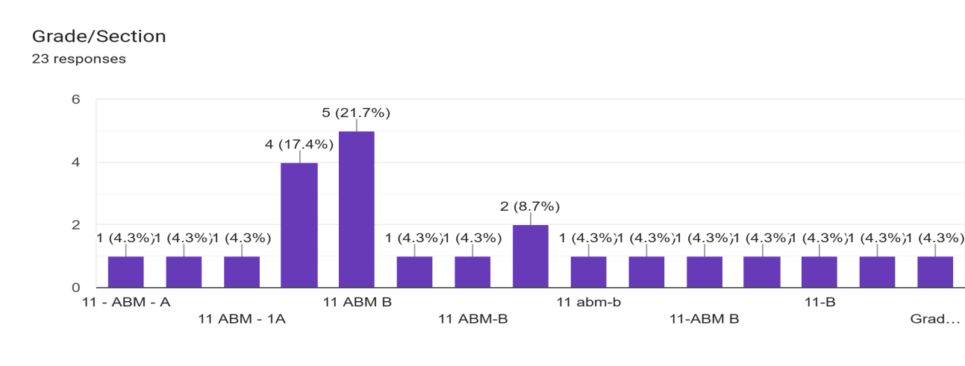

**Chart 4.1: Grade Level & Strand of Respondents**

Chart 4.1 illustrates the distribution of respondents based on their grade level and strand. Among the group, 11 ABM B stands out with the highest number of respondents, accounting for 6 individuals (21.7&). In contrast, the other group - 11 ABM - B - each have 1 respondent (4.3%). Overall, the data represents a total of 20 respondents, with 11 ABM B being the most represented strand.

1. **Age**

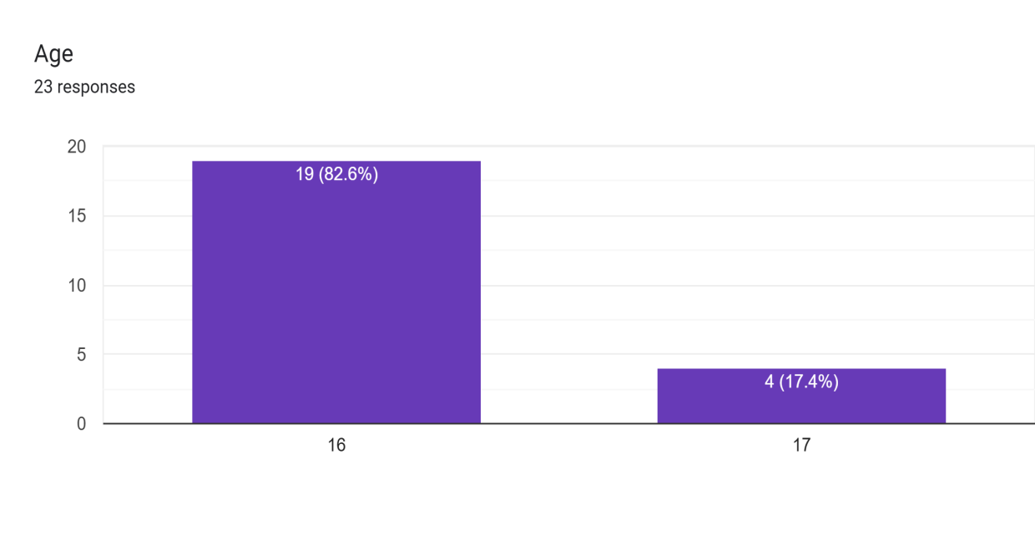

**Chart 4.2: Age of Respondents**

Chart 4.2 illustrates the ages of respondents in the research study. The majority of the respondents, representing 19 individuals (82.6%), are 16 years old, including that this age group is the most prominent among the participants. Meanwhile 4 respondents (17.4) are 17 years old. This age distribution highlights that the study primary focus on senior high school students in their late teenage years. Reflecting a critical demographic for analyzing using Facebook in school.

1. **Gender**

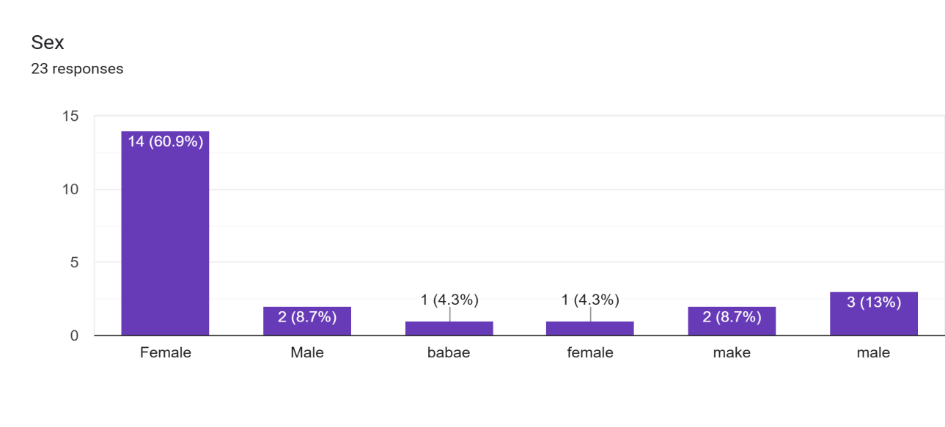

**Chart 4.2: Gender of Respondents**

Chart 4.3 illustrate that the study reveals a significant gender disparity among the respondents, with 60.9% of the participants being female and only 13% being male. This indicate that females constitute a majority of those involved in the research study. The larger representations of females suggests that they may be more actively engaged in Facebook. Conversely, the lower percentage of males highlights a potential gap in their involvement or interest in this area, which could offer insights into gender-specific behaviors and preferences in Facebook.

**PIE NUMBER 1**

**USING FACEBOOK OFTEN AFFECTS MY GRADES**

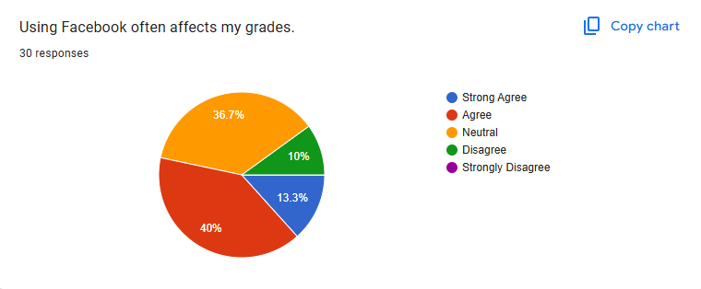

The result of the survey indicate that 29 of the respondents were 11 ABM A student and among them (40%)of respondents agree and the majority express and neutral stands at (36.7%) meanwhile (10%) Disagree and (13.3%) Strongly Agree and there is no percentage in strongly disagree and This result suggest that most respondents take strong position there is Fairly balance distribution between agreement and disagreement with a significant portion remaining undecided.

**PIE NUMBER 2**

**I GET DISTRACTED FROM STUDYING WHILE USING FACEBOOK**

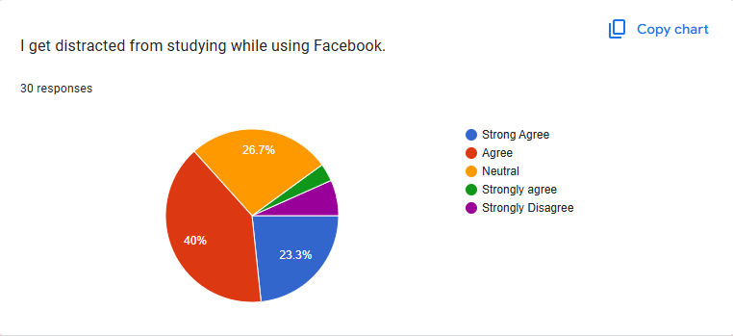

Among the 29 responded of 11 A ABM students, (40%) Agreed and (26.7%) Stands Neutral and (23.3%) Strongly Agree and Strongly Disagree has no percent Their for, majority of the respondents still undecided if using Facebook will get them distracted and there is fairly balance of agreed and strongly disagree.

**PIE NUMBER 3**

**FACEBOOK HELPS ME FIND USEFUL INFORMATION FOR MY ASSIGMENTS.**

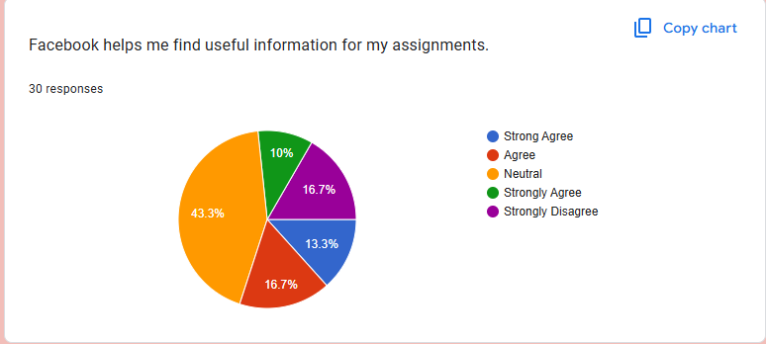

29 respondents 11 ABM A Students answered (43.3%) Stands for Neutral dissension and Agree and Strongly Disagree has same percent of (16.7%) While (13.3%) Strong Agree and the lest Strongly agree of (10%).

**PIE CHART 4**

**I FEEL LIKE FACEBOOK HAS A NEGATIVE IMPACT ON MY STUDY HABITS**

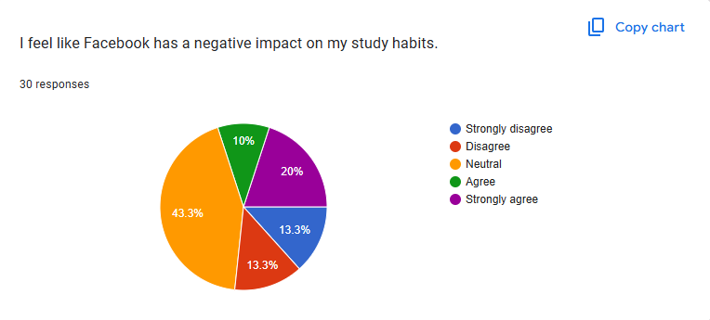

The majority of the respondents (43.3%) are in between, meaning they do not express a clear view on whether Facebook is detrimental to their study practices. While 30% (20% Strongly Agree and 10% Agree) think that Facebook impacts them negatively in terms of study practices, 26.6% (13.3% Strongly Disagree and 13.3% Disagree) do not view Facebook as a deterrent to studies.

**PIE CHART 5**

**I IMPROVED MY GRADES BY USING FACEBOOK FOR GROUP STUDY.**

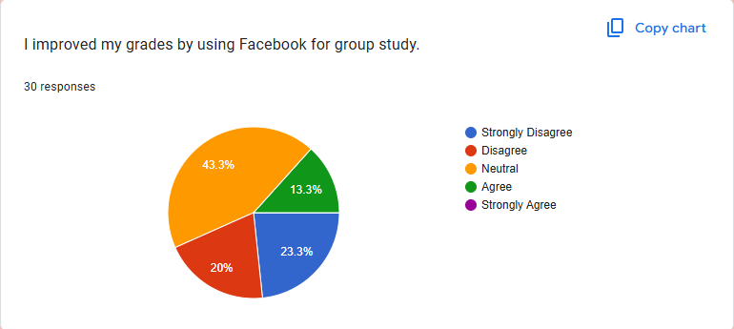

Most (43.3%) keep neutral stance with an assumption of either no response or suspicion towards the utility of Facebook to contribute towards group studies that result in good grades. While 13.3% (Disagree + Strongly Agree) reveal that they don't consider Facebook an appropriate aid to good grades by studying groups, merely 20% opine in a general consensus with respect to utility for studying in a group so as to produce better grades and there's none of strong agree opinion.

**PIE CHART 6**

**FACBOOK HELPS ME STAY CONNECTED WITH CLASSMATES FOR SCHOOL-RELATED DISCUSSIONS.**

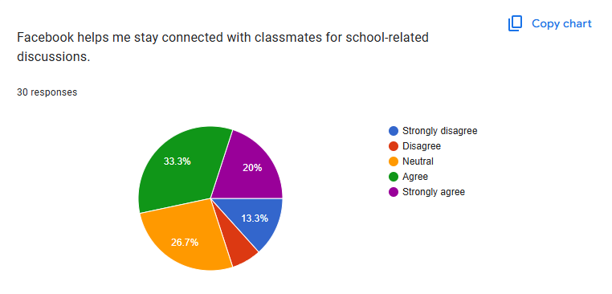

Survey outcomes show that 53.3% of participants (33.3% Agree and 20% Strongly Agree) opine that Facebook assists them to remain in contact with classmates to discuss school-related matters. Alternatively, (26.7%) of participants hold a neutral stand, implying that they neither rate Facebook as helpful nor unhelpful for that reason. Then, 13.3% strongly disagree and an estimated (6.7% )disagree, implying that 20% of participants do not find Facebook effective for academic exchange.

**PIE CHART 7**

**I BELIEVE USING FACEBOOK FOR SCHOOLWORK MAKE ME MORE PRODUCTIVE**

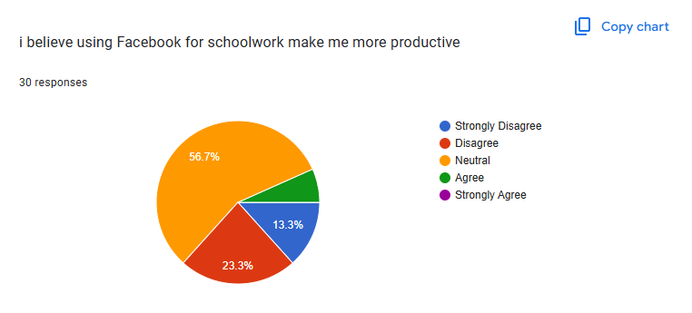

The majority of respondents (56.7%) remain neutral, indicating that they neither strongly agree nor disagree with the idea that Facebook enhances their productivity for schoolwork. However, a significant percentage (36.6% - combining 13.3% Strongly Disagree and 23.3% Disagree) believe that Facebook does not help them become more productive in their studies. Only a small portion (around 6.7%) agree, and no one strongly agrees.

**PIE CHART 8**

**SPENDING TOO MUCH TIME ON FACEBOOK AFFECTS MY PERFORMANCE**

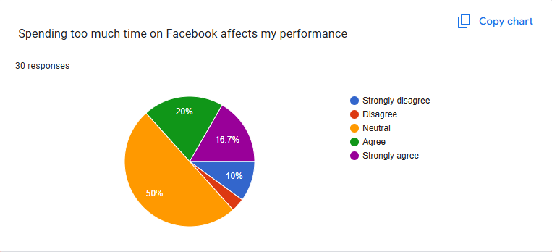

50% of the respondents stay neutral, with no clear uncertainty or mixed opinions about Facebook and its effect on their performance. 36.7% of the respondents think that too much Facebook usage reduces their performance negatively (20% Agree and 16.7% Strongly Agree). About 13.3% of the respondents believe that too much time on Facebook does not hurt their performance (10% Strongly Disagree and 3.3% Disagree).

**PIE CHART 9**

**I THINK FACEBOOK IS A MAJOR DISTRACTION DURING MY CLASSES OR HOMEWORK**

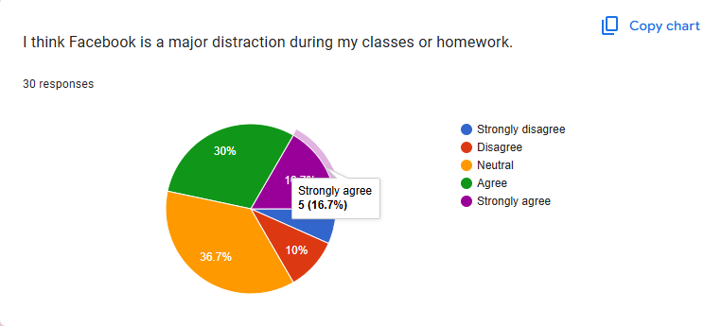

A large percentage (36.7%) of the students are neutral, suggesting that they might not have a strong feeling or experience mixed impacts of Facebook on their concentration. Yet, 46.7% (30% Agree and 16.7% Strongly Agree) admit that Facebook is a significant distraction in their classes or when they are assigned homework. Conversely, mere 13.3% (3.3% Strongly Disagree and 10% Disagree) do not perceive Facebook as a significant distraction.

**PIE CHART 10**

**I USE FACEBOOK MORE FOR SOCIALIZING THAN FOR STUDYING**

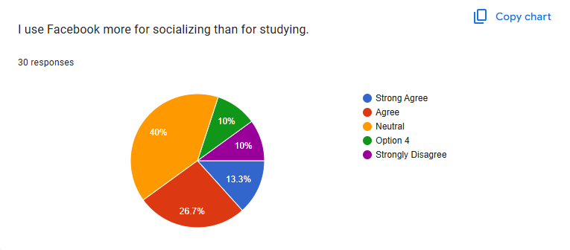

A major percentage (40%) are neutral, which means that they may use Facebook for both socializing and studying or they may have conflicting views about their usage. But more percentage (40% included Strongly Agree and Agree) acknowledge that they use Facebook more for socializing rather than for studying. Contrarily, only 20% (10% Disagree and 10% Strongly Disagree) disagree with this statement, i.e., they use Facebook mainly for studying.

**ANALYSIS**

1. The title reflects a particular demographic interest in Grade 11 ABM students at Informatics College and a targeted field of research related to their performance. This implies that the study will look into how Facebook usage affects their learning outcomes, which is pertinent since the site is popular with students for both academic and social use.
2. The term "Impact of Facebook Usage" reflects a research-based strategy focused on determining causality and correlation. It means that the study will not only monitor but also quantify the degree to which Facebook usage impacts students' academic achievement. This might include examining time spent on Facebook, the nature of activities (educational or non-educational), and how these routines impact study efficiency, focus, and overall grades.
3. The phrase "Academic Performance" implies that the research will discuss different areas of student learning, including study habits, time management, information retention, and school activity engagement. By analyzing this connection between high school students, the study might lead to insights on whether Facebook is an effective academic aid or a distraction factor and hence inform teachers and students about how to utilize social media for optimum academic performance.

**CHAPTER V**

**SUMMARY OF FINDINGS**

This chapter presents a summary of the findings, conclusions, and recommendations of the study, addressing the problems “The Impact Of Facebook Usage On The Academic Performance Of Grade 11 ABM Student”.

The researcher employed a Purposive method to assess the impact of Social Media on the behavior of Senior High School

Students At Informatics. The study hypothesized that there is significant relationship between social media Usage and the Academic Performance of the Students, particularly when categorized according to age, sex, frequency of social media usage, and familiarity of the Academic.

The level of social media Usage, knowledge among students was found to be moderate, while their Academic Performance behavior was generally categorized as frequent. Data revealed a correlation between the frequency of social media usage and the students' effectiveness in Academic Performance.

The findings indicated that students who are more familiar with advanced social media Usage strategies exhibited higher levels of the Academic performance. The results also showed that there is a significant relationship between social media usage and Academic Performance, with variations observed when grouped by frequency of social media usage and familiarity on their Academic.

In summary, the study concluded that social media Usage has a considerable influence on the Academic Performance of senior high school students, with effective performance significantly enhancing their Academic.

**CONCLUSION**

The study concluded that social media usage plays a significant role in Academic Performance behaviour of Senior High School Students At Informatics. It highlights how social media usage can shape and improve of the habits of Senior High School Students At Informatics, showing that those who actively use and understand Social Media Usage tend to be more successful in the Performances of the ABM 11 Students. Findings revealed that the students with higher familiarity and frequent use of Social Media Usage strategies demonstrated increased effectiveness in Academic Performance. A significant relationship was observed between Social Media and the Academic Performance behavior, particularly influenced by the Students frequency of the Social Media Usage and the knowledge of the Grade 11 ABM Students . Overall, the study highlights that enhancing student understanding and application of social media usage can greatly improve their Academic Performance.

R**ECOMMENDATIONS**

<https://www.ajmesc.com/index.php/ajmesc/article/view/43>

<https://www.sciencedirect.com/science/article/pii/S2199853124000775>

[https://www.journals.edu.ph/reyes2022](https://www.journals.edu.ph/reyes2022)](https://www.journals.edu.ph/reyes2022%5D(https://www.journals.edu.ph/reyes2022))

<https://www.scribd.com/document/507015593/RRL-NEWWWWWW>

(<https://www.sciencedirect.com/science/article/pii/S2212567120300071>).

<https://www.emerald.com/insight/content/doi/10.1108/YC-07-2016-00622/full/html>

**CURRICULUM VITAE**



Name:Jenerose Basay

Adress: Casili Consolacion Cebu

Email: jenerosebasay36@gmail.com

Cell :09534977117

Date of birth: June 01.2007

Citizenship: Filipino

Education Background

Junior High School: Mandaue Day High School 2021-2023

Senior High School: General Academic Strand

INFORMATICS CONSOLACION COLLEGE Cebu-consolacion Pitogo, National Highway Consolacion Cebu

2023-2025

Name:Buny Mae C. Morpus



Adress:Casili Consolacion Cebu

Email:bunymorpos14@gmail.com

Cell:09358235142

Date of Birth: May 04, 2006

Citezinship: Filipino

Educational Background

Junior High School: Consolacion National High School (EC)

2021-2023

Senior High School: General Academic Strand

INFORMATICS CONSOLACION COLLEGE CEBU- Consolacion Pitogo, National Highway Consolacion Cebu

2023-2025

Kese Mae V. Escanilla

Casili, Sto nino 2,Consolacion Cebu



Kesev.escanilla@gmail.com

09691332404

July 21, 2006

Filipino

Educ background:

Junior High School:

Consolacion ational High School Evening Class

Senior High School:

Informatics Consolacion

Cristel Ann Alfeche

Upper Jagobiao, Sta. Teresita, Mandaue City



Cristelenalfeche@gmail.com

09105636375

July 27, 2007

Filipino

Educ background:

Junior High School:

Jagobiao National High School

Senior High School:

Informatics Consolacion

Riza Mae Sanchez

Pob. Oriental, Centro, Consolacion



rizamaesanchez07@gmail.com

09752216598

January 30, 2007

Filipino

Educ background:

Junior High School:

Jagobiao National High School

Senior High School:

Informatics Consolacion

Sheina Dawn Tero



Bag ong , Dan Yati Liloan

sheinadawntero32@gmail.com

09815698702

July -28-2007

Filipino

0Educ Background

junior high school: Anonang Sur Bogo City

Senior High school: Informatics Consolacion

Name:Ashley Jane B. Niez



Address:H.Abellana Street Cubacub Mandaue City

Email:niezashley81@gmail.com

Call No.:0993-033-7399

Date of Birth:August 19,2007

Citizenship:Filipino

EDUCATIONAL BACKGROUND

JUNIOR HIGH SCHOOL:CANDUMAN NATIONAL HIGH SCHOOL

2021-2023

SENIOR HIGH SCHOOL: GAS

INFORMATICS CONSOLACION College Cebu-Consolacion Pitogo,National Highway Consolacion Cebu

2023-2025

Dyrah Y. Aguinaldo



Bagalnga Compostela

Cebu

dyrahyap@gmail.com

09703652648

October 20,2006

Filipino

Educ background:

Junior High School:

Ramon Duterte Memorial National High School

Morning Class

Senior High School:

Informatics Consolacion

Chamy B. Camporidondo



Simborio,yati,liloan

Shami2007@gmail.com

09526013935

January 21 2007

Filipino

Jonior high school: Tayud national high school

Senior high: Informatics consolation

Gian Renee M. Arsua



Sitio Cardava Basak Mandaue City

giannearsua@gmail.com

09124660756

April 18, 2007

Filipino

Educ background:

Junior High School:

Jagobiao National High School

Senior High School:

Informatics Consolacion

Name:Althea Ricaplaza



Adress:Casili Consolacion Cebu

Email:ricaplazalthea75@gmail.com

Cell:09930034984

Date of Birth: March 14, 2007

Citezinship: Filipino

Educational Background

Junior High School: Consolacion National High School (DC)

2021-2023

Senior High School: General Academic Strand

INFORMATICS CONSOLACION COLLEGE CEBU- Consolacion Pitogo, National Highway Consolacion Cebu

2023-2025