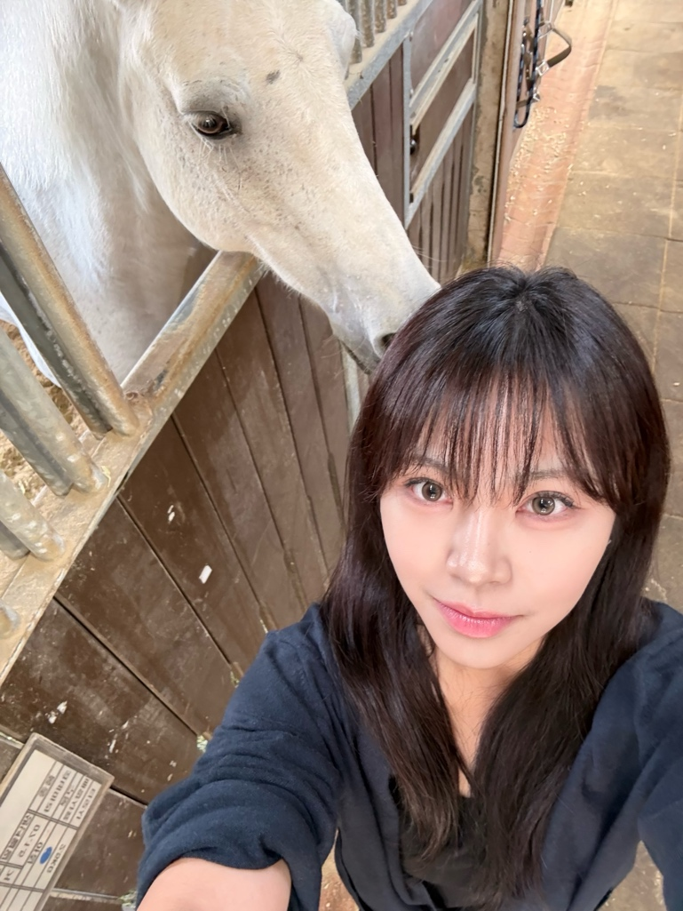
“What? You are going to the Let’s Run Park?” My mother was stunned when I told her I had to visit the park for a class project. It is the only park in Korea that includes a horse racing track, and in Korea, horse racing is often associated with gambling.
To be honest, I was also a bit worried because of the negative images of horse racing that I had seen on TV and in movies before: images of gaunt gambling addicts smoking while shouting for their picks.
When I finally went, however, I was shocked. I had not expected to find such a beautiful park filled with sunlight everywhere. In fact, only 30% of the park was occupied by the track, while the rest featured many attractive spaces, including scenic promenades, large grassy areas for picnics, and playgrounds for children.
And for horse lovers, there were also many places to explore and enjoy, such as horse stables and training tracks.
I also realized that not everyone went to the racetrack to gamble. Some came simply to appreciate the horse races themselves. Nor was everyone a heavy or chronic gambler. Many people bet $5 or $10 just for fun after an honest, hard day’s work—indeed, Disneyland for grown-ups.
In sum, this was a fun and healthier-than expected park. However, its long-held negative image was hurting the park. My analyses revealed a troubling pattern: many excellent programs, such as horse-riding experiences for children, had been discontinued.
This, to me, was a question of fairness. The problem was not the park itself, but the unjustified negative images associated with the park, horse racing, and even the horses.
But horses are also our friends. Around the world, there are many joyful horse-related events and festivals, such as rodeos in the US, where there are even categories for children. Anyone, regardless of age, gender, or ethnicity, can enjoy these events with their families and loved ones. Also, take polo in the UK, a healthy sport that families and friends can enjoy together.
Korea also has a long history with horses. In fact, there are wall paintings depicting horses that date back hundreds of years.
With this in mind, my team got to work. First, we explored ways to highlight the park’s potential. To better understand the challenges it faced, we conducted a fishbone diagram analysis to really identify the root causes of its negative image. We then carried out a SWOT analysis to determine the key strengths and opportunities that should be emphasized in our revival plan.
For example, one interesting finding was that, beyond its association with gambling, horse-related sports in Korea are often seen as something for the wealthy rather than for ordinary people. That is, they are considered sports for the rich and posh. However, our analysis showed that while this is true to a certain degree, this perception is not entirely true.
For one, the number of places where people can enjoy horse riding, to my own surprise, was much higher than I expected. Even as a Korean, I never knew that this tiny country of ours had as many as 1,450 horse-riding facilities. And surprisingly, many were very affordable, starting from $2 for a horse ride, including admission for the entire day, at that. In other words, a sport that many people consider exclusive was, in some cases, even more affordable than other sports like badminton, an immensely popular sport where court rentals can cost around $5.
Thus, I recommended that we focus on the horses themselves, specifically on horse-related sports rather than simply promoting the park (although we did do that as well) because the PR messages until then were all and only about the park. Since there were many horse-riding facilities across the country, we emphasized the need to host PR activities year-round, with many held both permanently and periodically; until then, the park relied mainly on one-time promotional events.
By hosting these kinds of activities, we wanted people to start asking, “This Sunday, should we go swimming or go horse riding?”
We didn’t stop at this, however. We also tried to improve the negative image by highlighting the fact that the Korea Racing Authority (KRA), which operates the park and the racetrack, is, in fact, a government-run organization under the Ministry of Agriculture, Food and Rural Affairs (MAFRA). In other words, a portion of its profits is used to support the livestock industry and its farmers. The list goes on; significant funds are directed to subsidize education in rural areas, and so forth.
In fact, aside from operational costs, close to 100% of the profits are returned to society for its benefit—a fact that I did emphasize, of course, as not many people know this. In a way, the KRA also suffers from society’s perception that horse racing equals gambling.
In the same way, I also suggested that we highlight past measures and future plans for the public good, such as ESG initiatives, and showcase how the KRA takes good care of retired racehorses, how hard it works to promote the well-being of horses and other animals, and so forth.
Last, but never least, we also suggested that the number of activities should increase (the more the merrier to attract people to the park), including horse riding courses, using race tracks that are idle during weekdays to hold amateur races, opening horse-related healing programs, and leasing space for film shoots, which is also a great way to promote the park.
This is a memorable project that taught me that behind every problem, there is an essential root cause, such as the negative images of horses in this case. That is, I learned to link a problem with a bigger issue. Moreover, I learned to carry out all kinds of relevant analyses, realizing once again that sometimes a good numerical analysis is better than a thousand words.

