Registration No.-20BCE1837

Name- Rupin

Sub: CSE2005 (Lab)

Lab No-3 Date: 20.01.2021

# Aim:

1. To implement FCFS without arrival time
2. To implement FCFS with arrival time
3. To implement SJF without arrival time
4. To implement SJF without arrival time

# Algorithm:

* FCFS

Step1: Create the number of process.

Siep2: Get the ID and Service time for each process.

Step3: Initially, Waiting time of first process is zero and Total time for the first process is the starting time of that process.

Step4: Calculate the Total time and Processing time for the remaining processes. StepS: Waiting time of one process is the Total time of the previous process.

Step6: Total time of process is calculated by adding Waiting time and Service time. Step7: Total waiting time is calculated by adding the waiting time for lack process. Step&: Total turn around time is calculated by adding all total time of each process. Step9: Calculate Average waiting time by dividing the total waiting time by total number of process.

Step 10: Calculate Average turn around time by dividing the total time by the number of process.

* SJF

Step1 1: Display the result. Step1:Get the number of process.

Step2:Get the id and service time for each process.

Step3:Initially the waiting time of first short process as 0 and total time of first short is process the service time/gf that process.

Step4:Calculate the total time and waiting time of remaining process. StepS: Waiting time of one process is the total time of the previous process.

Step6:Total time of process is calculated by adding the waiting time and service time of each process.

Step7:Total waiting time calculated by adding the waiting time of each process.

Step8:Total turn around time calculated by adding all total time of each process. Step9:calculate average waiting time by dividing the total waiting time by total number of process.

Step10:Calculate average turn around time by dividing the total waiting time by total no of process

Step11: Display the result

# Code:

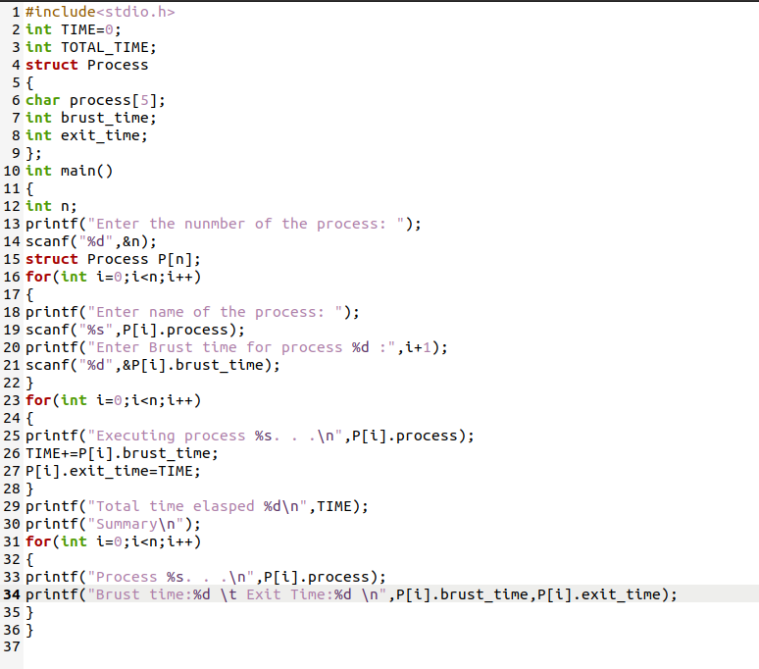

# Output:

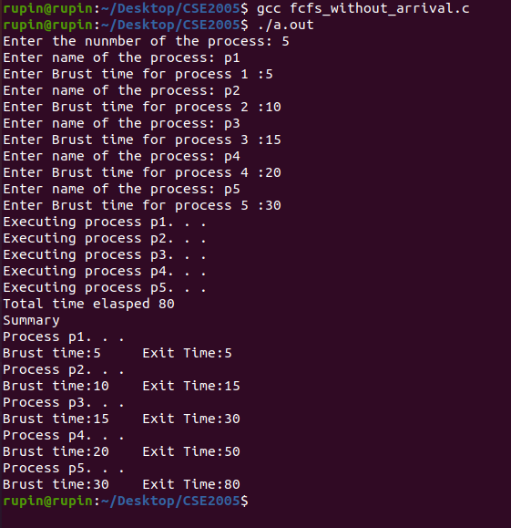

2.

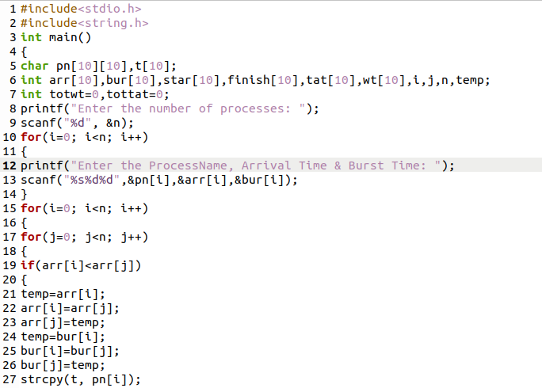

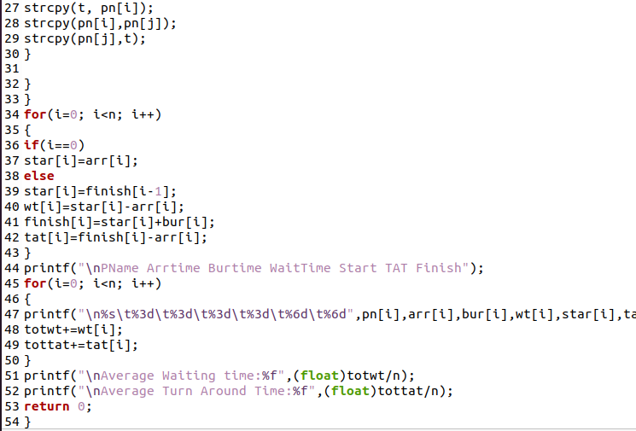

Output:

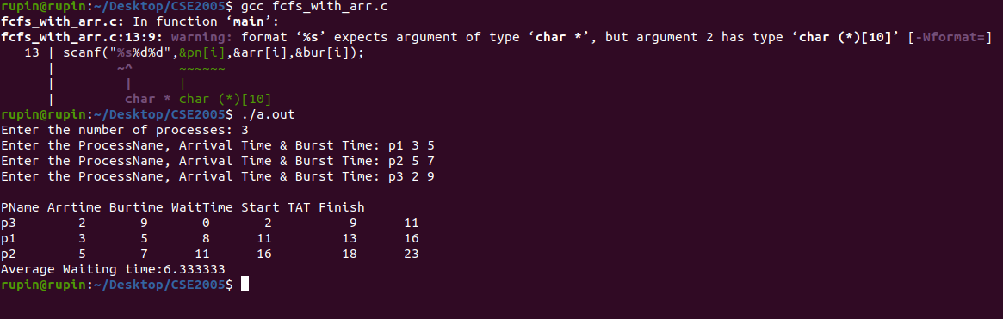

3.

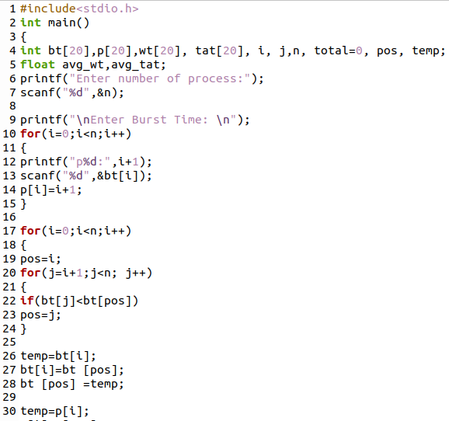

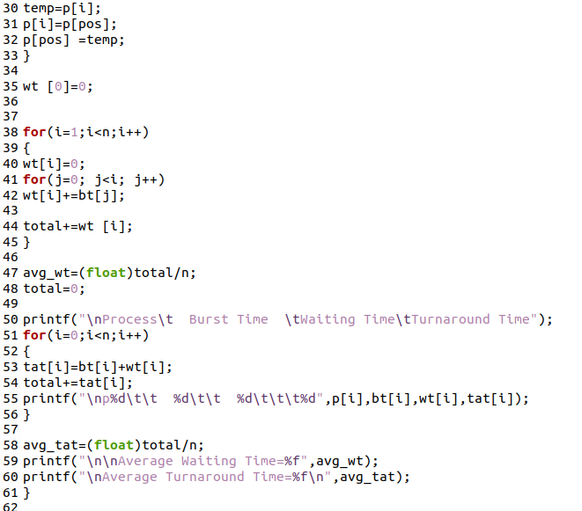

# Output:

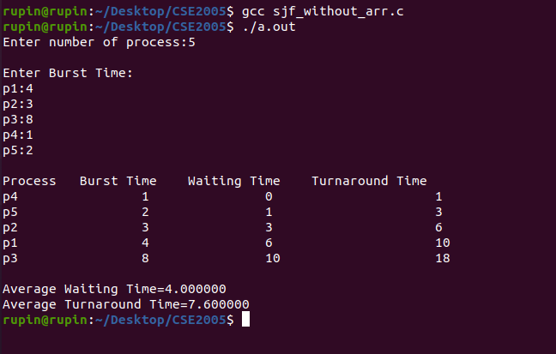

4.

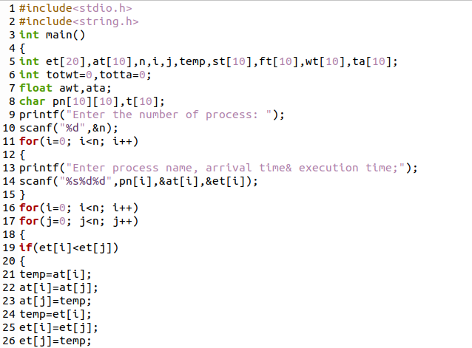

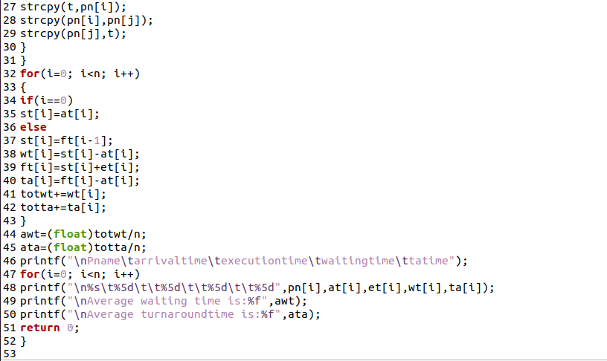

# Output:

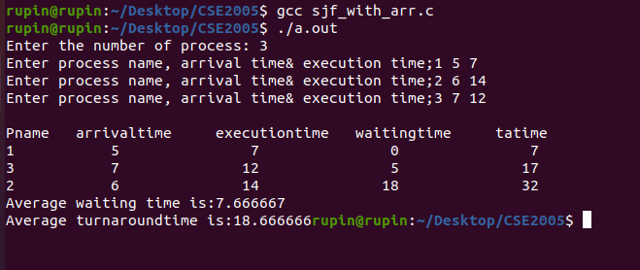

Result:

All the scheduling programmes are implemented sucessfully.