**Question 3:**

**What are loops, and what do we need them? Explain different types of loops with their syntax and examples.**

Loops are used to run the repeated block of code.

i.e When you want print a statement for 10 times, then use loops to print the statement instead of writing a statement for 10 times.

There are different types of loops.

1. For loop
2. While loop
3. Do. While loop
4. **For loop:**

For loop is a simple to iterate the loop for multiple times until the condition is false.

**Syntax:**

for (initialisation; condition check; changer/increment/decrement)

{

---------------------------- block of statement;

}

**Example:**

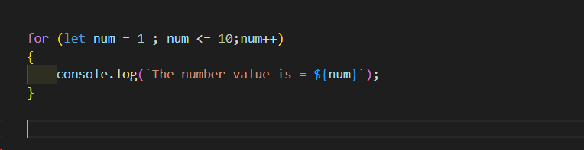

When a variable is initialized,

1. The variable should satisfy the condition,
2. Then for loop statement will execute.
3. Then performs increment/decrement operation
4. And so on it repeats, until the condition satisfies.
5. If the condition is false, it will come out of the loop.
6. **While loop:**

While loop is an iterative loop that until the condition is false.

**Syntax:**

While(condition)

{

// statements

}

**Example:**

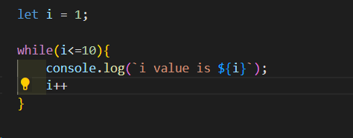

**Steps:**

1. Initialize the variable
2. Condition will be evaluated.
3. If condition is true, the set of statements will execute until the condition satisfies.
4. Once the condition fails, loop ends.
5. **Do While:**

Do while also is an iterative loop until the condition fails.

And at least set of statements will be executed once even though the condition fails.

Syntax:

do

{

//set of statements

}while(condition)

**Example:**

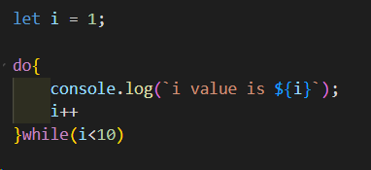

**Break and Continue:**

In a loop, we can terminate the execution by using break statement when condition meets.

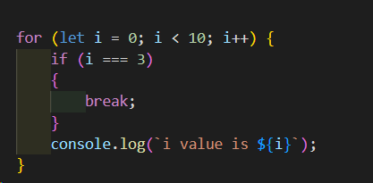

Here when condition i === 3 satisfies, execution comes out of the loop.

It will print up 0,1,2 iterations.

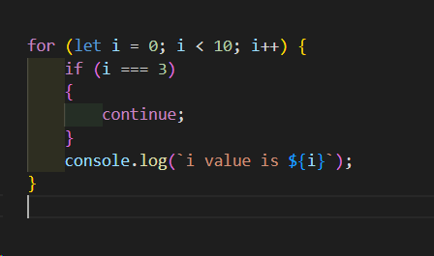

Here when condition i === 3 satisfies, current execution will be skipped.

It will print up 0,1,2,4,5,6,7,8,9 iterations.