**2. Describe the categorization of operators in JavaScript based on their functionality. Provide examples for each category?**

Operators are used to perform operations on variables. Operators are used for high accuracy and faster calculation.

Operators are in different types.

1. Arithmetic Operators
2. Assignment operators
3. Comparison
4. Unary
5. Logical Operators
6. **Arithmetic Operators:**

Arithmetic operations to do mathematical operations like addition, subtraction, multiplication, division, modulus.

// Arithmatic

let num1 = 20

let num2 = 10

let addition = num1 + num2

console.log("Addition of num1 and num2 : " +  addition)

let subtract = num1-num2

console.log("Subtraction of num1 and num2 : " +  subtract)

let multiply = num1*num2

console.log("Multiplication of num1 and num2 : " +  multiply)

let divide = num1/num2

console.log("Division of num1 and num2 : " +  divide)

let modulo = num1%num2

console.log("Modulus of num1 and num2 : " +  modulo)

1. **Assignment Operators:**

Assignment operator is used to assign values to variables.

1. **Single Assignment**

let num1 = 10

value 10 is assigning to num1. num1 is a variable name.

1. **Compound Assignment:**

Combination of Arithmetic operations with assignment operator.

+=, -=, *=,/=,%=

Eg :

let x = 10

x += 5;   // x = x+5

let y = 20

y -= 5  // y = y-5

let z = 30

z *= 5 // z = z*5

1. **Comparison Operators**
2. Equality and not equality without data types **(==, !=)**

In comparison operators, it will check only the data.

**== -** checks whether both the values are equal,returns true

!= - checks whether both the values are not equal,returns false

console.log(true == true)

console.log(true != true)

1. Equality and not equality with data types

**===** -- checks whether both the values are equal with same data type , returns true.

**!==** -- checks whether both the values are not equal and different data type, returns false.

console.log("amar" === "raja"); // false

console.log("amar" === "amar"); //true

console.log("amar" !== "raja"); //true

console.log(10 === "10"); //false

console.log(10 === 10); //true

1. **Unary Operators:**

Unary operators will work on single operands.

There are different types:

1. **Unary plus operator (+)** :

Usually, unary plus operator is used when string is used to convert into a number.

If the string is a proper in number format, it will convert into a number otherwise it will return NaN.

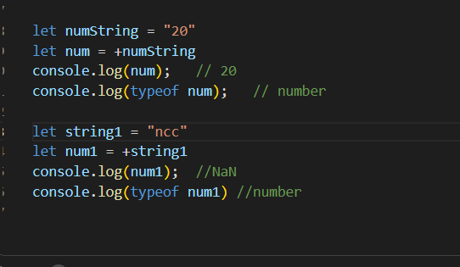

1. **Unary minus operator(-):**

Unary minus operator is used to convert its operand to negative value.

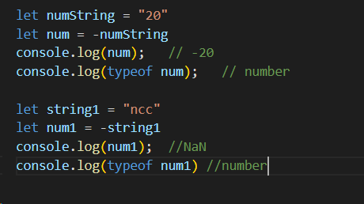

1. **Prefix and Postfix:**

Prefix: means it adds number by 1 and it assigns to the same number.

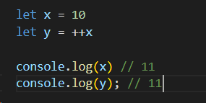

Postfix : means it assigns the value and increments

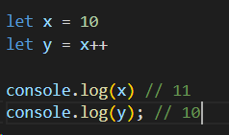

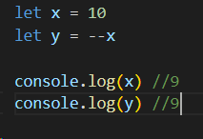 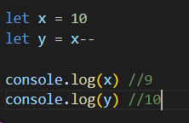

1. **Logical Operators:**

Different types in logical operators like logical AND, logical OR, logical NOT.

Logical AND(&&) : if both operands are true then it returns true.

If either one operand is false, it returns false

Logical OR(||) : if one is true, then it returns true

Logical NOT(!) : if value is true , returns false

