**3.** **Differentiate between unary, binary, and ternary operators in JavaScript. Give examples of each**

**Unary Operator:** Unary operator means, it requires only single operand.

**Binary Operator:** Binary operator means, it requires two operands.

**Ternary Operator:** Ternary operator means, it requires three operands.

**Unary Operator:**

Unary plus operator, that converts numberstring to number.

If the number is in string format, then try to convert , it will return NaN.

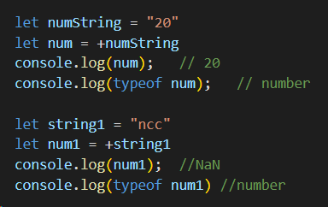

Unary minus operator, that converts positive number to negative number.

If the number is in string format, then try to convert , it will return NaN.

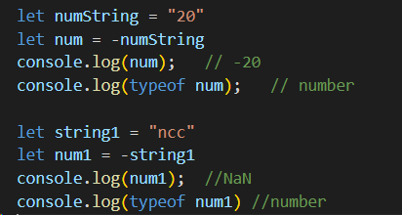

**Binary Operator:**

Binary operator will be performed between two operands. Like addition, subtract, multiply, divide…etc

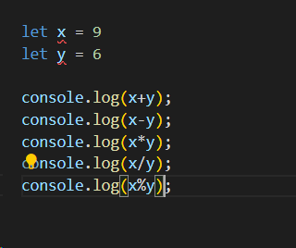

**Ternary Operator:**

Ternary operator is one, that it takes 3 operands.

One is expr, second 2nd truth value and finally third is false value.

Eg:

const ternary = condition ? truthy : falsy ;

