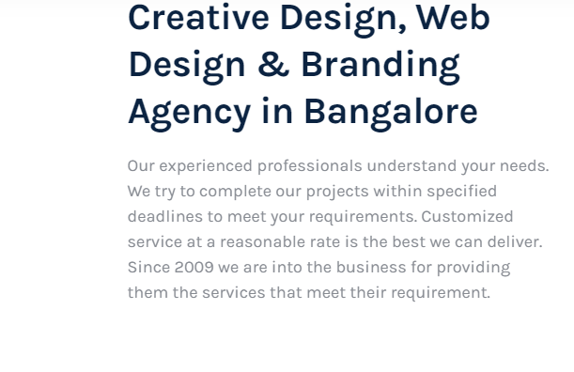

**Branding service in Bangalore for creative designing and web designing!**

We have a team of experts and experienced employees to ensure your satisfaction!

We, at ForAds start with the understanding of your needs and requirements, and the business agenda of your service. After all the analysis, we design the branding for your services and manage to deliver it at your doorsteps in the decided time-span. We work for customized projects and requirements and provide a reasonable and cost-effective service.

Since 2009, we have successfully helped various clients to achieve their success by providing them the best branding services.

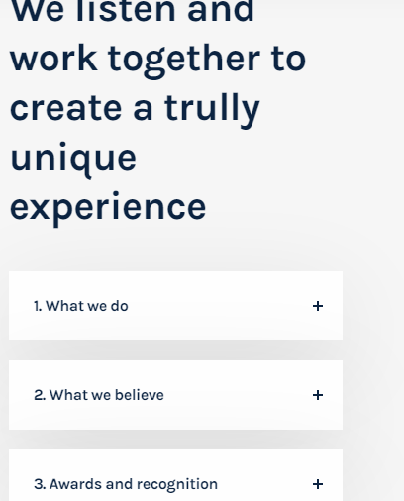

**Uniqueness is our specialty!**

**We work and collaborate for plagiarism free experiences.**

*What we do*

We provide branding services to help various firms to get global recognition. We help with logo designing and title designing for the agencies and help them get a user-base and a market value with a trustful image.

*What we believe*

We believe in uniqueness and plagiarism free content with a world-class facility and the satisfaction of our client is our sole goal. We believe in helping every small and big firm to get a market reputation.

*Achievements*

We have helped several MNCs and companies along with the unicorns to get their branding done after various market analyses. We have designed world-class logos and titles and have provided attractive and admirable services to clients to help them build their fan-base.

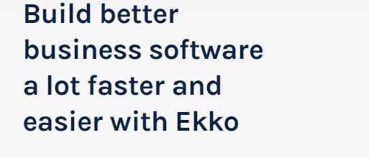

**Get the best branding with memorable icons and logos with ForAds!**

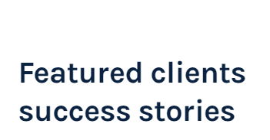

*Success stories of clients of FogAds who have achieved a giant success.*

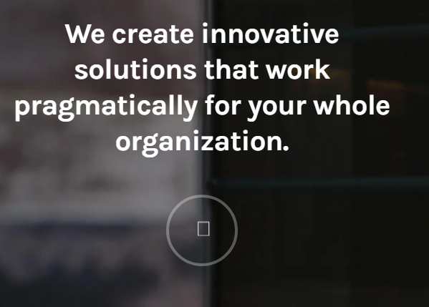

**Dignissim per dis dignissim mi nibh a parturient habitasse suspendisse ut a feugiat morbi neque tortor.Tellus volutpat scelerisque tempor.**

**https://www.ekko-wp.com/static/wp-content/uploads/sites/3/2018/10/testimonial3.jpg**

**Claire Olson**

**Innovation never wears off with us!**

**We develop new services and ensure innovations to be opted by the whole of our team.**

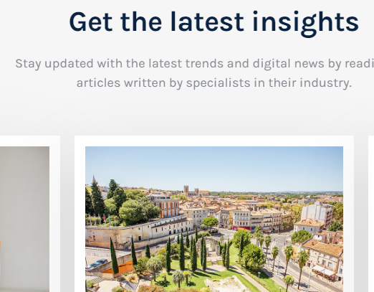

**Stay tuned...**

Stay updated about various technological advancements and digitalization with the blogs and articles provided by the team of our expert researchers.

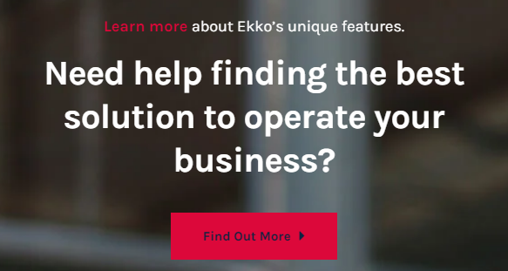

**Dignissim per dis dignissim mi nibh a parturient habitasse suspendisse ut a feugiat morbi neque tortor.Tellus volutpat scelerisque tempor.**

**https://www.ekko-wp.com/static/wp-content/uploads/sites/3/2018/10/testimonial2.jpg**

**Luke Jacobs**

**Why wait, when everything easy and accessible with us?**

**Best solutions for business growth and trends are there with FogAds.**