**Configurations**

To login to your merchant dashboard, please visit <https://indomarche.com/login>.

Before starting to sell on IndoMarche, please configure your shop first for better understanding and performance. While configuration, you follow certain steps to set-up your shop on the portal. To start with the same, you must configure at least one payment method to get all the payments for the sales. Also, you must add a shipping zone too to allow the customers to make the orders from the shop.

We hope that you must have already registered with IndoMarche, so let’s start with our journey!

**Attention!** Some of the options might not be accessible to you due to certain rules of the marketplace, IndoMarche. To access any option that is not available and is a must for you, please reach out to us at merchant support helpline, or open a ticket!

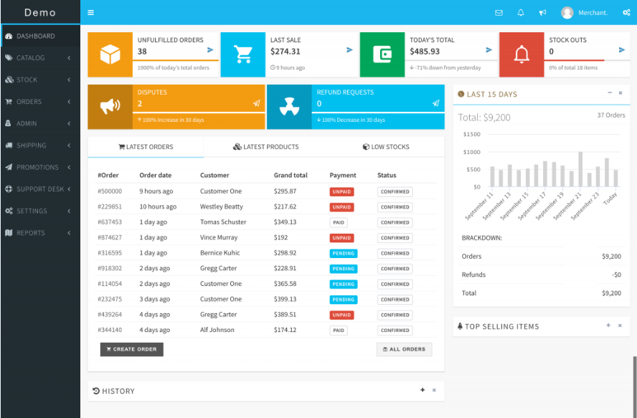

Here is a brief on what all is to be configured for a successful journey ahead!

* General Configurations
* Shop Settings
* Payment Methods
* Tax Settings
* Go Live
* Get Verified

**General Configurations**

The initial step in the configuration is setting up the brand information of your business. For this, you must add several details like the business name, its logo, your cover image, the physical location of the business, and many more.

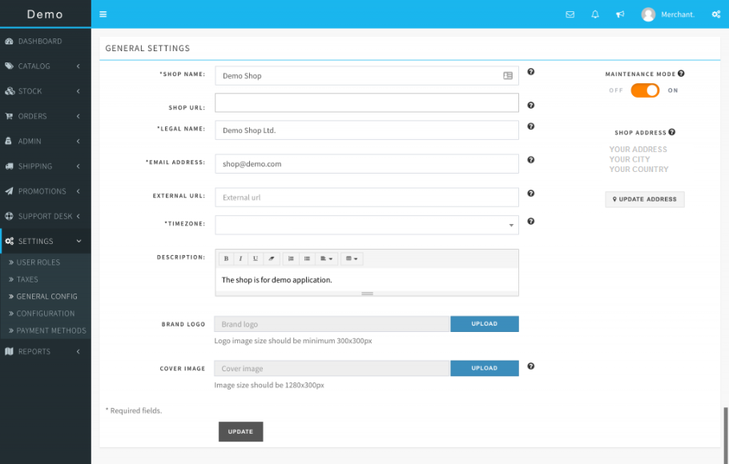

**Shop Settings**

This is all about your virtual shop store at IndoMarche’s portal and here you can manage everything about it including the inventories, orders, notifications, and also the supports.

SETTINGS >> CONFIGURATIONS

-----------------------------------------

*INVENTORY*

ALERT quantity level can be set for your shop to get the notification via Email whenever an item goes below the limit and hence helps ensure fast actions on any changes.

*Notification can be turned off too by visiting the notification settings.*

SETTINGS >> CONFIGURATIONS >> INVENTORY

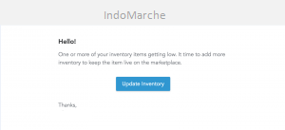

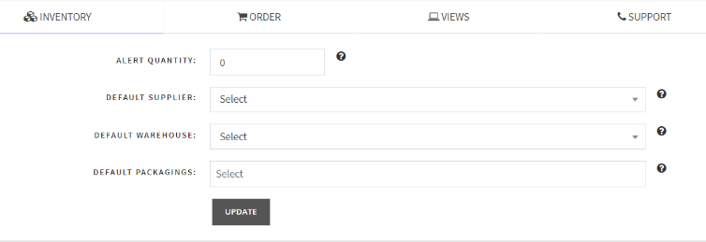

*ORDER*

To set the order rules, you can access this section! You can set the handling cost that is the extra cost to be added with the orders’ shipping costs during the checkout. In this section, you can also set the prefix and suffix for the order number to set the defaults for payments, order tax, etc.

SETTINGS >> CONFIGURATIONS >> ORDER

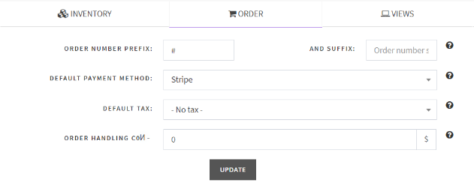

*SUPPORT INFORMATION*

You can set customer support information like Email, phone number, or address, wherever you wish to solve the issues of the customer. Default sender Email and name can also be set here.

SETTINGS >> CONFIGURATIONS >> SUPPORT

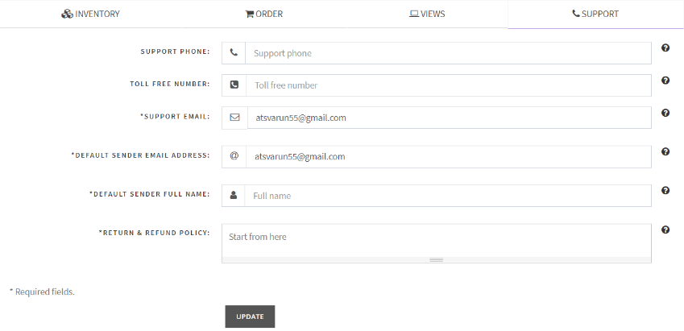

*NOTIFICATION SETTINGS*

This section is the turn the notifications on or off.

SETTINGS >> CONFIGURATIONS >> NOTIFICATIONS

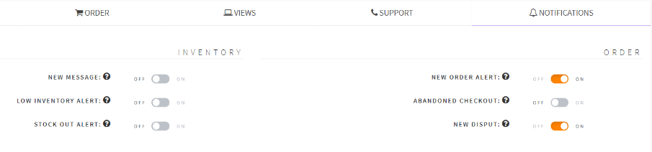

**Payment Methods**

Setting the payment methods is among the most significant steps of the configurations before going live on the IndoMarche’s portal. There must be at least one payment method activated to get instant payments on every order confirmation by the customers. To get the in-depth directions for the same, visit the configuration page.

**Warning!** Unless there is an active payment method available on your store account, your product listing will not be visible to the customers.

SETTINGS >> PAYMENT >> METHOD

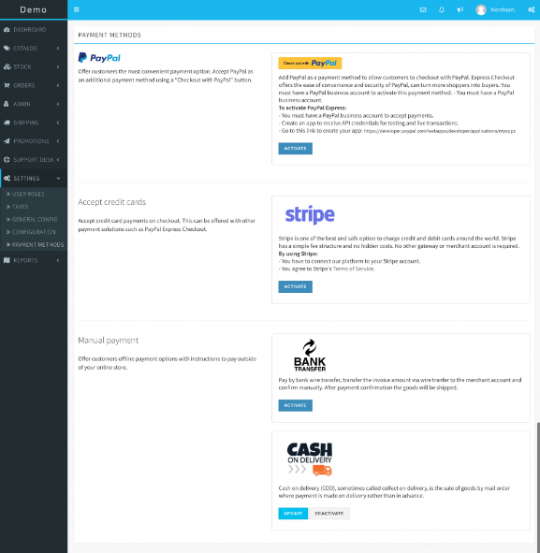

**Attention!** Some options might be hidden from you because of the configuration of the marketplace! To access any of the hidden options, please reach out to us at the customer support helpline.

**Tax Settings**

You can list all the tax profiles here for your products. Once you are done creating the tax profiles, later while creating the shipping zones, these tax profiles will be linked with the shipping zones.

SETTINGS >> TAXES

**Go Live**

Everything is configured now, and it is time to go live. Turn OFF the MAINTENANCE MODE, and confirm to move further.

SETTINGS >> GENERAL >> CONFIG



Hurray! Your shop is live now.

**Get Verified**

Verified sellers are preferred more by the customers, hence ensuring better sales for their shop stores. A verified tag makes the customers feel comfortable and secure and gets assured of the quality. Get verified now, and win a shiny *Verified badge!* *https://support.incevio.com/wp-content/uploads/2019/09/verified_badge-20x20.png*

ACCOUNT >> PROFILE

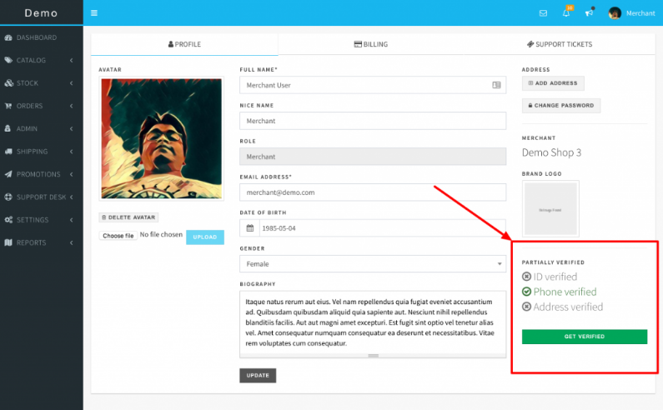

There is a verification status available at your profile, click over GET VERIFIED to submit all the required documents and get the verified tag.

ACCOUNT >> PROFILE >> GET VERIFIED

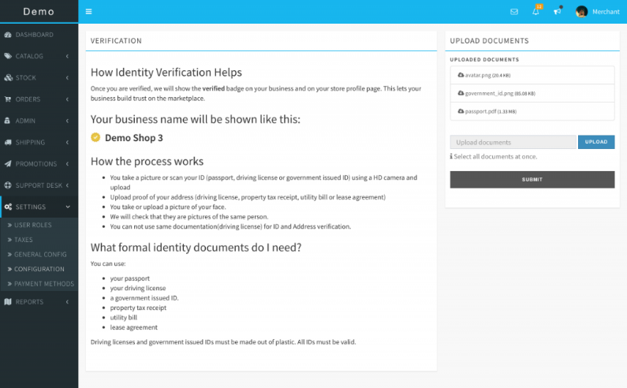

Go through the instruction and follow the same, and finally submit all the required documents. Further, the team of IndoMarche will verify and review all the submitted documents and will take the required measures to complete the process.