**Discount Coupons**

To attract the maximum number of customers, the best possible way is to offer discount coupons. Unlimited coupons can be created by your merchant account for your store. Also, you can complete the promotions for your store too. You can set several details for the discount coupons like the period for its availability, the total quantity of it, how many times each buyer can avail the benefits, and many more. The value of the coupon can be fixed or be depended on the percentage of the total order value.

PROMOTIONS >> COUPONS >> CREATE COUPON

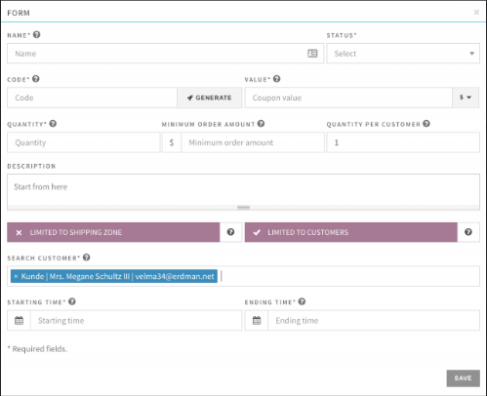

**Coupon for specific customer/s:**

To attract maximum customers, there must be a range of coupons usable for single or even the groups of customers. To limit the usage of a coupon to a single customer, check the LIMITED TO CUSTOMERS option, and from there, select the customer/s.

**Coupon for specific shipping zone/s:**

You can also create coupons that can only be accessible from some specific shipping zones. To limit the coupons to some shipping zones, select the LIMITED TO SHIPPING ZONE option and select the zone/s.