**Shipping**

This section is there to set up all the modules related to the shipping of your products. Several details like shipping zone, carrier, cost, packaging, and many others are required here.

Here is what all is required in this section:

* Shipping Zones
* Shipping rates
* Shipping Carriers
* Packaging

**Shipping Zones**

These are the areas where your products and services are accessible and where you are doing your business. Customers of these zones only can access your products from the store at IndoMarche’s portal. You can select and save as many shipping zones as you want. There is also an option of a worldwide shipping zone available to cover all the areas across the globe that are excluded from the other zones.

**Warning!** Without an active shipping zone, your product listing will be hidden from the customers.

SHIPPING >> SHIPPING ZONES

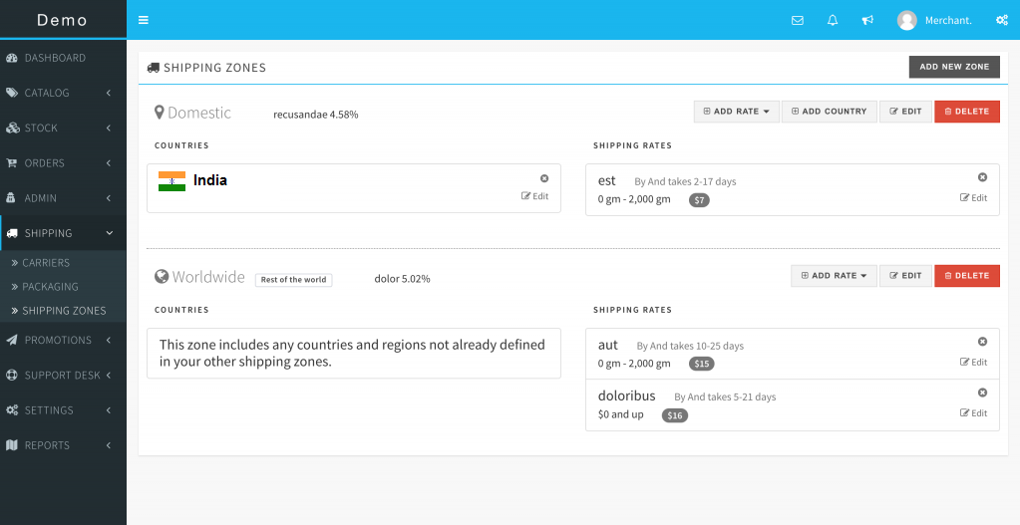

**Shipping Rates**

Multiple shipping rates can be created from a single shipping zone. Also, the shipping rates can be dependent on the PRICE and the WEIGHT too. The shipping carrier that is used can also be linked to develop the confidence and trust among the buyers.

SHIPPING >> SHIPPING ZONES >> ADD RATE

**Attention!** For the shipping rates that are based on the weight, they must be added along with a product description for the reference.

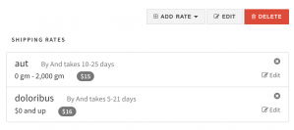

*Based on Price:*

Lower and Upper limit of the price must be set for the rate. This option will only be visible to the customer if their cart value (total order price) is within the price range.

*Based on Weight:*

You must set the lower and upper limits for the weight to set the rate accordingly. The option will only be visible to the customer if the total order weight lies between the set ranges.

**Warning!** If you select the FREE SHIPPING option, then the shipping charges will remain zero irrespective of the set rate.

**Shipping Carriers**

Shipping carriers can be added and linked with the shipping rates. They are visible to the customers on selecting the shipping option.

SHIPPING >> CARRIERS

**Packaging**

This is an optional yet recommendable feature to be available in some options for the customers. They are recommendable as it increases the buyers’ interest whenever they want to access any special packaging for a gift or a surprise. The availability of packaging gift wraps might make your customers happier!

SHIPPING >> PACKAGING