**Reports**

This is the module that will provide a sharp view on the performance of your shop on the IndoMarche portal. Several reports are available like:

* Sales by month
* Conversion rates
* Top-selling items
* Top-grossing items
* Top customers
* Returning customers
* Abandoned customers
* Average order value
* Top-selling categories
* Top suppliers

Apart from the ones mentioned here, there are many more reports available with us with detailed insights.

REPORTS >> PERFORMANCE

**KPI**

KPI stands for Key Performance Indicator. It shows the sales report for the last 12 months and provides a financial overview of the whole year. You can check several things here like the conversion rate, total revenue earned in the last 12 months, the total number of carts left abandoned, average order value for your store, and many more.

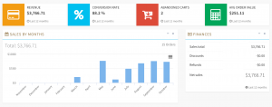

**Top Selling Items**

This section will provide detailed information about the top 10 items present in your inventory. Here there is a table for the same displaying the units sold and revenue generated from them. This is important to set marketing strategies and add inventories accordingly.

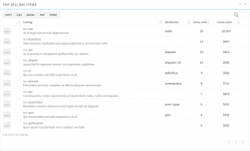

**Top Customers**

This is the list of customers who spend more on your store. This list can help you more in marketing and you can also offer them discounts and coupons to these customers to convert them into a returning buyer.

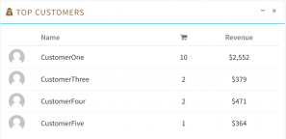

**Returning Customers**

This is the list of the frequent customers of your store. These are the most important customers because you do not need to do any marketing to maintain them. Also, you can offer discounts to them to make them happier with your services.

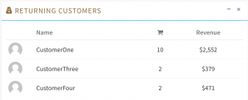

**Top Categories**

This is the list of your best performance categories. It also has a listing of all the products available in your store. This is the perfect list to get a proper idea of the trends and get the trendy items in your inventory too.

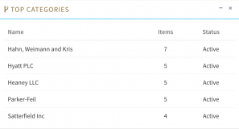

**Top Suppliers**

This is the list of the suppliers that you are associated with and there is also a list of all the items in your store from the associated suppliers.

