Automating Manual Business Workflows in SaaS Products: A Rule-Based and Event-Driven Framework
Bhomya Sharma  Dept. of Computer Science Engg.  Chitkara University  Punjab, India  bhomya224.be22@chitkara.edu.in | Chahat  Dept. of Computer Science Engg.  Chitkara University  Punjab, India  chahat231.be22@chitkara.edu.in | Prerana Thakur  Dept. of Computer Science Engg.  Chitkara University  Punjab, India  prerana2085.be22@chitkara.edu.in | Noovi Bedi  Dept. of Computer Science Engg.  Chitkara University  Punjab, India  noovi2004.be22@chitkara.edu.in

Abstract - A‌ lot of what keeps SaaS platforms running day-to-day is surprisingly manual - someone has to route the task‚ follow up on the approval‚ run the report‚ sync the data․ When the platform is small‌ that is fine‚ but as it scales‚ doing all of this by hand becomes a real bottleneck․ BPM‚ RPA‌ and low-code tools are the existing alternatives‚ but none of them are designed to fit lightweight SaaS environments [1][2]․ The aforementioned results motivated us to realize our‌ own rule-based event-driven approach for automating such processes․ To quantify the success‌ of such automation‚ we introduced the Task Execution Time (TET)‚ the Error Frequency Rate (EFR)‚ and the Manual Dependency Index (MDI)․ Simulations using this condition revealed a 68-82% reduction in‌ TET‚ a reduction in EFR from 20-25% to 5-8%‚ and a 100% improvement in throughput: from 20 tasks/hour to over 60 tasks/hour․

Keywords- SaaS-based automation‚ workflow orchestration‚ rule-based‌ systems‚ event-driven architecture‚ business process automation‚ robotic process automation

I․ Introduction
SaaS apps grow fast‚ but so does the work behind them: routing requests‚ getting signatures‚ getting approvals from multiple people‚ pulling reports‚ keeping data in sync‚ and so on․ People have to spend time on all these workflows‚ but manual work does not scale․ It just piles up [3]․
We believe we found enough evidence that this is a general issue; repetitive workflows are usually taking longer than necessary․ These increasing effects are especially pronounced in SaaS workflows‚ where one failure early on can bring the entire process to a halt‚ and where systems are under greatest stress at the points where manual effort is most likely to fail [4]․
There are tools that try to solve parts of this‚ BPM systems‚ event driven architectures‚ low code platforms․ But they fail in specific ways․ BPM is often overkill for what your average SaaS team actually needs․ Low-code platforms seem well-suited for simple use cases‚ but fail when the use case is more specific․ For example‚ event-driven systems without a dedicated rule layer often result in unpredictable workflows that are difficult to maintain․ [1][2][5][6]
Could we create a set of easy to understand rules to define what is going to happen and then apply an event-driven framework to execute it at speed for SaaS workflows? So we created TET‚ EFR and MDI to measure the results․ We even ran the whole system through the rigors of a simulation to verify it․

II․ Related Work
Workflow automation has a long history in research‚ and Georgakopoulos et al․ defined the concept of workflow management system as middleware for supporting process modeling and execution in heterogeneous environments in the early 1990s [6]․ Key concepts from that work are still used in contemporary cloud and parallel computing research․
A large systematic literature review from 2016 to 2023 identified that the overwhelming majority of the over 300 papers in the field highlighted RPA‚ WMS and ERP as the main tools used by industry [1]․ This approach works for large enterprise systems‚ but is too much overhead for SaaS products‚ which need to be lean and fast․
RPA has also attracted interest․ Agostinelli et al․ proposed integrating process mining and automation scripting to develop a self-improving RPA system [7]․ Tavares et al․ showed that a hybrid RPA-BPM approach working on design‚ modeling‚ execution‚ monitoring‚ and optimization provided real savings in practice [8]․ Consequently‚ that five-stage view influenced our proposal for the orchestration layer․
From an architectural perspective‚ Chavan states that EDA microservices are more loosely coupled and more responsive than their API-based counterparts [5]․ Experimental investigations conducted by Stiawan et al․ showed that EDA microservices had a lower response time of 19% and a 34% lower error rate than synchronous alternatives [9]․ Those findings were one of the main factors leading us to choose an event-driven architecture․
Li et al․ list a few well-known challenges of SaaS workflow‚ including multi-tenancy and dynamic task assignment‚ that remain unsolved [3]․ Some tools such as Zapier and Microsoft Power Automate solve part of this problem without requiring any programming‚ but cannot describe and automate tailored SaaS workflows due to their closed architecture․ From everything we read‚ there was no existing framework that put rule-based control‚ event-driven execution‚ and proper performance measurement together in something designed for SaaS from the start․

Component | Role | Example
Trigger Engine | Detects events | New ticket created
Rule Engine | Evaluates conditions | Priority = High
Execution Engine | Runs actions | Assign to agent
Integration Layer | Connects systems | API / Webhook
Monitoring Module | Tracks metrics | Logs, alerts

III․ PROPOSED AUTOMATION FRAMEWORK
A․ Architectural Overview
We broke up the framework into five parts‚ one for each job‚ and the major design decision was to decouple all of them so that each could be replaced independently․
• Workflow Trigger Engine - An event-based engine that watches for threshold conditions based on system events to trigger the automation
• Rule Evaluation Module - compares the current state of the system against the rule set and determines which action should be taken
• A Playbook Execution Engine that executes a sequence of actions and is able to do branching based on runtime conditions‚ and make clean rollbacks
• Integration Layer - handles communication with other applications‚ using REST APIs‚ webhooks and event listeners‚ without the need for vendor lock-in
• Monitoring and Feedback Module - captures execution metrics as things run‚ so that there is always something measurable to act on
Everything passes through a fixed pipeline:
The event processing pipeline consists of five steps: Trigger detection‚ Rule evaluation‚ Actions‚ Logging and Monitoring․
Because each component is separate, the framework is not tied to any particular stack and can be updated incrementally as needed․

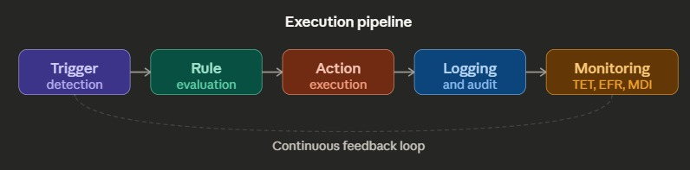

B․ Design Principles
The design decisions were based on six key principles‚ mostly derived from BPA literature [1][4]: it has to work across many different SaaS stacks without re-design․ When under load‚ it should be possible to‚ without modifying the internal architecture‚ increase capacity horizontally․ The rules should be easily readable‚ versionable and transferrable between environments‚ ideally being specified in JSON or YAML format․ Message passing should be asynchronous in order to not bottleneck the system under excessive load [5]․ Components should be independent․ And automation logic needed to be packaged into reusable playbooks to avoid needing to rewrite the same logic for every new category of workflow․

IV․ FRAMEWORK DESIGN AND CONCEPTUAL MODEL
A․ Automation Orchestration Layer
The orchestration layer is the glue that holds everything together: it listens for events‚ matches them against active rules‚ runs the appropriate playbook‚ and logs what it has done․ We modeled it after Tavares et al's five-stage BPM lifecycle model (design‚ modeling‚ execution‚ monitoring‚ and optimization) since it maps cleanly onto what the orchestration layer actually does [8]․

B․ Formal Rule Configuration Model
Each rule consists of five fields that define when and how it runs‚ what it does‚ and how it reacts to failure:
- Trigger condition (TC): The system event or threshold that will trigger the rule
- Evaluation Criteria (EC): logical check against current system state‚ run before anything executes‚ that checks if the rule is applicable
- Action Mapping (AM): the sequence of steps to carry out once the rule is confirmed․
- Execution priority (EP): rank determining behavior when multiple rules become true at the same time
- Failure Policy (FP): retry‚ skip‚ or rollback‚ what the rule should do if it has failed․

To promote portability and adherence to the technology-agnostic BPA standard [4]‚ rules are expressed in either JSON or YAML․ The formal definition is:
R = { TC‚ EC‚ AM‚ EP‚ FP }

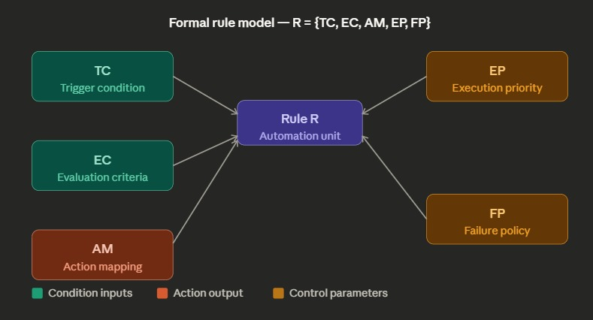

C․ Performance Metric Definitions
- Task Execution Time (TET)‚ defined as the elapsed time between the trigger firing and the writing of the completion log: TET = Tcomplete - Ttrigger
• Error Frequency Rate (EFR): the fraction of executions that failed‚ computed as EFR = Nfailed/Ntotal × 100%
• Manual Dependency Index (MDI): what fraction of workflow steps still need a human involved․ MDI = (Smanual / Stotal) × 100%.

D․ Playbook-based workflow modeling
This is called a workflow and is a playbook‚ which can contain a sequence of steps‚ including conditional branching based on what is happening‚ the external systems that are to be used‚ and a path for rollback․ This reuse of workflows allows a single playbook to be used in a number of places in the SaaS product‚ avoiding duplication between them․

E․ Integration Model
For external interaction‚ REST APIs for synchronous calls‚ webhooks for the external service to post data‚ and event listeners for consuming asynchronous messages were chosen․ We followed the loosely coupled architecture from the event-driven microservice literature [5‚ 9] and kept the design deliberately vendor-neutral.

F. Monitoring and Feedback Layer
While the workflows are executing‚ the monitoring module tracks the TET‚ the EFR‚ the MDI and the throughput․ In fact‚ one thing Agostinelli et al․ make clear is that this kind of data of actual automation execution is what will actually allow an automation system to get better rather than staying static [7]․ That figured into how we designed that part of the framework․

V. Performance Evaluation
A. Simulation Setup
Since we have not tried this in a production environment‚ we ran a controlled test․ We kept the experiment small for validation of this scale:
• 100 workflow instances in 10 categories of repetitive workflows
• A manual baseline modeling how these workflows are typically handled today
• Two loading conditions were considered: a standard loading and an elevated loading (2× event volume)
• 30 automation rules across all 10 categories‚ which works out to an average of 3 rules per category
It is also common in BPA research to test the concept with simulation prior to implementation [2]‚ and that is what we did․

B. Comparative Results
Table I shows how the framework performed versus the manual baseline. To give TET a real value rather than just saying “high”, we measured the average manual task at around 42 minutes end-to-end. The automated framework brought that down to 8–14 minutes, which is where the 68–82% reduction comes from.

TABLE I. PERFORMANCE COMPARISON: MANUAL VS. AUTOMATED MODEL
Metric | Manual | Automated
Avg. TET | ~42 min/task | 8–14 min/task
EFR | 20–25% | 5–8%
Throughput (tasks/hr) | 20 | 60+
Load Degradation @ 2× | 35% | < 12%
MDI | ~78% | < 15%

A 20 to 60+ task per hour throughput gain‚ or a 3x improvement‚ makes sense‚ as tasks are completing 3 to 5 times faster․ This matches up with the results found in Tavares et al․ on the RPA-BPM hybrid implementation [8]․ The most surprising result is the load reductions possible with manual challenge degradation․ The 35% load reduction in that case‚ even at twice the event volume‚ is a large benefit‚ and results from exactly the way asynchronous execution distributes the load [9]․

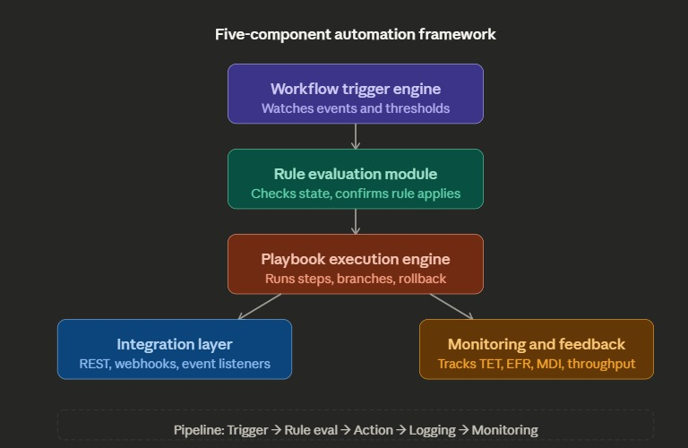
VI. Discussion
The improvement demonstrated by the EFR result is probably the most interesting․ Going from an error rate of 20-25% to 5-8% looks easy‚ but the failed approval step blocks three downstream processes‚ and in an enterprise environment that gets expensive fast [1]․ Catching errors late in programming‚ while useful‚ is less important than making sure to minimize error rate from the start․
We did better than we projected‚ but still 35% slowdown at double volume in the manual model seems reasonable because people are limited․ That's exactly what asynchronous execution is supposed to do‚ but seeing the automated framework hold at the same load without exceeding 12% was gratifying [5][9]․
We try to be straightforward about what the simulation cannot capture: the rule module is only able to consider circumstances that it was set up to be aware of at the moment the rules were written․ It cannot catch true surprises․
We did not test multi-tenant isolation‚ which Li et al․ note is an open problem in SaaS workflow systems [3]․ Likewise‚ since we did not actually deploy our framework against Zapier‚ Power Automate‚ or Airflow‚ we cannot say how our framework compares to them in practice [10]․

VII․ FUTURE WORK
If we were to develop this further‚ there are four things we would look at:
• ML-based rule generation: Currently‚ the rules have to be written manually‚ which makes the tool inflexible․ Using process mining techniques on historical logs to automatically create and refine the rules would solve the main gap [7]․
•Multi-tenant Testing․ This is the most immediate gap․ The framework cannot make any real production claims unless tested under multi-tenant concurrent load [3]
•Compare to commercial tools like Zapier‚ Microsoft Power Automate and Apache Airflow using the same workflows to get a better idea of where the framework really stands [10]
Anomaly Detection and Audit Logging: Improved monitoring module with anomaly detection and GDPR- and SOC 2-compliant audit logs would allow the framework to support finance and healthcare SaaS applications more easily
VIII. Conclusion
We aimed to create a system for automating repetitive manual workflows that slow down SaaS platforms as they grow. We defined TET, EFR, and MDI to have clear metrics for comparison and tested the system through simulation against a manual baseline. The results across all three metrics exceeded our expectations: task execution time decreased by 68 to 82%, error rates dropped from 20 to 25% to 5 to 8%, and load degradation at double the volume remained below 12%. The system is still in the conceptual phase, and we have significant work to do, particularly regarding multi-tenant testing and evaluation against existing tools. However, the simulation results are promising enough to suggest that the underlying method is solid and deserves further development.

References
[1] H. Pouresmaeil, R. Tavares, and C. Silvares, “Business Process Automation in SMEs: A Systematic Literature Review,” IEEE Access, DOI: 10.1109/ACCESS.2024.3406548, 2024.
[2] C. Silvares and R. Tavares, “Best practices for business process automation description, a case study,” Enterprise Information Systems, Taylor & Francis, DOI: 10.1080/17517575.2024.2400474, 2024.
[3] J. Li, X. Chen, and W. Zhang, “An analysis of new features for workflow system in the SaaS software,” in Proc. Int. Conf. on Service-Oriented Computing, 2009, pp. 1–8.
[4] E. A. Stohr and J. L. Zhao, “Workflow Automation: Overview and Research Issues,” Information Systems Frontiers, vol. 3, no. 3, pp. 281–296, 2001.
[5] A. Chavan, “Exploring event-driven architecture in microservices: patterns, pitfalls, and best practices,” International Journal of Science and Research Archive, vol. 4, no. 1, pp. 229–249, 2021.
[6] D. Georgakopoulos, M. Hornick, and A. Sheth, “An overview of workflow management, from process modeling to workflow automation infrastructure,” Distributed and Parallel Databases, vol. 3, no. 2, pp. 119–153, 1995.
[7] S. Agostinelli, A. Marrella, and M. Mecella, “Towards Intelligent Robotic Process Automation for BPMers,” arXiv:2001.00804, 2020.
[8] R. Tavares, C. Silvares, and H. Pouresmaeil, “Developing Robotic Process Automation to Efficiently Integrate Long-Term Business Process Management,” Technologies, vol. 11, no. 6, p. 164, MDPI, 2023.
[9] D. Stiawan, A. Idris, and M. Y. Idris, “Event-Driven Architecture to Improve Performance and Scalability in Microservices-Based Systems,” in Proc. 2022 Int. Conf. ICADEIS, IEEE, DOI: 10.1109/ICADEIS56544.2022.10037390, 2022.
[10] M. Dumas, M. La Rosa, J. Mendling, and H. A. Reijers, “AI-Augmented Business Process Management Systems: A Research Manifesto,” ACM Trans. Management Information Systems, vol. 14, no. 1, pp. 1–19, 2023.

