Programme Name: B.Tech (CSE)
Course Name: Fundamentals of Machine Learning
Course Code: TCS 303

1. ARTIFICIAL INTELLIGENCE
Definition, Nature, and Significance
Definition:
Artificial Intelligence (AI) refers to the simulation of human intelligence in machines that are programmed to think, learn, and make decisions in a manner similar to humans. AI can be defined as the capability of a machine to imitate intelligent human behaviour, enabling it to perform tasks that typically require human intelligence such as visual perception, speech recognition, decision making, and language translation.
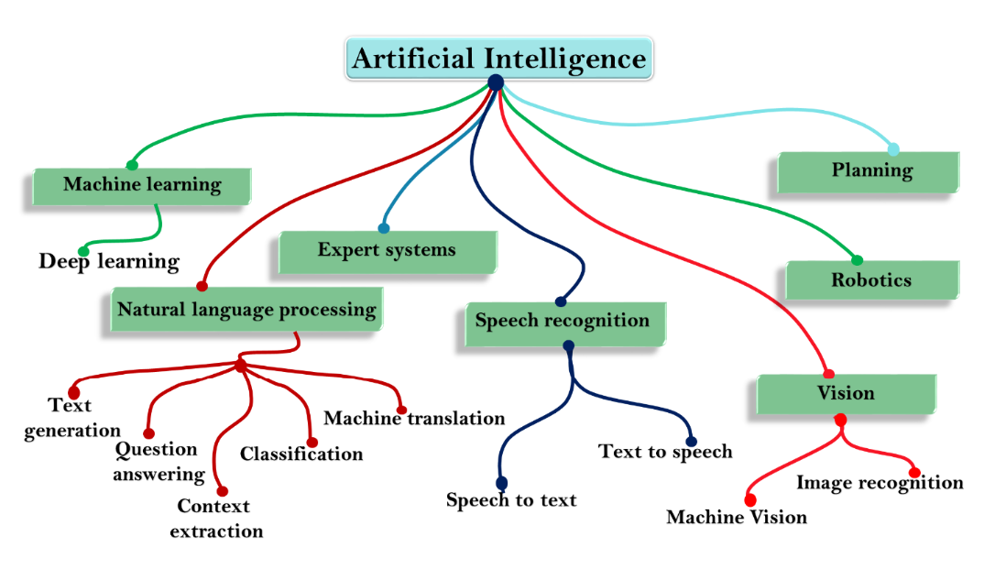
Fig 1 Subset of Artificial Intelligence

Types of AI
- Narrow AI (Weak AI): AI designed to perform a specific task, like voice recognition or chess-playing.
- General AI (Strong AI): AI with generalized human cognitive abilities, still theoretical.
- Superintelligent AI: AI that surpasses human intelligence, currently a speculative concept.
Subset of AI
1. Machine Learning (ML):
Machine Learning is a branch of AI that enables computers to learn from data and improve their performance over time without being explicitly programmed. It involves creating algorithms that can identify patterns in data and make predictions or decisions based on those patterns. ML can be categorized into different types, including supervised learning, unsupervised learning, and reinforcement learning.
2. Natural Language Processing (NLP):
Natural Language Processing is a field of AI that focuses on the interaction between computers and humans through natural language. The goal of NLP is to enable computers to understand, interpret, and generate human language in a way that is both meaningful and useful. NLP is used in various applications such as speech recognition, language translation, sentiment analysis, and chatbots.
3. Computer Vision:
Computer Vision is a subset of AI that enables computers to interpret and understand the visual world. By using digital images or videos, computer vision systems can recognize objects, identify patterns, and make decisions based on visual data. Applications of computer vision include facial recognition, image classification, and autonomous vehicles.
4. Deep Learning:
Deep Learning is a specialized subfield of machine learning that uses neural networks with many layers (hence "deep") to model complex patterns in large datasets. Deep learning has been particularly successful in tasks such as image and speech recognition, where it has achieved performance levels comparable to or even surpassing human abilities.
5. Robotics:
Robotics is a field that combines AI with mechanical engineering to design, build, and operate robots. These robots can perform tasks autonomously or semi autonomously. AI in robotics is used to enable robots to perceive their environment, make decisions, and perform complex actions, such as navigating a space or interacting with objects.
6. Neural Networks:
Neural Networks are a set of algorithms modelled loosely after the human brain. They consist of interconnected layers of nodes (neurons) that process data. Neural networks are the foundation of deep learning and are used in various AI tasks such as image recognition, natural language processing, and predictive analytics.
These subsets of AI often overlap and work together to create powerful, intelligent systems capable of performing a wide range of tasks.
UNIT I INTRODUCTION TO MACHINE LEARNING
Machine Learning
The study of algorithms and statistical models that computer systems use to perform specific tasks without explicit instructions. Instead, they rely on patterns and inference derived from data. Machine learning (ML) is a branch of artificial intelligence (AI) that focuses on designing and developing algorithms that allow computers to learn from and make predictions or decisions based on data.
A machine learning system builds prediction models, learns from previous data, and predicts the output of new data whenever it receives it. The amount of data helps to build a better model that accurately predicts the output, which in turn affects the accuracy of the predicted output.
Let's say we have a complex problem in which we need to make predictions. Instead of writing code, we just need to feed the data to generic algorithms, which build the logic based on the data and predict the output. Our perspective on the issue has changed as a result of machine learning. The Machine Learning algorithm's operation is depicted in the following block diagram:
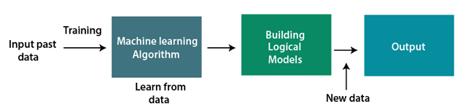
Fig 1 How Machine learns
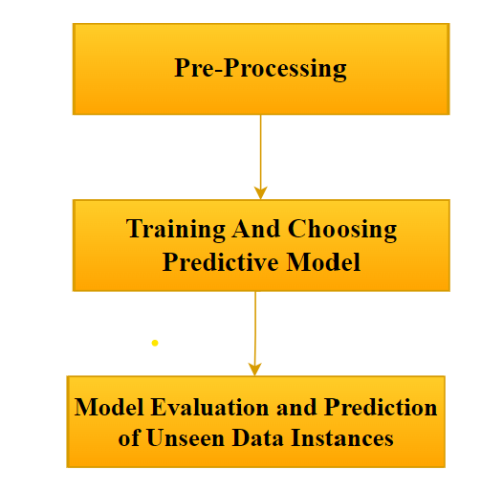
Fig 2 How Machine learning Works
Motivation for Machine Learning
1. Handling Complex Data:
- Volume and Variety: We live in an era of massive data generation. ML enables the analysis of vast amounts of data that would be impractical for humans to process manually.
- Patterns and Insights: ML algorithms can uncover complex patterns and relationships in data that might be hidden or non-obvious through traditional analysis methods.
2. Automation and Efficiency:
- Task Automation: ML models can automate repetitive tasks, improving efficiency and freeing up human resources for more complex or creative work.
- Real-time Processing: ML can handle and analyse data in real time, making it possible to make immediate decisions and predictions (e.g., fraud detection in financial transactions).
3. Personalization:
- Tailored Experiences: ML enables personalized experiences by analysing user preferences and behaviour. This is seen in recommendation systems used by platforms like Netflix and Amazon, which suggest content or products based on individual tastes.
4. Predictive Capabilities:
- Forecasting: ML can be used to predict future events or trends based on historical data. This is valuable in fields like finance (stock market predictions), healthcare (disease outbreaks), and logistics (demand forecasting).
5. Enhanced Decision-Making:
- Data-Driven Decisions: ML helps organizations make more informed decisions by providing insights derived from data rather than intuition alone. This can lead to better strategic planning and resource allocation.
6. Advancements in Science and Technology:
- Innovation: ML is driving advancements across various scientific fields, from genomics and drug discovery to astrophysics and climate modeling.
- New Applications: It enables the development of new technologies and applications, such as autonomous vehicles, advanced robotics, and intelligent virtual assistants.
7. Solving Unstructured Problems:
- Natural Language Processing (NLP): ML allows computers to understand and generate human language, facilitating applications like translation, sentiment analysis, and chatbots.
- Computer Vision: ML enables computers to interpret and process visual information, which is crucial for applications like image recognition, video analysis, and medical imaging.
8. Improving Quality of Life:
- Healthcare: ML assists in diagnosing diseases, personalizing treatments, and managing healthcare resources.
- Safety and Security: It enhances security measures through applications like biometric authentication and surveillance systems, improving public safety.
9. Economic Value:
- Business Growth: ML can drive business growth by optimizing operations, improving customer experiences, and identifying new market opportunities.
- Cost Reduction: It can help reduce costs by automating processes and minimizing errors, leading to greater efficiency.
10. Curiosity and Innovation:
- Exploring New Frontiers: The quest to understand and leverage the capabilities of ML fuels curiosity and innovation, pushing the boundaries of what technology can achieve.

Applications of Machine Learning
1. Healthcare
- Diagnostics: ML algorithms analyze medical images (e.g., X-rays, MRIs) to detect diseases like cancer, often with accuracy comparable to or exceeding human experts.
- Personalized Medicine: ML helps tailor treatment plans based on individual patient data, such as genetic information and lifestyle factors.
- Predictive Analytics: Predicts disease outbreaks, patient readmissions, and other health trends to improve prevention and management.
2. Finance
- Fraud Detection: ML models analyze transaction patterns to identify and prevent fraudulent activities.
- Algorithmic Trading: Automated trading systems use ML to analyze market data and execute trades at optimal times.
- Credit Scoring: ML enhances credit risk assessment by analyzing a wider range of financial and behavioral data.
3. Retail and E-commerce
- Recommendation Systems: ML algorithms suggest products to users based on their browsing history, past purchases, and preferences (e.g., Amazon, Netflix).
- Inventory Management: Predicts demand for products to optimize stock levels and reduce overstock or stockouts.
- Customer Segmentation: Analyzes customer data to group consumers into segments for targeted marketing strategies.
4. Transportation
- Autonomous Vehicles: ML powers self-driving cars by interpreting sensor data, making real-time decisions, and navigating complex environments.
- Traffic Management: Optimizes traffic flow and reduces congestion through predictive analytics and real-time traffic monitoring.
- Route Optimization: ML helps in planning efficient delivery routes and reducing fuel consumption.
5. Manufacturing
- Predictive Maintenance: ML predicts equipment failures before they occur, reducing downtime and maintenance costs.
- Quality Control: Analyzes production data to detect defects and ensure product quality.
- Supply Chain Optimization: Enhances supply chain efficiency by forecasting demand and optimizing inventory levels.
6. Entertainment
- Content Recommendation: ML algorithms suggest movies, music, and other content based on user preferences and behavior (e.g., Spotify, YouTube).
- Content Creation: Assists in generating music, art, and even writing through generative models and AI tools.
- Audience Analysis: Analyzes viewer engagement and preferences to tailor content and marketing strategies.
7. Education
- Personalized Learning: Adaptive learning systems use ML to tailor educational content to individual students' needs and learning styles.
- Grading and Assessment: Automates the grading process for assignments and tests, providing instant feedback to students.
- Student Support: AI-driven chatbots and virtual assistants provide academic support and answer questions.
8. Agriculture
- Precision Farming: ML analyzes data from sensors and satellites to optimize crop yields, manage resources, and reduce waste.
- Pest and Disease Detection: Identifies signs of pests and diseases in crops through image analysis and sensor data.
- Weather Forecasting: Enhances weather predictions to aid in planning and resource management.
9. Energy
- Smart Grids: ML optimizes energy distribution and consumption in smart grids, improving efficiency and reducing costs.
- Energy Forecasting: Predicts energy demand and supply to better manage resources and integrate renewable energy sources.
- Maintenance and Optimization: Analyzes data from energy infrastructure to predict failures and optimize performance.
10. Security
- Cybersecurity: ML detects and responds to cyber threats by analyzing patterns of network traffic and identifying anomalies.
- Surveillance: Analyzes video feeds for suspicious activities and enhances security measures.
- Identity Verification: Uses biometric data (e.g., facial recognition, fingerprint scanning) for secure access control.
11. Natural Language Processing (NLP)
- Language Translation: ML-based systems provide real-time translation between different languages (e.g., Google Translate).
- Sentiment Analysis: Analyzes text data to determine sentiment and opinions, often used in social media monitoring and customer feedback.
- Text Generation: Creates coherent and contextually relevant text for various applications, including chatbots and automated content creation.
12. Environmental Monitoring
- Climate Change: Analyzes climate data to model and predict environmental changes and impacts.
- Wildlife Conservation: Monitors animal populations and habitats through image recognition and tracking technologies.
Learning associations (discovering patterns)
Learning associations in machine learning typically refers to association rule learning, which is a technique used to discover interesting relationships or patterns among variables in large datasets. This approach is widely used in market basket analysis, recommendation systems, and various other domains.

- Association Rules:
  - Definition: Association rules are used to identify relationships between variables. They often take the form "If X, then Y," indicating that if an item or condition X occurs, it is likely that item or condition Y will also occur.
  - Components:
    - Antecedent (LHS): The item or condition on the left-hand side of the rule.
    - Consequent (RHS): The item or condition on the right-hand side of the rule.
    - Support: Measures the frequency with which the antecedent and consequent occur together in the dataset. It is defined as Support (X→Y)=P(X∪Y).
    - Confidence: Measures the likelihood that the consequent occurs given the antecedent. It is defined as Confidence (X→Y)=P(Y∣X).
    - Lift: Measures how much more likely the consequent is to occur given the antecedent compared to if they were independent. It is defined as Lift(X→Y)=P(Y)P(Y∣X)​.
- Applications:
  - Market Basket Analysis: Identifies which products are frequently bought together. For example, if customers who buy bread often also buy butter, this insight can be used to optimize store layouts or create promotional offers.
  - Recommendation Systems: Suggests products or content based on user behaviour and preferences. For example, recommending movies or books based on past choices.
Algorithms for Association Rule Learning
- Apriori Algorithm:
  - Overview: One of the earliest and most popular algorithms for mining frequent item sets and generating association rules. It uses a breadth-first search strategy and works in multiple passes.
  - Procedure:
    - Generate Frequent Item sets: Identify all item sets that appear frequently in transactions.
    - Generate Rules: From the frequent item sets, generate association rules that meet minimum support and confidence thresholds.
  - Key Steps:
    - Candidate Generation: Generate candidate item sets of length kkk from item sets of length k−1k-1k−1.
    - Pruning: Eliminate candidates that do not meet the minimum support threshold.
    - Rule Generation: Create rules from frequent item sets that satisfy the minimum confidence threshold.
- FP-Growth Algorithm:
  - Overview: An alternative to the Apriori algorithm that uses a compressed representation of the database (the Frequent Pattern, FP-tree) to mine frequent item sets more efficiently.
  - Procedure:
    - Build FP-Tree: Construct a compact tree structure that retains the itemset information.
    - Mine Frequent Item sets: Extract frequent item sets from the FP-tree without candidate generation.
  - Advantages: More efficient than Apriori, especially for large datasets, as it avoids generating and testing candidate item sets.
- Eclat Algorithm:
  - Overview: Uses a depth-first search strategy to find frequent item sets by intersecting transaction lists.
  - Procedure:
    - Generate Item sets: Use intersection operations on transaction lists to find frequent item sets.
    - Mine Rules: Generate association rules from the frequent item sets.
  - Advantages: Can be faster than Apriori in some cases due to its intersection-based approach.
Metrics for Evaluation
- Support: Helps identify the frequency of an itemset or rule in the dataset. Higher support indicates that the rule or itemset is common.
- Confidence: Indicates the reliability of the rule. Higher confidence means that the rule has a stronger association between the antecedent and consequent.
- Lift: Measures how much more likely the consequent is to occur when the antecedent is present, compared to the overall probability of the consequent occurring. A lift value greater than 1 indicates a positive correlation.
Practical Considerations
- Data Preprocessing: Ensure that data is cleaned and transformed into a format suitable for association rule mining, often involving discretization or binning of continuous variables.
- Parameter Tuning: Select appropriate support and confidence thresholds to balance between finding meaningful rules and avoiding overfitting or generating too many trivial rules.
- Scalability: For very large datasets, algorithms like FP-Growth are preferred due to their efficiency in handling large volumes of data.
Challenges
- High Dimensionality: Large datasets with many items can lead to a combinatorial explosion of item sets, making computation expensive.
- Rule Interpretation: Interpreting and making sense of the generated rules can be challenging, especially when the rules are numerous or complex.
- Sparsity: In some datasets, many item sets may have low support, making it difficult to find significant associations.
In machine learning (ML), learning paradigms are typically classified based on how they use data to build models and make predictions. Here's a detailed classification of learning in ML:
1. Supervised Learning
Definition: In supervised learning, the model is trained on a labeled dataset. Each training example includes an input and a corresponding output label. The goal is to learn a mapping from inputs to outputs so that the model can predict the label for new, unseen data.
Types of Supervised Learning
- Classification:
  - Objective: Predict categorical labels.
  - Examples: Email spam detection, image classification, medical diagnosis.
  - Algorithms: Logistic Regression, Decision Trees, Support Vector Machines (SVM), k-Nearest Neighbors (k-NN), Neural Networks.
- Regression:
  - Objective: Predict continuous numerical values.
  - Examples: Predicting house prices, forecasting stock prices, estimating patient risk.
  - Algorithms: Linear Regression, Polynomial Regression, Ridge/Lasso Regression, Support Vector Regression (SVR), Neural Networks.
2. Unsupervised Learning
Definition: Unsupervised learning involves training a model on data that does not have labeled responses. The goal is to uncover hidden patterns or intrinsic structures in the data.
Types of Unsupervised Learning
- Clustering:
  - Objective: Group data into clusters where similar items are grouped together.
  - Examples: Customer segmentation, image compression, anomaly detection.
  - Algorithms: k-Means Clustering, Hierarchical Clustering, DBSCAN, Gaussian Mixture Models (GMM).
- Dimensionality Reduction:
  - Objective: Reduce the number of features while retaining the essential information.
  - Examples: Data visualization, noise reduction, feature extraction.
  - Algorithms: Principal Component Analysis (PCA), t-Distributed Stochastic Neighbour Embedding (t-SNE), Linear Discriminant Analysis (LDA).
- Association Rule Learning:
  - Objective: Discover interesting relationships or associations between variables in large datasets.
  - Examples: Market basket analysis, cross-selling strategies.
  - Algorithms: Apriori Algorithm, FP-Growth Algorithm, Eclat Algorithm.
3. Semi-Supervised Learning
Definition: Semi-supervised learning combines a small amount of labelled data with a large amount of unlabelled data during training. This approach leverages the unlabelled data to improve learning accuracy.
Applications and Examples
- Text Classification: Improving accuracy by using a small labelled set of documents and a large set of unlabelled documents.
- Image Recognition: Enhancing model performance with a few labelled images and many unlabelled ones.
4. Reinforcement Learning
Definition: Reinforcement learning (RL) involves training an agent to make decisions by interacting with an environment. The agent learns to take actions that maximize cumulative rewards through trial and error.
Types of Reinforcement Learning
- Model-Free RL:
  - Objective: Learn policies directly from interaction with the environment without a model of the environment.
  - Algorithms: Q-Learning, Deep Q-Networks (DQN), Policy Gradient Methods.
- Model-Based RL:
  - Objective: Learn a model of the environment’s dynamics and use it to plan and make decisions.
  - Algorithms: Model Predictive Control (MPC), Dynamic Programming.
Applications
- Game Playing: Training agents to play and win games (e.g., AlphaGo).
- Robotics: Teaching robots to perform tasks through interactions.
- Autonomous Vehicles: Navigating and making driving decisions.

Regression
Regression in machine learning is used to predict a continuous numerical outcome based on input features. It's a fundamental technique in statistical modelling and data analysis that has a wide range of applications. Here's an in-depth look at why regression is used and its importance:
1. Understanding the Purpose of Regression
Objective: The primary goal of regression is to model the relationship between one or more independent variables (features) and a dependent variable (target). This relationship can then be used to predict or estimate the value of the dependent variable for new, unseen data.
2. Why Regression is Used
a. Predicting Continuous Outcomes
- Examples:
  - House Price Prediction: Estimating the price of a house based on features like size, location, number of rooms, etc.
  - Stock Market Forecasting: Predicting future stock prices based on historical data and market indicators.
  - Sales Forecasting: Predicting future sales revenue based on past sales data and other influencing factors.
- Importance: Helps businesses, investors, and analysts make informed decisions by providing quantitative estimates of future events or outcomes.
b. Modelling Relationships
- Examples:
  - Economic Indicators: Analysing how variables like unemployment rate and interest rates influence economic growth.
  - Healthcare: Understanding how various factors such as age, weight, and lifestyle affect blood pressure or disease progression.
- Importance: Provides insights into how different factors are related, which can be used to make data-driven decisions and improve strategic planning.
c. Understanding Trends and Patterns
- Examples:
  - Climate Change: Modelling how temperature changes over time based on various environmental factors.
  - Customer Behaviour: Analyzing how customer spending patterns change with different promotional strategies.
- Importance: Helps in identifying and understanding trends, making it easier to adjust strategies and anticipate future changes.
d. Feature Selection and Model Interpretation
- Examples:
  - Feature Impact: Determining which features (e.g., number of bedrooms, property age) most significantly impact house prices.
  - Model Insights: Interpreting the coefficients of a linear regression model to understand the effect size of each feature.
- Importance: Assists in selecting the most relevant features for modeling and helps interpret the relationships between features and the target variable.
3. Types of Regression and Their Applications
a. Linear Regression
- Definition: Models the relationship between the dependent variable and one or more independent variables using a linear equation.
- Use Cases:
  - Predicting salaries based on experience and education.
  - Forecasting demand based on historical sales data.
b. Polynomial Regression
- Definition: Extends linear regression by fitting a polynomial equation to the data, allowing for more complex relationships.
- Use Cases:
  - Modelling non-linear trends in data, such as growth curves or seasonal patterns.
d. Support Vector Regression (SVR)
- Definition: A type of regression that uses support vector machines to model non-linear relationships by transforming the input space.
- Use Cases:
  - Predicting non-linear patterns in complex datasets.
e. Decision Tree Regression
- Definition: Uses a decision tree structure to model the target variable, making decisions based on feature values.
- Use Cases:
  - Handling data with complex, hierarchical relationships.
f. Neural Network Regression
- Definition: Uses neural networks with multiple layers to capture complex, non-linear relationships.
- Use Cases:
  - Modeling intricate patterns in large datasets, such as image or speech data.
4. Benefits of Using Regression
- Predictive Power: Provides predictions for continuous outcomes, which is valuable for decision-making in various fields.
- Interpretability: Linear regression models, in particular, offer clear interpretations of how features impact the target variable.
- Trend Analysis: Helps in identifying and understanding trends, which can be used to forecast future events and make informed decisions.
- Feature Importance: Assists in understanding which features are most influential in predicting the target variable.
5. Challenges and Considerations
- Overfitting: Complex models can overfit the training data, leading to poor generalization. Regularization techniques can help mitigate this.
- Multicollinearity: High correlation between features can affect the stability of the regression coefficients. Techniques like Ridge Regression can address this issue.
- Non-Linearity: Simple linear regression may not capture complex relationships, requiring polynomial or non-linear models.
- Data Quality: The accuracy of regression models depends on the quality of the data. Outliers, missing values, and incorrect data can affect predictions.

The Origin of machine learning
1. Early Theoretical Foundations
a. Statistical Learning and Pattern Recognition
- Statistics: The principles of statistical learning, which involve making predictions or inferences based on data, have been foundational. Early 20th-century statisticians such as Sir Francis Galton and Karl Pearson developed concepts like regression analysis and correlation, which are crucial to modern ML algorithms.
- Pattern Recognition: The study of pattern recognition, which focuses on classifying and interpreting data patterns, also contributed to ML. This includes the work of pioneers like E. J. Gumbel and Andrey Kolmogorov.
b. Computational Theories
- Alan Turing (1950): Turing proposed the concept of a "universal machine" and introduced the Turing Test, which laid the groundwork for artificial intelligence (AI). His ideas about machine learning were implicit in his discussions about machines learning from experience.
- John von Neumann: His work on automata theory and the design of electronic computers was crucial for creating the computational infrastructure needed for ML.
2. The Birth of Machine Learning as a Field
a. Early Algorithms and Models
- Perceptron (1957): Frank Rosenblatt developed the perceptron, an early neural network algorithm that could perform binary classification. It was one of the first algorithms capable of learning from data.
- Linear Regression and Classifiers: Early work also included various statistical methods such as linear regression, logistic regression, and decision trees, which formed the basis for more advanced ML algorithms.
b. The Dartmouth Conference (1956)
- Origins of AI: The Dartmouth Conference, organized by John McCarthy, Marvin Minsky, Nathaniel Rochester, and Claude Shannon, is considered the birth of AI as a field. The conference introduced the term "artificial intelligence" and established the foundational goals of developing machines that could simulate human intelligence.
- Machine Learning: Although the term "machine learning" was not used explicitly at the time, the ideas discussed at the conference laid the groundwork for future research in ML.
3. Early Developments and Theoretical Advances
a. Symbolic AI and Expert Systems
- 1950s-1960s: Early AI research focused on symbolic AI and expert systems, which used predefined rules and logic to solve problems. These systems were limited by their inability to learn from data.
- ELIZA (1966): Joseph Weizenbaum developed ELIZA, an early natural language processing program that simulated conversation but did not learn from interactions.
b. Evolution of Neural Networks
- Backpropagation Algorithm (1974-1986): The rediscovery and popularization of the backpropagation algorithm by Geoffrey Hinton and others allowed for the training of multi-layer neural networks, which significantly advanced the field of ML.
4. Modern Machine Learning Emerges
a. Development of Key Algorithms
- Support Vector Machines (1990s): The development of Support Vector Machines (SVMs) by Vladimir Vapnik and Alexey Chervonenkis introduced a powerful method for classification and regression tasks.
- Ensemble Methods (1990s-2000s): Techniques such as random forests and boosting (e.g., AdaBoost) improved predictive accuracy by combining multiple models.
b. The Rise of Big Data and Deep Learning
- Big Data (2000s): The explosion of digital data and advances in computing power enabled the training of more complex models and the use of large datasets.
- Deep Learning (2010s): Breakthroughs in deep learning, particularly with convolutional neural networks (CNNs) for image recognition and recurrent neural networks (RNNs) for sequence data, drove significant advancements. Key moments include:
  - ImageNet Competition (2012): AlexNet, developed by Alex Krizhevsky, Ilya Sutskever, and Geoffrey Hinton, won the ImageNet competition, demonstrating the power of deep learning techniques.
  - GPT-3 (2020): OpenAI's GPT-3 showcased the capabilities of large language models, highlighting the potential of deep learning in natural language processing.
5. Current Trends and Future Directions
a. Integration with AI and Other Technologies
- AI Integration: Machine learning is now a core component of broader AI systems, contributing to advancements in natural language processing, computer vision, and robotics.
- Interdisciplinary Applications: ML is increasingly applied in fields such as healthcare, finance, autonomous vehicles, and personalized recommendations.
b. Ethical and Societal Considerations
- Bias and Fairness: Researchers are focusing on addressing ethical issues, including bias in algorithms and ensuring fairness in ML applications.
- Explainability: There is a growing emphasis on making ML models more interpretable and transparent to build trust and understanding.
Uses and abuses of machine learning
Uses of Machine Learning
1. Healthcare
- Diagnosis and Prediction: ML algorithms help in diagnosing diseases and predicting patient outcomes by analyzing medical images, genetic data, and patient records.
  - Examples: Early detection of cancer through image analysis, predicting patient readmission rates.
- Personalized Medicine: Tailoring treatments based on individual patient profiles and responses to drugs.
  - Examples: Drug efficacy prediction, personalized treatment plans based on genetic information.
- Drug Discovery: Accelerating the process of discovering new drugs by analyzing biological data and predicting how different compounds will interact with targets.
  - Examples: Identifying potential drug candidates, predicting side effects.
2. Finance
- Fraud Detection: Identifying unusual patterns and anomalies in transactions to detect fraudulent activities.
  - Examples: Credit card fraud detection, money laundering detection.
- Algorithmic Trading: Using ML models to analyze market data and make trading decisions at high speeds.
  - Examples: High-frequency trading algorithms, portfolio optimization.
- Risk Management: Assessing and managing financial risks by analyzing historical data and predicting future trends.
  - Examples: Credit risk assessment, market risk prediction.
3. Retail and E-Commerce
- Recommendation Systems: Personalizing product recommendations based on user preferences and past behavior.
  - Examples: Netflix’s content recommendations, Amazon’s product suggestions.
- Demand Forecasting: Predicting future product demand to optimize inventory management and reduce wastage.
  - Examples: Stock level optimization, supply chain management.
- Customer Service: Enhancing customer support through chatbots and automated responses.
  - Examples: Customer service chatbots, automated email responses.
4. Transportation
- Autonomous Vehicles: Developing self-driving cars that use ML to navigate and make driving decisions.
  - Examples: Tesla’s Autopilot, Waymo’s self-driving cars.
- Traffic Management: Optimizing traffic flow and reducing congestion by analyzing traffic patterns and adjusting signals.
  - Examples: Adaptive traffic signal control, predictive traffic management.
5. Education
- Personalized Learning: Adapting educational content and learning experiences to individual students’ needs and progress.
  - Examples: Adaptive learning platforms, personalized tutoring systems.
- Automated Grading: Using ML to assess and grade student work, reducing the workload on educators.
  - Examples: Essay scoring systems, automated test grading.
6. Natural Language Processing (NLP)
- Language Translation: Translating text between languages with high accuracy.
  - Examples: Google Translate, language translation services.
- Sentiment Analysis: Analyzing and categorizing opinions expressed in text to gauge public sentiment.
  - Examples: Social media sentiment analysis, customer feedback analysis.
- Speech Recognition: Converting spoken language into text, enabling voice-activated systems and services.
  - Examples: Virtual assistants like Siri and Alexa, transcription services.
Abuses of Machine Learning
1. Privacy Concerns
- Surveillance: Using ML for surveillance can infringe on individual privacy and lead to mass monitoring.
  - Examples: Facial recognition in public spaces, tracking online activities.
- Data Misuse: Personal data can be misused if not handled properly, leading to privacy breaches and unauthorized access.
  - Examples: Data leaks, unauthorized data sharing.
2. Bias and Discrimination
- Algorithmic Bias: ML models can perpetuate or even amplify biases present in training data, leading to unfair treatment of individuals or groups.
  - Examples: Discrimination in hiring algorithms, biased criminal justice predictions.
- Inequality: Unequal access to ML technologies can exacerbate existing social and economic inequalities.
  - Examples: Disparities in access to AI-driven educational tools, economic impacts of automation.
3. Security Risks
- Adversarial Attacks: Exploiting vulnerabilities in ML models to deceive them into making incorrect predictions.
  - Examples: Manipulating image recognition systems, fooling autonomous vehicles.
- Deepfakes: Creating convincing but fake images, videos, or audio that can be used maliciously.
  - Examples: Fake news and misinformation, identity theft.
4. Ethical Issues
- Autonomous Weapons: The use of ML in military applications can lead to ethical concerns regarding the deployment of autonomous weapons.
  - Examples: Drone strikes, automated military systems.
- Lack of Transparency: Complex ML models, particularly deep learning networks, can be opaque, making it difficult to understand their decision-making processes.
  - Examples: "Black box" models in critical applications, lack of explainability in AI decisions.
5. Economic Impact
- Job Displacement: Automation driven by ML can lead to job loss and disruption in various industries.
  - Examples: Job loss in manufacturing, reduction in customer service roles.
- Market Manipulation: ML algorithms used for trading and decision-making can lead to market instability and manipulation.
  - Examples: High-frequency trading affecting stock prices, algorithmic trading causing market crashes.
Success cases:
1. Healthcare
a. Early Detection and Diagnosis
- Google Health’s DeepMind: DeepMind's AI has achieved breakthroughs in early detection of eye diseases. Their model can analyze retinal scans and predict the onset of conditions like diabetic retinopathy and age-related macular degeneration with high accuracy.
  - Impact: This early detection helps in timely intervention, potentially preventing vision loss.
- IBM Watson for Oncology: IBM Watson uses ML to analyze medical literature, clinical trial data, and patient records to assist in cancer diagnosis and treatment recommendations.
  - Impact: Helps oncologists by providing evidence-based treatment options, improving patient outcomes.
b. Drug Discovery
- AlphaFold: Developed by DeepMind, AlphaFold uses ML to predict protein folding with high accuracy. Understanding protein structures is crucial for drug discovery and developing treatments for various diseases.
  - Impact: Accelerates the drug discovery process and aids in understanding diseases at a molecular level.
2. Finance
a. Fraud Detection
- Mastercard’s Decision Intelligence: Mastercard uses ML algorithms to analyze transaction patterns in real-time and detect fraudulent activity. Their system adapts to new threats by learning from ongoing transaction data.
  - Impact: Reduces fraud and enhances security for millions of transactions globally.
b. Algorithmic Trading
- Renaissance Technologies: This hedge fund employs ML algorithms to analyze vast amounts of financial data and execute trades based on predictive models. Their Medallion Fund is renowned for its exceptional returns.
  - Impact: Demonstrates the power of ML in financial markets, optimizing trading strategies and improving profitability.
3. Retail and E-Commerce
a. Recommendation Systems
- Amazon: Amazon’s recommendation engine uses ML to analyze user behavior, purchase history, and preferences to suggest products. The system accounts for factors like browsing history and similar users’ choices.
  - Impact: Drives a significant portion of Amazon’s sales by personalizing shopping experiences and increasing customer engagement.
- Netflix: Netflix uses ML to recommend movies and TV shows based on user preferences, viewing history, and ratings. The recommendation system is critical for user retention and engagement.
  - Impact: Enhances user satisfaction and keeps viewers engaged by suggesting content that matches their interests.
4. Transportation
a. Autonomous Vehicles
- Waymo: Waymo, a subsidiary of Alphabet Inc., has developed self-driving cars using ML algorithms for perception, decision-making, and control. Their autonomous vehicles navigate complex urban environments with high precision.
  - Impact: Advances the development of self-driving technology, potentially transforming transportation and enhancing road safety.
- Tesla’s Autopilot: Tesla’s Autopilot uses ML to enable semi-autonomous driving features, including lane-keeping, adaptive cruise control, and automatic parking.
  - Impact: Improves driving convenience and safety, pushing the boundaries of autonomous driving technology.
5. Natural Language Processing (NLP)
a. Language Translation
- Google Translate: Google Translate uses ML models, particularly neural machine translation, to provide real-time translation between numerous languages. The system continually improves by learning from vast amounts of multilingual data.
  - Impact: Facilitates communication across different languages, making information and services more accessible globally.
b. Content Generation
- OpenAI’s GPT-3: GPT-3, a state-of-the-art language model, can generate human-like text, perform language translation, and answer questions. It’s used in various applications, from chatbots to creative writing.
  - Impact: Enhances content creation, improves customer interactions through conversational agents, and assists in generating creative content.
6. Education
a. Adaptive Learning
- Khan Academy: Khan Academy uses ML to personalize learning experiences for students by recommending resources, practice problems, and videos based on their performance and learning needs.
  - Impact: Improves educational outcomes by tailoring learning to individual student needs and progress.
b. Automated Grading
- Grammarly: Grammarly uses ML to analyze text for grammar, punctuation, and style errors, providing writing enhancement suggestions. It’s used by millions of people to improve writing quality.
  - Impact: Assists users in improving their writing skills and enhancing communication effectiveness.
7. Agriculture
a. Precision Agriculture
- John Deere: John Deere integrates ML with agricultural machinery to optimize planting, fertilizing, and harvesting processes. ML models analyze soil conditions, weather data, and crop health.
  - Impact: Increases crop yields, reduces resource usage, and improves farming efficiency.
8. Environmental Monitoring
a. Wildlife Conservation
- Wildlife Insights: Wildlife Insights uses ML to analyze camera trap images for species identification and behavior monitoring. This helps in understanding and protecting wildlife populations.
  - Impact: Enhances conservation efforts by providing valuable data on animal populations and their habitats.
b. Climate Change Analysis
- Climate Models: ML models are used to analyze climate data, predict future climate patterns, and assess the impact of various factors on global warming.
  - Impact: Supports climate research and policy-making by providing more accurate and timely predictions.

How do machines learn
Machines learn through a process that involves training algorithms on data to make predictions or decisions without being explicitly programmed for specific tasks. Here's a detailed breakdown of how machines learn:
1. Data Collection
a. Data Gathering: The first step in machine learning is to collect relevant data. This data could be anything from images, text, and numbers to more complex forms like video and sensor readings.
- Examples: Collecting medical records for a disease prediction model, gathering user behavior data for a recommendation system.
b. Data Preparation: The raw data often requires preprocessing to make it suitable for analysis. This includes cleaning the data, handling missing values, normalizing or scaling features, and encoding categorical variables.
- Examples: Removing duplicates, filling in missing values, and converting text data into numerical form.
2. Choosing a Model
a. Selecting an Algorithm: Based on the problem at hand, an appropriate machine learning algorithm is chosen. Different algorithms are suited for different types of problems.
- Types of Algorithms:
  - Supervised Learning: Algorithms like linear regression, decision trees, support vector machines, and neural networks.
  - Unsupervised Learning: Algorithms like k-means clustering, hierarchical clustering, and principal component analysis (PCA).
  - Reinforcement Learning: Algorithms like Q-learning and deep reinforcement learning.
b. Model Architecture: For complex models, particularly in deep learning, the architecture is defined, including the number of layers, type of layers, and how they are connected.
- Examples: Convolutional Neural Networks (CNNs) for image processing, Recurrent Neural Networks (RNNs) for sequential data.
3. Training the Model
a. Splitting Data: The dataset is usually divided into training, validation, and test sets. The training set is used to teach the model, the validation set is used to tune hyperparameters, and the test set is used to evaluate performance.
- Examples: A dataset might be split into 70% training, 15% validation, and 15% test.
b. Learning Process: The chosen algorithm is trained on the training data. During training, the model learns to recognize patterns and relationships in the data.
- Supervised Learning: The model makes predictions on the training data, compares them to actual outcomes, and adjusts its parameters to minimize errors.
- Unsupervised Learning: The model identifies patterns or groupings in the data without predefined labels.
- Reinforcement Learning: The model learns through trial and error by receiving rewards or penalties based on its actions.
c. Optimization: Algorithms use optimization techniques to adjust model parameters. Techniques such as gradient descent are commonly used to minimize a loss function, which measures how well the model is performing.
- Examples: Stochastic Gradient Descent (SGD), Adam optimizer.
4. Evaluation
a. Testing the Model: After training, the model's performance is evaluated using the test data, which was not seen during training. This helps to assess how well the model generalizes to new, unseen data.
- Metrics: Depending on the task, metrics like accuracy, precision, recall, F1 score, mean squared error (MSE), and area under the curve (AUC) are used.
b. Validation: If the model performs well on the test data, it is validated on the validation set to ensure that hyperparameters and model choices are optimal.
5. Deployment
a. Integration: Once a model is trained and validated, it is deployed into production environments where it can make predictions or decisions based on new data.
- Examples: Implementing a recommendation system on an e-commerce site, deploying an image classification model in a mobile app.
b. Monitoring and Maintenance: The performance of the deployed model is continuously monitored to ensure it remains accurate and relevant. Models might need retraining or updating as new data becomes available or conditions change.
6. Learning from Feedback
a. Iterative Improvement: Based on performance and feedback, models may be iteratively improved. This involves retraining with new data, tweaking algorithms, or exploring different model architectures.
- Examples: Updating a recommendation algorithm based on user feedback, retraining a fraud detection model with new transaction patterns.
Abstraction and knowledge representation
Abstraction and knowledge representation are foundational concepts in computer science, artificial intelligence (AI), and machine learning. They involve simplifying complex systems and capturing information in a way that machines can process, understand, and utilize. Here’s a detailed exploration of both concepts:
1. Abstraction
Definition: Abstraction is the process of simplifying complex systems by focusing on the essential features and ignoring irrelevant details. It helps in managing complexity by creating models or representations that encapsulate only the necessary information for a given purpose.
a. Levels of Abstraction
- Data Abstraction: Involves representing data in a simplified manner, hiding the complexities of data storage and management.
  - Examples: Abstract data types (like stacks, queues), relational databases with tables, and views that simplify data access.
- Algorithmic Abstraction: Simplifies algorithms by focusing on the high-level steps rather than implementation details.
  - Examples: Sorting algorithms like QuickSort or MergeSort, which can be represented with pseudocode abstracting away the details of specific programming languages.
- Architectural Abstraction: Defines system architecture at a high level, focusing on the structure and behavior of components without delving into implementation specifics.
  - Examples: Software architecture diagrams, microservices architecture, and layered architecture models.
- Object-Oriented Abstraction: Involves creating classes and objects to represent real-world entities and their interactions in a simplified manner.
  - Examples: Classes in object-oriented programming (OOP) that model real-world entities like "Car" or "Employee" with attributes and methods.
b. Benefits of Abstraction
- Simplification: Reduces complexity by focusing on essential features and hiding unnecessary details.
- Modularity: Allows the development of modular systems where components can be designed, implemented, and tested independently.
- Reusability: Promotes the reuse of abstracted components or models in different contexts.
- Maintenance: Facilitates easier maintenance and updates by isolating changes to specific levels of abstraction.
2. Knowledge Representation
Definition: Knowledge representation is the field of AI that focuses on how knowledge about the world can be formally represented in a way that a machine can understand, reason about, and use to make decisions.
a. Types of Knowledge Representation
- Logical Representation
  - Propositional Logic: Represents knowledge using propositions and logical connectives (AND, OR, NOT). It’s suitable for simple statements and their relationships.
    - Example: “It is raining” can be represented as a proposition P.
  - First-Order Logic: Extends propositional logic by including quantifiers (e.g., “for all,” “there exists”) and predicates to represent more complex relationships and objects.
    - Example: ∀x (Human(x)→Mortal(x)) meaning all humans are mortal.
- Semantic Networks
  - Definition: Represents knowledge in the form of graphs where nodes represent concepts and edges represent relationships between concepts.
  - Example: A graph where nodes are “Cat” and “Animal,” and there’s an edge labeled “is a” connecting them.
- Frames
  - Definition: Structures that represent stereotypical situations or objects. Each frame consists of slots that can hold information or attributes related to the concept.
  - Example: A “Car” frame with slots for “make,” “model,” “year,” and “color.”
- Rules-Based Systems
  - Definition: Represents knowledge as a set of rules or condition-action pairs (if-then statements). These systems use inference engines to apply rules to given facts.
  - Example: Expert systems that use rules to diagnose medical conditions based on symptoms.
- Neural Networks
  - Definition: Represents knowledge implicitly through the weights and structure of artificial neural networks. Neural networks learn patterns and relationships from data.
  - Example: Deep learning models that recognize objects in images by learning from labeled datasets.
b. Challenges in Knowledge Representation
- Complexity: Accurately representing complex, real-world knowledge can be challenging due to its intricacy and variability.
- Consistency: Ensuring that the knowledge representation is consistent and free from contradictions is crucial.
- Scalability: Managing and scaling knowledge representations to accommodate large and diverse datasets can be difficult.
- Inference: Developing efficient methods for reasoning and inference based on the knowledge representation.

Generalization
Generalization in machine learning refers to a model's ability to perform well on new, unseen data that is drawn from the same distribution as the data used during training. It indicates how well the model captures patterns that apply broadly, rather than just memorizing the training data.
Key Concepts in Generalization:
- Training vs. Testing: A model is trained on a subset of the data (training set) and then evaluated on another subset (test set). Good generalization means it performs well on both sets.
- Overfitting: This occurs when a model learns not only the underlying patterns but also the noise in the training data, leading to poor performance on unseen data. It’s a sign of poor generalization.
- Underfitting: When a model is too simple to capture the underlying pattern in the data, resulting in poor performance on both training and test data.
- Bias-Variance Tradeoff: Generalization is closely linked to the balance between bias (error due to overly simplistic models) and variance (error due to sensitivity to small fluctuations in training data). Striking the right balance is crucial for good generalization.
- Regularization: Techniques like L1/L2 regularization, dropout, and data augmentation are used to prevent overfitting and enhance generalization by introducing constraints or noise.
- Cross-Validation: This involves splitting the data into multiple folds and training/testing across these folds to ensure the model generalizes well across different subsets of data.
Factors to be considered Assessing the success of learning
1. Model Performance Metrics
- Classification Metrics:
  - Accuracy: The ratio of correct predictions to the total predictions made. While it’s widely used, accuracy can be misleading when dealing with imbalanced datasets.
  - Precision: The ratio of true positives to all predicted positives. High precision indicates a low false-positive rate, which is crucial in scenarios like fraud detection.
  - Recall (Sensitivity or True Positive Rate): The ratio of true positives to all actual positives. It’s essential when the cost of missing true positives is high, such as in medical diagnoses.
  - F1-Score: The harmonic mean of precision and recall, offering a balanced measure especially useful when dealing with imbalanced data.
  - ROC-AUC (Receiver Operating Characteristic - Area Under the Curve): Represents the model’s ability to distinguish between classes, focusing on the trade-off between the true positive and false positive rates.
- Regression Metrics:
  - Mean Squared Error (MSE): Penalizes large errors more heavily by squaring them, useful when large deviations are undesirable.
  - Root Mean Squared Error (RMSE): The square root of MSE, making it interpretable in the same units as the target variable.
  - Mean Absolute Error (MAE): The average of absolute errors, offering a direct measure of prediction error.
  - R² (Coefficient of Determination): Measures the proportion of variance in the dependent variable that’s predictable from the independent variables.
- Confusion Matrix: Provides insights into the model’s classification performance by showing true positives, false positives, true negatives, and false negatives, revealing class imbalances and areas of improvement.
2. Model Generalization and Overfitting
- Overfitting and Underfitting: A model should neither be too complex (overfitting) nor too simple (underfitting). Overfitting leads to poor performance on unseen data, while underfitting fails to capture the underlying trends.
- Validation Performance: Cross-validation techniques like k-fold cross-validation help ensure that the model generalizes well across different subsets of data.
- Bias-Variance Tradeoff: Finding the right balance between bias (error due to overly simplistic assumptions) and variance (error due to model sensitivity to small fluctuations) is crucial.
3. Data Quality and Preprocessing
- Data Quantity and Diversity: Sufficient and representative data are essential for capturing the underlying patterns. Lack of diversity leads to poor generalization.
- Data Preprocessing: How well data is cleaned, normalized, and transformed impacts model performance. Handling missing values, outliers, and scaling features are critical steps.
- Feature Engineering: The success of a model is often tied to how well features are selected, engineered, and represented. Domain knowledge and creativity play significant roles here.
4. Model Interpretability and Explainability
- Black-box vs. Transparent Models: In some cases, complex models (like deep neural networks) might offer high accuracy but are difficult to interpret. On the other hand, simpler models (like decision trees) are easier to understand.
- Model Explainability Techniques: Methods like SHAP (Shapley Additive Explanations), LIME (Local Interpretable Model-agnostic Explanations), and feature importance scores help provide insights into how and why the model makes decisions, which is essential in regulated industries like finance and healthcare.
- Trust and User Adoption: Stakeholders and users need to trust the model’s predictions. A well-explained model is more likely to be adopted in practice.
5. Deployment Feasibility and Scalability
- Model Complexity vs. Deployment Resources: A model that is computationally efficient is easier to deploy and scale. Complex models might require significant computational resources, making them impractical for real-time applications.
- Inference Time: The speed at which the model can generate predictions is critical for applications like online recommendations, fraud detection, and autonomous systems.
- Integration with Existing Systems: The ease of integrating the model into production systems, including compatibility with the tech stack and APIs, affects the feasibility of deployment.
6. Business Impact and ROI
- Alignment with Business Objectives: A model’s success should be evaluated based on how well it meets the intended business goals, such as increasing revenue, reducing costs, or improving customer satisfaction.
- Cost-Benefit Analysis: The benefits of deploying the model should outweigh the costs involved in development, training, maintenance, and deployment.
- Impact on Key Performance Indicators (KPIs): Success is measured by improvements in KPIs such as conversion rates, customer retention, operational efficiency, etc.
- Scalability and Long-term Maintenance: The model should be scalable as business needs grow. It’s also crucial to consider the cost and effort involved in retraining and updating the model as new data becomes available.
7. Model Monitoring and Maintenance
- Performance Drift and Data Drift: After deployment, models should be monitored for performance degradation, often caused by changes in the underlying data distribution (data drift) or evolving business needs.
- Retraining and Updating: Strategies for retraining models periodically or when performance dips are critical to maintaining effectiveness.
- Version Control and Reproducibility: Keeping track of different model versions, along with the ability to reproduce results, is essential for effective model management.
8. Ethical Considerations and Fairness
- Bias and Fairness: Models must be assessed for bias against specific demographic groups. Unfair models can cause reputational damage, regulatory penalties, and harm to affected populations.
- Ethical AI and Compliance: Ensure the model adheres to ethical standards, including transparency, accountability, and user consent, and complies with regulations like GDPR or CCPA.
- User Privacy: How the model handles sensitive data, ensuring privacy and security, is vital for trust and regulatory compliance.
9. User and Stakeholder Acceptance
- User Experience: For models directly interacting with users (e.g., chatbots, recommendation systems), the user experience is a key determinant of success.
- Stakeholder Buy-in: Business stakeholders must be convinced of the model’s value. Clear communication, visualization, and interpretability can help achieve this.
- Feedback Loops: Incorporating feedback from users and stakeholders can lead to iterative improvements and better alignment with expectations.
10. Robustness and Reliability
- Handling Edge Cases: A successful model should perform well even in unexpected or edge-case scenarios.
- Robustness Against Adversarial Attacks: In sensitive applications, it’s important to test how the model responds to adversarial inputs or attempts to manipulate outcomes.
Metrics for evaluation of classification method
Classification Metrics is about predicting the class labels given input data. In binary classification, there are only two possible output classes(i.e., Dichotomy). In multiclass classification, more than two possible classes can be present. I’ll focus only on binary classification.
A very common example of binary classification is spam detection, where the input data could include the email text and metadata (sender, sending time), and the output label is either “spam” or “not spam.” (See Figure) Sometimes, people use some other names also for the two classes: “positive” and “negative,” or “class 1” and “class 0.”
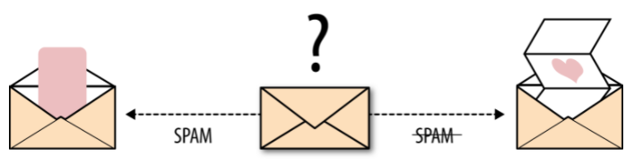
Email spam detection is a binary classification problem (source: From Book — Evaluating Machine Learning Model — O’Reilly)
There are many ways for measuring classification performance. Accuracy, confusion matrix, log-loss, and AUC-ROC are some of the most popular metrics. Precision-recall is a widely used metrics for classification problems.
- Accuracy
Accuracy simply measures how often the classifier correctly predicts. We can define accuracy as the ratio of the number of correct predictions and the total number of predictions.
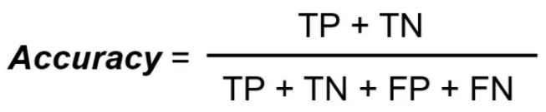
When any model gives an accuracy rate of 99%, you might think that model is performing very good but this is not always true and can be misleading in some situations. I am going to explain this with the help of an example.
Example
Consider a binary classification problem, where a model can achieve only two results, either model gives a correct or incorrect prediction. Now imagine we have a classification task to predict if an image is a dog or cat as shown in the image. In a supervised learning algorithm, we first fit/train a model on training data, then test the model on testing data. Once we have the model’s predictions from the X_test data, we compare them to the true y_values (the correct labels).
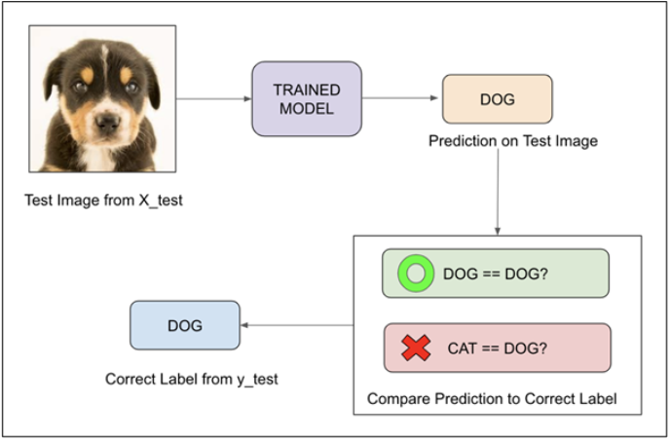
We feed the image of the dog into the training model. Suppose the model predicts that this is a dog, and then we compare the prediction to the correct label. If the model predicts that this image is a cat and then we again compare it to the correct label and it would be incorrect.
We repeat this process for all images in X_test data. Eventually, we’ll have a count of correct and incorrect matches. But in reality, it is very rare that all incorrect or correct matches hold equal value. Therefore one metric won’t tell the entire story.
Accuracy is useful when the target class is well balanced but is not a good choice for the unbalanced classes. Imagine the scenario where we had 99 images of the dog and only 1 image of a cat present in our training data. Then our model would always predict the dog, and therefore we got 99% accuracy. In reality, Data is always imbalanced for example Spam email, credit card fraud, and medical diagnosis. Hence, if we want to do a better model evaluation and have a full picture of the model evaluation, other metrics such as recall and precision should also be considered.
- Confusion Matrix
Confusion Matrix is a performance measurement for the machine learning classification problems where the output can be two or more classes. It is a table with combinations of predicted and actual values.
A confusion matrix is defined as thetable that is often used to describe the performance of a classification model on a set of the test data for which the true values are known.
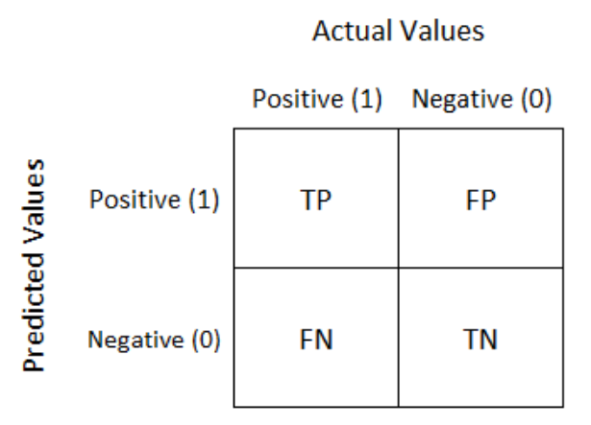
It is extremely useful for measuring the Recall, Precision, Accuracy, and AUC-ROC curves.
Let’s try to understand TP, FP, FN, TN with an example of pregnancy analogy.
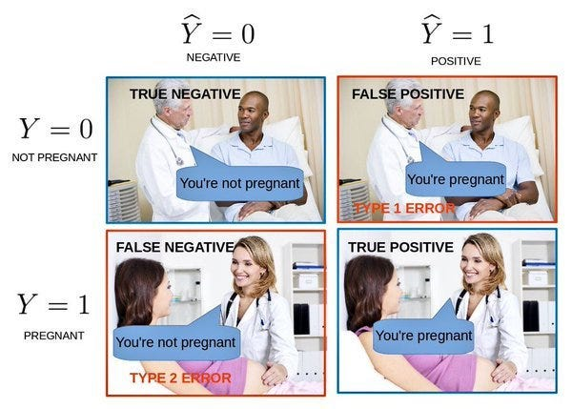
- True Positive: We predicted positive and it’s true. In the image, we predicted that a woman is pregnant and she actually is.
- True Negative: We predicted negative and it’s true. In the image, we predicted that a man is not pregnant and he actually is not.
- False Positive (Type 1 Error): We predicted positive and it’s false. In the image, we predicted that a man is pregnant but he actually is not.
- False Negative (Type 2 Error): We predicted negative and it’s false. In the image, we predicted that a woman is not pregnant but she actually is.
We discussed Accuracy, now let’s discuss some other metrics of the confusion matrix
- Precision
It explains how many of the correctly predicted cases actually turned out to be positive. Precision is useful in the cases where False Positive is a higher concern than False Negatives. The importance of Precision is in music or video recommendation systems, e-commerce websites, etc. where wrong results could lead to customer churn and this could be harmful to the business.
Precision for a label is defined as the number of true positives divided by the number of predicted positives.
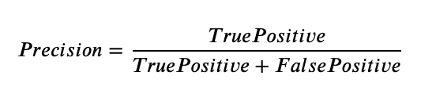
- Recall (Sensitivity)
It explains how many of the actual positive cases we were able to predict correctly with our model. Recall is a useful metric in cases where False Negative is of higher concern than False Positive. It is important in medical cases where it doesn’t matter whether we raise a false alarm but the actual positive cases should not go undetected!
Recall for a label is defined as the number of true positives divided by the total number of actual positives.
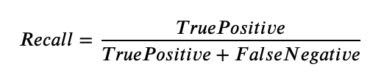
- F1 Score
It gives a combined idea about Precision and Recall metrics. It is maximum when Precision is equal to Recall.
F1 Score is the harmonic mean of precision and recall.
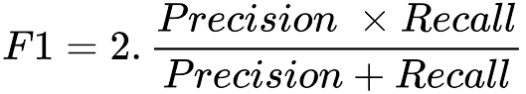
The F1 score punishes extreme values more. F1 Score could be an effective evaluation metric in the following cases:
- When FP and FN are equally costly.
- Adding more data doesn’t effectively change the outcome
- True Negative is high

- AUC-ROC
The Receiver Operator Characteristic (ROC) is a probability curve that plots the TPR(True Positive Rate) against the FPR(False Positive Rate) at various threshold values and separates the ‘signal’ from the ‘noise’.
The Area Under the Curve (AUC) is the measure of the ability of a classifier to distinguish between classes. From the graph, we simply say the area of the curve ABDE and the X and Y-axis.
From the graph shown below, the greater the AUC, the better is the performance of the model at different threshold points between positive and negative classes. This simply means that When AUC is equal to 1, the classifier is able to perfectly distinguish between all Positive and Negative class points. When AUC is equal to 0, the classifier would be predicting all Negatives as Positives and vice versa. When AUC is 0.5, the classifier is not able to distinguish between the Positive and Negative classes.
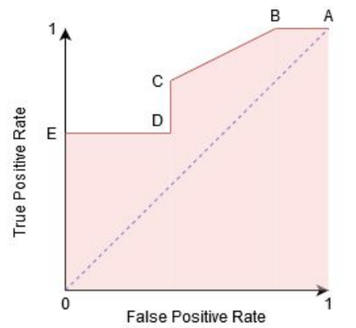
Working of AUC
In a ROC curve, the X-axis value shows False Positive Rate (FPR), and Y-axis shows True Positive Rate (TPR). Higher the value of X means higher the number of False Positives(FP) than True Negatives(TN), while a higher Y-axis value indicates a higher number of TP than FN. So, the choice of the threshold depends on the ability to balance between FP and FN.
- Log Loss
Log loss (Logistic loss) or Cross-Entropy Loss is one of the major metrics to assess the performance of a classification problem.
For a single sample with true label y∈{0,1} and a probability estimate p=Pr(y=1), the log loss is:
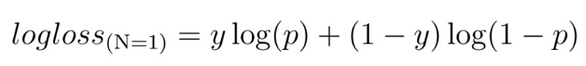

Steps to apply machine learning to data
1. Problem Definition and Understanding the Data
- Understand the Business Problem: Clearly define the problem or goal you aim to achieve. For example, predicting customer churn, classifying emails as spam or not, detecting fraud, etc.
- Identify the Type of Problem: Determine whether it is a:
  - Classification Problem (e.g., spam detection, disease diagnosis).
  - Regression Problem (e.g., predicting house prices, stock market forecasting).
  - Clustering Problem (e.g., customer segmentation).
  - Dimensionality Reduction Problem (e.g., reducing features while retaining most of the information).
  - Reinforcement Problem (e.g., learning strategies in game AI, robot control).
2. Data Collection
- Identify Data Sources: Collect data relevant to the problem from databases, APIs, sensors, or publicly available datasets.
- Types of Data:
  - Labeled Data: Data where each input has a corresponding output label (used for supervised learning).
  - Unlabeled Data: Data with no labels, used for unsupervised learning.
  - Partially Labeled Data: Contains both labeled and unlabeled data (used for semi-supervised learning).
3. Exploratory Data Analysis (EDA)
- Understand Data Characteristics: Visualize the data distribution, identify patterns, correlations, outliers, and missing values.
- Feature Understanding: Assess the features (input variables) and how they relate to the target variable (output). Tools like histograms, scatter plots, and pair plots are helpful.
- Data Imbalance: Check if the classes in the data are balanced, which is important for choosing the right algorithms (e.g., for imbalanced classification problems, algorithms like SMOTE, weighted loss functions, or cost-sensitive learning might be necessary).
4. Data Preprocessing and Feature Engineering
- Data Cleaning: Handle missing values (using techniques like mean/median imputation or advanced methods like KNN imputation). Deal with noisy data and outliers.
- Data Transformation:
  - Scaling: Standardize or normalize numerical features (important for algorithms like SVM, k-NN, and neural networks).
  - Encoding Categorical Variables: Convert categorical variables using techniques like one-hot encoding, label encoding, or target encoding.
- Feature Engineering: Create new features, transform existing ones, or reduce dimensionality using techniques like Principal Component Analysis (PCA) or Feature Selection methods.
- Splitting Data: Divide your dataset into training, validation, and test sets (commonly in a 70-20-10 or 60-20-20 split).
5. Choose the Right Learning Approach Based on the Data
- Supervised Learning: Used when you have labeled data (input-output pairs).
  - Classification Algorithms:
    - Decision Trees and Random Forests: Great for both small and large datasets, can handle mixed data types.
    - Logistic Regression: Good for binary classification problems.
    - Support Vector Machines (SVM): Effective for high-dimensional data with clear margins.
    - Neural Networks (Deep Learning): Ideal for large datasets with complex relationships (e.g., image or text classification).
  - Regression Algorithms:
    - Linear Regression: Simple linear relationships.
    - Ridge/Lasso Regression: Handles multicollinearity and regularization.
    - Gradient Boosting (e.g., XGBoost, LightGBM): High-performance models for non-linear relationships.
- Unsupervised Learning: Used when you have unlabeled data, and you want to discover patterns.
  - Clustering Algorithms:
    - k-Means Clustering: Simple and effective for well-separated clusters.
    - Hierarchical Clustering: Suitable for nested clusters.
    - DBSCAN: Handles clusters of varying density and outliers well.
  - Dimensionality Reduction Algorithms:
    - PCA: Reduces dimensionality by preserving variance.
    - t-SNE and UMAP: Great for visualizing high-dimensional data in 2D/3D space.
- Semi-Supervised Learning: Used when you have a small amount of labeled data and a large amount of unlabeled data.
  - Algorithms like Label Propagation or Self-training Neural Networks can learn from both labeled and unlabeled data.
- Reinforcement Learning: Used for sequential decision-making problems where an agent learns by interacting with an environment to maximize cumulative rewards.
  - Algorithms like Q-Learning or Deep Q Networks (DQN) are suitable for problems like robotics, game AI, or autonomous driving.
6. Model Training and Hyperparameter Tuning
- Train the Model: Fit the chosen model(s) on the training data.
- Cross-Validation: Use techniques like k-fold cross-validation to validate the model’s performance and avoid overfitting.
- Hyperparameter Tuning: Optimize model parameters using grid search, random search, or Bayesian optimization.
7. Model Evaluation
- Evaluate Using the Test Set: Assess the model’s performance on the test set using appropriate metrics:
  - Classification Metrics: Accuracy, precision, recall, F1-score, ROC-AUC.
  - Regression Metrics: MAE, MSE, RMSE, R².
- Confusion Matrix: For classification tasks, use confusion matrices to analyze the distribution of true positives, true negatives, false positives, and false negatives.
8. Model Interpretability and Explainability
- Feature Importance: Identify which features are driving predictions.
- Explainability Tools: Use LIME, SHAP, or Partial Dependence Plots to explain complex models, particularly when using black-box models like neural networks.
9. Model Deployment
- Prepare for Production: Ensure the model is ready for real-world usage by considering scalability, latency, and integration into existing systems.
- Deployment Options: Deploy as a microservice via REST API, integrate into applications, or automate in batch pipelines.
- Real-time vs. Batch Predictions: Depending on the use case, deploy the model for real-time inference (e.g., fraud detection) or periodic batch predictions (e.g., churn analysis).
10. Monitor and Maintain the Model
- Performance Monitoring: Track the model’s performance over time. Set up alerts for any performance drops due to data drift, concept drift, or other changes in the environment.
- Model Retraining: Regularly update and retrain the model with new data to keep it accurate.
- Feedback Loops: Incorporate user feedback or expert insights to continually improve the model.
11. Iterate and Improve
- Experimentation: Continuously experiment with new features, algorithms, or preprocessing steps to enhance model performance.
- Version Control: Use version control for models to track improvements and compare versions systematically.
- A/B Testing: When deploying new versions, conduct A/B testing to compare performance in production environments.
Machine learning process
1. Problem Definition
- Clearly define the problem you want to solve (e.g., classification, regression, clustering).
- Understand the business objectives and translate them into machine learning goals.
2. Data Collection
- Gather relevant data from various sources (databases, APIs, sensors).
- Ensure the data is representative of the problem you want to solve.
3. Data Exploration and Preparation
- Exploratory Data Analysis (EDA): Analyze the data to understand distributions, correlations, outliers, and patterns.
- Data Cleaning: Handle missing values, remove duplicates, and correct inconsistencies.
- Feature Engineering: Create new features, select important ones, and transform data (e.g., scaling, encoding).
- Data Splitting: Split the data into training, validation, and test sets.
4. Model Selection
- Choose an appropriate model or algorithm based on the problem type and data characteristics (e.g., decision trees, neural networks).
- Consider the complexity, interpretability, and scalability of the model.
5. Model Training
- Train the model using the training data.
- Fine-tune hyperparameters (e.g., learning rate, regularization) to optimize performance.
- Use techniques like cross-validation to improve model robustness and avoid overfitting.
6. Model Evaluation
- Evaluate the model using validation data with metrics relevant to the problem (e.g., accuracy, precision, recall, RMSE).
- Analyze the confusion matrix, ROC curves, or other diagnostic tools based on the problem type.
7. Model Tuning
- Adjust hyperparameters and retrain the model if performance is not satisfactory.
- Consider trying different algorithms or adding/removing features if needed.
8. Model Testing
- Test the model on unseen data (test set) to assess generalization performance.
- Confirm the model’s effectiveness on real-world or production data.
9. Model Deployment
- Deploy the model to production environments (e.g., web services, cloud platforms).
- Integrate the model with existing systems or applications.
10. Monitoring and Maintenance
- Continuously monitor model performance in production.
- Detect and address data drift or model degradation.
- Retrain the model periodically with new data to keep it relevant.
11. Iteration and Improvement
- Iterate by collecting feedback, experimenting with new features or models, and refining the solution.
- Implement A/B testing if necessary for performance comparisons in production
Input data
1. Types of Input Data
- Numerical Data: Continuous or discrete numbers (e.g., age, salary, temperature).
  - Example: height = 170 cm, income = $50,000.
- Categorical Data: Discrete categories or labels (e.g., gender, country).
  - Example: gender = male, color = red.
- Text Data: Unstructured or semi-structured textual data (e.g., emails, articles, reviews).
  - Example: "The movie was fantastic!"
- Time Series Data: Data points collected or recorded at specific time intervals (e.g., stock prices, weather data).
  - Example: timestamp = 2023-08-26, value = 30°C.
- Image Data: Pixel values representing images (e.g., photos, medical scans).
  - Example: A 28x28 grayscale image for handwritten digit recognition.
- Audio Data: Sound waveforms or spectrograms (e.g., voice recordings, music).
  - Example: Audio signal data for speech recognition.
- Video Data: Sequences of image frames (e.g., surveillance footage, video clips).
  - Example: A series of images representing a moving object.
2. Features (Input Variables)
- Features are the measurable properties or attributes of the input data used to make predictions.
- Feature Vectors: In machine learning, input data is typically represented as a feature vector, where each element corresponds to a specific feature (e.g., [height, weight, age]).
3. Label (Target Variable)
- In supervised learning, each input data point is associated with a label (output). For example, in a classification task, labels might be categories like "spam" or "not spam".
4. Input Data Formats
- Tabular Data: Data organized in rows and columns, typical in structured datasets (e.g., CSV, Excel).
- Textual Data: Documents, sentences, or words organized in a sequence (e.g., JSON, TXT).
- Image Data: Grayscale or color images stored as pixel matrices (e.g., PNG, JPEG).
- Time Series Data: Data with a timestamp associated with each value, often in CSV or database formats.
5. Data Preprocessing
Input data often needs to be preprocessed before being used in a model:
- Scaling and Normalization: Adjusting numeric data to a standard scale (e.g., Min-Max scaling).
- Encoding Categorical Data: Converting categorical variables into numerical values (e.g., one-hot encoding, label encoding).
- Text Vectorization: Converting text data into numerical vectors using techniques like Bag of Words (BoW), TF-IDF, or Word Embeddings.
- Image Preprocessing: Resizing, normalizing pixel values, and augmenting images.
- Handling Missing Data: Imputation or removal of missing values.
- Feature Selection/Engineering: Creating or selecting the most relevant features to improve model performance.
6. Splitting Input Data
Input data is typically split into three parts:
- Training Set: Used to train the model (usually 60-80% of the data).
- Validation Set: Used to tune hyperparameters and evaluate model performance during training (10-20% of the data).
- Test Set: Used to assess the model’s final performance on unseen data (10-20% of the data).
7. Examples of Input Data in Different ML Tasks
- Classification: Email text used to classify whether it’s spam or not.
- Regression: House features (e.g., square footage, number of rooms) used to predict house prices.
- Clustering: Customer data used to group customers into segments based on purchasing behavior.
- Image Classification: Pixels of an image used to predict whether the image is of a cat or a dog.
- Time Series Forecasting: Historical stock prices used to predict future prices.
ML algorithm:
1. Supervised Learning Algorithms
- In supervised learning, the model is trained on labeled data (input-output pairs) where the output (target) is known.
1.1. Classification Algorithms
- Used for predicting discrete categories or classes.
  - Logistic Regression: A linear model used for binary classification (e.g., spam vs. not spam).
  - Decision Trees: A tree-structured model that makes decisions based on feature splits (e.g., determining whether a patient has a disease).
  - Random Forest: An ensemble of decision trees that improves accuracy by averaging multiple tree predictions.
  - Support Vector Machine (SVM): A model that finds the best decision boundary to separate different classes.
  - k-Nearest Neighbors (k-NN): A simple algorithm that classifies a data point based on the majority class among its nearest neighbors.
  - Naive Bayes: A probabilistic model based on Bayes' theorem, often used for text classification.
  - Neural Networks: Models inspired by the human brain, capable of capturing complex patterns (e.g., deep learning models for image classification).
1.2. Regression Algorithms
- Used for predicting continuous numerical values.
  - Linear Regression: A linear model that predicts the output based on a linear relationship between features.
  - Ridge and Lasso Regression: Variants of linear regression with regularization to prevent overfitting.
  - Polynomial Regression: Extends linear regression by considering polynomial relationships.
  - Decision Trees and Random Forest (for Regression): Can be used for predicting continuous values.
  - Support Vector Regression (SVR): An adaptation of SVM for regression tasks.
  - Gradient Boosting Machines (GBM), XGBoost, LightGBM: Powerful ensemble models that work well for both classification and regression.
2. Unsupervised Learning Algorithms
- In unsupervised learning, the model learns from data without any labeled outputs. It is mainly used for discovering patterns or grouping data.
2.1. Clustering Algorithms
- Group similar data points into clusters.
  - k-Means Clustering: Partitions data into k clusters based on feature similarity.
  - Hierarchical Clustering: Builds a hierarchy of clusters using a tree-like structure.
  - DBSCAN: A density-based algorithm that groups data points based on density and can handle outliers.
2.2. Association Rule Learning
- Identifies relationships or patterns in large datasets.
  - Apriori Algorithm: Used for finding frequent itemsets and association rules in transactional data (e.g., market basket analysis).
  - Eclat Algorithm: Another technique for discovering frequent itemsets.
2.3. Dimensionality Reduction Algorithms
- Reduce the number of features while retaining essential information.
  - Principal Component Analysis (PCA): Projects data into lower dimensions by capturing the most variance.
  - t-SNE (t-Distributed Stochastic Neighbor Embedding): Used for visualizing high-dimensional data in 2D or 3D.
  - UMAP (Uniform Manifold Approximation and Projection): A newer method for dimension reduction, particularly for visualization.
3. Semi-Supervised Learning Algorithms
- Combines labeled and unlabeled data for training, often used when obtaining labeled data is expensive or time-consuming.
- Label Propagation: Spreads label information from labeled data to unlabeled data.
- Self-training: The model is trained on labeled data, and then it predicts labels for unlabeled data, which are added to the labeled set for further training.
4. Reinforcement Learning Algorithms
- In reinforcement learning, an agent learns to make decisions by interacting with an environment to maximize cumulative rewards.
- Q-Learning: A value-based method where the agent learns the value of actions in different states.
- Deep Q Networks (DQN): Combines Q-learning with deep learning to handle complex environments like video games.
- Policy Gradient Methods: Learn policies that directly map states to actions (e.g., REINFORCE algorithm).
- Proximal Policy Optimization (PPO): A popular reinforcement learning algorithm used for continuous control tasks
The relationship between input data and machine learning algorithms is crucial for building effective models. The type of data you have often determines which algorithms are most suitable for processing and analyzing it. Here's a detailed guide on how different types of input data relate to various machine learning algorithms:
1. Numerical Data
- Description: Data represented by numbers, which can be either continuous (e.g., temperature, height) or discrete (e.g., count of items).
- Suitable Algorithms:
  - Regression Algorithms:
    - Linear Regression: Predicts a continuous target variable based on numerical features.
    - Ridge/Lasso Regression: Handles regularization to prevent overfitting.
  - Classification Algorithms:
    - Logistic Regression: Used for binary classification problems with numerical features.
    - Decision Trees/Random Forest: Can handle both numerical and categorical data for classification tasks.
    - k-Nearest Neighbors (k-NN): Classifies data points based on proximity in numerical space.
    - Support Vector Machines (SVM): Effective for high-dimensional numerical data.
2. Categorical Data
- Description: Data representing categories or groups without inherent order (e.g., colors, country names).
- Suitable Algorithms:
  - Classification Algorithms:
    - Naive Bayes: Works well with categorical data, especially when using techniques like one-hot encoding.
    - Decision Trees/Random Forest: Handles categorical data directly by splitting on categorical features.
  - Preprocessing Needed:
    - Encoding Techniques:
      - One-Hot Encoding: Converts categorical variables into binary vectors.
      - Label Encoding: Assigns a unique integer to each category.
3. Text Data
- Description: Unstructured or semi-structured data in the form of text (e.g., documents, tweets).
- Suitable Algorithms:
  - Classification Algorithms:
    - Naive Bayes: Often used for text classification tasks like spam detection.
    - Support Vector Machines (SVM): Effective for text classification when combined with text vectorization techniques.
    - Neural Networks: Particularly deep learning models like Recurrent Neural Networks (RNNs) and Transformers (e.g., BERT, GPT) for complex text data.
  - Preprocessing Needed:
    - Text Vectorization:
      - Bag of Words (BoW): Converts text into a fixed-length vector based on word frequency.
      - TF-IDF (Term Frequency-Inverse Document Frequency): Adjusts word frequencies by their importance.
      - Word Embeddings: Converts words into dense vectors (e.g., Word2Vec, GloVe).
4. Image Data
- Description: Data in the form of images, represented by pixel values.
- Suitable Algorithms:
  - Classification Algorithms:
    - Convolutional Neural Networks (CNNs): Specialized for image classification, object detection, and other visual tasks.
  - Preprocessing Needed:
    - Image Resizing: Standardize image dimensions.
    - Normalization: Scale pixel values (e.g., [0, 1] range).
    - Data Augmentation: Apply transformations like rotation and flipping to increase data diversity.
5. Time Series Data
- Description: Data points collected or recorded at specific time intervals (e.g., stock prices, sensor readings).
- Suitable Algorithms:
  - Forecasting Algorithms:
    - ARIMA (AutoRegressive Integrated Moving Average): Classical method for time series forecasting.
    - Long Short-Term Memory Networks (LSTMs): A type of RNN designed to handle sequential data and capture long-term dependencies.
    - Prophet: A tool for forecasting time series data with seasonality and trends.
  - Preprocessing Needed:
    - Feature Engineering: Create lag features, rolling statistics, or trend indicators.
    - Seasonal Decomposition: Separate the time series into trend, seasonality, and residual components.
6. Audio Data
- Description: Data in the form of audio signals or recordings.
- Suitable Algorithms:
  - Classification Algorithms:
    - Recurrent Neural Networks (RNNs): Can handle sequential nature of audio data.
    - Convolutional Neural Networks (CNNs): Used for spectrogram-based audio classification.
  - Preprocessing Needed:
    - Feature Extraction: Convert audio signals into features like Mel-frequency cepstral coefficients (MFCCs).
    - Spectrograms: Visual representations of the frequency spectrum of audio signals.
7. Video Data
- Description: Sequences of images or frames representing moving content (e.g., video clips, surveillance footage).
- Suitable Algorithms:
  - Classification Algorithms:
    - 3D Convolutional Neural Networks (3D CNNs): Designed for capturing temporal and spatial features in videos.
    - Two-Stream Networks: Combine spatial CNNs with temporal networks to process video data.
  - Preprocessing Needed:
    - Frame Extraction: Convert videos into frames for processing.
    - Temporal Smoothing: Handle variations between frames to stabilize input.

