**LEACH (Low-Energy Adaptive Clustering Hierarchy)**

W. R Heinzeolman proposed LEACH protocol, which based on cluster structure and hierarchical technology. Relative to the traditional protocol, LEACH could save a greater degree of energy. It used adaptive technology and Next Node, node rotation technology, the LEACH was more efficient than the original class network structure; the whole WSN was more balanced on load distribution, and could extend the WSN lifetime greatly. In addition, each cluster could calculate locally and remove redundant data, reduce the communication burden of Next Node, node. As the energy consumption of calculation was much less than the energy consumption of communication, so LEACH could save energy greatly. At the beginning of each round, each node advertises it probability, (depending upon its current energy level) to be the Cluster Head, to all other nodes. Nodes (k for each round) with higher probabilities are chosen as the Cluster Heads. Cluster Heads broadcasts an advertisement message (ADV) using CSMA MAC protocol. Based on the received signal strength, each non-Cluster Head node determines its Cluster Head for this round (random selection with obstacle). Each non-Cluster Head transmits a join-request message (Join-REQ) back to its chosen Cluster Head using a CSMA MAC protocol. Cluster Head node sets up a TDMA schedule for data transmission coordination within the cluster. Flow chart for CH selection in setup phase is given below:

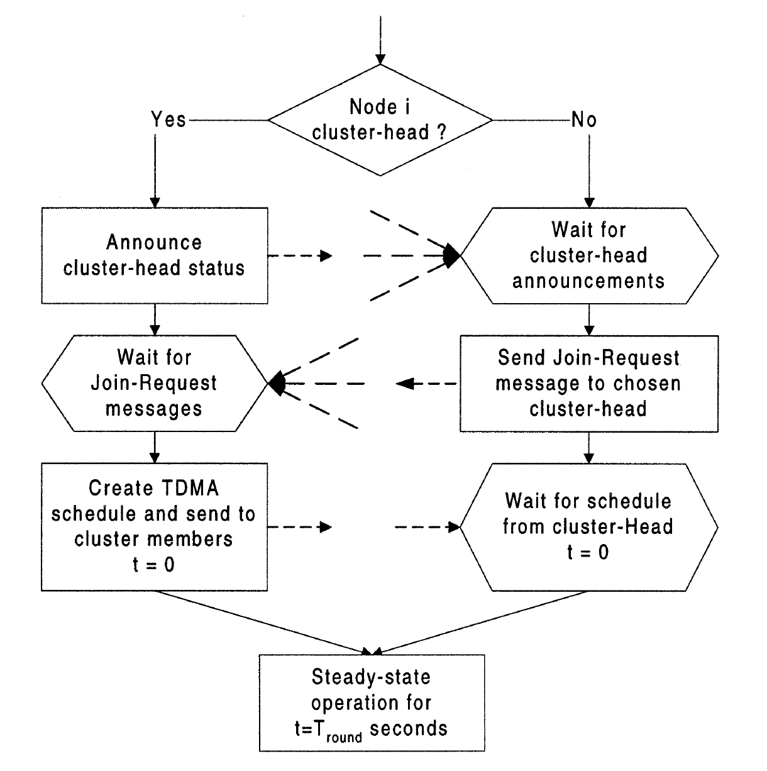

**Flow chart for LEACH**

**Algorithm for LEACH protocol:**

// The number of rounds

r=0

while node alive do

for i=1to N do

checkNumDeadNode(arrNode[i].E<0)

end

// loop to select cluster heads

for i=1 to N do

if arrNodes[i].E>0 then

randomNumber=rand()

if randomNumber<threshold (r,k) then

// node i selected as cluster head

arrNode[i].type=’cluster head’

//increase the number of cluster heads

numClusterHeads++

calcdissipation CH()

end

end

end

// computations for nodes not selected as cluster heads

for i=1 to N do

if arrNodes[i].Type!=’clusterhead’ AND arrNodes[i].E>0 then

assign nodes to clusters

calcDisssipationNodes()

end

end

// increment number of rounds only if cluster head selected

If numClusterHeads>0 then

r=r+1

end

end

This is the basic algorithm for LEACH protocol.