1. **Title**

A 2D and 3D raster analysis and simulation exercise using R.

1. **Abstract**

R language is widely used in the field of geospatial analysis, including imagery from UAV, Aircraft and Satellite. Majority of digital data is based on 8 bit model and all the data value are in range of 0-255. With advancement of various mathematical models the computation power of different statistical models is increasing, the analysis of 2D and 3D data set became faster and user friendly. Various packages for spatial data handling have been developed in last decade with efficiency.

1. **Introduction:**

In this assessment, 2D dataset is generated, imported and analysed using spatial analysis packages. The implantation of various data manipulation techniques such as reclassification, crop is illustrated on actual dataset from EDINA Digimap. Additionally, A 3D plot of happisburgh is illustrated with help of 3D raster handling packages.

1. **Task 1**
2. **Algorithm/ Methods used:**
   1. **Runif**

Runif(‘runif’) function generates random deviates with given arguments. In this case, runif generated 10000 values within range of 0 to 255. Generated values are round down to nearest integer by using ‘floor’ function.

* 1. **Floor**

Floor(‘floor’) function round down given values to nearest integer. It is used in this case because we had to generate 8-bit data which contain only integer values from 0(20-1) to 255(28-1).

* 1. **Matrix**

Matrix function creates matrix from given set of values. In this case, matrix function is given values that are generated by runif function.

* 1. **Raster**

Raster(‘raster’) function converts all the supported formats to raster or creates rasterlayer from different supported formats.

* 1. **Plot**

Plot(‘plot’) is a generic function for plotting R objects including graphs, images, rasters.

* 1. **Hist**

Hist(‘hist’) function generates histogram plot of given data with different attributes. In this case, hist was used to analyse the data distribution of the matrix/raster.

* 1. **Reclassify**

Reclassify(‘reclassify’) function reclassify value of a raster object. It converts the data and ranges in accordance to reclassification matrix provided by the user.

1. **Methodology:**

The task 1 was based on idea to generate an image that could be treated as a digital UAV/aerial photograph or satellite image and application of general operations on the generated image. For image generation, a matrix with size 100*100 with data range 0 to 255(integer) is generated using runif function.



Runif function generates numeric data with decimal points, to eliminate the decimal points and to convert data into integer numbers ‘floor’ function was used. For simulation of matrix as a map, the matrix is converted into raster using ‘raster’ function and plotted using ‘plot’ function(figure 1).



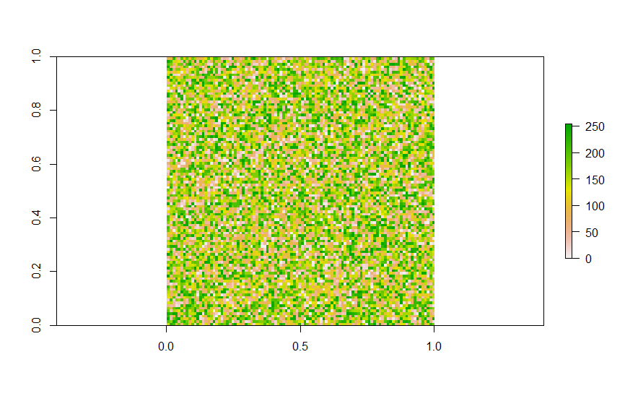

Figure Converted Raster from generated matrix with data range of 256

The raster contains value from 0 to 255, for better analysis the raster is reclassified to scale of 0 to 10. For reclassification, a reclassification matrix(size 3*n, where n is number of ranges required) was provided with initial ranges to new ranges, i.e. ((lower value 1, higher value 1, new range 1),( lower value 2, higher value 2, new range 2),… new range n)).



Figure Reclassified raster with data range of 10

After reclassification, the reclassified raster was plotted for illustration(figure 2).



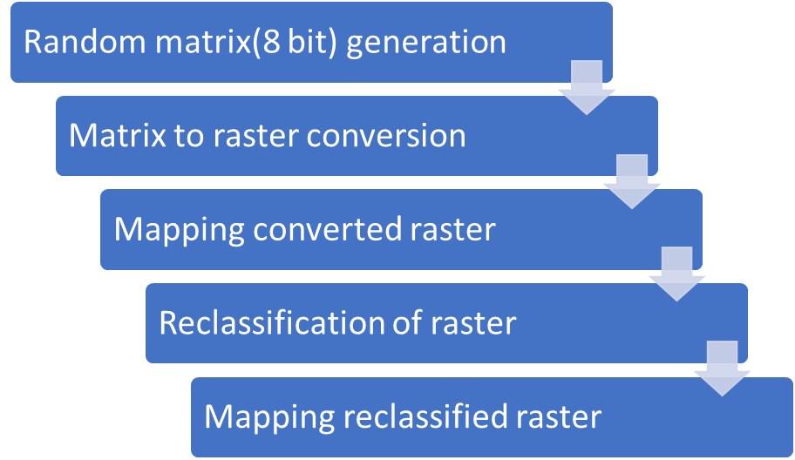

Figure Flow diagram showing structure of methodology for task 1.

1. **Task 2:**
2. **Study Area:** Findhorn Bay

Findhorn Bay is an important Scottish costal landmark. The Findhorn Bay is part of Scotland’s Costal Heritage, there is a wooden fishing boat graveyard present that contains remains of 30 wooden fishing boats. The site illustrates the picture of decline of local herring fishery in early 20th century. In this boat graveyard, boats from 18th,19th 20th centuries are present, but due to change in sea level there is possibility of damage to the heritage site(SCHARP ShoreDIG, June 2017) .

1. **Library:**
   1. **Sp**

SP(‘sp’) library provides methods and classes for computation of spatial data in R. The spatial data include points, polygons and 3D data. The library provides utility for data plotting, spatial data manipulation, computation, coordinate handling etc.

* 1. **Raster**

Raster(‘raster’) library provides different functions for data computation and provide a link between statical data and spatial data. It also helps in conversion of all the supported formats to raster and in creation of rasterlayer from different supported formats.

* 1. **Lattice**

Lattice(‘lattice’) provides a powerful high-level data visualization system based on Trellis graphics. It is proven sufficient for standard and nonstandard data handling.

* 1. **LatticeExtra**

LatticeExtra (‘latticeExtra’) is an R package for statistical computing environment to provide functions for generating statical graphics. It is extend of lattice package and it is maintained by Deepayan Sarkar and Felix Andrews.

* 1. **GISTools**

GISTools (‘GISTools’) package provides mapping and spatial data manipulation tools with nice looking components like legends, north arrow etc.

* 1. **Rastervis**

Rastervis (‘rasterVis’) package provides a set of methods for enhanced visualisation and intraction. It provides visualisation methods for univariate and multivariate rasters.

* 1. **Rgl**

Rgl(‘rgl’) package is used to produce intractive 3-D plots and working 3-D environment.

1. **Methodology:**

Task 2 consists of analysis of digital terrain model present in ASCII file format(.asc). The DTM of Findhorn Bay was downloaded from EDINA Digimap. To read the asc file, raster function was used and raster was plotted using plot function with X and Y axis deactivated for better aesthetics (Figure 4).



Figure Plot of Findhorn Bay without any function implementation

To specify the region of interest, ‘drawExtent’ function was used followed by crop function (Figure 5).



Figure Plot with drawExtent input feature activated

Contours were projected on the plot for better understanding of DTM and elevations (Figure 6).



Figure Plot with contour projection.

The DTM was reclassified for better visualisation and for observation of sea level and different land type.



The reclassified map was plotted using plot function along with different attributes like title, sub title, scale, north arrow with the help of function provided by GISTools package (Figure 7).

Figure Final Plot with reclassification and all mapping features

Figure Flow diagram showing structure of methodology for task 2.

1. **Additional Task:**
2. **Methodology:**

Additional Task consists of plotting a 3D model (DTM). For visualisation and simulation of 3D model, rasterVis and rgl package provide plot3D function (Figure 9 & 10). The visualized 3D plot also include intractive interface and different cursor based operations could be performed on it.



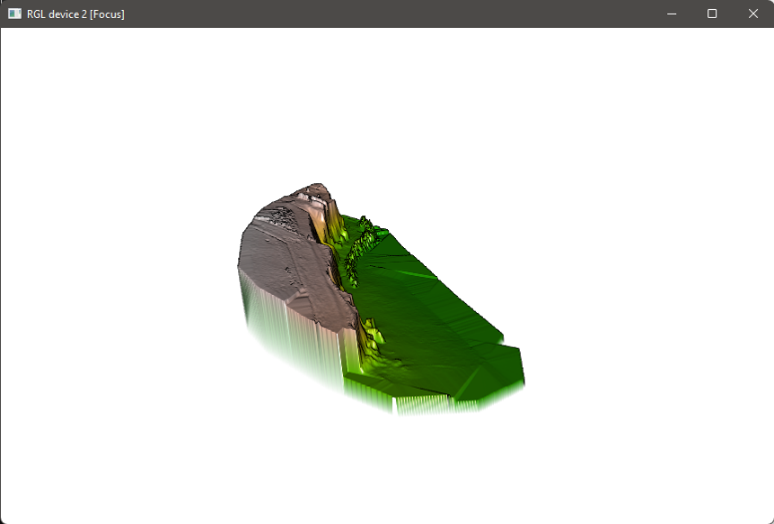

Figure 3D plot of Happisburgh_survey_dsm

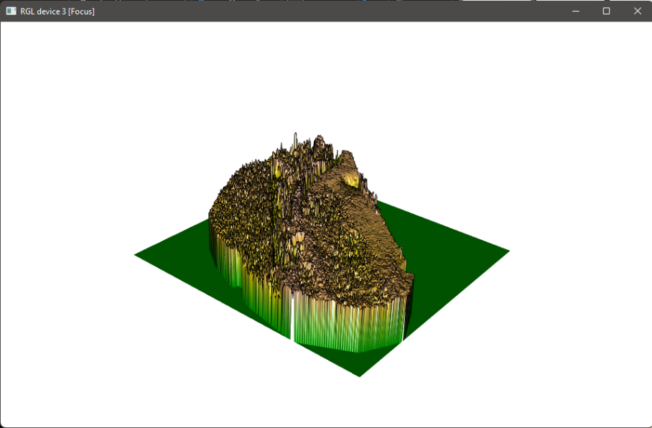

Figure 3D plot of Happisburgh_Survey_transparent_mosaic_group1

1. **Summary and Conclusion**

An analysis of 2D and 3D raster was done using different R packages. The analysis was done on generated and imported dataset, the generated dataset was matrix and imported dataset was ASCII file. DTM/DEM were plotted and raster data was manipulated for possible future analysis. A 2D map was generated as final result with features including north arrow, scale, legend and title.

**References**

SCHARP ShoreDIG: Findhorn Bay boat graveyard Data Structure Report June 2017

Available at: https://scapetrust.org/wp-content/uploads/reports/FINDHORN-DSR-FINAL-small.pdf

**Appendix-A**

Complete R Code:

#Package installation and inclusion

#install.packages("pacman")

pacman**::**p_load**(**pacman,RColorBrewer,ggplot2,gplots,lattice,sf,tmap,tmaptools,leaflet,dplyr,maptools,ggspatial,GISTools,prettymapr,rasterVis,rgl**)**

library**(**raster**)**

library**(**sf**)**

library**(**tmap**)**

library**(**tmaptools**)**

library**(**leaflet**)**

library**(**dplyr**)**

library**(**maptools**)**

library**(**ggspatial**)**

options**(**"max.contour.segments"**=** 300000**)**

#Task 1

matrix_generated**<-**matrix**(**floor**(**runif**(**10000,min**=**0,max**=**255**))**,100,100**)**

raster**<-**raster**(**matrix_generated**)**

str**(**raster**)**

plot**(**raster**)**

summary**(**raster**)**

hist**(**raster,main**=**"Distribution of cells",xlab**=**"value",ylab**=**"Number of Pixels",col**=**"springgreen"**)**

reclassification_df**<-**c**(-**1,25,1,

25,50,2,

50,75,3,

75,100,4,

100,125,5,

125,150,6,

150,175,7,

175,200,8,

200,225,9,

225,255,10**)**

reclassification_matrix**<-**matrix**(**reclassification_df,ncol**=**3,byrow**=TRUE)**

classified_raster**<-**reclassify**(**raster,reclassification_matrix**)**

barplot**(**classified_raster,main**=**"number of pixels in each class"**)**

plot**(**classified_raster,col**=**c**(**"black","red","blue","green","white"**))**

#Task 2

getwd**()**

setwd**(**dirname**(**rstudioapi**::**getSourceEditorContext**()$**path**))**

Findhorn_Bay**=**raster**(**"Data/nj0060_dtm.asc"**)**

plot**(**Findhorn_Bay**)**

class**(**Findhorn_Bay**)**

plot**(**Findhorn_Bay,col**=**topo.colors**(**32**)**,xaxt**=**'n',yaxt**=**'n'**)**

Roi_ext**=**drawExtent**()**

Roi_Bay**=**crop**(**Findhorn_Bay,Roi_ext**)**

plot**(**Roi_Bay,col**=**topo.colors**(**32**))**

contour**(**Roi_Bay,add**=TRUE**,levels**=**c**(-**2,**-**1,0,1,3,5,8,12,17,23,27,32**))**

Elevation_classification_df**<-**c**(-**3,0,1,

0,3,2,

3,6,3,

6,**Inf**,4**)**

Elevation_classification_matrix**<-**matrix**(**Elevation_classification_df,ncol**=**3,byrow**=TRUE)**

Roi_classified_raster**<-**reclassify**(**Roi_Bay,Elevation_classification_matrix**)**

plot**(**Roi_classified_raster,topo.colors**(**10**)**,xaxt**=**'n',yaxt**=**'n'**)+**

contour**(**Roi_classified_raster,add**=TRUE**,levels**=**c**(**1,2,3,4**))+**

title**(**

main **=** "Findhorn Bay ", sub **=** "1:Submerged, 2:Semi-Submerged, 3:Coastal Land, 4:Mainland",

col.main**=**"darkgreen", col.lab**=**"black", col.sub**=**"darkgreen",

font.main **=** 4, font.lab **=** 4, font.sub **=** 3,

cex.main **=** 3, cex.lab **=** 1.7, cex.sub **=** 1**)+**

box**(**which**=**"outer",lwd**=**5,col**=**'blue'**)+**north.arrow**(**xb**=**15.75, yb**=**43.25, len**=**0.05, lab**=**"N"**)** **+**

north.arrow**(**xb**=**15.75, yb**=**43.25, len**=**0.05, lab**=**"N"**)+**addnortharrow**()+**addscalebar**()**

#Additional Task

Happisburgh**<-**raster**(**"Happisburgh_Survey_dsm.tiff"**)**

plot3D**(**Happisburgh**)**

Happisburgh_mosaic**<-**raster**(**"Happisburgh_Survey_transparent_mosaic_group1.tiff"**)**

plot3D**(**Happisburgh_mosaic**)**