

Explore Egypt

Explore Egypt
Software Requirements Specification (SRS)
Version: 1.0
CM Identifier: G12_SE02_v1.0

Revision History

Sl. No. | Prepared/  Modified by | E-mail | Version | Date | Approved by | Descriptions/  Remarks
1. | Chahira Hamza | Chahia.hamza@live.com | <1.0> | <03.11, 2018> | <TA: Dina Elreedy  TA: Ali Elseddeek >
2. | Farah Amr | Farah.amr.95@hotmail.com | <1.0> | <03.11, 2018> | <TA: Dina Elreedy  TA: Ali Elseddeek >
3. | Nooran Helmy | Nooran.helmi@hotmail.com | <1.0> | <03.11, 2018> | <TA: Dina Elreedy  TA: Ali Elseddeek >
4. | Shrouk Ismail | shroukismailmohamed@gmail.com | <1.0> | <03.11, 2018> | <TA: Dina Elreedy  TA: Ali Elseddeek >

Distribution list
Name | E-mail | Notes
Dr. Ahmed Hamdy
TA: Eng. Ali Elseddeek | alielseddeek@gmail.com
TA: Eng. Dina Elreedy | dinaelreedy@gmail.com

Table of Contents
1. Introduction 5
1.1 Purpose 5
1.2 Scope 5
1.3 Definitions, Acronyms and Abbreviations 5
1.4 References 5
1.5 Overview 6
2. Market Survey 6
2.1 Explore Egypt 6
2.1.1 Project Description 6
2.1.2 Functional Specifications 6
2.1.3 Non-Functional Specifications 7
2.1.4 Limitations 7
2.2 Summary 7
2.2.1 Functional Specifications 8
2.2.2 Non-Functional Specifications 8
2.2.3 Limitations 8
3. Cost Estimate 8
4. Feasibility Study 9
5. Requirements Specifications 9
5.1 User Requirements (User Stories) 11
5.1.1 For Admins
5.1.2 For Tourists
5.1.3 For Tour guides
5.1.4 For Advertisers
5.2 System Requirements (Use Cases) 12
5.2.1 UC1.0 Register.
5.2.2 UC1.1 Sign in.
5.2.3 UC1.2 Add a new site.
5.2.4 UC1.3 View sites description/tour guides info.
5.2.5 UC1.4 Rate sites.
5.2.6 UC1.5 Edit sites info.
5.2.7 UC1.6 Add/remove tour guides and advertisements.
5.2.8 UC1.7 Suggest new sites.
5.2.9 UC1.8 Add advertisements and pay fees.
5.2.10 UC1.9 Tour guide edits his info.
5.2.11 UC1.10 Pay fees.
5.3 Non-functional Requirements 17
5.3.1 NFR1: Attractive GUI
5.3.2 NFR2: The system shall be secured and not hacked.
5.3.3NFR3: All user inputs shall be validated to ensure that no fake or wrong data is inserted in the database.

6. High level plan 17
7. Supporting Information 18

Software Requirements Specification

Introduction

Purpose
This document describes our website “Explore Egypt” and clarifies its scope. It is a guide to using all the website functionalities from an end-user’s point of view (user’s requirements) and contains all needed details by admins and developers such as the system functional and nonfunctional requirements. The end result of the project will be a website which is able to advise users what to visit in every governorate in Egypt, and provide them with all needed details about these places. It will serve both tourists and Egyptians as there are a lot of hidden gems in Egypt that need to be revealed to both.

Scope
Explore Egypt will be available on a website with a connected database. It will provide users with details about many places that shouldn’t be missed by any tourist, and for Egyptians to discover as well. The software allows for other types of users to register such as advertisers and tour guides. Advertisers can put their ads for a specified amount of time, and renew them if needed. Tour guides will share their contact information so that tourists can easily communicate with them.

Definitions, Acronyms and Abbreviations

SRS | Software Requirement Specification
End-user | Mainly tourists or Egyptians that will use the website without the need to log in or register. Other types of users (advertisers, tour guides) will not be addressed in the document as end-user, but will be addressed explicitly as advertisers or tour guides.
Advertisers | A type of user that will need to create an account and add advertisements on the website.
Tour guides | A type of user that will use the website in order to market himself, and offer contact info for tourists to contact him.
DB | Database

References
Engel, K. (2018, January 01). How Much Does a Website Cost? Retrieved March 10, 2018, from https://www.whoishostingthis.com/blog/2014/07/29/website-cost/
Rampton, J. (2015, January 20). 12 Tips to Protect Your Company Website From Hackers. Retrieved March 10, 2018, from https://www.entrepreneur.com/article/241620

Overview
[This subsection should describe what the rest of the SRS contains and explain how the SRS is organized.]

Market Survey

Explore Egypt

Project Description
The software allows user to log in first as a normal end-user such as a tourist without the need for password. These users will be able to surf through the suggested places to visit in Egypt. Other users such as advertisers, and tour guides will need to create an account then log in with their password. Advertisers will need to pay an online fee for the time their ads are posted on the website. As for Tour guides, they are exempt from fees, since this software can be viewed as a collaboration afterwards with the faculty of tourism in order to increase the chances of finding work for young graduate tour guides. Tour guides will add their personal contact information, and any needed details such as languages they speak, price per hour, and availability to facilitate the communication between them and the tourists.

Functional Specifications

End-Users

End-users should be able to easily navigate through the website and choose their preferred category of places to visit from Pharaonic, Islamic, Coptic, and modern.

End-users should be able to add a review about the places they visited and the tour guides with them if available, and give a rating from 0 to 3 hearts.

End-users should be able to navigate through the tour guides, and see their search results filtered by language, availability and price.

End-users should be able to suggest new places to the website by navigating to a “contact us” webpage where their suggestions should be submitted

Tour guides

Tour guides should be able to create an account and add their contact information (email and phone number) during the registration process

Tour guides should be able to add/edit their knowledge of languages, availability each week, and price per hour

Tour guides should be able to suggest new places worth visiting in the “contact us” webpage

Advertisers

Advertisers should be able to create an account and log in

Advertisers should be able to add multiple advertisements and choose the amount of time for each of them.

Advertisers should be able to pay online their fees

Non-Functional Specifications

The software response time should be efficient and fast enough for the end-users.

The software should be reliable and dependable. The DB should also act as a secondary storage in order to handle any crashes in the system or server.

The software should be user friendly with clear layout and results

The software should be secure against hacking attempts

The software needs to be constantly maintained and checked for new suggestions of places to visit

Limitations

The software needs internet connection since it is a website running on a server

Summary
<This should summarize the previous section. You should classify the specifications above into categories and specify the essential and non-essential specifications>

Functional Specifications
<This should provide a structured listing of the functional specification in similar projects grouped into categories. Write two sections for essential and non-essential specifications>

Essential Specifications

Allowing end-users to add reviews and give ratings to the visited locations
Allowing advertisers to add their advertisements after logging in in exchange to pre-specified fee

Ability to navigate through the website and filter the search results by their preferred interests as an end-user with no login required.
Ability for tour guides to add/update their contact info.

Non-Essential Specifications

Non-Functional Specifications

Essential Specifications

The software should be dependable and have backup in case of any crash of system or server.
The software should be secure against hacking

Non-Essential Specifications

The software should be user-friendly with clear layout and results

Limitations

The software needs internet connection, however a mobile application can be later made than can need only the internet connection during the download, and for updates and new releases.

Cost Estimate

Item | Estimated Cost
Item | US Dollars | L.E.
1. Development Cost
1.1. Software developers | 570 | 10000
1.2. Web Designers | 284 | 5000
1.3 Testers | 284 | 5000
Total | 1’138 | 20’000
2. Deployment Cost
1.1 Server | 5/month | 90/month
1.2 Domain name | 200 | 3525
Total | 200 + 5/month | 3’525 + 90/month
Total Estimated Cost | 1’338+ 5/month | 23’525 + 90/month
Table 2: Cost Estimate

Feasibility Study

1. | The software is a realistic application that is needed these days in order to encourage tourism and enhance Egypt’s position worldwide. It also gives a fair chance for young graduates of tourism faculty to market themselves in the real world.
2. | The system can be perfectly engineered using today’s technologies since many websites are available for the same purpose of tourism for other countries, and the web development is in its peak and is still getting better. The fees paid by the advertisers can also help in the continuous cost of the server.
3. | The system is independent, and can’t be easily integrated into another system. However the fees payment can be integrated with Verified by Visa or Fawry, where the user would be directed to another webpage dedicated for the payment.

Requirements Specifications

User Requirements (User Stories)

For Admins:
5.1.1.1 US1: Users shall be able to sign in for an account.
5.1.1.2 US2: Users shall be able to add new sites.
5.1.1.3 US3: Users shall be able to edit sites info.
5.1.1.4 US4: Users shall be able to logout.
5.1.1.5 US5: Users shall be able to add/remove tour guides/advertisements.

5.1.2 For Tourists:

5.1.2.1 US6: Users shall be able to enter the website as a guest without providing any personal info.
5.1.2.2 US7: Users shall be able to rate sites.
5.1.2.3 US8: Users shall be able to view site’s history, events and pictures.
5.1.2.4 US9: Users shall be able to navigate through tour guides and filter them by language, availability and price.
5.1.2.5 US10: Users shall be able to suggest new places to the website .
5.1.2.6 US11: Users shall be able to easily navigate through the website and choose their preferred category of places to visit from pharaonic, Islamic, Coptic, and Modern.

5.1.3 For Tour guides:

5.1.3.1 US12: Users shall be able to sign up/login .
5.1.3.2 US13: Users shall be able to logout.
5.1.3.3 US14: Users shall be able to suggest new places to the website.
5.1.3.4 US15: User shall be able to edit his info on the website.

5.1.4 For Advertisers:

5.1.4.1 US16: Users shall be able to sign up/login .
5.1.4.2 US17: Users shall be able to logout.
5.1.4.3 US18: Users shall be able to add multiple advertisements and choose the amount of time for each of them.
5.1.4.4 US19: Users shall be able to pay online their fees.

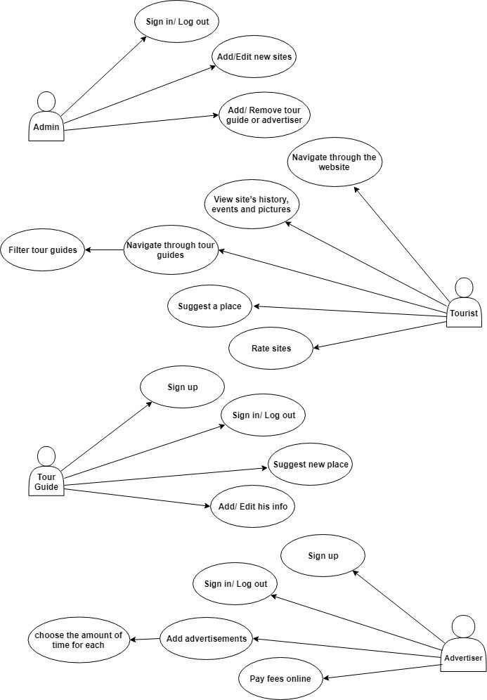
System Requirements (Use Cases)

Name: Register

Identifier UC1.0

Preconditions
- User should visit Home Page.
- User should have a valid email address.

Basic Course
- User clicks “Sign Up” button.
- Enter name, password and email.
- The user chooses to add advertisements or to add his info as a tour guide.
- According to their choice, users will be redirected to another page to add their info as tour guides or to add advertisements.

Alternate Course A:
Condition: The user chooses to cancel the sign up process by clicking on “Cancel” button .
A1.1 User is redirected to Home Page.

Post conditions
- User’s account will not be added to database.

Map to: 5.1.3.1, 5.1.4.1

Name: Sign in

Identifier UC1.1

Preconditions
1. The user should visit the Home Page
2. The user should already have a valid account or login as a guest.

Basic Course
1. The user enters his ID as username
2. The user enters his Password
3. The user clicks on “Sign in” Button
4. The system validates the user-name and password together from database.
5. Use case ends when the user redirected to his profile page.

Alternate Course A:
Condition: These user enters an incorrect username or password
A2.1 A message will appear to enter the correct password
A2.2 The user enters his username
A2.3 The user enters his Password
A2.4 The user clicks on “Sign in” Button

Post conditions
1. The user will sign in to the website

Map to: 5.1.1.1, 5.1.2.2, 5.1.3.1, 5.1.4.1

Name: Add new site.

Identifier UC1.2

Preconditions
1.Admin is logged into the system.
2.The Admin pressed Add site button.

Basic Course
1. The user enters the site description , history and pictures.
2.After finishing the user shall press done to save the information.
3.A new site will be stored in the database.

Post conditions:
1.The site will be added on the website.

Map to: 5.1.1.2

5.2.4
Name: View sites description/tour guides info.

Identifier UC1.3

Preconditions
1-The user must be in the home page.
2.The user filter sites/tour guide.

Basic Course
1-Use case begins when the user opens the sites list/tour guides list.
2-The user chooses the site/tour guide he wants to see .
3-Use case ends when the user access the sites/tour guide page.

Post conditions
1. The user has all information about the site/tour guide he wants.

Map to: 5.1.2.3,5.1.2.4

5.2.5

Name: Rate sites.

Identifier UC1.4

Preconditions
1.Site page is opened.

Basic Course
1. The user click on the heart from 1 to 3 hearts.
2. A new site’s review will be updated in the database.

Post conditions
1.The site’s review will be added on the website.

Map to: 5.1.2.2

5.2.6

Name: Edit sites info.

Identifier UC1.5

Preconditions
1.Admin is logged into the system.
2.The Admin pressed Edit site button.

Basic Course
1.The site info will be editable.
2.After editing the user shall press done to save the new information.

Post conditions
1.The site information will be updated on the website.

Map to: 5.1.1.3

5.2.7

Name: Remove/Add tour guide/advertisement.

Identifier UC1.6

Preconditions
1. The User must have an account with admin permission.
2.The Admin pressed Remove/Add button.

Basic Course
1.Use case begins when the admin opens the remove form/add form.
2.The admin enters the email and username of the user he wants to remove/add.
3.If the user is advertiser the admin chooses which advertisement to remove/add.
4.Use case ends when the admin receives a notification that user is deleted/added.

Alternate Course A: Description of the alternate course
Condition: the email or username is invalid
1. the admin receives a notification that entered e-mail address or username.
2. the user is redirected to the remove/add form again.

Post conditions
1.Tourguide/advertisement is removed/added.

Map to: 5.1.1.5

5.2.8

Name: Suggest new sites..

Identifier UC1.7

Preconditions
1. The User press contact us button.

Basic Course
1.Use case begins when the user opens the contact us form.
2.The user enters the suggested site name , description and history to be add .
3.Then press add button.

Post conditions
1.the new site will be redirected to admin to decide to add it or not

Map to: 5.1.2.5, 5.1.3.3.

5.2.9

Name: Add advertisements and pay fees.

Identifier UC1.8

Preconditions
1.Advertiser is logged into the system.
2. Advertiser pressed ADD button.

Basic Course
1-Use case begins when the user opens add form.
2-The user enters the suggested advertisement name , description and photo to be add .
3-The user enters the amount of time to appear his advertisement.
4-Then press add button.

Post conditions
1.The new advertisement will be redirected to admin to decide to add it or not

Map to: 5.1.4.3.

5.2.10

Name: Edit Tour guide info.

Identifier UC1.9

Preconditions
1.Tour guide is logged into the system.
2.Tour guide pressed Edit button.

Basic Course
1.The tour guide info will be editable.
2.After editing the tour guide shall press done to save the new information.

Post conditions:
1.Tourguide information will be updated in the database and then admin decide to update it or not on the website.

Map to: 5.1.3.4

5.2.11

Name: pay fees.

Identifier UC1.10

Preconditions
1.Advertiser is logged into the system.
2. Advertiser pressed PAY button.
Basic Course
1.Use case begins when the user opens pay form.
2.The user pay his fees.
3.Then press done button.

Map to: 5.1.4.4.

Non-functional Requirements
    - NFR1 : Attractive GUI : attractive interface with colourful and attention grabbing photos/pictures.
    - NFR2 : The system shall be secured and not hacked.

5.3.3 NFR3 : All user inputs shall be validated to ensure that no fake or wrong data is inserted in the database

High level plan

Iteration 1:
User Stories | Estimated Time
1. Admin functionalities | 2 weeks
2. Database | 1 week
Total Time | 3 weeks

Iteration 2:
User Stories | Estimated Time
1. Tourist functionalities | 1 week
2. GUI | 2 weeks
Total Time | 3 weeks

Iteration 3:
User Stories | Estimated Time
1. Advertiser functionalities | 1.5 weeks
2. Tour Guide functionalities | 1.5 weeks
Total Time | 3 weeks
Table 1: High Level Plan

Supporting Information
Appendix A
Traceability Matrix
RID | US1 | US2 | US3 | US4 | US5 | US6 | US7 | US8 | US9 | US10
UC1.1 |  |  |  |  |  | 
UC1.2 |  | 
UC1.3 |  |  |  |  |  |  |  |  | 
UC1.4 |  |  |  |  |  |  | 
UC1.5 |  |  | 
UC1.6 |  |  |  |  | 
UC1.7 |  |  |  |  |  |  |  |  |  | 

RID | US11 | US12 | US13 | US14 | US15 | US16 | US17 | US18 | US19
UC1.0 |  |  |  |  |  | 
UC1.7 |  |  |  | 
UC1.8 |  |  |  |  |  |  |  | 
UC1.9 |  |  |  |  | 
UC1.9 |  |  |  |  |  |  |  |  | 

Appendix B

Dependability Matrix

RID | US1 | US2 | US3 | US4 | US5 | US6 | US7 | US8 | US9 | US10 | US11 | US12 | US13
US1 |  |  |  | 
US2 |  |  |  |  |  |  |  |  |  | 
US3 | 
US4 | 
US5 |  |  |  |  |  |  |  |  |  |  |  | 
US6
US7 |  |  |  |  |  |  |  |  |  |  |  | 
US8 |  |  |  |  |  |  |  |  | 
US9 |  |  |  |  | 
US10
US11 |  |  | 
US12 |  |  |  |  |  |  |  |  |  |  |  |  | 
US13 |  |  |  |  |  |  |  |  |  |  |  | 
US14 |  |  |  |  |  |  |  |  |  |  |  | 
US15 |  |  |  |  |  |  |  |  |  |  |  | 
US16 |  |  |  |  | 
US17
US18
US19

RID | US14 | US15 | US16 | US17 | US18 | US19
US1
US2 | 
US3
US4
US5 |  |  |  |  |  | 
US6
US7
US8
US9 |  | 
US10
US11
US12
US13
US14
US15
US16
US17 |  |  | 
US18 |  |  | 
US19 |  |  | 

